Commission for Accreditation of

Park and Recreation Agencies

Self-Assessment Report and

Visitation Report

2014 CAPRA Standards, 5th Edition

Park District of Oak Park

Jan Arnold, Executive Director

Oak Park, Illinois

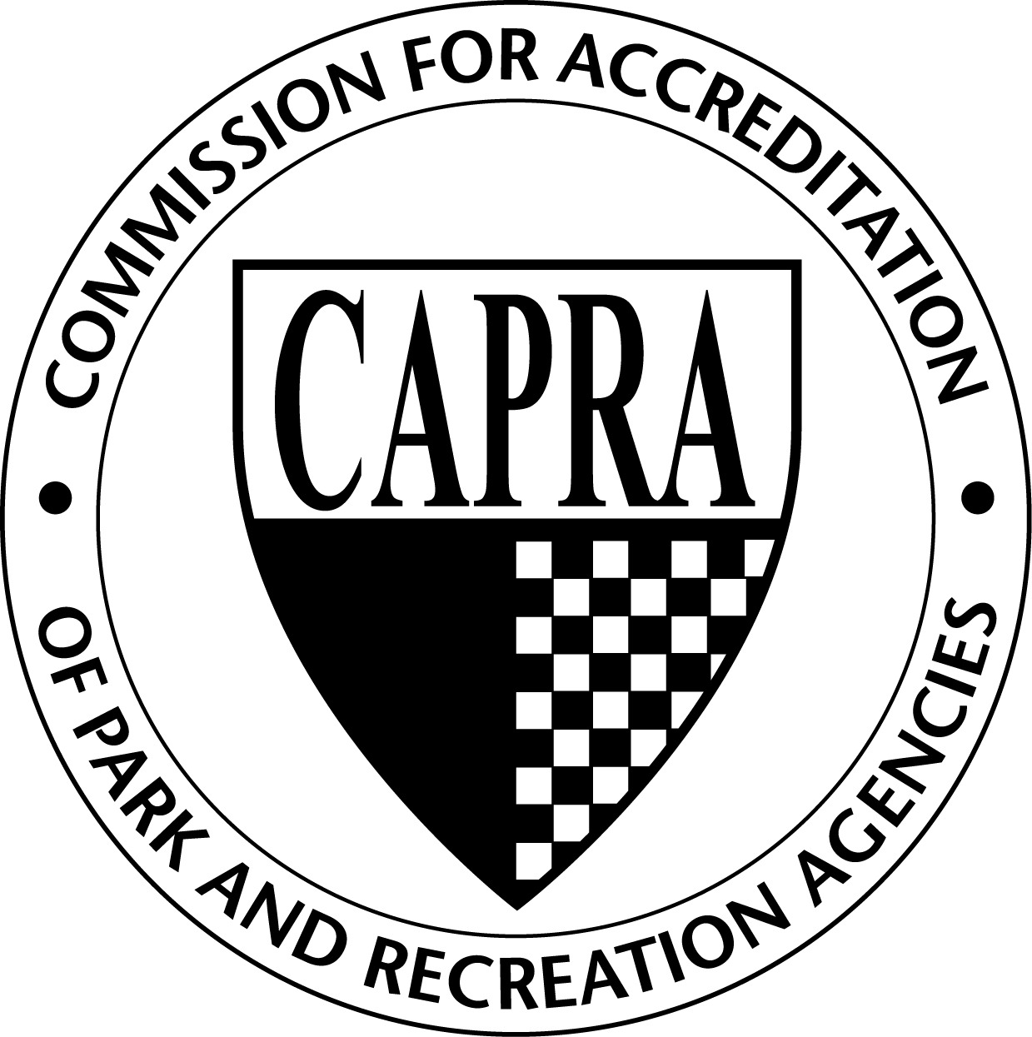

May 6-8, 2015

Visitation Team:

Irby Brinson, Chair

Greg Morris
Self-Assessment Report Introduction

Agency Overview:

The Park District of Oak Park is an independent, local government body with its own taxing authority, governed by a 5-member elected Board of Commissioners. The Park District of Oak Park’s tax jurisdiction and geographical boundaries are the same as the Village of Oak Park.

Agency Contact Information:

Director:
Jan Arnold, CPRP
Executive Director
Park District of Oak Park
218 Madison St
Oak Park, IL 60302
(708) 725-2020
jan.arnold@pdop.org

Accreditation Primary Contact:
Bobbi Nance, CPRP
Project Manager
Park District of Oak Park
218 Madison St
Oak Park, IL 60302
(708) 725-2103
(708) 256-8816 (cell)
bobbi.nance@pdop.org

Visitation Report Introduction

The visitation team will include a brief introduction about the overall context in which the team members approached their task. This might include the types of data gathering processes undertaken, the types of individuals interviewed, and materials reviewed.

Agency Overview
Park District of Oak Park
218 Madison St
Oak Park, Illinois 60302

- Community Demographics
  - Predominant form(s) of government in the tax jurisdiction (i.e., manager, mayoral, commission):

Elected Board with Appointed Director

  - Population of tax jurisdiction:

51,878

  - Population of metropolitan service area:

51,878

  - Age profile of tax jurisdiction:

Median Age: 38.9
Under Age 18: 24%
Ages 18-64: 65%
Ages 65+: 11%

  - Income profile of tax jurisdiction:

Median Household Income: $78,802
Persons Below Poverty Level: 8.6%

  - Racial diversity of the tax jurisdiction:

White: 67.7%
African American:21.7%
Hispanic or Latino: 6.8%
Asian: 4.8%
Two or more races: 3.6%

- Agency Characteristics
  - Operating budget:

$16,210,423

  - Capital budget:

$6,376,000

  - Full-time employees:

49

  - Part-time/seasonal employees:

280-520 depending on time of year

  - Parkland acreage:

80 acres

  - Significant agency awards and/or recognitions:

Summary of Awards/Recognitions from previous 5 years:
  - 100 Year Anniversary Celebrated in 2012
  - $4.1 million in grants awarded since 2005
  - Cavalcade of Pride Award, 2012, 2014
  - 1st Place in IPRA Agency Showcase, Website Design, 2014
  - 2nd Place in IPRA Agency Showcase, Logo Design, 2014
  - 2nd Place in IPRA Agency Showcase, Marketing Campaign, 2014
  - Ellis & Associates Risk Management Platinum Safety Award (Top 10%), 2012
  - Ellis & Associates Risk Management Gold Safety Award, 2009-2011, 2013-present
  - Golden Guard Award, Ellis & Associates, 2014
  - GFOA Certificate of Achievement for Excellence in Financial Reporting, 2013 - present
  - GFOA Distinguished Budget Award, 2009 – present
  - Illinois Distinguished Accredited Agency
  - American Camping Association Accredited
  - PDRMA Loss Control Accredited

- Physical Characteristics
  - Geographic size of tax jurisdiction (square miles):

4.7 square miles

  - Describe significant rivers, lakes, mountain ranges, which influence the community:

Oak Park is a very flat, dense, urban environment. With over 51,000 people in 4.7 square miles, it is one of the top 100 most dense cities in the United State according to US Census data. Oak Park is bordered on the east by the City of Chicago and 3 train lines provide easy access for city commuters. The Park District has had to be creative with its 83 acres of land to serve all of its residents, but the urban environment also means that every block in Oak Park is walkable.

- Cultural Characteristics
  - Significant social and/or cultural factors that influence the agency's delivery of service:

Because of land and space constraints, many of the demographics of the Oak Park community are not expected to vary through 2028, including size and racial make-up. However, there are several unique characteristics about Oak Park from the Park District’s Comprehensive Master Plan and the Park District’s Branding Study that influence the Park District of Oak Park’s delivery of service, including:
- 55% of Oak Park housing units are in multi-unit structures (apartments, condos, etc.). Many of these residents use Oak Park neighborhood parks as their alternative backyard.
- 67% of Oak Park households do not have any children living in them. It’s important that the Park District never become too child-focused and miss serving the majority of the population.
- The median household income is estimated to be $72,867 in 2013 and per capita income is an estimated $44,599. The service area’s median household income is well above the state ($56,576) and national ($52,762) averages. Per capita income is also much higher than state ($29,511) and national ($27,915) averages. Both of these high-income numbers mean both that there is a greater level of disposable dollars in the community, and that they come with higher expectation for quality program and facility offerings within the target audiences. Thus, what might be ‘good enough’ in many places may not be acceptable in Oak Park and the staff must continue to place additional emphasis on service offerings and service delivery through outstanding customer service as a way to differentiate themselves from their competitors.
- Approximately 96% of residents have at least a high school diploma, and nearly 70% have a Bachelor’s degree or better. This is significantly higher than national averages and correlates directly with higher income levels and could also indicate a propensity to make greater use of online and social media tools to seek information for Park District offerings.
- Entertainment/recreation ranks fifth out of the 14 spending categories reported, averaging over $4,700 spent per resident per year, which is higher than even travel and dining out.

Additionally, Oak Park is on several of City Data’s “Top 100” lists.
- #1 on the list of “Top 100 cities with oldest houses (pop. 50,000+)”
- #13 on the list of “Top 100 best educated cities (highest percentage of bachelor degree holding residents) (pop. 50,000+)”
- #53 on the list of “Top 101 cities with the biggest property tax revenues per resident in 2004 in $ (population 10,000+)”
- #78 on the list of “Top 101 cities with the largest percentage of likely homosexual households (counted as self-reported same-sex unmarried-partner households) (population 5,000+)”

1.0 - Agency Authority, Role, and Responsibility
Note: Standards marked with a star () are fundamental standards,
and are required of all agencies seeking accreditation.

Delineation of jurisdiction and authority are the foundation upon which the park and recreation agency is organized. Policy and rule-making functions and the development of procedures to implement policy create the organizational framework. The mission establishes the organizational purpose, and goals and objectives establish the strategic direction. Organization values affect how the agency through its leadership and staff relate to other governing bodies, agencies, organizations and how it incorporates input from citizens and staff.

1.1 - Source of Authority
Standard: The source of agency authority or legal basis of operation and the extent of powers shall be identified in a legal document such as the state statute, local charter, city ordinance, or park district code.

Suggested Evidence of Compliance: Provide legal citation and, if appropriate, date of resolution by local governing entity or legal authority (i.e., enabling act, support documentation, ordinance; if permissive state authority, provide charter).

Informational reference in the Management of Park and Recreation Agencies, (2010), 3rd Ed., Chapter 3 - Legal Authority and Jurisdiction, pp. 41-42.
Agency Evidence of Compliance:

The Park District of Oak Park was created in 1912, as evidenced by a proclamation¹ from the State of Illinois signed by the governor, "the Park District of Oak Park was formed by a voter referendum on April 2, 1912, and since that day has been providing quality parks and recreational opportunities for its residents and guests from around the world..."
The Park District has been unable to locate its articles of incorporation, however is still recognized as a duly constituted Illinois municipal corporation as explained by Mark E Burkland of Holland & Knight, General Counsel for the Park District of Oak Park, in a letter² in 2008:
"Park District of Oak Park representatives, after diligent research including contact with the Illinois Secretary of State and record-keepers in other government offices, have been unable to locate a copy of the Park District of Oak Park's articles of incorporation. The Park District does have information, however, indicating (a) the first meeting of the Board of Commissioners of the Park District of Oak Park was held on Monday, April 8, 1912, at which the first terms of the five commissioners were decided and (b) that the Park District of Oak Park has operated continuously as a park district after that date.
Based on the information available to us, it is our opinion that the Park District is a duly constituted Illinois unit of local government.
When the Illinois Park District Code³ (the "Park District Code") was enacted in 1947, the Illinois General Assembly declared that it was the intent of the Park District Code that all existing park districts shall be governed by the Park District Code (with exceptions applicable only to the Chicago Park District). Since the enactment of the Park District Code, the Park District of Oak Park has operated under the provisions of that Code. The Park District's Board of Commissioners has met regularly to conduct the business of the Park District in accordance with the Park District Code, and the Park District has purchased and sold property, created and maintained park and recreation programs, conducted referenda, levied taxes, issued obligations, and in every other respect conducted and managed its affairs in the manner of an Illinois unit of local government.
It is our further opinion, therefore, that Illinois common law recognizes the Park District of Oak Park as a duly constituted Illinois municipal corporation organized and existing under the Park District Code, regardless of the inability of the Park District to find a copy of its articles of incorporation. See People ex rel. Mohlenbrock v. Pike, 197 Ill. 449 (1902) ("Municipal corporations being required by public necessity, the law itself, for the purpose of strengthening the infirmity of evidence and upholding the public peace and the security of private property, will indulge, after long continued use of corporate powers and the public acquiescence, in presumptions in favor of their legal existence.")"
Documentation of Evidence:
- Proclamation from the State of Illinois (photo below)
- 01.01.00_Letter-Regarding-Park-District-Incorporation.pdf
- Illinois Park District Code
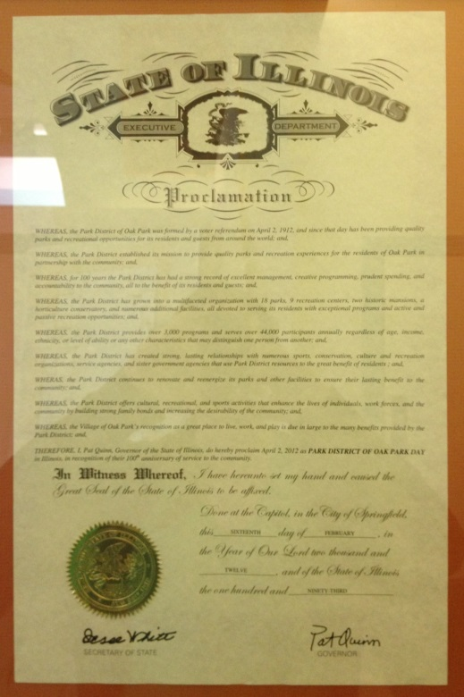

Agency Self Review: Met Not Met

Visitor Comments:

Visitor Evaluation: Met Not Met

1.1.1 - Approving Authority/Policy Body
Standard: The agency organizational structure shall provide for one public entity responsible for policy-making functions. This entity usually has taxing power and must approve the budget; it holds title to property. It also serves an important function in providing input to improve and expand park and recreation programs, services, and facilities.

Suggested Evidence of Compliance: Provide a chart or diagram and narrative description of the organizational structure, interrelationship of organizational components and powers of authority over policy-making; show the relationship of the agency to its approving authority and provide the approving authority bylaws or charter.

Informational reference in the Management of Park and Recreation Agencies, (2010), 3rd Ed., Chapter 3 - Legal Authority and Jurisdiction, pp. 38-52.
Agency Evidence of Compliance:

The Park District of Oak Park is a council-manager form of local government and is its own entity, separate from all other taxing bodies in Oak Park. The Park District of Oak Park is governed by a Board of Commissioners, an elected board of five citizens. The Board of Commissioners has legislative power including the power to tax, holds title to the Park District's property, and is responsible for all policy-making functions, as well as approval of the budget. The Board appoints and oversees an Executive Director who is responsible for managing the Park District's operations and carrying out the policies and direction set by the Board. These responsibilities and powers are outlined in the Board of Commissioners Policies¹.
The organizational structure outlined on the Park District's Municipal Directory² shows the relationship between the governing body, the Executive Director, and the various Park District components. .
Documentation:
- 01.01.01_Board-Policies.pdf
- Park District of Oak Park Municipal Directory

Agency Self Review: Met Not Met

Visitor Comments:

Visitor Evaluation: Met Not Met

1.1.2 - Citizen Advisory Boards/Committees
Standard: There shall be citizen boards/committees that are advisory to the agency and the approving authority that appoints them. Advisory boards engage the community and serve as advocates for the advancement of programs, facilities, and services.

Suggested Evidence of Compliance: Provide list of boards/committees with membership, authority, responsibilities and duties, terms of office, meeting minutes.

Informational reference in the Management of Park and Recreation Agencies, (2010), 3rd Ed., Chapter 3 - Legal Authority and Jurisdiction, pp. 53-54.
Agency Evidence of Compliance:

The Park District values community input and involvement and has organized four citizen-led volunteer committees to work the Park Board of Commissioners and staff for the betterment of the Park District and community. Basic information about the committees as well as current membership is listed in the Park District's Municipal Directory¹.
Park District Citizen Committee (PDCC). Originally organized in 2003 to assist in the comprehensive planning process, this committee oversees the implementation of the Park District's comprehensive plan and capital improvement plan and provides a valuable communication channel between the Park District and the citizens of Oak Park. With the help of the PDCC, the Park District is better able to assess community needs and expectations necessary to carry out its mission. The PDCC is made up of 11 members, and up to 2 alternate members and 2 student members. They are appointed by the Park District Board of Commissioners to serve staggered 3 year terms. Student members must be Oak Park residents and a junior or senior attending an Oak Park high school who serve a 1 year term from September through August. Meetings are held monthly and PDCC Meeting Minutes² are taken. More information about this committee can be found in the PDCC Mission & Guiding Principles³.
Greening Advisory Committee (GAC). The GAC was originally organized in 2007 as the Greening Task Force to discuss the environmental issues that the Park District was facing, to explore measures to be taken to meet citizens' greening interests, and maintain the health of the parks. The committee acts as a liaison between the Park District and the community, helping implement the Park District's Environmental Policy⁴, assisting the Park Board in identifying and exploring sustainability issues and environmental initiatives, helping determine annual projects, and maintaining the Green Team, the Park District's park stewardship program. The GAC is made up of 6-8 members appointed by the Park District Board of Commissioners who serve staggered 3 year terms and select Park District staff. The committee meets monthly and GAC Meeting Minutes⁵ are taken. More information about this committee can be found in the GAC Mission & Guiding Principles⁶.
Art Advisory Committee (AAC). The purpose of the AAC is to enhance the cultural and esthetic quality of life in Oak Park by integrating art throughout the Park District. The committee was formed as part of the development of Public Art Guidelines⁷ which spelled out guidelines for the acquisition, placement, and maintenance of art in the Park District. The committee acts as a resource and provides expertise in the area of fine arts; maintains an inventory, inspects, and provides public education on existing art in the Park District; works to encourage contribution of funds to the Park District Artworks Acquisition and Maintenance Fund and recommends the designation of these funds; and works with other public and private entities and individuals on art-related activities. The AAC is made up of 7 members appointed by the Park District Board of Commissioners who serve staggered 3 year terms. The committee meets on an as-needed basis; AAC Meeting Minutes⁸ are taken when meetings are held.
Senior Advisory Committee (SAC). The mission of the SAC is to provide guidance and recommend direction to the Park District regarding the development and implementation of recreational activities for senior citizens. The committee has developed the SAC Bylaws⁹ to outline committee roles and responsibilities. The committee is made up of seven voting members (3 are appointed by the Park District Board of Commissioners, 4 are elected by the Active Adult members-at-large) who serve 2 year terms. In addition, up to 2 Park District staff serve as non-voting representatives. The SAC meets approximately every 2 months and SAC Meeting Minutes¹⁰ are taken.
Documentation:
- 01.01.02_Municipal-Directory.pdf
- 01.01.02_PDCC-Meeting-Minutes.pdf
- 01.01.02_PDCC-Mission-and-Guiding-Principles.pdf
- 01.01.02_Environmental-Policy.pdf
- 01.01.02_GAC-Meeting-Minutes.pdf
- 01.01.02_GAC-Mission-and-Guiding-Principles.pdf
- 01.01.02_AAC-Public-Art-Guidelines.pdf (see highlighted portion beginning on page 4)
- 01.01.02_AAC-Meeting-Minutes.pdf
- 01.01.02_SAC-Bylaws.pdf
- 01.01.02_SAC-Minutes.pdf

Agency Self Review: Met Not Met

Visitor Comments:

Visitor Evaluation: Met Not Met

1.2 - Periodic Timetable for Review of Documents
Standard: All documents designated for periodic review shall be reviewed on a regular basis according to an established agency review schedule. For example, if the agency has determined that a document should be reviewed annually, the agency shall provide evidence that the document is reviewed annually and include a copy of the most recent annual review. Several standards in the accreditation process require that adopted plans, policies and procedures be reviewed and updated at various intervals. In those cases, the agency shall provide evidence that the document was reviewed and updates pursuant to the period specified in the standard.

Standards with a review requirement are:
1.4.1 Agency Goals and Objectives
1.6.1 Administrative Policies and Procedures
2.4 Park and Recreation System Master Plan
2.5 Strategic Plan
3.4.2 Community Relations Plan
3.4.3 Marketing Plan
3.6 Records Management Policy and Procedures
3.6.1 Records Disaster Mitigation and Recovery Plan and Procedures
4.1 Personnel Policies and Procedures Manual
4.1.2 Recruitment Process
4.1.8 Compensation Plan
4.3 Job Analyses for Job Descriptions
4.5 Workforce Health and Wellness Program
4.6.1 Employee Training and Development Program
5.1.1 Comprehensive Revenue Policy
6.1 Recreation Programming Plan
6.2 Program Objectives
6.4 Community Education for Leisure Process
7.1 Parkland Acquisition Procedures
7.2 Area and Facilities Development Policies and Procedures
7.5 Maintenance and Operations Management Standards
7.5.1 Facility Legal Requirements
7.9.1 Recycling and/or Zero Waste Plan
8.5 General Security Plan
8.6.2 Emergency Risk Communications Plan
9.1 Risk Management Policy
10.4 Needs Assessment
10.5.1 Recreation and Leisure Trends Analysis

Suggested evidence of compliance: Provide the agency review schedule for the document, program, policy or procedure referenced in the enumerated standards.
Agency Evidence of Compliance:

Agency Self Review: Met Not Met

Visitor Comments:

Visitor Evaluation: Met Not Met

1.2.1 - Document Approval Authority
Standard: All documents designated for approval by the appropriate approving authority shall be approved or adopted in a manner consistent with the agency process and procedure for adoption of policies, rules, regulations, and operational procedures, except that the agency budget and park and recreation system master plan must be adopted or approved by the entity responsible for policy-making.

Standards with an adoption or approval requirement are:
1.5 Vision
2.3.1 Community Comprehensive Plan with Park and Recreation Component
2.4 Park and Recreation System Master Plan
2.5 Strategic Plan
2.10 ADA Transition Plan
3.4 Public Information Policy and Procedure
4.4.1 Leadership Succession Procedure
5.4 Annual or Biennial Budget
8.1 Codes, Laws, and Ordinances
9.1 Risk Management Policy
9.1.1 Risk Management Plan and Procedures

Suggested Evidence of Compliance: Provide documentation that the agency budget and park and recreation system master plan have been duly adopted or approved by the entity responsible for policy-making and that other documents designated for approval by the appropriate approving authority have been approved in a manner consistent with the agency process and procedure for approval of policies, rules, regulations, and operational procedures.
Agency Evidence of Compliance:

In general, the Park District Board of Commissioners is responsible for creating and updating policies and plans governing the Park District and staff in administering the policies. The responsibility for creating and updating, or causing to be created or updated, procedures for implementing policy or departmental or operational plans falls to the Executive Director.
Standard | Authority for Approval | Proof of Approval
Vision | Board of Commissioners | 01.02.01_December-2012-Board-Meeting-Minutes.pdf
Community Comprehensive Plan with Park and Recreation Component | Village of Oak Park | 01.02.01_Comprehensive-Plan-Approval-at-September-2014-VOP-Board-Meeting.pdf (page 5)
Park and Recreation System Master Plan | Board of Commissioners | 01.02.01_PDOP-Comprehensive-Plan-Approval-at-December-2014-Board-Meeting.pdf
Strategic Plan | Board of Commissioners | 01.02.01_December-2012-Board-Meeting-Minutes.pdf
ADA Transition Plan | Board of Commissioners | 01.02.01_April-2013-Board-Meeting-Minutes.pdf
Public Information Policy and Procedure | Board of Commissioners | 01.02.01_Policy-Manual-Approval-at-December-2014-Board-Meeting.pdf
Leadership Succession Procedure | Board of Commissioners | 01.02.01_Policy-Manual-Approval-at-December-2014-Board-Meeting.pdf
Annual or Biennial Budget | Board of Commissioners | 01.02.01_Budget-Approval-at-November-2014-Board-Meeting.pdf
Codes, Laws, and Ordinances | Board of Commissioners | 01.02.01_Rules-and-Regulations-Approval-at-December-2014-Board-Meeting.pdf
Risk Management Policy | Board of Commissioners | 01.02.01_Policy-Manual-Approval-at-December-2014-Board-Meeting.pdf
Risk Management Plan and Procedures | Board of Commissioners | 01.02.01_Safety-Manual-Approval-at-December-2014-Board-Meeting.pdf

Agency Self Review: Met Not Met

Visitor Comments:

Visitor Evaluation: Met Not Met

1.3 - Jurisdiction
Standard: The specific geographical boundaries of the agency's jurisdiction shall be set forth by geographical description and map.

Suggested Evidence of Compliance: Provide a map with geographical boundaries of jurisdiction and service areas, including location of facilities identified.

Informational reference in the Management of Park and Recreation Agencies, (2010), 3rd Ed., Chapter 22 – Law Enforcement and Security, pp. 604-606.
Agency Evidence of Compliance:

DPRAC - 3.5.2 Map

Agency Self Review: Met Not Met

Visitor Comments:

Visitor Evaluation: Met Not Met

1.4 - Mission
Standard: There shall be an established mission statement that defines the direction and purpose of the agency. The agency mission is the purpose or reason for the existence of the agency and establishes the long-term direction for the agency services and activities.

Suggested Evidence of Compliance: Provide the established mission statement.

Informational reference in the Management of Park and Recreation Agencies, (2010), 3rd Ed., Chapter 5 – Organization Structure and Administrative Operations, pp. 71-72.
Agency Evidence of Compliance:

The Park District of Oak Park's mission statement defines the purpose of the agency, which is "In partnership with the community, we enrich lives by providing meaningful experiences through programs, parks and facilities."
The current mission statement was revised as part of the 2013-2015 Strategic Plan¹ with input from both staff and the Board of Commissioners. The final version of this plan, including the mission statement, was reviewed by the Board of Commissioners on December 6, 2012 and adopted on December 20, 2012. The mission statement is reviewed every 3 years as part of the District's regular strategic planning process.
Documentation:
- 01.04.00_Pages-3-4-Introduction-and-Mission-Vision-Values-of-2013-2015-Strategic-Plan.pdf
- 01.04.00_December-2012-COW-Meeting-Minutes.pdf
- 01.04.00_December-2012-Board-Meeting-Minutes.pdf
Agency Self Review: Met Not Met

Visitor Comments:

Visitor Evaluation: Met Not Met

1.4.1 - Agency Goals and Objectives
Standard: There shall be established, measurable goals and objectives for the agency and for each organizational component within the agency. Such goals and objectives shall be directed toward accomplishing the agency mission, be reviewed periodically, and distributed to all appropriate personnel.

Suggested Evidence of Compliance: Provide the measurable goals and objectives for each organizational component, with evidence of periodic review and distribution.

Informational reference in the Management of Park and Recreation Agencies, (2010), 3rd Ed., Chapter 5 – Organization Structure and Administrative Operations, pp. 72-73; Chapter 11 – Physical Resource Planning, pp. 220-224; Chapter 15 – Public Relations, Marketing, Customer Service, p. 360.
Agency Evidence of Compliance:

The Park District has several sets of goals and objectives it works throughout the year to achieve. One set of goals and objectives comes from the Park District's comprehensive plan¹ and another set comes from the strategic plan². The other set is developed annually by each Park District component³ during the budget development process.
Staff update the status of each goal and objective throughout the year. The percent of goals completed is a Park District performance measure and annual results are documented in the Park District Performance Measurement Annual Report⁴ (only strategic and department goals were tracked in 2014, comprehensive goal tracking added in 2015). Progress during the year is displayed on the Park District's dashboards software⁵, where it is made available to all staff as well as to the public on the Park District's website⁶. By clicking on the charts, both staff and the public are also able to view the current list of goals and objectives.
Documentation:
- 01.04.01_Comprehensive-Plan-Goals-and-Objectives.pdf
- 01.04.01_Strategic-Plan-Goals-and-Objectives.pdf
- 01.04.01_2015-Department-Goals.pdf
- 01.04.01_2014-Performance-Measurement-Report.pdf (current version is draft until the 2014 fiscal year closes out, final version to be uploaded in March)
- Screenshot of Goals on Park District dashboards (below)
- link to Goals & Objectives status on Park District website (scroll down to middle of webpage)
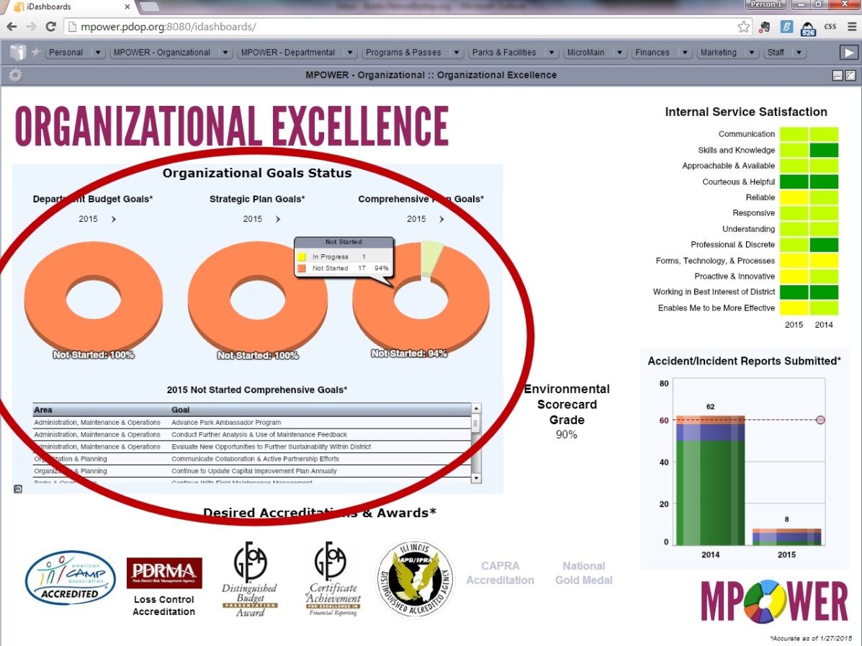
Screenshot of Staff Dashboard Displaying Current Status of all Goals and Objectives

Agency Self Review: Met Not Met

Visitor Comments:

Visitor Evaluation: Met Not Met

1.4.2 - Personnel Involvement
Standard: The agency shall have an established process for acquiring and considering input from personnel at various levels of the organization in the development of goals and objectives.

Suggested Evidence of Compliance: Provide examples of the methods utilized to obtain input from personnel at various levels of the organization (e.g., surveys, focus groups, etc.) and how the organization’s goals and objectives are communicated to all personnel.

Informational reference in the Management of Park and Recreation Agencies, (2010), 3rd Ed., Chapter 5 – Organization Structure and Administrative Operations, p. 72.
Agency Evidence of Compliance:

DPRAC - 1.3.1 District Goals

Agency Self Review: Met Not Met

Visitor Comments:

Visitor Evaluation: Met Not Met

1.5 - Vision
Standard: The agency shall provide an adopted Vision Statement that is aspirational, far reaching, and states where the agency is going. It should be available to the approving authority, staff, and participants.

Suggested Evidence of Compliance: Provide evidence of adopted Vision statement that is available to the approving authority, staff, and participants.

Informational reference in the Management of Park and Recreation Agencies, (2010), 3rd Ed., Chapter 4 – Politics and Advocacy, p. 58; Chapter 5 – Organization Structure and Administrative Operations, pp. 72-73; Chapter 7 – Planning for Strategic Management, pp. 115-116.
Agency Evidence of Compliance:

The Park District of Oak Park's vision statement demonstrates what the agency aspires to become, which is "We strive to exceed the needs of our diverse community with a collaborative and innovative approach."
The current vision statement was revised as part of the 2013-2015 Strategic Plan¹ with input from both staff and the Board of Commissioners. The final version of this plan, including the vision statement, was reviewed by the Board of Commissioners on December 6, 2012² and adopted on December 20, 2012³. The vision statement is reviewed every 3 years as part of the District's regular strategic planning process.
The vision statement is available the Board of Commissioners, staff, and the community through signage⁴ in District facilities and on the District website⁵.
Documentation:
- 01.05.00_Pages-3-4-Introduction-and-Mission-Vision-Values-of-2013-2015-Strategic-Plan.pdf
- 01.05.00_December-2012-COW-Meeting-Minutes.pdf
- 01.05.00_December-2012-Board-Meeting-Minutes.pdf
- Photo of Mission, Vision, Values Signage (below)
- Screenshot of Vision on Park District website (below)
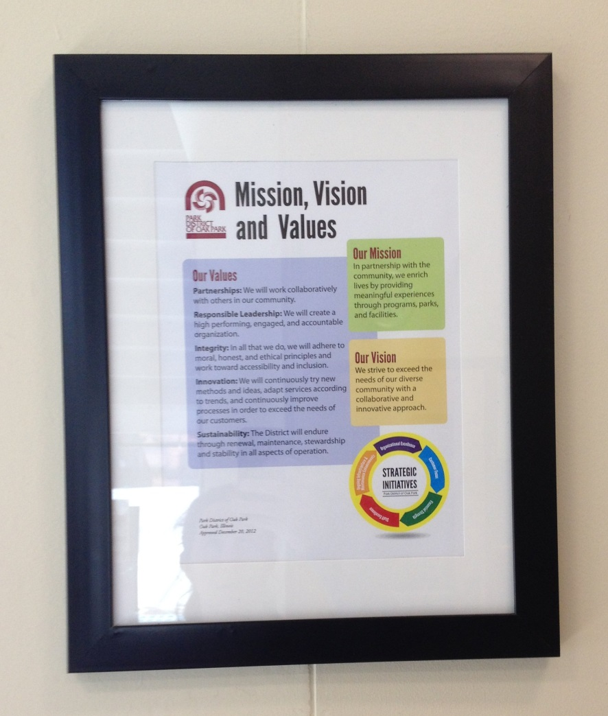
Example of Mission, Vision, and Values Posted in District Facilities
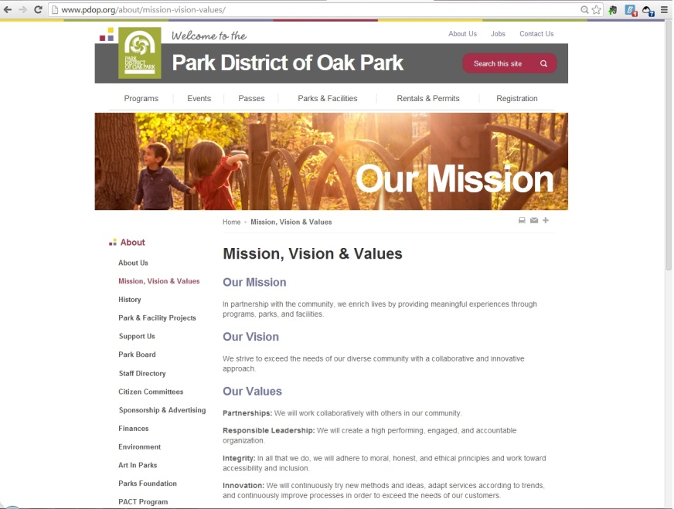
Mission, Vision, and Values Posted on District Website

Agency Self Review: Met Not Met

Visitor Comments:

Visitor Evaluation: Met Not Met

1.6 - Policies, Rules, Regulations, and Operational Procedures
Standard: There shall be delegation of responsibilities for the policy-making functions of the approving authority and the administrative functions of the chief administrator and staff.

Suggested Evidence of Compliance: Show delegation of responsibilities among approving authority, chief administrator, and staff regarding development and implementation of policies, rules, regulations, and operational procedures.

Informational reference in the Management of Park and Recreation Agencies, (2010), 3rd Ed., Chapter 2 – Management and the Law, p. 20; Chapter 5 – Organization Structure and Administrative Operations, p. 87.
Agency Evidence of Compliance:

DPRAC - 1.5.1 Comprehensive Board Policy Manual, 1.5.2 Administrative and Policy Making Functions, 1.5.3 Agency Rules and Regulations, 1.6.1 Operational Procedures

Agency Self Review: Met Not Met

Visitor Comments:

Visitor Evaluation: Met Not Met

1.6.1 - Administrative Policies and Procedures
Standard: There shall be policies and procedures, encompassing administrative aspects of the organization that are kept up-to date, reviewed periodically, and made available to pertinent administrative and supervisory personnel.

Suggested Evidence of Compliance: Provide access to the agency policies and procedures, demonstrate how they are made available to personnel, and provide evidence of periodic review by the approving authority and administrators.

Informational reference in the Management of Park and Recreation Agencies, (2010), 3rd Ed., Chapter 3 – Legal Authority and Jurisdiction, pp. 43-44; Chapter 5 – Organization Structure and Administrative Operations, pp. 87-88.
Agency Evidence of Compliance:

The Park District of Oak Park has a set of Park District Policies¹ that is reviewed, updated, and approved² by the Park District Board of Commissioners at least every 2 years. The last review took place in December 2014. Additionally, the Park District has a comprehensive set of Park District Procedures³ that is reviewed as a whole every 2 years by Park District staff. The last overall review³ occurred August-September 2013, before the procedures were copied to The Hub (hence the difference in document format). The Hub⁵, the Park District's internal document management software, is where all Park District policies, procedures, and important information is stored. Each staff member is given access to the software as part of the hiring and orientation process. The software can be accessed on any computer, tablet, or smartphone with internet access. The Park District has the ability to produce PDFs of any of the information included in The Hub if needed for offline viewing.
Documentation:
- 01.06.01_Administrative-Policies.pdf
- 01.06.01_Policy-Manual-Approval-at-December-2014-Board-Meeting.pdf
- 01.06.01_Administrative-Procedures.pdf
- 01.06.01_Procedure-Review.pdf
- Screenshot of The Hub (below)

Agency Self Review: Met Not Met

Visitor Comments:

Visitor Evaluation: Met Not Met

1.7 - Agency Relationships
Standard: There shall be ongoing liaison roles with complementary organizations, such as nearby park and recreation agencies, social service organizations, and other governmental units and regulatory bodies.

Suggested Evidence of Compliance: Provide evidence of cooperative efforts, including a list of staff with liaison responsibility. This information may be evidenced through Memoranda of Agreement, Memoranda of Understanding, Cooperative Agreements, etc.

Informational reference in the Management of Park and Recreation Agencies, (2010), 3rd Ed., Chapter 2 – Management and the Law, p. 28; Chapter 4 – Politics and Advocacy, p. 66; Chapter 6 – Partnerships, pp. 95-110; Chapter 7 – Planning for Strategic Management, pp. 110-122.
Agency Evidence of Compliance:

The Park District of Oak Park recognizes the importance of working with local governments and other community organizations as evidenced by the Cooperation with Community Organizations Policy¹. As part of the development of the 2015-2024 Park District of Oak Park Comprehensive Master Plan process, over 60 Partnership Examples² were collected demonstrating how the Park District has partnered with local agencies for the greater good of the community.
The Executive Director serves as the liaison to other governmental entities, including those that the Park District has formal intergovernmental agreements with:
- School District 97³
- School District 200⁴
Additionally, Park District commissioners and staff serve as liaison to community groups and also as representatives of the Park District on several committees and boards. In 2012, the Board of Commissioners formalized this process in a memo which outlined Commissioner Representation Roles⁵ that would be covered by the 5 commissioners. Other examples include:
Organization(s) | Park District Commissioner/Staff | Role
Pioneering Health Community | Jan Arnold, Executive Director | Team Member⁶
Management Council | Jan Arnold, Executive Director | Council Member⁷
Rotary Club of Oak Park-River Forest | Jan Arnold, Executive Director | Member⁸
Collaboration for Early Childhood | Amanda Heiman, Program Manager | Partner⁹
Community Business Manager | Kyle Cratty, Director of Finance | Member¹⁰
Documentation:
- 01.07.00_Cooperation-with-Community-Organizations-Policy.pdf
- 01.07.00_Partnership-Examples-in-Comprehensive-Master-Plan.pdf
- 01.07.00_School-District-97-Intergovernmental-Agreement.pdf
- 01.07.00_School-District-200-Intergovernmental-Agreement.pdf
- 01.07.00_Commissioner-Representation-Roles.pdf
- link to Wild About Wellness' Pioneering Healthy Community Team
- 01.07.00_Management-Council-Participation.pdf
- 01.07.00_Evidence-of-Rotary-Membership.pdf
- link to Collaboration for Early Childhood Partners
- 01.07.00_Community-Business-Managers-Meetings-and-Members.pdf
Agency Self Review: Met Not Met

Visitor Comments:

Visitor Evaluation: Met Not Met

1.7.1 - Operational Coordination and Cooperation Agreements
Standard: There shall be established agreements with other agencies, organizations, or individuals that entail cooperative use and maintenance of facilities, programing, facility design, land development, finances, etc.

Suggested Evidence of Compliance: Provide examples of cooperative agreements.

Informational reference in the Management of Park and Recreation Agencies, (2010), 3rd Ed., Chapter 6 – Partnerships, pp. 109-107.
Agency Evidence of Compliance:

DPRAC - 1.9.1 Policy on Cooperative Use and Maintenance of Facilities

Agency Self Review: Met Not Met

Visitor Comments:

Visitor Evaluation: Met Not Met

Visitation Report Summary for
Category 1.0 - Agency Authority, Role, and Responsibility

Reviewed By: (Visitor Name)

Unmet Standards: (List the Standard # and Name)

Provide clarification for all unmet fundamental standards:

2.0 - Planning
Note: Standards marked with a star () are fundamental standards,
and are required of all agencies seeking accreditation.

Planning activities are essential to effective agency management. Frequently, they are the responsibility of a permanent component of the agency; however, they may be performed by staff from various units or contracted to an outside professional consultant. Complex demands for services and limited public resources require that the park and recreation agency carefully research operational alternatives and plan future programs. Precise guidelines should establish the parameters of planning tasks and responsibilities.

The strength of the planning unit's leadership is a major ingredient in a productive and effective planning effort. This competence may be reflected both in academic training and in prior professional experience. The chief administrator should be closely involved in the planning process. A direct relationship between planning personnel and the chief administrator enhances the ability for the planning personnel to collect data and make recommendations, and the chief administrator's ability to make informed decisions.

Strategic planning is vital to high performing organizations and involves organizational and community input to identify and come to agreement on vision, mission, and values that support and guide the systems, structures, and strategies as a framework for organizational progress to achieve results.

These standards examine the types of planning necessary for administrators to efficiently and effectively manage both day-to-day and long-term operations of a park and recreation agency.

Informational reference in the Management of Park and Recreation Agencies, (2010), 3rd Ed., Chapter 7 – Planning for Strategic Management, pp. 111-125.

2.1 - Overall Planning Function within Agency
Standard: The agency shall have planning functions with established responsibilities, including at least one staff member or consultant with planning capability.

Suggested Evidence of Compliance: Provide the responsibilities and functions of the planning entity. Provide resumes of training and experience for staff and/or consultants who have planning capabilities.

Informational reference in the Management of Park and Recreation Agencies, (2010), 3rd Ed., Chapter 7 – Planning for Strategic Management, pp. 120-121.
Agency Evidence of Compliance:

At the Park District of Oak Park, the Board of Commissioners provides for the planning of parks and facilities by working with the Executive Director and staff to hire the most qualified consultant for each individual project affecting or having an impact on the overall agency, including comprehensive system master plans, park master plans, as well as other studies and plans that will drive the future plans of the Park District. Consultants hired for recent planning projects have included:
Project | Consultant | Evidence of Experience
Comprehensive Master Plan | Daniel Grove, RLA, LEED AP for Lakota Group | Resume on LinkedIn (full profile screenshot below)
Carroll Park & Field Park Master Plan Updates | Josephine Bellalta, RLA, ASLA for Altamanu Inc. | Resume on LinkedIn (full profile screenshot below)
Fox Park & Longfellow Park Master Plan Updates | Darrell E Garrison, ASLA, PLA, CPSI for Planning Resources Inc. | Resume on LinkedIn (full profile screenshot below)
Athletic Field Maintenance and Operations Plan | Barbara Heller for Heller and Heller Consulting, Inc. | Resume on LinkedIn (full profile screenshot below)
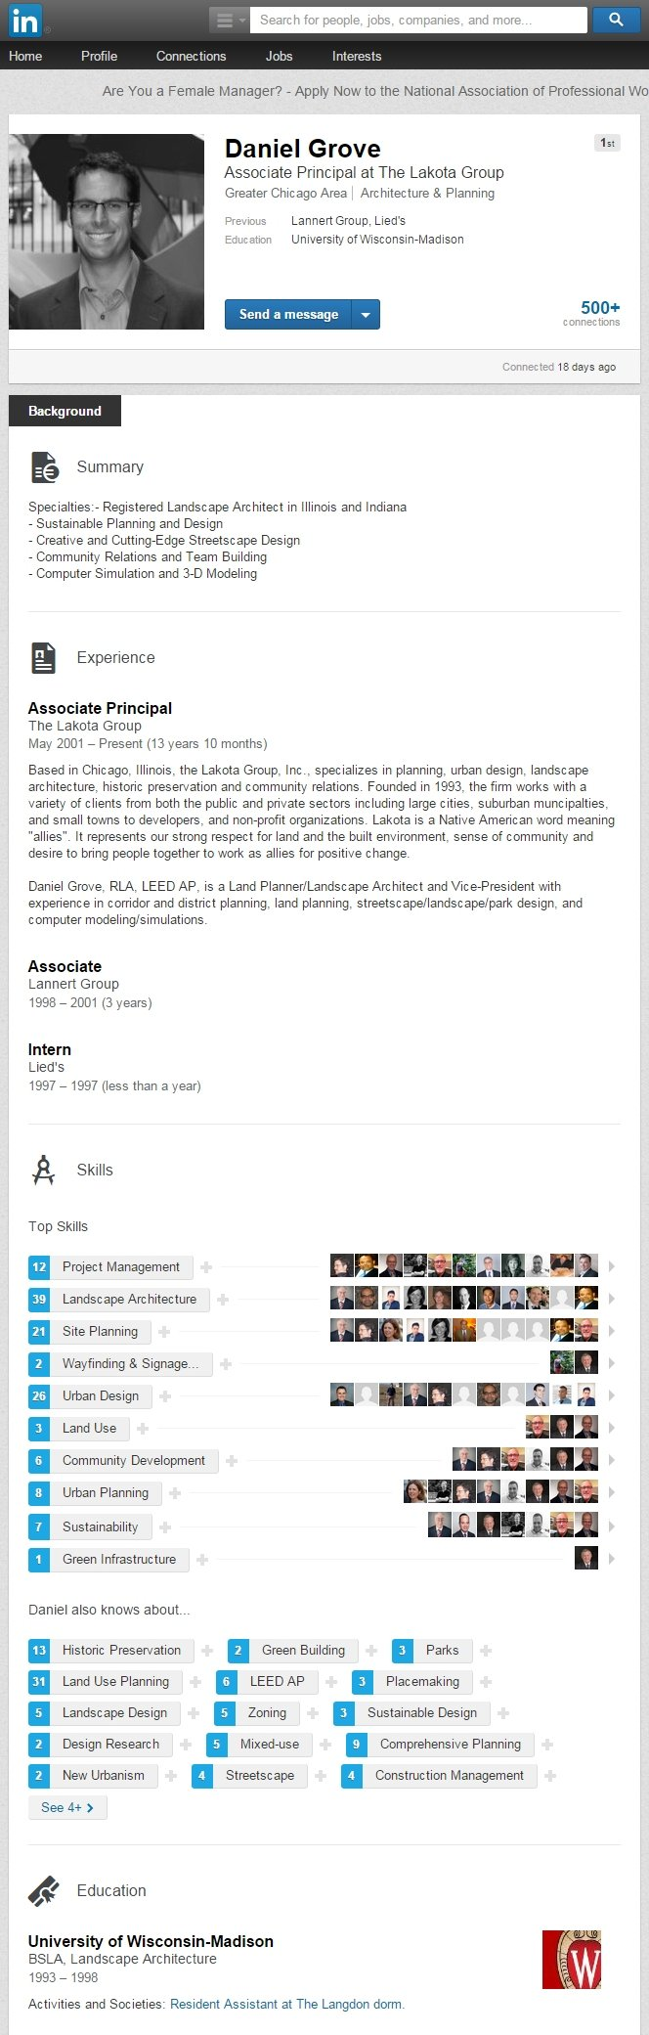
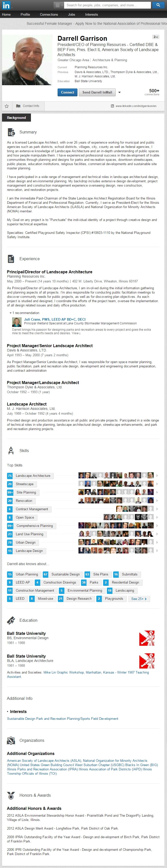
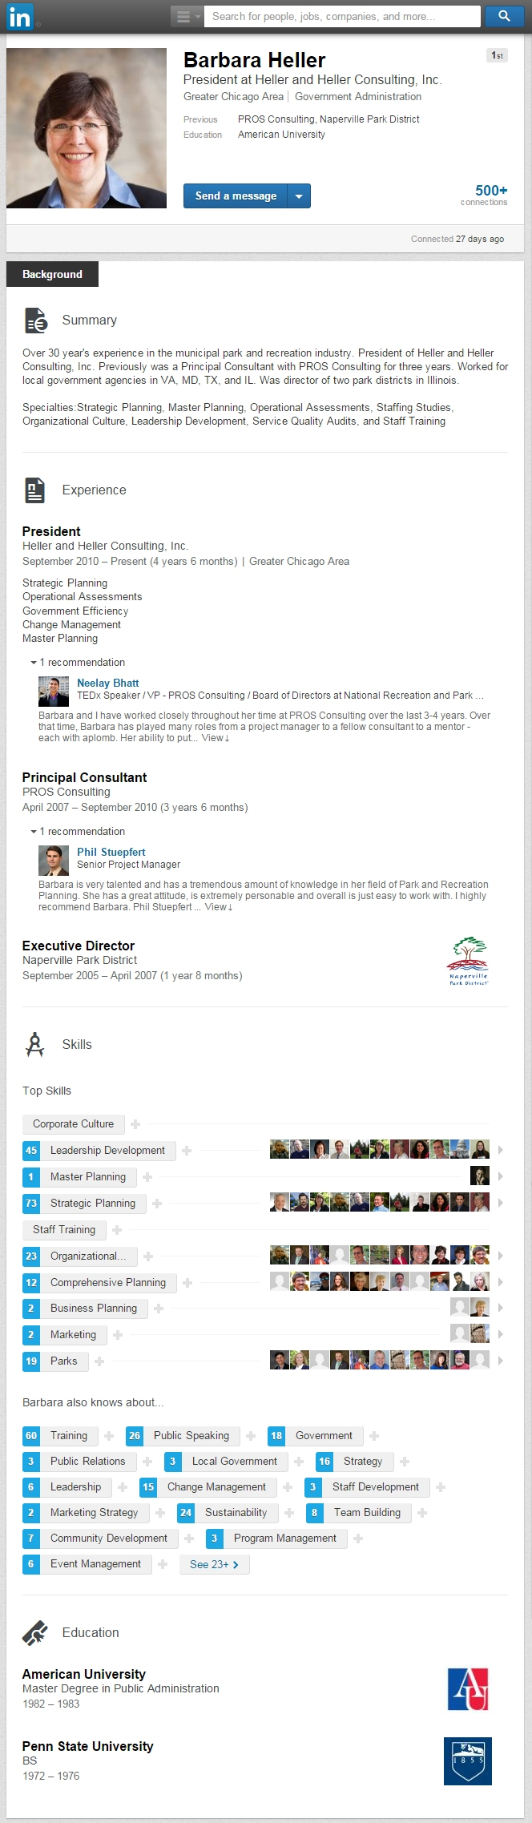

Agency Self Review: Met Not Met

Visitor Comments:

Visitor Evaluation: Met Not Met

2.2 - Involvement in Local Planning
Standard: The agency shall be involved in local planning, e.g. comprehensive planning, strategic planning, and capital improvement planning by reviewing development proposals, monitoring the decisions of planning and zoning boards or commissions and participating on task forces and committees that will impact parks and recreation services within the jurisdiction.

Suggested Evidence of Compliance: Demonstrate the role of the agency in local planning through personnel assignments and documentation of involvement, e.g. minutes, agendas, and cooperative agreements.

Informational reference in the Management of Park and Recreation Agencies, (2010), 3rd Ed., Chapter 7 – Planning for Strategic Management, p. 120.
Agency Evidence of Compliance:

The Park District of Oak Park is actively involved in local planning efforts. The Executive Director typically represents the Park District in working with other governments in planning for the community. She recently served as a Steering Committee member of the strategic planning process for Oak Park River Forest High School¹. Additionally, she participated in the Parks, Open Space, and Environmental Features portion of the Village of Oak Park comprehensive master planning process², including monitoring the progress of the report and how it would affect the Park District³. She was also a member of the Advisory Committee for the Cook County Forest Preserve's Recreation Master Plan⁴ The Park District was also an active participant in the development of a 10-year Bike Plan⁵ for Oak Park, of which the Executive Director still participates in the roll-out of in conjunction with the Active Transportation Alliance⁶.
Documentation:
- 02.02.00_OPRFHS-Strategic-Plan.pdf
- 02.02.00_Oak-Park-Comprehensive-Plan-Participants-Package.pdf
- 02.02.00_E-mail-from-Executive-Director-Regarding-Oak-Park-Comprehensive-Plan.pdf
- 02.02.00_Cook-County-Forest-Preserve-Recreation-Master-Plan.pdf
- 02.02.00_Oak-Park-Bike-Plan.pdf
- 02.02.00_Active-Transportation-Alliance-Planning-Process.pdf

Agency Self Review: Met Not Met

Visitor Comments:

Visitor Evaluation: Met Not Met

2.3 - Planning with Regional, State, and Federal Agencies
Standard: The agency shall have a working relationship with the regional, state, and federal agencies to ensure the coordination of planning efforts that affect the delivery of parks and recreation services within the jurisdiction.

Suggested Evidence of Compliance: Define the role of agency personnel and documentation of involvement (minutes, agendas, cooperative agreements) in regional, state, and federal agencies planning.

Informational reference in the Management of Park and Recreation Agencies, (2010), 3rd Ed., Chapter 7 – Planning for Strategic Management, p. 120.
Agency Evidence of Compliance:

DPRAC - 1.8.1 Working Relationship

Agency Self Review: Met Not Met

Visitor Comments:

Visitor Evaluation: Met Not Met

2.3.1 - Community Comprehensive Plan with Park and Recreation Component
Standard: The jurisdiction with land use authority within which the agency operates shall have a comprehensive plan adopted by the governing authority that dictates public policy in terms of transportation, utilities, public facilities, land use, recreation, and housing. In some jurisdictions the comprehensive plan is called the general plan or the land use plan. Zoning for the jurisdiction is based upon the comprehensive plan. To meet this standard, the comprehensive plan shall have a park and/or recreation component that discusses how the jurisdiction intends to meet the needs for parkland and public recreation facilities in concert with other land use priorities.

Suggested Evidence of Compliance: Provide the current plan, with date of official approval.
Agency Evidence of Compliance:

The Village of Oak Park completed its comprehensive plan, entitled "Envision Oak Park," with adoption by the Village Trustees on September 15, 2014. The plan includes a variety of items of importance to the future of the community and its land use, including parks and recreation. Chapter Six of this document, "Parks, Open Space & Environmental Features¹," demonstrates the importance of parks and recreation in the overall development priorities and the metrics that the Village of Oak Park will use in cooperation with other government and community agencies to achieve its goals.
Documentation:
- 02.03.01_VOP-Comprehensive-Plan-with-Parks-and-Recreation-Component.pdf
Agency Self Review: Met Not Met

Visitor Comments:

Visitor Evaluation: Met Not Met

2.4 - Park and Recreation System Master Plan
Standard: The agency shall have a comprehensive park and recreation system plan that provides recommendations for provision of facilities, programs and services; parkland acquisition and development; maintenance and operations; and administration and management. The plan shall be officially adopted by the policy-making body, updated periodically and linked with a capital improvement budget and a phased development program. The system master plan shall implement policies adopted in the comprehensive plan for the jurisdiction. Interested and affected agencies, organizations, and groups shall be engaged in the planning process.

Suggested Evidence of Compliance: Provide the current plan with documentation of official approval; describe update process; and describe a phased implementation program with linkage to the agency's capital improvement budget. The system master plan shall include:
  - Agency mission (1.4);
  - Agency objectives (1.4.1);
  - Recreation and leisure trends analysis (10.5.1);
  - Needs assessment (10.4);
  - Community inventory (10.5.2); and
  - Level of service standards (10.3.1).

Informational reference in the Management of Park and Recreation Agencies, (2010), 3rd Ed., Chapter 7 – Planning for Strategic Management, p. 120.
Agency Evidence of Compliance:

The Park District completed its Comprehensive Master Plan¹⁻⁷ with adoption by the Board of Commissioners on December 18, 2014. A consulting firm, The Lakota Group, was hired to lead the Park District through the development of the current comprehensive master plan. A website was created for the project which included important updates, links to online surveys, community open house announcements and important planning documents. The consultants, with assistance from staff, collected and analyzed data concerning the Park District's parks, open spaces, and facilities. Additionally, the Park District's parks and facilities were assessed in the context of the Village of Oak Park, the region, and against recreational trends. Many focus groups, individual interviews, and a community-wide needs assessment was completed to gather community input.
All of this information was used to created a strategy and set of priorities for the Park District of Oak Park, including plans for recreation programming and improved parks and facilities. These strategies were incorporated into specific recommendations and objectives were placed into a 10-Year Action Plan which serves as the core of the final Comprehensive Master Plan Report. Staff have begun incorporating the recommendations and objectives from the plan into the Park District's Capital Improvement Plan⁸, which drives the capital improvement budget each year.
Documentation:
- 02.04.00_2015-2024-Comprehensive-Master-Plan.pdf
- 02.04.00a_Agency-Mission-in-2015-2024-Comprehensive-Master-Plan.pdf
- 02.04.00b_Agency-Objectives-in-2015-2024-Comprehensive-Master-Plan.pdf
- 02.04.00c_Trends-Analysis-in-2015-2024-Comprehensive-Master-Plan.pdf
- 02.04.00d_Needs-Assessment-in-2015-2024-Comprehensive-Master-Plan.pdf
- 02.04.00e_Community-Inventory-in-2015-2024-Comprehensive-Master-Plan.pdf
- 02.04.00f_Level-of-Service-in-2015-2024-Comprehensive-Master-Plan.pdf
- 02.04.00_2015-2019-Capital-Improvement-Plan.pdf (incorporation of CMP Recommendations below)
Comprehensive Master Plan Recommendation | Inclusion in current Capital Improvement Plan
Pursue Park/Recreation Space Acquisition & Development | The Capital Improvement Plan has money planned for property acquisition slated for the following years:  - 2016 - $400,000  - 2017 - $200,000  - 2018 - $200,000  - 2019 - $200,000
Enhance Walking & Biking Amenities | The Capital Improvement Plan has money planned for additional and/or improved walking and biking paths at the following locations:  - Euclid Square Park - 2017  - Field Park - 2019  - Maple Park - 2015
Update and Implement Master Plans and ADA Transition Plan | The Capital Improvement Plan has the following total park and master plan improvements (including ADA improvements) slated for the following years:  - 2015 - $3,575,000  - 2016 - $1,195,000  - 2017 - $1,090,000  - 2018 - $1,240,000  - 2019 - $1,300,000  Additionally, $50,000/year is also budgeted for additional ADA improvements not included in master plans as well as master plan updates.
Align Park Master Plans with District Level of Service | The Capital Improvement Plan has planned funds to remove a tennis court at Rehm Park in 2019 based on Level of Service.
Manage District Historic Resources | The Capital Improvement Plan has $800,000 planned in 2018 to improve the roof at Pleasant Home. In 2015 and 2017, a total of $515,000 of improvements are planned to the Oak Park Conservatory.
Improve Environmental Education Programming | The Capital Improvement Plan has plans for the construction of a new environmental center in Austin Gardens in 2015 which will serve as a natural location for increased environmental education programming.
Update the Capital Improvement Plan Annually | The current version of the Capital Improvement Plan was approved in July 2014.

Agency Self Review: Met Not Met

Visitor Comments:

Visitor Evaluation: Met Not Met

2.5 - Strategic Plan
Standard: An agency shall have a strategic plan, approved by the approving authority, stating how the agency will achieve its mission, goals, and objectives over an extended period of time, typically three to five years. The strategic plan shall be reviewed annually. The goals and objectives of the plan shall be measurable to demonstrate progress and results. The strategic plan shall support the priorities and initiatives of the whole organization. The strategic plan is a tool to implement the Parks and Recreation System Master Plan.

Suggested Evidence of Compliance: Provide the agency's strategic plan, date of approval by approving authority, evidence of last review, and indicate progress being made in implementing the plan.

Informational reference in the Management of Park and Recreation Agencies, (2010), 3rd Ed., Chapter 7 – Planning for Strategic Management, pp. 114-120.
Agency Evidence of Compliance:

In 2012, the District developed its 2013-2105 Strategic Plan¹ which was adopted by the Board of Commissioners on December 20, 2012². The plan included goals and objectives, the status of which are monitored on a regular basis as part of the District performance measurement program³, as well as at agency leadership team meetings and annually at a board meeting⁴.
- 02.05.00_Park-District-of-Oak-Park-Strategic-Plan.pdf
- 02.05.00_December-2012-Board-Meeting-Minutes.pdf
- Screenshot of Strategic Goals on Dashboards (below)
- ​02.05.00_December-2013-COW-Meeting-Minutes.pdf
- 02.05.00_Strategic-Plan-Review-at-December-2014-Board-Meeting.pdf
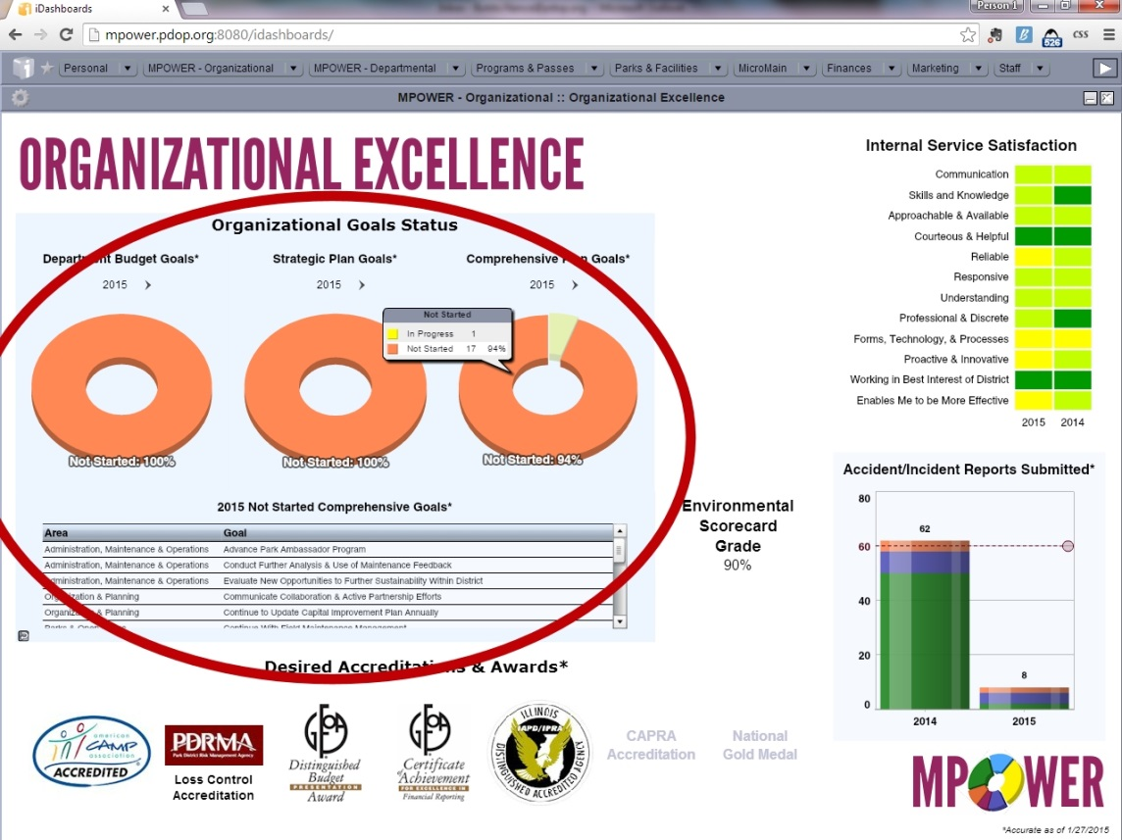
Strategic Goals Status Displayed on MPOWER

Agency Self Review: Met Not Met

Visitor Comments:

Visitor Evaluation: Met Not Met

2.6 - Feasibility Studies
Standard: Studies shall be conducted to determine the feasibility of proposed facilities.

Suggested Evidence of Compliance: Provide examples of recent feasibility studies such as market, cost benefit, site, transportation, environmental and economic analyses.

Informational reference in the Management of Park and Recreation Agencies, (2010), 3rd Ed., Chapter 11 – Physical Resource Planning, pp. 215-215.
Agency Evidence of Compliance:

As stewards of public resources, the Park District strives to ensure that all major projects undertaken are financially sound, environmentally responsible, and are appropriate to the community's needs and wants. To this end, the Park District conducts various studies to determine the feasibility of new recreation services and facility projects as well as renovation and improvements to existing facilities.
When planning a possible facility or park renovation, the Park District may choose to complete an Existing Conditions Study. For example, when determining the best direction to take at the Ridgeland Common park and facility (now the Ridgeland Common Recreation Complex), a thorough Ridgeland Common Existing Conditions Study¹ was done. Once renovation plans were made, a Preliminary Geotechnical Engineering Report² was completed as well. Smaller studies, such as traffic or travel studies may be completed as well, as was the case with the Gymnastics Center Travel Study³.
When investigating the feasibility of a new service or facility, the Park District may choose to create a Pro Forma. When the Park District was trying to determine whether or not it should expand its gymnastics programs and facility operations, a Pro Forma Operation and Financial Analysis Report for a Proposed Expanded Gymnastics Center⁴ was created.
When acquiring or developing a property, the Park District may choose to conduct environmental reviews. For example, when the Park District was purchasing the property at 25 Lake Street, Phase I Environmental Site Assessment⁵ and Phase II Environmental Site Assessment⁶ were completed.
​After the Park District ultimately decided to purchase this property, the Board of Commissioners and staff had to determine whether or not it should be used to house an expanded building & grounds facility or an expanded gymnastics center. A Validation Study was completed and a 25 Lake Street Property Validation Study Presentation⁷ was given.
Documentation:
- 02.06.00_Ridgeland-Common-Existing-Conditions-Study.pdf
- 02.06.00_Preliminary-Geotechnical-Engineering-Report-for-Ridgeland-Commons.pdf
- 02.06.00_Gymnastics-Center-Travel-Study.pdf
- 02.06.00_Pro-Forma-Operations-and-Financial-Analysis-Report-for-a-Proposed-Expanded-Gymnastics-Center.pdf
- 02.06.00_Phase-I-Environmental-Site-Assessment-for-25-Lake-Street.pdf
- 02.06.00_Phase-II-Environmental-Site-Assessment-for-25-Lake-Street.pdf
- 02.06.00_25-Lake-Street-Property-Validation-Study-Presentation.pdf
Agency Self Review: Met Not Met

Visitor Comments:

Visitor Evaluation: Met Not Met

2.7 - Site Plans
Standard: There shall be site plans to guide the use of existing and the development of future areas and facilities. A site plan is a depiction of a park site of that is drawn to scale and delineates features such as building and facility locations, roads and trails, use areas and utility easements.

Suggested Evidence of Compliance: Provide a representative sampling of the agency’s area and facility site plans.

Informational reference in the Management of Park and Recreation Agencies, (2010), 3rd Ed., Chapter 11 – Physical Resource Planning, pp. 230-232.
Agency Evidence of Compliance:

Park District Site plans for all Park District parks and facilities are stored in the Building & Grounds Department office. The plans are stored in drawers by site. Included in the drawer for each site or facility are surveys showing legal boundaries, utility details, topographical features, buildings, and other major features.
Documentation:
Photo of location where all Park District site plans are stored
Agency Self Review: Met Not Met

Visitor Comments:

Visitor Evaluation: Met Not Met

2.8 - Historical and Cultural Resource Management Plans
Standard: Historical and cultural plans include an inventory of historical, cultural resources and strategies for how they will be managed. These resources may be addressed as part of the jurisdiction’s comprehensive plan or the agency’s park and recreation system master plan.

Suggested Evidence of Compliance: Provide the historical and cultural plan(s).
Agency Evidence of Compliance:

In a community well-known as the 1899 birthplace of author Ernest Hemingway and home to architect Frank Lloyd Wright's Home and Studio, the mix of history and culture plays an important role in the identify of Oak Park.
The Park District of Oak Park owns three historic resources that are listed in the National Register for Historic Places including:
- Oak Park Conservatory, constructed in 1929
- Pleasant Home, constructed in 1897 and designed by noted Prairie School architect George W Maher
- Scoville Park, constructed in 1913 and designed by famous landscape architect Jens Jensen
In addition to the National Register listing, Pleasant Home is also a National Historic Landmark and 1 of only 86 in Illinois. Several other Park District parks and facilities are part of National Register Historic Districts and/or Village of Oak Park Landmarks. The Park District's 2015-2024 Comprehensive Master Plan contains a Historic Preservation Plan and Recommendations¹.
The Park District of Oak Park is supportive of arts and culture in our parks and facilities and contributing to the overall arts and culture offerings in the community by displaying public works of art and offering artistic and cultural educational and entertainment options to the community. The Village of Oak Park's Envision Oak Park Comprehensive Plan Art and Culture section² outlines the Cultural Plan for Oak Park.
Documentation:
- 02.08.00_Historical-Plan-in-2015-2024-Comprehensive-Master-Plan.pdf
- 02.08.00_Arts-and-Culture-Plan-in-Envision-Oak-Park-Comprehensive-Plan.pdf
Agency Self Review: Met Not Met

Visitor Comments:

Visitor Evaluation: Met Not Met

2.9 - Community Involvement
Standard: The agency shall include community involvement in the planning process that includes ongoing and systematic outreach to include the entire community. It is critical that the diversity of individuals (i.e., all cultures, ages, and abilities) and local, regional, and national non-governmental community organizations, agencies, businesses, and service providers such as the Red Cross, Sierra Club, Trust for Public Land, YMCA/YWCA, Boys and Girls Club, and local foundations and employers are afforded opportunities for input.

Suggested Evidence of Compliance: Describe how the diverse interests (community organizations, businesses and individuals) of the community were involved in the planning process.

Informational reference in the Management of Park and Recreation Agencies, (2010), 3rd Ed., Chapter 11 – Physical Resource Planning, p. 220
Agency Evidence of Compliance:

As evidenced by the Park District's mission which begins with "In partnership with the community...," involvement and participation with the local community is highly valued. Anytime that planning processes are undertaken, the Park District seeks community input. The Park District's Procedures for Master Planning Processes¹ includes Community Involvement as an important part of the overall process. Recent examples of community input in planning processes include:
- The Park District 2015-2024 Comprehensive Master Plan process² included a community needs assessment, as well as 8 community focus groups representing over 60 stakeholders, and one-on-one interviews with Park District Board of Commissioners and 4 other additional key community members.
- The Stevenson Park Master Plan process³ included community focus groups (including one specifically for youth that used the park although names are omitted because they are minors), meetings, and surveys.
- The Scoville Park Master Plan process⁴ included community focus groups, meetings, and surveys.
- The Pools Master Plan process⁵ included community meetings and surveys.
The Park District's continual willingness to include public input in its planning processes has also been noticed by local media. Regarding a planning process that did not ultimately result in moving forward, the local newspaper, the Wednesday Journal, noted in their editorial⁶ that the Park District that "...the board and administration have developed an uncanny ear for public input. Whether the issue was large or small, the parks have actively and effectively invited citizens to speak out and then astounded critic by actually listening and adjusting plan."
Documentation of Evidence:
- 02.09.00_Procedures-for-Park-Master-Planning-Processes.pdf
- 02.09.00_Community-Involvement-in-Comprehensive-Master-Plan-Process.pdf
- 02.09.00_Community-Involvement-in-Stevenson-Park-Master-Plan-Process.pdf
- 02.09.00_Community-Involvement-in-Scoville-Park-Master-Plan-Process.pdf
- 02.09.00_Community-Involvement-in-Pools-Master-Plan-Process.pdf
- 02.09.00_November--2012-Wednesday-Journal-Editorial.pdf
Agency Self Review: Met Not Met

Visitor Comments:

Visitor Evaluation: Met Not Met

2.10 - ADA Transition Plan
Standard: The agency shall develop and adopt a phased plan for the removal of barriers at existing recreation facilities, parks, and amenities owned or operated by the agency, pursuant to the requirements of the US Department of Justice Title II regulation issued September 14, 2010 and effective March 15, 2011.

Suggested Evidence of Compliance: Submit minutes of the approving authority meeting approving the transition plan, or a copy of the plan noting the dates and times when plan tasks were completed.

Informational reference in the Management of Park and Recreation Agencies, (2010), 3rd Ed., Chapter 9 – Program Services and Event Management, p. 188; Chapter 11 – Physical Resource Planning, p. 236; Chapter 12 – Physical Resource Management, p. 253; Chapter 13 – Management Operations, pp. 288 and 400.
Agency Evidence of Compliance:

DPRAC - L.6.1 Americans with Disabilities

Agency Self Review: Met Not Met

Visitor Comments:

Visitor Evaluation: Met Not Met

Visitation Report Summary for
Category 2.0 - Planning

Reviewed By: (Visitor Name)

Unmet Standards: (List the Standard # and Name)

Provide clarification for all unmet fundamental standards:

3.0 – Organization and Administration

Note: Standards marked with a star () are fundamental standards,
and are required of all agencies seeking accreditation.

The organizational structure provides alignment of responsibility and delegation of authority to enable the agency to carry out its mission. The roles, responsibilities and structure should be clearly understood by staff and the public.

Administrative reporting systems provide management information on the activities of the agency. Properly designed administrative reports will reflect comparative data and trends on activities. An effective administrative reporting system ensures communications throughout the chain of command.

Public information, community relations, and marketing are complementary functions within the agency. The functions overlap because they all deal with an organization’s relationships and employ similar communication tools. While they have the same ultimate purpose of helping assure an organization’s success, the purpose of each differs and each approaches the task from a different perspective.

To operate effectively, a park and recreation agency must have the support of its community. An agency can obtain such support by informing the public and news media of events that affect the lives of citizens in the community. By providing the news media and the community with information on agency administration and operations, a relationship of mutual trust, cooperation, and respect can be maintained.

An agency should make use of the many community organizations that exist in its jurisdiction and establish relationships with them. The park and recreation agency should play an active role in organizing community groups where they do not exist. By establishing such links with the community, the park and recreation agency learns of issues, needs, and opportunities and responds to them before they become problems. A well-organized community relations effort can act as an effective means of eliciting public support and can serve to identify problems in the making.

Effective market research, planning, product and program development, strategies, and objectives for delivering demand-driven, high quality programs and services contribute to successful park and recreation operations. Marketing is a process for accomplishing agency mission and objectives by developing, pricing, making accessible, and providing accurate and timely information about recreational opportunities that satisfy the wants/desires of target markets.

All park and recreation agencies perform certain marketing functions; the scope of their work however, depends on their size and mandate. Among the functions are user inquiry, development of an agency marketing philosophy and marketing plan, and development of operational procedures and policy guidelines to implement that philosophy. The complexities of marketing and related research functions require that all agency staff be appropriately educated about marketing and its application across functions.

3.1 - Organizational Structure
Standard: The agency shall establish a staff organizational structure that reflects its methods of operation, its relationship to the community, and the relationships among the different organization components.

Suggested Evidence of Compliance: Provide a chart showing the agency’s organizational structure, interrelationships among organizational components, and the function of each component. Organizational components are the major subdivisions of the organization, e.g. departments and divisions. Indicate how this information is made available to staff and the public.

Informational reference in the Management of Park and Recreation Agencies, (2010), 3rd Ed., Chapter 5 – Organization Structure and Administrative Operations, pp. 73-87.
Agency Evidence of Compliance:

To meet the needs of the citizens to whom the staff ultimately report to, the Park District is led by an Executive Director that reports to a board of elected citizens and leads Park District staff who are organized into seven departments. The District's organizational chart¹ shows the agency's overall structure and components.
Documentation:
- 03.01.00_Organizational-Chart.pdf
Agency Self Review: Met Not Met

Visitor Comments:

Visitor Evaluation: Met Not Met

3.2 - Administrative Offices
Standard: The agency administrative offices shall be accessible to the public and staff. There shall be administrative, meeting and storage space, and equipment adequate to perform the agency's functions and responsibilities.

Suggested Evidence of Compliance: Provide documentation that describes the types of office space and administrative equipment used by the agency and how access is provided to the staff and the public.

Informational reference in the Management of Park and Recreation Agencies, (2010), 3rd Ed., Chapter 5 – Organization Structure and Administrative Operations, p. 90.
Agency Evidence of Compliance:

DPRAC - 3.2.5 Location and Accessibility of Administrative Office

Agency Self Review: Met Not Met

Visitor Comments:

Visitor Evaluation: Met Not Met

3.2.1 - Support Services
Standard: Sufficient and appropriate equipment, technology, clerical and administrative staff shall be provided to enable the professional staff to perform their appropriate functions.

Suggested Evidence of Compliance: Describe the equipment, technology, and services used to support professional staff.

Informational reference in the Management of Park and Recreation Agencies, (2010), 3rd Ed., Chapter 5 – Organization Structure and Administrative Operations, pp. 90-91.
Agency Evidence of Compliance:

Clerical and administrative staff play an important role in ensuring that the District operates as efficiently and effectively as possible. The Park District's organizational chart¹ highlights these staff. Equally important to the success of the agency are the tools that staff are provided with to accomplish their tasks.
Clerical, administrative and professional staff all have access to workstations²⁻⁴ with phones, internet and e-mail access, and desktop or laptop computers, each with current Microsoft Office programs, and other software programs as needed such as registration, accounting, time-keeping, and work order software. The Park District provides office equipment for staff to use ranging from basic supplies to more specialized items such as paper cutters, laminating machines, etc.⁵ High-capacity all-in-one printer/scanner/fax machines⁶ are located at each Park District facility where business or customer service operations are housed (and are accessible outside of these facilities on the Park District's network) and smaller versions are available at all other facilities.
Documentation of Evidence:
- 03.20.01_Organizational-Chart-with-Support-Staff-Highlighted.pdf
- Photo of Customer Service Desk (below)
- Photo of Support Staff workstation (below)
- Photo of Professional Staff office (below)
- Photo of Office equipment (below)
- Photo of Office technology (below)

Example of a Customer Service Desk for front-line customer service staff

Example of workstations for support staff

Example of an office and workstation for professional staff

Example of office equipment available to all staff

Example of office technology available to all staff

Agency Self Review: Met Not Met

Visitor Comments:

Visitor Evaluation: Met Not Met

3.3 - Internal Communication
Standard: A communication system shall be established to ensure the accurate and timely transfer of internal information among staff.

Suggested Evidence of Compliance: Provide a communication matrix illustrating how internal communications are managed by the agency.

Informational reference in the Management of Park and Recreation Agencies, (2010), 3rd Ed., Chapter 5 – Organization Structure and Administrative Operations, pp. 86-87.
Agency Evidence of Compliance:

The Park District of Oak Park communicates internally with its staff using the methods outlined in the Internal Communication matrix below.
Communication Event | Frequency | Responsible Party | Method
Senior Leadership Meetings | Twice a month | Executive Director | In Person, Agendas
Management Meetings | Once a month | Executive Director | In Person, Agendas
Department Meetings | Once a month | Department Heads | In Person
District Directions Employee Newsletter | Every other month | Director of Marketing & Customer Service | Bulletin Boards, Hub
Full-Time Job Announcements (separations, openings, hiring) | As needed | Director of Human Resources | E-mail
Policy Changes | As needed | Executive Assistant | Hub
Meeting/Training Announcements | As needed | Varies | E-mail, Outlook calendars
Other Organizational Announcements | As needed | Director of Human Resources | E-mail, Bulletin Boards

Agency Self Review: Met Not Met

Visitor Comments:

Visitor Evaluation: Met Not Met

3.4 - Public Information Policy and Procedure
Standard: The agency shall have approved policies that govern what information shall be released, when it should be released, and by whom it should be released and that demonstrate the agency’s commitment to inform the community and news media of events involving the agency.

Suggested Evidence of Compliance: Provide the written statement of policy and procedure, indicating approval by the proper authority.

Informational reference in the Management of Park and Recreation Agencies, (2010), 3rd Ed., Chapter 15 – Public Relations, Marketing, and Customer Service, pp. 375-377.
Agency Evidence of Compliance:

The Park District of Oak Park is committed to providing quality information to residents, visitors, other community organizations, and the media about parks and recreation services and news. Doing so fosters trust with the community. As outlined in the Park District's Policy on Public Information¹, the Park District uses a variety of communication tools to provide information to the public. The Director of Marketing & Customer Service oversees the process and timing of dissemination of information to the public, including the media.
The Park District has the ability to distribute press releases through its website by adding them through the "News" feature and tagging them as "Press Releases." The press and the public have the ability to sign up to receive an E-Alert anytime that a press release is added to the website, which increases the distribution and timing of news delivery. As of February 2015, the Park District has released over 60 press releases² through the website since it was re-launched in August 2014. The public can use this same tool to sign up for other types of notifications³, including when a new RFP, RFQ, or Bid becomes available or even when registration and park & facility updates become available.
Media inquiries are first routed through the Director of Marketing & Customer Service who serves as the first point of contact with responsibility for coordinating and handling inquiries. In the event of a crisis, the Park District will follow the procedures outlined in the Park District Crisis Management and Communication Plan⁴.
Documentation:
- 03.04.00_Policy-on-Public-Information.pdf
- Link to Park District Press Releases on Park District website
- Link to Sign up for E-Alerts on Park District website
- 03.04.00_Crisis-Management-and-Communication-Plan.pdf
Agency Self Review: Met Not Met

Visitor Comments:

Visitor Evaluation: Met Not Met

3.4.1 - Public Information and Community Relations Responsibility
Standard: A specific position in the agency shall be designated to direct the public information and community relations functions. The position serves as a point of control for information dissemination to the community and the media. The intent of the standard is to establish the authority and responsibility for developing and coordinating the agency's community relations function in an identifiable position.

Suggested Evidence of Compliance: Provide the position description that reflects responsibilities for public information and community relations functions.

Informational reference in the Management of Park and Recreation Agencies, (2010), 3rd Ed., Chapter 15 – Public Relations, Marketing, and Customer Service, pp. 375-377.
Agency Evidence of Compliance:

DPRAC - 1.10.3 Authority for Coordinating Public Relations

Agency Self Review: Met Not Met

Visitor Comments:

Visitor Evaluation: Met Not Met

3.4.2 - Community Relations Plan
Standard: The agency shall have an established community relations plan that identifies and addresses community needs for all segments of its service population, which is evaluated periodically for effectiveness.

Suggested Evidence of Compliance: Provide the community relations plan and latest evaluation. The community relations plan shall address the following:
- Community relations policies for the agency;
- Process and procedure for establishing contact with community organizations and other community groups;
- Training needs for staff and community.
The community relations plan and marketing plan is often included in a single document.

Informational reference in the Management of Park and Recreation Agencies, (2010), 3rd Ed., Chapter 15 – Public Relations, Marketing, and Customer Service, pp. 375-377.
Agency Evidence of Compliance:

The Park District has developed a Community Relations & Marketing Plan¹ based on information from recent branding and demographic studies. The plan references Park District administrative policies related to community relations and outlines outreach efforts by the Park District. Additionally, it includes training provided to Park District staff as well as community members and media regarding community relations. This plan was recently updated to include information from the Park District's 2015-2024 Comprehensive Master Plan.
The plan is evaluated using metrics tracked through the Park District's Performance Measurement Program and annual Performance Measurement Report², which includes results related to community relations & marketing efforts.
Documentation:
- 03.04.02_Community-Relations-and-Marketing-Plan.pdf
- 03.04.02_2014-Community-Relations-Evaluation-in-Performance-Measurement-Report.pdf
Agency Self Review: Met Not Met

Visitor Comments:

Visitor Evaluation: Met Not Met

3.4.3 - Marketing Plan
Standard: The agency shall have an established marketing plan, based on market research that is evaluated periodically for effectiveness. The fundamental principle of marketing is to gain an understanding of customer needs, wants, concerns and behaviors. The marketing plan addresses the appropriate mix of communications tools to promote agency programs, facilities, events and services and to provide accurate, timely and useful information to the various segments of the target audience.

Suggested Evidence of Compliance: Provide the plan and latest evaluation. The plan shall include:
- Marketing objectives;
- Situation assessment, to include:
    - Examination of demographic trends
    - Economic climate
- Market coverage by alternative providers;
- Segmentation, targeting, and positioning;
- Marketing mix;
- Marketing methods
- Evaluation criteria and methods.
Research is important to support segmentation, targeting, and positioning. Common evaluation methods include surveys, focus groups, customer comment cards, and mystery shopping.

Informational reference in the Management of Park and Recreation Agencies, (2010), 3rd Ed., Chapter 15 – Public Relations, Marketing, and Customer Service, pp. 359-377.
Agency Evidence of Compliance:

The Park District's Marketing & Public Relations Plan¹ includes a mix of overall communication strategies as well as specific information for certain targeted groups and facilities. The current version of the plan is guided by the latest information available to the Park District, including details from a 2013 Branding Study and the 2015-2025 Comprehensive Master Plan, both of which included feedback from residents in the form of a large community survey, focus groups, and participation by the Park District Citizens Committee. Additionally, the Park District incorporates data from on-going customer satisfaction surveys, website analytics, and agency performance measures² to refine the overall plan and to set a specific detailed calendar of tasks to be accomplished for the following year.
Documentation:
- 03.04.03_Community-Relations-and-Marketing-Plan.pdf
- 03.04.03_2014-Marketing-Evaluation-in-Performance-Measurement-Report.pdf
Agency Self Review: Met Not Met

Visitor Comments:

Visitor Evaluation: Met Not Met

3.4.3.1 - Marketing Responsibility
Standard: A specific position shall be designated to direct the marketing function. Marketing functions shall be the responsibility of a permanent position of the agency that works closely with all agency units in developing, coordinating, and implementing the agency marketing plan.

Suggested Evidence of Compliance: Provide the position description that includes responsibility for marketing.
Agency Evidence of Compliance:

The responsibility for directing marketing functions falls to the District's full-time Director of Marketing & Customer Service. This position manages the marketing team which includes a full-time Communications & Marketing Coordinator and 3 part-time positions: Sponsorship Coordinator, Web Designer, and Communications & Marketing Assistant. The Director of Marketing & Customer Service job description¹ outlines the specific responsibilities and duties of the position.
Documentation:
- Director of Marketing & Customer Service Job Description
Agency Self Review: Met Not Met

Visitor Comments:

Visitor Evaluation: Met Not Met

3.5 - Utilization of Technology
Standard: Technology shall be used to enable the agency to operate more efficiently and effectively. The agency should research and apply such resources progressively.

Suggested Evidence of Compliance: Provide examples of progressive adoption, upgrade, installation, and/or use of technology. Examples could include but are not limited to communications and security systems, energy and records management systems, data management and sharing systems, lighting and irrigation systems, work orders and work assignment applications, financial systems, and class registration systems.

Informational reference in the Management of Park and Recreation Agencies, (2010), 3rd Ed., Chapter 14 – Information Technology Management, pp 305-345.
Agency Evidence of Compliance:

The Park District continues to identify ways to provide efficient and effective service delivery, including through the use of technology. A list of current technology available to staff¹ is stored on the Hub, the Park District's internal document management program.
The Park District works to keep the technology it uses up-to-date. The following are examples of new technology equipment or software programs that have been recently implemented or upgraded (or are scheduled to be implemented or upgraded by the end of the year):
2014
- iDashboards - live dashboards used to display key agency performance metrics and data through the Park District's "MPOWER" program
- ShoreTel phone system - new phone system that allows staff greater functionality in managing phone calls and voicemail
- Hub - new internal document management software
2015
- UserEcho - software that allows staff to share ideas to improve services and operations through the Park District's "Launch Pad" program
- Applitrack Document Module - add-on to recruitment and applicant processing software to allow staff to complete and sign Human Resource documents online
- SmartFusion - new accounting and human resources software (scheduled for mid 2015)
- RecTrac - major upgrade to the Park District's current registration & facility management software (scheduled for late 2015)
Documentation:
- 03.05.00_Technology-Available-to-Staff.pdf
Agency Self Review: Met Not Met

Visitor Comments:

Visitor Evaluation: Met Not Met

3.5.1 - Management Information Systems
Standard: The Agency shall have management information systems that can produce reliable statistical and data summaries of agency activities, such as daily, monthly, and annual reports for use in management decision-making. The reports shall provide comparative data and statistics.

Suggested Evidence of Compliance: Provide examples of recent statistical and data summaries and describe their use in management decision-making.

Informational reference in the Management of Park and Recreation Agencies, (2010), 3rd Ed., Chapter 14 – Information Technology Management, pp 310-313.
Agency Evidence of Compliance:

The Park District has created live dashboards¹ to track agency performance in a variety of areas which all full-time and year-round part-time staff have access to. The charts, graphs, and tables displayed on these dashboards are directly connected with all of the District's major software programs, including Vermont Systems (program registration, sales, and facility management), MSI (finances, accounting, and human resources), TimeClock Plus (payroll), MicroMain (maintenance work orders), SurveyGizmo (surveys), and Google Analytics (website). This set-up allows staff to see up-to-the-minute results of performance measures in nearly all cases, allowing for much more accurate and quicker decision-making.
The charts, graphs, and tables are set up to display data in a variety of ways, including year-to-date, daily, weekly, or monthly results, depending on what is most useful for staff. Additionally, staff have the ability to export the data from the dashboards into PDF reports and Excel spreadsheets for further analysis. Staff review the dashboards on a regular basis on their own and at staff meetings. Additionally, in some cases, such as with the monthly financial reports, the staff use the dashboard tables to update the Finance Manager on any accounts that are over or under 10% of the budgeted amount.
Additionally, the software programs used by staff have their own ability to produce reports as needed.
Documentation:
- Dashboard Screenshots (below)
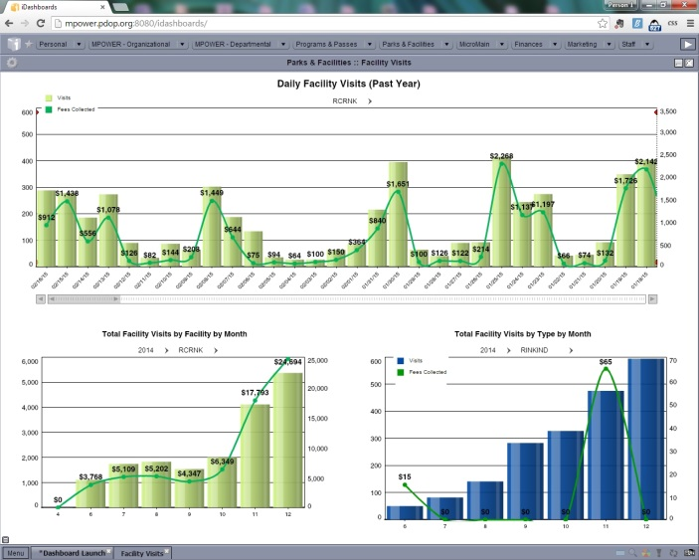

This dashboard shows visits and money collected at individual Park District facilities by both daily (top chart) and monthly (bottom left chart) totals. Additionally, staff are able to view visits and money collected for different pass and visit types on a monthly basis.

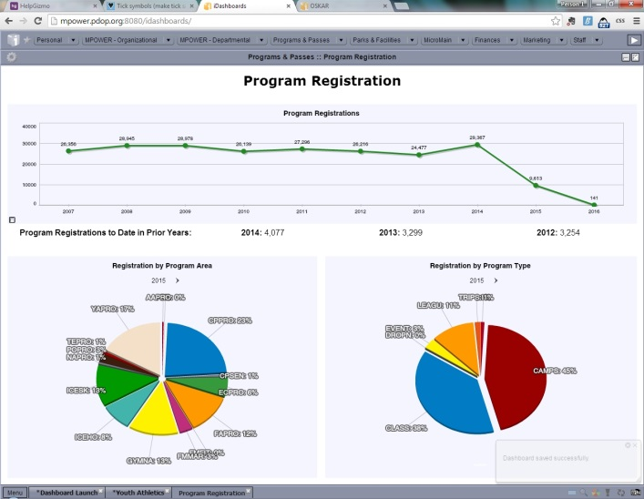

This dashboard shows total program registrations at the Park District by year, including comparisons with year-to-date registration for the prior 3 years. Additionally, staff are able to view program registrations by program area and also program type for each year.

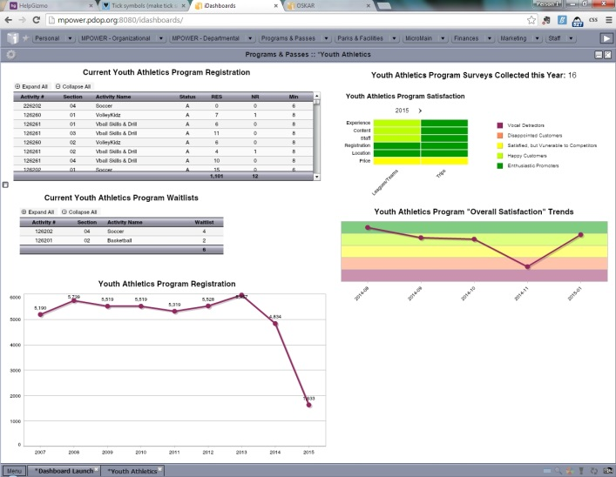

This dashboard shows a more comprehensive view for each program area, pulling in information specific to that program area from multiple locations, include current registrations, waitlists, total registrations, and customer satisfaction scores.

This dashboard shows information for completed maintenance work orders by any date that the user would like to enter. Users are able to see the types of work orders completed, the average time to complete, as wells that number of work orders, hours assigned, and hours worked for each staff member in that area.

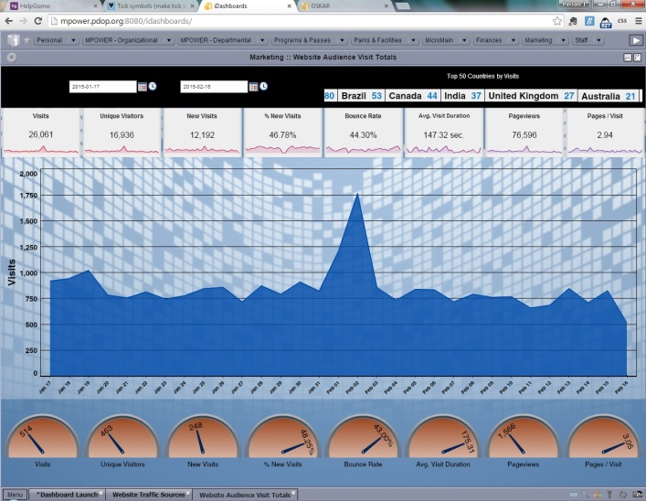

This dashboard shows a variety of information regarding visits to the Park District website over any time period that the user would like to view it for.

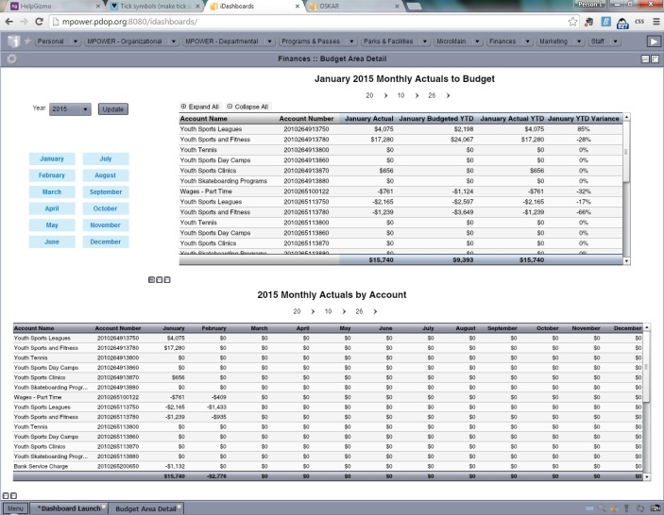

This dashboard shows a financial report for staff to view current performance to budgets, as well as year-to-date totals in each account line.

Agency Self Review: Met Not Met

Visitor Comments:

Visitor Evaluation: Met Not Met

3.6 - Records Management Policy and Procedures
Standard: The agency shall have established policy and procedures for control, maintenance, and retention of records that are periodically reviewed. Records management policies and procedures address retention, disposal, access, disclosure and distribution of documents, including freedom of information requests, and they must be consistent with legal requirements.

Suggested Evidence of Compliance: Provide records management policy and procedures and a copy of the most recent review.

Informational reference in the Management of Park and Recreation Agencies, (2010), 3rd Ed., Chapter 14 – Information Technology Management, pp 312-313.
Agency Evidence of Compliance:

The Park District complies with its Records and Data Management Policy¹, Freedom of Information Act Policy², and State of Illinois statutes, including the Illinois Local Records Act³, regarding the retention, access, and disposal of any Park District records. Additionally, the Park District has developed Procedures for Verbatim Records⁴, Procedures for FOIA Requests⁵, and Procedures for Record Retention and Destruction⁶. Much of this information has been compiled into the Park District's Records Management Manual⁷ which was recently reviewed and updated as referenced in the Records Management Plan Review Memo⁸.
The Executive Assistant is the designated FOIA Representative for the Park District and is required to pass an exam⁹ regarding the Freedom of Information Act each year to ensure that knowledge and procedures are up-to-date. The Park District includes information about FOIA requests and the process for the public to submit a request on its website¹⁰. Additionally, the Park District publishes a Municipal Directory¹¹ that includes important information regarding the Park District that includes information regarding the Park District, its operations, finances, boards and committees, and FOIA information to satisfy the Illinois Freedom of Information Act (5 ILCS 140/4) (from Ch. 116, par. 204).
Park District Board Meeting Agendas and Minutes¹² are generally available on the Park District's Document Library on the website, with the most recent documents appearing automatically on the "Board of Commissioners" page of the website.
The Park District recently reviewed these policies as part of the overall policy review¹³ and they were re-approved by the Board of Commissioners at the December 2014 Board Meeting.
Documentation:
- 03.06.00_Records-and-Data-Management-Policy.pdf
- 03.06.00_Freedom-of-Information-Act-Policy.pdf
- link to Illinois Local Records Act
- 03.06.00_Procedures-for-Verbatim-Records.pdf
- 03.06.00_Procedures-for-FOIA-Requests.pdf
- 03.06.00_Procedures-for-Record-Retention-and-Destruction.pdf
- 03.06.00_Records-Management-Manual.pdf
- 03.06.00_Records-Management-Plan-Review-Memo.pdf
- 03.06.00_FOIA-Training-Certificate-of-Completion.pdf
- link to Freedom of Information Act Requests information on Park District website
- link to Municipal Directory on Park District website
- link to Board Meeting minutes on Park District website
- 03.06.00_Policy-Manual-Review-Memo.pdf
Agency Self Review: Met Not Met

Visitor Comments:

Visitor Evaluation: Met Not Met

3.6.1 - Records Disaster Mitigation and Recovery Plan and Procedures
Standard: There shall be an established records disaster mitigation and recovery plan and procedures that are periodically reviewed for protecting records, storing them and recovering critical information after a disaster.

Suggested Evidence of Compliance: Provide the records disaster mitigation and recovery plan and procedures and a copy of the most recent review.

Informational reference in the Management of Park and Recreation Agencies, (2010), 3rd Ed., Chapter 14 – Information Technology Management, pp 325-330.
Agency Evidence of Compliance:

The Park District has developed a Records Management Manual1 which includes procedures in place to mitigate records disasters, as well as sets a Records Disaster Recovery Team and establishes procedures to respond to a records disaster. The plan was recently reviewed and updated as referenced in the Records Management Plan Review Memo2.
Documentation:
- 03.06.01_Disaster-Migitation-Recovery-in-Records-Management-Manual.pdf
- 03.06.01_Records-Management-Plan-Review-Memo.pdf
Agency Self Review: Met Not Met

Visitor Comments:

Visitor Evaluation: Met Not Met

Visitation Report Summary for
Category 3.0 – Organization and Administration

Reviewed By: (Visitor Name)

Unmet Standards: (List the Standard # and Name)

Provide clarification for all unmet fundamental standards:

4.0 - Human Resources
Note: Standards marked with a star () are fundamental standards,
and are required of all agencies seeking accreditation.

To produce the level of quality that customers have come to expect, organizations must employ qualified employees. Qualified personnel bring to the organization the knowledge, skills, and abilities in specialized areas that are needed to design and deliver the benefits that customers seek from recreation and park experiences. Organizations that employ quality individuals who are capable of packaging and delivering experiences can attract and retain a strong and satisfied customer base; organizations that compromise on hiring quality may face difficulties in remaining competitive.

Employing qualified individuals is not only one of the most important functions of recreation, park, and leisure services organizations; it is also one of the most expensive. Generally, more than half of the operational expenditures of recreation and park organizations are allocated to personnel salaries and benefits. Considering the vital importance of hiring quality employees and the associated expense, it is essential for management to have a working knowledge of the principles, practices, and procedures for employing personnel in the recreation, park, and leisure services field. A well-prepared personnel policies and procedures manual provide a consistent road map for human resources decision making as well as standardized procedures. The development of a personnel policies and procedures manual may include a systematic and comprehensive outline of how the organization administers the policies and procedures for both the professional and non-professional employees, fair employment practices, and how it communicates to all employees the specific expectations of employment and finally, how the organization deals with complaints, grievances, and morale problems.

4.1 - Personnel Policies and Procedures Manual
Standard: There shall be established policies that are reviewed periodically and govern the administration of personnel procedures for both professional and nonprofessional employees. The personnel policies and procedures manual shall be available to each employee, as appropriate to the position.

Suggested Evidence of Compliance: Provide the personnel policies and procedures manual and the date of latest review. The personnel practices shall include procedures for
- Selection, hiring, and dismissal;
- Benefits including retirement, insurance, leaves, and other benefits;
- Salary schedule;
- Incentive system; and
- Staff development program.

Informational reference in the Management of Park and Recreation Agencies, (2010), 3rd Ed., Chapter 17 – Human Resource Management, pp 443-444; Compendium Section 17-7.
Agency Evidence of Compliance:

The Park District of Oak Park has a set of policies (which includes Personnel Policies¹) that is reviewed, updated, and approved² by the Park District Board of Commissioners at least every 2 years. The last review took place in December 2014. Additionally, the Park District has a comprehensive set of Personnel Procedures3 that is reviewed as a whole every 2 years by Park District staff. The last overall review3 occurred August-September 2013, before the procedures were copied to The Hub (hence the difference in document format).
The Hub5, the Park District's internal document management software, is where all Park District policies, procedures, and important information is stored. Each staff member is given access to the software as part of the hiring and orientation process. The software can be accessed on any computer, tablet, or smartphone with internet access. The Park District has the ability to produce PDFs of any of the information included in The Hub if needed for offline viewing.
Documentation:
- 04.01.00_Park-District-Personnel-Policies.pdf
- 04.01.00_Policy-Manual-Approval-at-December-2014-Board-Meeting.pdf
- 04.01.00_Personnel-Procedures.pdf
- 04.01.00_Personnel-Procedure-Review.pdf
- Screenshot of The Hub (below)

Agency Self Review: Met Not Met

Visitor Comments:

Visitor Evaluation: Met Not Met

4.1.1 - Code of Ethics
Standard: There must be an established statement of ethical principles for agency personnel that provide a clear understanding of ethical responsibility involving issues as related to the park and recreation system, business dealings with other entities, interrelationships with other organizations and agencies, and interactions with participants.

Suggested Evidence of Compliance: Provide the code of ethics.

Informational reference in the Management of Park and Recreation Agencies, (2010), 3rd Ed., Chapter 17 – Human Resource Management, pp 422-423.
Agency Evidence of Compliance:

The Park District adopted the Ethics Ordinance¹ which all employees and persons providing work or services on behalf of the Park District must comply with.
Documentation:
- 04.01.01_Ethics-Ordinance.pdf
Agency Self Review: Met Not Met

Visitor Comments:

Visitor Evaluation: Met Not Met

4.1.1.1 - Staff Acceptance of Gifts and Gratuities
Standard: The agency shall have an established policy for the acceptance of gifts and gratuities by staff members.

Suggested Evidence of Compliance: Provide the policy on acceptance of gifts and gratuities by staff members.
Agency Evidence of Compliance:

DPRAC - Ethics Ordinance/Resolution

Agency Self Review: Met Not Met

Visitor Comments:

Visitor Evaluation: Met Not Met

4.1.2 - Recruitment Process
Standard: There shall be a comprehensive recruitment process to attract qualified personnel that is based upon established recruitment procedures with specific recruitment objectives that are reviewed periodically. It is understood that in certain cases an agency is required to handle its personnel through a state or local civil service merit system, and is, therefore, linked to that system in the recruitment of its park and recreation personnel. Agencies are obligated to comply with all applicable statutes and policy statements.

Suggested Evidence of Compliance: Provide recruitment procedures, recruitment objectives, and last review.

Informational reference in the Management of Park and Recreation Agencies, (2010), 3rd Ed., Chapter 16 – Human Resource Employment, pp 404-406.
Agency Evidence of Compliance:

The Park District strives to attract highly-qualified applications for every position and desires to select employees who bring a combination of talent and passion to the Park District. The Park District's recruitment objectives include:
- To attract highly-qualified applicants with desired education and certifications,
- To attract applicants who possess a combination of talent and passion, and
- To encourage workplace diversity by following all applicable laws related to equal opportunity employment.
Procedures for Employee Recruitment¹ (which were created and last reviewed in September 2014 as evidenced by the Memo Regarding Recruitment Procedures Review²) are in place to request the filling of a vacancy as well as determine recruitment efforts that will be used to attract quality candidates. Staff use a variety of traditional recruitment techniques such as advertising positions online on the Park District's website³, advertising in the classified section of newspapers, or asking employees for referrals. The Park District also attends job fairs to help fill seasonal positions and has even held its own Job Fair⁴ in the past. For specialized positions, staff will identify the most appropriate and effective methods to attract qualified applicants. For instance, the Park District frequently advertises openings for professional positions with the Illinois Park & Recreation Association⁵.
Documentation:
- 04.01.02_Procedures-for-Employee-Recruitment.pdf
- 04.01.02_Memo-Regarding-Recruitment-Procedures-Review.pdf
- link to Current Job Openings on the Park District website
- 04.01.02_Job-Fair-Flyer.pdf
- Screenshot of Positions Advertised on IPRA Website (below)
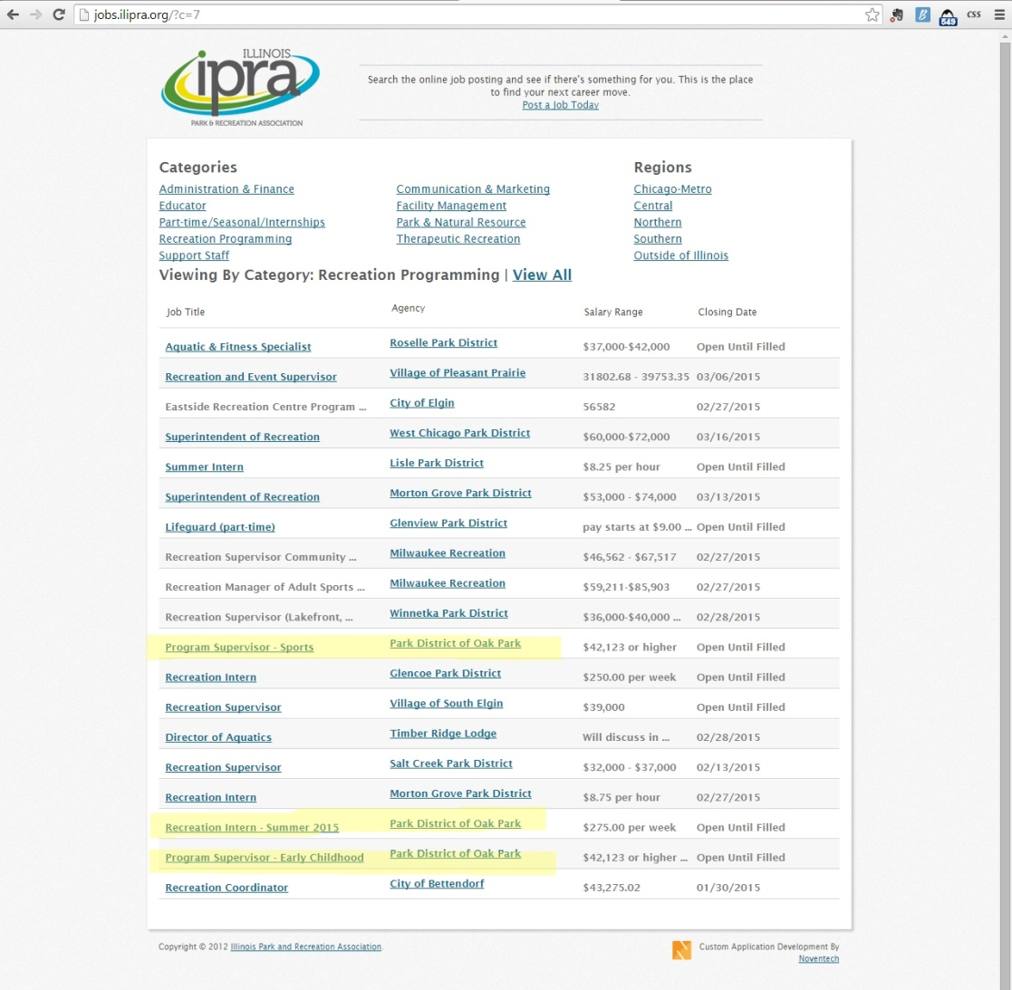

Agency Self Review: Met Not Met

Visitor Comments:

Visitor Evaluation: Met Not Met

4.1.3 - Equal Opportunity Employment and Workforce Diversity
Standard: There shall be an established policy regarding diversity with evidence of implementation that assures equal opportunities for employment, promotion, and equity in employment working conditions and that complies with the American Disabilities Act.

Suggested Evidence of Compliance: Provide the equal opportunity and workforce diversity policy and show evidence of implementation.

Informational reference in the Management of Park and Recreation Agencies, (2010), 3rd Ed., Chapter 16 – Human Resource Employment, pp 437-438.
Agency Evidence of Compliance:

The Park District of Oak Park is committed to having a diverse staff reflective of the Oak Park community. This is reflected in the Park District's recruitment procedures as well as its Equal Employment Opportunity Policy¹. The Park District advertises this commitment² on the "Jobs" page on the Park District website, the Park District's Job Openings website, as well as with job advertisements. The Park District also provides training³ for its staff on this and other related topics to ensure that all staff are aware of the policy.
Documentation:
- 04.01.03_Equal-Employment-Opportunity-Policy.pdf
- Screenshots of EEO Statement on Park District website (below)
- 04.01.03_Staff-Training-Review-of-Equal-Employment-Opportunity-Policy.pdf
Commitment to Equal Employment Opportunity & Workforce Diversity displayed on Park District "Jobs" page:

Commitment to Equal Employment Opportunity & Workforce Diversity displayed on Park District Job Openings website:
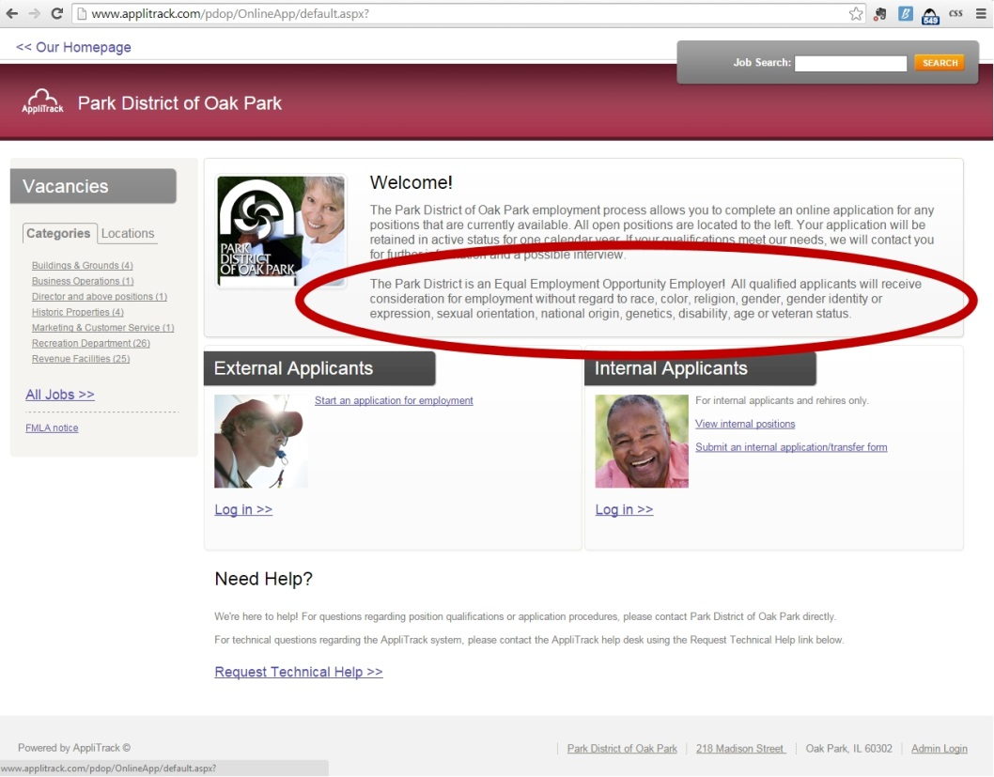

Agency Self Review: Met Not Met

Visitor Comments:

Visitor Evaluation: Met Not Met

4.1.4 - Selection Process
Standard: There shall be comprehensive procedures for hiring personnel. The agency shall also have a role in determination of skills and the personal attributes required for positions.

Suggested Evidence of Compliance: Provide selection process procedures and evidence that procedures are being followed. The procedures shall include information about the purpose, development, validity, utility, fairness, adverse impact, administration, scoring, and interpretation of all elements used in the selection process.

Informational reference in the Management of Park and Recreation Agencies, (2010), 3rd Ed., Chapter 16 – Human Resource Employment, pp 408-414.
Agency Evidence of Compliance:

The Park District of Oak Park has procedures in place to guide the selection and hiring processes to address the variety of situations, including the hiring of a mix of full-time, part-time, and seasonal staff, as well as a mix of both new hires and rehires. As evidenced in the Procedures for Employee Recruitment¹, before advertising any position opening, the hiring supervisor has the ability to make adjustments and modifications to the position description, including the skills and personal attributes required, in order to fit current business needs. The position description then goes through a series of approvals before being posted as a job opening on the Park District's website.
The next steps in the hiring process are outlined in the Procedures for Applicant Selection and Hiring². All applicants for a position are reviewed, taking into consideration the skills, experience, and educational requirements listed in the job description. The interview process may include a mix of phone and in-person interviews. Questions developed for the interview processes are tailored to the job, but are standardized across all applicants for a position to ensure fairness. References are checked and other screening tests, ranging from skills tests to physical, drug, and various types of background checks, may be required in order to ensure that the candidate is well-suited and eligible for the position.
Documentation:
- 04.01.04_Procedures-for-Employee-Recruitment.pdf
- 04.01.04_Procedures-for-Applicant-Selection-and-Hiring.pdf

Agency Self Review: Met Not Met

Visitor Comments:

Visitor Evaluation: Met Not Met

4.1.5 - Background Investigation
Standard: The agency process for hiring personnel shall include procedures for a national background investigation prior to appointment, including verification of a candidate's qualifying credentials, review of a candidate's civil and criminal record, particular attention to drug and child/adult-abuse records, and driving record for employees assigned to operate motor vehicles. Part of the process shall include criteria for disqualification which at a minimum is consistent with the “Criteria for Exclusion” guidelines adopted by the National Recreation and Parks Association.

Suggested Evidence of Compliance: Provide the background investigation procedures and examples of background checks completed.

Informational reference in the Management of Park and Recreation Agencies, (2010), 3rd Ed., Chapter 16 – Human Resource Employment, pp 412-413.
Agency Evidence of Compliance:

The Park District conducts a pre-employment screening on all new employees according to the guidelines and procedures outlined in Policy on Employment Screening and Procedure on Pre-Employment Testing¹. All candidates for hire are required to complete an application, which is reviewed for any disclosed civil or criminal offenses. Copies of resumes, college transcripts, licenses, and/or certifications may also be required.
Human Resources conducts additional screenings, including both Illinois State Police² and national criminal background checks³ and the national sex offender registry checks⁴ for all new and rehired employees, as well as driving record background checks⁵ for employees assigned to operate motor vehicles. If the candidate discloses a civil or criminal offense, or one is discovered through the additional screenings, the Director of Human Resources will assess the infraction taking into consideration factors such as the Park District procedures regarding recommended criteria for disqualification as well as the position applied for to determine whether or not it will disqualify the candidate.
Documentation of Evidence:
- 04.01.05_Procedures-for-Employment-Screening.pdf
- 04.01.05_Illinois-State-Police-Example.pdf
- 04.01.05_National-Background-Check-Example.pdf
- National Sex Offender Registry Example (see image below)
- 04.01.05_Drivers-License-Check-Example.pdf
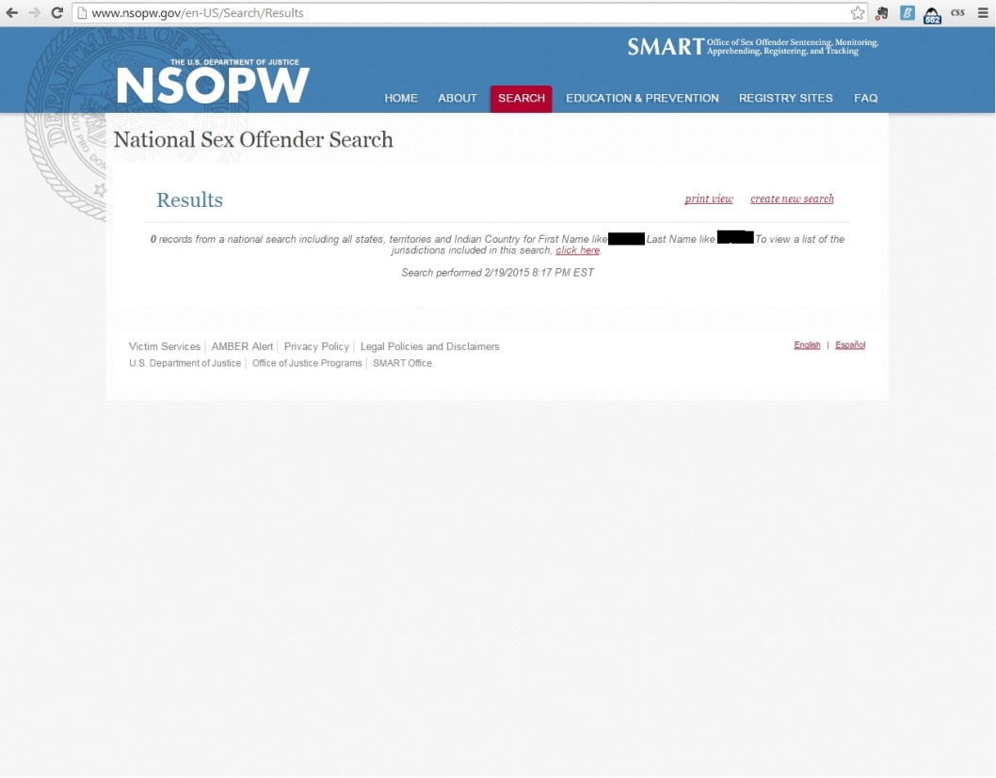

Agency Self Review: Met Not Met

Visitor Comments:

Visitor Evaluation: Met Not Met

4.1.6 - Employee Benefits
Standard: There shall be an established employee benefits plan. Each of the benefits provided to employees shall be described in terms of what is provided, under what conditions, and the extent of the benefit. Types of benefits often include administrative leave, holiday leave, sick leave, vacation leave, retirement program, health insurance program, disability and death benefits program, liability protection program, provision of clothing and equipment used by employees in performing park and recreation functions, employee education benefits, if any, and personnel support services to employees.

Suggested Evidence of Compliance: Provide the employee benefits plan.

Informational reference in the Management of Park and Recreation Agencies, (2010), 3rd Ed., Chapter 16 – Human Resource Employment, pp 416-422.
Agency Evidence of Compliance:

DPRAC - 4.5.1 Comprehensive Personnel Policies Manual

Agency Self Review: Met Not Met

Visitor Comments:

Visitor Evaluation: Met Not Met

4.1.7 - Supervision
Standard: There shall be constructive and effective supervision of all personnel to help them grow professionally and improve programs and services. Supervision is an on-going and systematic process that is helpful for the well-being of the individual and agency. Important characteristics of effective supervision are the ability to communicate expectations, delegate authority commensurate with the assigned tasks, provide feedback, and motivate. There should be supervisory processes, procedures, or tools that highlight staff orientation, staff coaching, mentoring and training, performance review, and human resource policies affecting supervision of staff such as those dealing with harassment and discipline.

Suggested Evidence of Compliance: Provide examples of processes, procedures, or tools used to assure constructive and effective employee supervision.

Informational reference in the Management of Park and Recreation Agencies, (2010), 3rd Ed., Chapter 18 – Supervision of Personnel, pp 461-484.
Agency Evidence of Compliance:

The Park District of Oak Park is committed to the success of the organization and staff. The Organizational Structure¹ is designed to provide appropriate levels of supervision to staff who provide services and maintain facilities.
The Park District provides many tools to make the process of communicating information, expectations, and performance as transparent and as simple as possible. The first step includes an Orientation Presentation² for all new staff to introduce them to the Park District and its policies, procedures, and services offered to the community, as well as for supervisors to learn more about supervisory responsibilities related to topics such as harassment. "The Hub" is home to all of the Park District's policies, procedures, manuals, job descriptions, and other important information. All staff have access to The Hub³ from any device with internet access and a browser and have the ability to use the easy search tool to quickly find the specific information needed. Additionally, agency-wide staff meetings are held in order to share to disseminate important information and review expectations. Senior leadership meetings are held twice a month, management team meetings are held once a month, and all staff meetings are held every other month.
The Park District believes that it is important for staff to receive training on leadership and supervision. The Park District has actively participated in the Illinois Park & Recreation Association's Leadership Academy with a total of 9 staff having graduated from, or are currently attending the academy since its inception in 2013. Additionally, 2 staff have also graduated from the NRPA Supervisor's Management School at Oglebay. The Park District has also sent many staff through PDRMA's HELP Human Resources Training and has provided its own internal training, such as the Interview Techniques Training⁵.
Performance evaluations are a critical part of any supervisory relationship. The Performance Reviews Policy⁶ outlines the performance review requirements for all staff.
Park District policies and procedures also provide direction to supervisors and staff about expectations and personnel processes with examples such as the Non-Discrimination and Anti-Harassment Policy⁸, Pregnancy Non-Discrimination and Accommodation Policy⁹, Disciplinary Actions Policy¹⁰, and Open Door Policy¹¹.
Documentation:
- 04.01.07_Organizational-Chart.pdf
- 04.01.07_Orientation-Presentation.pdf
- Screenshot of The Hub (below)
- 04.01.07_Interview-Techniques-Training-Presentation-Slides.pdf
- 04.01.07_Performance-Reviews-Policy.pdf
- 04.01.07_Non-Discrimination-and-Anti-Harassment-Policy.pdf
- 04.01.07_Pregnancy-Non-Discrimination-and-Accommodation-Policy.pdf
- 04.01.07_Disciplinary-Actions-Policy.pdf
- 04.01.07_Open-Door-Policy.pdf

Agency Self Review: Met Not Met

Visitor Comments:

Visitor Evaluation: Met Not Met

4.1.8 - Compensation Plan
Standard: There shall be an established compensation plan and that establishes equity of compensation among units within the agency that is reviewed periodically. The compensation plan for an agency shall take into account agency employment standards, agency skill needs, and compensation levels offered by other local employers.

Suggested Evidence of Compliance: Provide the compensation plan and a copy of its most recent review or update.

Informational reference in the Management of Park and Recreation Agencies, (2010), 3rd Ed., Chapter 16 – Human Resource Employment, pp 414-422.
Agency Evidence of Compliance:

DPRAC - 4.8.1 Salary Ranges

Agency Self Review: Met Not Met

Visitor Comments:

Visitor Evaluation: Met Not Met

4.1.9 - Performance Evaluation
Standard: There shall be a fair and systematic procedure for annual or periodic appraisal of job performance. Personnel evaluation shall be utilized for the development and improved quality of the individual's performance on the job, as well as a basis for promotion, monetary increments, and dismissal. Although evaluation is a day-by-day process, there shall be periodic specific reviews with the employee. An employee's personnel file shall include a written annual evaluation.

Suggested Evidence of Compliance: Provide the procedures and a sample of completed performance evaluations without identifying personal information.

Informational reference in the Management of Park and Recreation Agencies, (2010), 3rd Ed., Chapter 17 – Human Resource Management, pp 445-448.
Agency Evidence of Compliance:

DPRAC - 4.8.3 Appraisals of Job Performance

Agency Self Review: Met Not Met

Visitor Comments:

Visitor Evaluation: Met Not Met

4.1.10 - Promotion
Standard: There shall be an established policy and procedures available to all employees defining the promotion process and the agency's role. The park and recreation agency may rely upon a state or local civil service commission, or other public or private external organization to administer one or more elements of the process in accordance with legal, professional, and administrative requirements.

Suggested Evidence of Compliance: Provide the policy and procedures, and indicate how they have been communicated to employees.

Informational reference in the Management of Park and Recreation Agencies, (2010), 3rd Ed., Chapter 17 – Human Resource Management, pp 445-448.
Agency Evidence of Compliance:

When vacancies occur, the Park District may choose to fill the position by promotion. The factors that shall be considered will include, but not be limited to, work performance, knowledge, training, education, ability, skill, efficiency, and length of continuous service from the last date of hire or promotion. Performance reviews are also considered in promotional opportunities as indicated in the Performance Reviews Policy¹ as well as the Procedures for Applicant Selection & Hiring². An employee who has been promoted will be subject to an introductory period in the new position and any salary adjustment associated with the promotion shall be in accordance with the pay plan in effect for that position.
This information, along with all Park District policies and procedures, are posted on The Hub for review by staff at any time.
Documentation:
- 04.01.10_Performance-Reviews-Policy.pdf
- 04.01.10_Procedures-for-Applicant-Selection-and-Hiring.pdf

Agency Self Review: Met Not Met

Visitor Comments:

Visitor Evaluation: Met Not Met

4.1.11 - Disciplinary System
Standard: There shall be an established disciplinary system based on the code of conduct and performance. The system shall specify the conduct expected of employees. Prohibitions should be specific, whereas approved behavior may be stated in general terms (e.g., courtesy, punctuality).

Suggested Evidence of Compliance: Provide the code of conduct and performance and the policies and procedures that guide the disciplinary system and how this information is communicated and made accessible to employees. Include copies of disciplinary action steps included in collective bargaining agreements, if applicable. This system shall address the following topics:
  - Compliance with agency statements;
  - Unbecoming conduct;
  - Appropriate appearance;
  - Use of alcohol and drugs;
  - Acceptance of gratuities, bribes, or rewards;
  - Abuse of authority; and
  - Proper care and maintenance of equipment.

Informational reference in the Management of Park and Recreation Agencies, (2010), 3rd Ed., Chapter 16 – Human Resource Employment, pp 423-427.
Agency Evidence of Compliance:

The Park District of Oak Park strives to make expectations of staff as clear as possible in order prevent disciplinary issues from occurring whenever possible. The first step includes an Orientation Presentation¹ for all new staff to introduce them to the Park District and its policies, procedures, and services offered to the community, including some of the agency's important performance expectations. "The Hub" is home to all of the Park District's policies, procedures, manuals, job descriptions, and other important information. All staff have access to The Hub2 from any device with internet access and a browser and have the ability to use the easy search tool to quickly find the specific information needed.
The Compliance with Policies in Performance of Duties Policy³ requires employees to comply with all policies and procedures established by the Park District. Any corrective action that needs to be taken by the Park District is guided by the Disciplinary Actions Policy⁴, which includes the disciplinary actions that supervisors may take as well as the specific reasons for disciplinary action. Additional policies further outline specific expectations in the Employee Conduct Section of the Personnel Policies⁵.
The Park District's Union Contract⁶ further outlines expectations and disciplinary actions specifically for collective bargaining unit employees.
Documentation:
- 04.01.11_Orientation-Presentation.pdf
- Screenshot of The Hub (below)
- 04.01.11_Compliance-with-Policies-in-Performance-of-Duties-Policy.pdf
- 04.01.11_Disciplinary-Actions-Policy.pdf
- 04.01.11_Employee-Conduct-Section-of-the-Personnel-Policies.pdf
- 04.01.11_Union-Contract.pdf
Agency Self Assessment: MET

Agency Self Review: Met Not Met

Visitor Comments:

Visitor Evaluation: Met Not Met

4.1.12 - Grievance Procedures
Standard: There shall be an established grievance procedure, available to all employees. The procedure shall identify matters that are grievable; establish time limitations for filing or presenting the grievance; establish steps and time limitations at each step in the grievance procedure; and establish criteria for employee representation. Formal grievance procedures shall be written in clear, concise terms.

Suggested Evidence of Compliance: Provide the grievance procedures and indicate how the procedures have been communicated to the employees. Include grievance procedures included in collective bargaining agreements, if applicable.

Informational reference in the Management of Park and Recreation Agencies, (2010), 3rd Ed., Chapter 16 – Human Resource Employment, pp 427-430.
Agency Evidence of Compliance:

DPRAC - 4.5.1 Comprehensive Personnel Policies Manual and 4.5.2 Distribution of Personnel Policy

Agency Self Review: Met Not Met

Visitor Comments:

Visitor Evaluation: Met Not Met

4.1.13 - Termination and End of Employment
Standard: There shall be established policies and procedures for termination and end of employment.

Suggested Evidence of Compliance: Provide the termination and end of employment policies and procedures, and indicate how they have been communicated to employees.

Informational reference in the Management of Park and Recreation Agencies, (2010), 3rd Ed., Chapter 16 – Human Resource Employment, p. 426.
Agency Evidence of Compliance:

DPRAC - 4.5.1 Comprehensive Personnel Policies Manual and 4.5.2 Distribution of Personnel Policy

Agency Self Review: Met Not Met

Visitor Comments:

Visitor Evaluation: Met Not Met

4.2 - Staff Qualifications
Standard: The agency shall employ staff qualified to develop and operate programs and services in furtherance of goals and objectives. Staff shall be qualified for the positions as provided in the job descriptions and possess specified licenses and certificates. Park and recreation personnel shall have certification and/or educational training appropriate to the position.

Suggested Evidence of Compliance: Provide job descriptions for a representative sample of key positions and resumes for the current incumbents.

Informational reference in the Management of Park and Recreation Agencies, (2010), 3rd Ed., Chapter 17 – Human Resource Management, p. 451.
Agency Evidence of Compliance:

The Park District strives to employ well-qualified staff with the proper education and certifications to manage Park District operations. Examples of current employees and their job descriptions and resumes include:
Position Description | Staff Member's Resume
04.02.00_Director-of-Finance-Job-Description.pdf | 04.02.00_Kyle-Cratty-Resume.pdf
04.02.00_Director-of-Marketing-and-Customer-Service.pdf | 04.02.00_Diane-Stanke-Resume.pdf
04.02.00_Program-and-Operations-Manager-RCRC-Rehm-Job-Description.pdf | 04.02.00_Mike-Lushniak-Resume.pdf
04.02.00_Project-Manager-Job-Description.pdf | 04.02.00_Bobbi-Nance-Resume.pdf
04.02.00_Rink-and-Aquatics-Program-Supervisor-Job-Description.pdf | 04.02.00_Kyle-Sandine-Resume.pdf

Agency Self Review: Met Not Met

Visitor Comments:

Visitor Evaluation: Met Not Met

4.3 - Job Analyses for Job Descriptions
Standard: Established job descriptions for all positions shall be based on the job analysis and reviewed periodically.

Suggested Evidence of Compliance: Provide a job description for a full-time, part-time, temporary and internship position, and, if applicable, an example of a job analysis with last review. The job descriptions shall include, at a minimum:
  - Duties of each position;
  - Responsibilities of each position;
  - Tasks of each position; and
  - Minimum level of proficiency necessary in the job-related skills, knowledge, abilities, and behaviors.

Informational reference in the Management of Park and Recreation Agencies, (2010), 3rd Ed., Chapter 17 – Human Resource Management, pp.439-441.
Agency Evidence of Compliance:

All positions at the Park District have an established job description that indicate the essential and additional functions, which includes the duties, responsibilities, and tasks to be completed by the position. The job descriptions also include the list of knowledge, skills, experience, as well as psychological, physical, environmental, and cognitive considerations required for the job.
The Park District completed a review of all Non-Union Full-Time job descriptions incorporating information collected from the Job Analysis Questionnaire¹ in 2013 as part of a larger Comprehensive Compensation Study. A job description review is completed each time before a vacancy within that position is filled. If no vacancies occur with that position, a review shall be completed at least every 3 years, or when a major function of the position changes, whichever occurs first. The date of last review and last update are marked at the bottom of each job description.
Examples of various job descriptions include:
- Full-Time: Director of Horticulture & Conservatory Operations²
- Part-Time: Conservatory Receptionist Job Description³
- Seasonal: Camp Counselor Job Description⁴
- Intern Job Description⁵
Documentation:
- 04.03.00_Job-Analysis-Questionnaire.pdf
- 04.03.00_Director-of-Horticulture-Job-Description.pdf
- 04.03.00_Conservatory-Receptionist-Job-Description.pdf
- 04.03.00_Camp-Counselor-Job-Description.pdf
- 04.03.00_Intern-Job-Description.pdf
Agency Self Review: Met Not Met

Visitor Comments:

Visitor Evaluation: Met Not Met

4.4 - Chief Administrator
Standard: The agency shall have a chief administrator responsible to the approving authority for the management, direction, and control of the operations and administration of the agency and with authority to perform such responsibilities. The chief administrator shall be employed full-time, year-round, and be qualified by experience, education, certification, and/or training in park, recreation, leisure services, tourism, or related disciplines. These qualifications shall be verified and demonstrated specifically as to how it is related to park and/or recreation management.

Suggested Evidence of Compliance: Provide the chief administrator position description and the resume of the current incumbent. If she/he is from a related discipline, provide a summary of how the person’s qualifications relate to park and/or recreation management.

Informational reference in the Management of Park and Recreation Agencies, (2010), 3rd Ed., Chapter 17 – Human Resource Management, pp. 433-438.
Agency Evidence of Compliance:

The Park District employs a highly-qualified and experienced parks and recreation professional as its Executive Director. Jan Arnold¹ has 22 years of professional experience working for park districts, government, and non-profits. She currently holds a CPRP certification as well as a Bachelor of Science in Therapeutic Recreation from Murray State University, a Master of Science in Sports Administration from Indiana University, and an MBA from the Lake Forest Graduate School of Management.
The Executive Director is in essence the Board of Commissioner's only employee. The position of Executive Director does not have a traditional job description, but instead the commissioners have decided to include a list of responsibilities and authority with the Executive Director's contract² to clarify the responsibilities of the Board versus those of the Executive Director.
Documentation:
- 04.04.00_Jan-Arnold-Resume.pdf
- 04.04.00_Executive-Director-Contract.pdf
Agency Self Review: Met Not Met

Visitor Comments:

Visitor Evaluation: Met Not Met

4.4.1 - Leadership Succession Procedure
Standard: The agency shall have an established procedure to ensure that leadership is available when the agency's chief administrator is incapacitated, off duty, out of town, or otherwise unable to act.

Suggested Evidence of Compliance: Provide the written procedure, such as continuity plan, which indicates approval by the proper authority.
Agency Evidence of Compliance:

DPRAC - 1.4.5 Succession Procedure

Agency Self Review: Met Not Met

Visitor Comments:

Visitor Evaluation: Met Not Met

4.5 - Workforce Health and Wellness Program
Standard: The agency shall have an employee health and wellness program showing periodic evaluation of the program status.

Suggested Evidence of Compliance: Provide evidence of the agency’s employee health and wellness program, level of participation and most recent evaluation.

Informational reference in the Management of Park and Recreation Agencies, (2010), 3rd Ed., Chapter 17 – Human Resource Management, pp. 441-442.
Agency Evidence of Compliance:

The Park District offers a variety of resources to help encourage to develop and maintain a healthy lifestyle. The Park District partners with the Park District Risk Management Agency (PDRMA), the agency's risk management & health insurance provider, to communicate and encourage participation in events that support health and wellness. Previous year's PDRMA-sponsored events have included health risk assessments, and wellness and walking challenges. In 2015, these initiatives were brought under one program, PATH (Positive Activities Towards Health)¹, which includes assessments, challenges, education, and coaching and Park District staff are encouraged to participate in.
In addition to PATH, the Park District offers additional wellness opportunities to employees, including flu shots² at no cost and a reimbursement³ of up to $300/year for full-time staff for wellness-related programs or membership. Additionally, all year-round employees are eligible to receive a discount on Park District programs, including fitness classes.
The Park District includes the wellness program and participation as well as number of full-time sick days used by staff as two of its organizational performance measures. Data is tracked throughout the year so that staff can respond to it as they do other performance measures and evaluate progress at the end of the year. The results are documented in the Park District's Performance Measurement Report⁴.
Documentation:
- 04.05.00_PDRMA--PATH-Nov2014-Newsletter.pdf
- 04.05.00_Flu-Shot-Flyer.pdf
- 04.05.00_2014_Wellness-Reimbursements.pdf
- 04.05.00_Health-and-Wellness-Measures-in-Performance-Measurement-Report.pdf (these numbers are final, but the entire report will be finalized in March 2014)
Agency Self Review: Met Not Met

Visitor Comments:

Visitor Evaluation: Met Not Met

4.6 - Orientation Program
Standard: There shall be an orientation program for all personnel employed by the agency.

Suggested Evidence of Compliance: Provide outline of the orientation program and a representative example of materials distributed at an orientation. The orientation program should include:
  - Philosophy, goals, and objectives;
  - The history and development of the agency;
  - Pertinent sociological and environmental factors of the community and specific neighborhoods in which the individual is to serve (environmental scan); and
  - Review of program/parks policies and procedures manuals, job duties, staff procedures, first aid and safety concerns and guidelines and forms review.

Informational reference in the Management of Park and Recreation Agencies, (2010), 3rd Ed., Chapter 17 – Human Resource Management, pp. 442-443.
Agency Evidence of Compliance:

DPRAC - 4.6.1 Employee Orientation Program

Agency Self Review: Met Not Met

Visitor Comments:

Visitor Evaluation: Met Not Met

4.6.1 - Employee Training and Development Program
Standard: There shall be a program of employee development which is available to employees throughout the agency. It should be based on needs of individual employees, future organizational needs, and is evaluated and updated periodically. The program must notify personnel of available and/or required training, maintain training records, and assure that required training programs are attended. The program should incorporate in-service training and succession planning to ensure the continued effective performance of the organization after the departure of key staff.

Suggested Evidence of Compliance: Describe the scope and components of the employee development and training program, provide an outline of training offered (mandatory and discretionary), and provide lists of participants for the prior calendar year, and last review.

Informational reference in the Management of Park and Recreation Agencies, (2010), 3rd Ed., Chapter 17 – Human Resource Management, pp. 448-451.
Agency Evidence of Compliance:

DPRAC - 4.2.2 Continuing Education Opportunities, 4.3.1 In-House Training - Short Duration, 4.3.2 In-House Training - Long Duration, 4.3.3 Staff Attendance at Workshops

Agency Self Review: Met Not Met

Visitor Comments:

Visitor Evaluation: Met Not Met

4.6.2 - Professional Certification and Organization Membership
Standard: Professional staff shall be active members of their professional organization(s) and pursue professional certifications within their respective disciplines. "Active" means more than holding membership, including attendance at meetings, making presentations, participating in committee work, holding elected and appointed positions, and participation in educational opportunities.

Suggested Evidence of Compliance: Provide a list of staff with professional certifications and also provide a list of staff that have actively participated in a professional organization during the prior calendar year, indicating the nature of participation. The following are examples for park and recreation professionals e.g. Certified Park and Recreation Professional (CPRP), Certified Park and Recreation Executive (CPRE), Certified Therapeutic Recreation Specialist (CTRS) for park and recreation professionals.

Informational reference in the Management of Park and Recreation Agencies, (2010), 3rd Ed., Chapter 17 – Human Resource Management, p. 451.
Agency Evidence of Compliance:

DPRAC - 4.7.1 Professional Affiliation Guidelines

Agency Self Review: Met Not Met

Visitor Comments:

Visitor Evaluation: Met Not Met

4.7 - Volunteer Management
Standard: There shall be a volunteer management function within the agency, including a comprehensive volunteer management manual that includes policies and procedures related to the management of volunteers.

Suggested Evidence of Compliance: Provide the volunteer management manual.

Informational reference in the Management of Park and Recreation Agencies, (2010), 3rd Ed., Chapter 17 – Human Resource Management, pp. 454-458.
Agency Evidence of Compliance:

DPRAC - 1.13.2 Volunteer Manual

Agency Self Review: Met Not Met

Visitor Comments:

Visitor Evaluation: Met Not Met

4.7.1 - Use of Volunteers
Standard: Volunteers shall be used by the agency in a variety of positions.

Suggested Evidence of Compliance: Provide list of functions in which agency volunteers are used, the extent of use, and examples of volunteer position descriptions.

Informational reference in the Management of Park and Recreation Agencies, (2010), 3rd Ed., Chapter 17 – Human Resource Management, pp. 455-456.
Agency Evidence of Compliance:

DPRAC - 1.13.1 Policy or Procedure on Volunteers

Agency Self Review: Met Not Met

Visitor Comments:

Visitor Evaluation: Met Not Met

4.7.2 - Volunteer Recruitment, Selection, Orientation, Training, and Retention
Standard: There shall be an on-going function within the agency for the recruitment, selection, orientation, training and retention of volunteers, including procedures on background screening. Background investigations shall be made for all volunteers who work routinely with vulnerable populations, especially youth, senior adults, and persons with disabilities.

Suggested Evidence of Compliance: Provide the agency’s recruitment, selection, orientation, training, and retention procedures. Provide the agency’s background investigation procedures for volunteers and evidence of implementation.

Informational reference in the Management of Park and Recreation Agencies, (2010), 3rd Ed., Chapter 17 – Human Resource Management, pp. 456-457.
Agency Evidence of Compliance:

The Park District of Oak Park has developed Procedures for Volunteer Management¹ that explain the expectations to staff in regards to the recruitment, application, screening, selection, training, supervision, evaluation, tracking, recognizing, and retention of volunteers for the Park District. In addition to the general procedures, several program areas have developed additional procedures specific to their volunteer positions, including the Conservatory², Youth Athletic Leagues³, and Cheney Mansion⁴.
Documentation:
- 04.07.02_Procedures-for-Volunteer-Management.pdf
- 04.07.02_Procedures-for-Volunteers-at-the-Conservatory.pdf
- 04.07.02_Procedures-for-Volunteer-Coaches-with-Youth-Athletic-Leagues.pdf
- 04.07.02_Procedures-for-Volunteers-at-Cheney-Mansion.pdf
Agency Self Review: Met Not Met

Visitor Comments:

Visitor Evaluation: Met Not Met

4.7.3 - Supervision and Evaluation of Volunteers
Standard: Agency volunteers shall be monitored, shall receive supervisory visits, and be evaluated regarding performance. Supervision and evaluation of volunteers is important to ensure adequate training is provided and to verify satisfactory conduct and performance. The degree to which the agency supervises and evaluates volunteers may vary depending on the role of the volunteers.

Suggested Evidence of Compliance: Provide written description of the monitoring system including current practices for supervisory visits, and examples of evaluations.

Informational reference in the Management of Park and Recreation Agencies, (2010), 3rd Ed., Chapter 17 – Human Resource Management, p. 457.
Agency Evidence of Compliance:

The Park District's Procedures for Volunteer Management¹ outline the agency's expectations for supervision of volunteers. All volunteers must report to a full-time staff member at the Park District (except for volunteers for the Friends of Oak Park Conservatory, who report to their Volunteer Coordinator). Volunteers may receive supervision from part-time staff or occasionally other volunteers in certain situations. However, the full-time employee is responsible for volunteer management, including any recognition, mentoring, discipline, and evaluation that may need to take place.
In many cases, such as at special events, training is provided before the event and supervisors are present to check-in and are available in case of any questions. Because these are usually one-time volunteers, no formal evaluation is given.
Conservatory volunteers are monitored and supervised by Park District Conservatory staff, FOPCON Volunteer Coordinator, or experienced volunteers in leadership positions (depending on the nature of the volunteer activity. For these positions, as well as other volunteer positions at the Park District, verbal or written feedback is provided to volunteers as needed. For example, Cheney Mansion has a volunteer docent who received a Cheney Mansion Docent Evaluation².
In the case of our youth sports volunteer coaches, which make up a substantial amount of our volunteer hours, Youth Athletic League Volunteer Coaches receive pre-season training to ensure that all expectations are clear. Park District staff are on-site during games and practices to monitor volunteers. In addition, coaches are evaluated at least once a season using a Coach Evaluation Form³. If issues are identified, staff will meet with the coach. Negative evaluations or recurring issues can lead to termination as well as exclusion from further volunteer coaching in the future.
Documentation:
- 04.07.03_Procedures-for-Volunteer-Management.pdf
- 04.07.03_Cheney-Mansion-Docent-Evaluation.pdf
- 04.07.03_Coach-Evaluation-Forms.pdf
Agency Self Review: Met Not Met

Visitor Comments:

Visitor Evaluation: Met Not Met

4.7.4 - Recognition of Volunteers
Standard: There agency shall recognize volunteers for their contributions. Recognition may take many forms, depending on the nature of volunteer roles.

Suggested Evidence of Compliance: Provide a description of the recognition program and recognitions given over the past calendar year.

Informational reference in the Management of Park and Recreation Agencies, (2010), 3rd Ed., Chapter 17 – Human Resource Management, pp. 457-458.
Agency Evidence of Compliance:

DPRAC - 1.13.3 Volunteer Recognition Program

Agency Self Review: Met Not Met

Visitor Comments:

Visitor Evaluation: Met Not Met

4.7.5 - Liability Coverage for Volunteers
Standard: Agency volunteers shall be covered for negligence liability.

Suggested Evidence of Compliance: Provide documentation indicating coverage of volunteers for negligence liability.

Informational reference in the Management of Park and Recreation Agencies, (2010), 3rd Ed., Chapter 17 – Human Resource Management, p. 458.
Agency Evidence of Compliance:

As evidenced by the District's 2014 Liability Coverage Document¹ from the Park District Risk Management Agency (PDRMA), volunteers are covered by the District's liability insurance for "occurrences" or "wrongful acts" that may occur while acting on behalf of the District.
Documentation:
- 04.07.05_PDRMA-2014-Liability-Coverage-Document.pdf
Agency Self Review: Met Not Met

Visitor Comments:

Visitor Evaluation: Met Not Met

4.8 - Consultants and Contract Employees
Standard: The agency shall have policies and procedures regarding the use of consultants and contract employees.

Suggested Evidence of Compliance: Provide the agency’s policies and procedures regarding the use of consultants and contract employees.

Informational reference in the Management of Park and Recreation Agencies, (2010), 3rd Ed., Chapter 17 – Human Resource Management, pp. 458-459.
Agency Evidence of Compliance:

The Park District frequently procures consultant services for professional services such as comprehensive planning, master planning, architect services, engineering services, marketing studies, and landscape architecture services on an as-needed basis to assist, augment or enhance the capabilities of staff. Park District Board Policy on the Use of Expert Consultants¹ states that the board "shall seek the advice of expert consultants when the Board determines it is appropriate and shall use the advice of those consultants as an aid for Board decision-making."
Recent examples include the firm Altamanu¹, who was recently contracted to provide landscape architecture services for the Carroll Park construction project in 2014. The Park District also hired the Lakota Group³ to lead the comprehensive master planning process in 2014 and Planning Resource Inc.⁴ to conduct park master plan updates for Fox and Longfellow Parks in 2014.
Additionally, the Park District often works with independent contractors to provide specialized services as program instructors. The Park District has developed an Independent Contractor Guide⁵ who are interested in offering recreation services at the Park District. These contractors are required to comply with all Park District rules and regulations and other provisions in the Standard Independent Contractor Instructor Agreement.⁶
Documentation:
- 04.08.00_Use-of-Expert-Consultants-Policy.pdf
- 04.08.00_Altamanu-Carroll-Park-Project-Scope.pdf
- 04.08.00_Lakota-Group-Comprehensive-Plan-Contract.pdf
- 04.08.00_PRI-Fox-Park-Project-Scope.pdf
- 04.08.00_Independent-Contractor-Guide.pdf
- 04.08.00_Standard-Independent-Contractor-Instructor-Agreement.pdf
Agency Self Review: Met Not Met

Visitor Comments:

Visitor Evaluation: Met Not Met

Visitation Report Summary for
Category 4.0 – Human Resources

Reviewed By: (Visitor Name)

Unmet Standards: (List the Standard # and Name)

Provide clarification for all unmet fundamental standards:

5.0 - Financial Management
Note: Standards marked with a star () are fundamental standards,
and are required of all agencies seeking accreditation.

Financial management is the process of planning for, acquiring, and using funds to achieve predetermined organizational goals and objectives. The increasing demand for more and better services, continuing upward spiral of costs, increasing emphasis on fiscal responsibility and accountability, and the unwillingness of taxpayers support higher taxes, are all forcing park and recreation organizations to become more effective and efficient in all aspects of their financial operations. Parks and recreation managers must possess the ability to secure, organize, and control the financial resources of the organization to assure the success and survival of their organizations.

Formal fiscal control and monitoring procedures enable an agency to establish accountability, to comply with funding authorizations and restrictions, to ensure that disbursements are for designated and approved proposes and to alert agency management to possible problems.

5.1 - Fiscal Policy
Standard: Fiscal policies setting guidelines for management and control of revenues, expenditures, and investment of funds shall be set forth clearly in writing, and the legal authority must be clearly established.

Suggested Evidence of Compliance: Provide fiscal policies and legal authority.

Informational reference in the Management of Park and Recreation Agencies, (2010), 3rd Ed., Chapter 19 – Financial Management, pp. 487-494.
Agency Evidence of Compliance:

The Park District of Oak Park has taxing and spending authority granted by the Illinois statute "Park District Code" (70 ILCS 1205)¹. The Park District's Board Fiscal Policies² include policies which set forth the guidelines for the Park District's Board of Commissioners to levy taxes, pass a budget and appropriation ordinance, approve receipts and disbursements, and receive an annual audit. Administrative Fiscal Policies³ establish guidelines for Park District staff to manage the day to day finances of the Park District. They address the investment of public funds, monthly financial reporting to the Board of Commissioners, purchasing requirements, and fund balance requirements for the district.
Documentation:
- Illinois Park District Code
- 05.01.00_Park-District-Board-Fiscal-Policies.pdf
- 05.01.00_Park-District-Administrative-Fiscal-Policies.pdf
Agency Self Review: Met Not Met

Visitor Comments:

Visitor Evaluation: Met Not Met

5.1.1 - Comprehensive Revenue Policy
Standard: There shall be an established revenue policy that is periodically updated regarding fees and charges for services and the strategies and methodologies for determining fees and charges and levels of cost recovery.

Suggested Evidence of Compliance: Provide the policy on fees and charges, the current fee schedules or cost-recovery procedures, and the most recent review or update.

Informational reference in the Management of Park and Recreation Agencies, (2010), 3rd Ed., Chapter 19 – Financial Management, pp. 500-515.
Agency Evidence of Compliance:

The Park District's Revenue Policy¹ establishes the types of revenues the Park District will collect and is the basis of accounting. The policy on Fees and Charges² further details the fees and charges that the Park District will administer. These policies are reviewed and updated as part of the review of the entire set of Park District policies, which last took place in December 2014 when they were approved by the Park District Board of Commissioners³.
Potential increases in fees and charges are reviewed on an annual basis. Increases to fees and charges are based on numerous factors including the consumer price index (CPI), changes in staff costs, and estimated increases for contractual services and material and supplies. These factors are weighted based on their percentage of the overall Park District budget to create a blended increase in fees and charges. This information is shared with staff as part of the Park District of Oak Park Budget Guidelines⁴. The most recent update of the budget guidelines was completed in July 2014 in preparation for the development of the 2015 budget.
Documentation of Evidence:
- 05.01.01_Revenue-Policy.pdf
- 05.01.01_Fees-and-Charges-Policy.pdf
- 05.01.01_Policy-Approval-at-December-2014-Board-Meeting.pdf
- 05.01.01_2015-Budget-Guidelines.pdf
Agency Self Review: Met Not Met

Visitor Comments:

Visitor Evaluation: Met Not Met

5.1.2 - Agency Acceptance of Gifts and Donations
Standard: The agency shall have an established policy for the acceptance of gifts and donations.

Suggested Evidence of Compliance: Provide the policy on acceptance of gifts and donations.

Informational reference in the Management of Park and Recreation Agencies, (2010), 3rd Ed., Chapter 19 – Financial Management, pp. 511-514.
Agency Evidence of Compliance:

DPRAC - 2.16 Recreation Agency Acceptance of Donations, Gifts and Bequests

Agency Self Review: Met Not Met

Visitor Comments:

Visitor Evaluation: Met Not Met

5.1.3 - Grants Procedures
Standard: Where feasible and appropriate, the agency shall procure regional, state, federal and/or other applicable agency grants to supplement funding through an established procedure to research, coordinate and implement grant opportunities. Prior to grant procurement, agencies shall evaluate how application, approval, implementation and management processes will be coordinated.

Suggested Evidence of Compliance: Provide the procedure to procure grants along with a summary of grants received by the agency for the past five years, including identification of the following: project descriptions, grantor, date awarded, grant amount and agency match.

Informational reference in the Management of Park and Recreation Agencies, (2010), 3rd Ed., Chapter 19 – Financial Management, pp. 508-509.
Agency Evidence of Compliance:

The Park District of Oak Park consistently reviews possible grant opportunities on a regional, state, and federal level. The Park District's Procedures for Grants¹ sets forth the process when considering a grant opportunity. The Park District has been very successful in receiving grants, with over $4.1 million in grants awarded in the last 5 years. A list of these grants is included below:
Project Description | Grantor | Date Awarded | Grant Amount | Agency Match
Euclid Square Master Plan | Illinois Department of Natural Resources OSLAD Gran | 2015 | $400,000 | $400,000
Maple Park Master Plan | Illinois Department of Natural Resources OSLAD Grant | 2014 | $400,000 | $400,000
Austin Gardens Master Plan | Illinois Department of Natural Resources OSLAD Grant | 2013 | $400,000 | $400,000
Pleasant Home Summer Dining Porch Repair | Illinois State Museum Department Grant | 2013 | $80,455 | $80,455
Lindberg Park Master Plan | Illinois Department of Natural Resources OSLAD Grant | 2012 | $400,000 | $400,000
Multi-Facility Lighting Upgrades | Illinois Department of Commerce and Economic Opportunity Grant | 2012 | $14,663 | $3,666
Scoville Park Master Plan | Illinois Department of Natural Resources PARC Grant | 2011 | $1,600,000 | $400,000
Mills Park Master Plan | Illinois Department of Natural Resources OSLAD Grant | 2011 | $400,000 | $400,000
Taylor Park Master Plan | Illinois Department of Natural Resources OSLAD Grant | 2010 | $400,000 | $400,000
Euclid Square Master Plan | Illinois Department of Commerce and Economic Opportunity Grant | 2010 | $100,000 | $100,000

Documentation:
- 05.01.03_Procedures-for-Grants.pdf

Agency Self Review: Met Not Met

Visitor Comments:

Visitor Evaluation: Met Not Met

5.1.4 - Private, Corporate, and Non-Profit Support Procedures
Standard: Where feasible and appropriate, the agency shall solicit private, corporate, and non-profit support to supplement agency funding through an established procedure to research, coordinate and implement alternative funding options. Prior to acceptance of support the agency shall evaluate the terms of acceptance and how the implementation and management process will be coordinated.

Suggested Evidence of Compliance: Provide the procedure to solicit private, corporate and non-profit support along with a summary of such support received by the agency for the past five years including identification of the following: project descriptions, grantor/sponsor, date awarded, and value of the contribution and method of recognition.
Agency Evidence of Compliance:

The Park District of Oak Park consistently reviews possible support opportunities from private, corporate, and non-profit entities. The Park District provides numerous opportunities for organizations and individual to support the organization in variety of ways ranging from event sponsorships to dasher board sales at the ice rink to private donations. The Park District has developed policies and procedures to guide staff through this process that outline how the Park District should request aid, the criteria to be a sponsor, and payment requirements for sponsors and donors.
The Sponsorship Policy¹ explains the difference between a sponsorship and a donation, sets guidelines for acceptable sponsorships, determines staff approval levels and sets limits on a sponsor's commercial advertisements as they relate to the sponsorship. The Procedures for Securing a Sponsor² provides additional direction to staff regarding the basic steps required to secure a sponsorship. The Agency Gift Acceptance Policy³ provides guidance to the Board and staff regarding the acceptance of gifts (any form of cash, tangible property, real estate, or miscellaneous charitable items that do not fall within the parameters of the Park District's Sponsorship Policy).
The Park District actively pursues support of this type from the community. The Sponsorship and Ad Sales⁴ spreadsheets include the total sponsorships, dasherboard sales, and ad sales secured by the Park District in the past five years. Sample Sponsorship and Ad Sales Agreements⁵ demonstrate examples of recognition methods.
The Park District has also received additional support in the forms of financial donations. For example:
- In 2010, a private donor gave $90,000, which was combined with a gift of $140,000 from the Friends of Oak Park Conservatory (FOPCON), for the construction of the Conservatory Garden. Per the agreement⁵, the garden was named after a family member of the donor who had substantial ties to the Conservatory and a marker commemorating the donation was place.
- In 2012, a private donor gave $54,000 to the agency to the Cheney Mansion south garden restoration project. Per the agreement⁶, the Park District added and will maintain a marker in the South Garden to commemorate the gift.
- In 2014, the Friends of the Oak Park Conservatory donated $200,000 raised from fundraising and individual donors to fund the creation of the East Avenue Garden⁷.
Documentation:
- 05.01.04_Sponsorship-Policy.pdf
- 05.01.04_Procedures-for-Securing-a-Sponsor.pdf
- 05.01.04_Agency-Gift-Acceptance-Policy.pdf
- 05.01.04_Sample-Sponsorship-and-Ad-Sales-Agreements.pdf
- 05.01.04_2010-FOPCON-Rubenstein-Garden-Agreement.pdf
- 05.01.04_2012-Kouvel-Cheney-Gift-Agreement.pdf

Agency Self Review: Met Not Met

Visitor Comments:

Visitor Evaluation: Met Not Met

5.2 - Fiscal Management Procedures
Standard: There shall be established procedures for the fiscal management of the agency.

Suggested Evidence of Compliance: Provide the procedures for the fiscal management of the agency.

Agency Evidence of Compliance:

Park District of Oak Park fiscal management operations are overseen by Director of Finance and carried about by members of the Business Operations Department. The Park District has developed a set of Fiscal Procedures¹ that dictate the financial procedures to be followed by staff.
Documentation:
- 05.02.00_Fiscal-Procedures.pdf
Agency Self Review: Met Not Met

Visitor Comments:

Visitor Evaluation: Met Not Met

5.2.1 - Authority and Responsibility for Fiscal Management
Standard: The agency's chief administrator shall be designated as having the authority and responsibility for the fiscal management of the agency. Although an agency's chief administrator is ultimately responsible for all agency fiscal matters, the size and complexity of the agency may dictate the need to delegate responsibility for fiscal management functions to an identifiable person or component within the agency.

Suggested Evidence of Compliance: Provide documentation demonstrating clear delegation of fiscal authority for the agency.
DPRAC - 2.1.1 Responsibility for Fiscal Management Functions
Agency Self Review: Met Not Met

Visitor Comments:

Visitor Evaluation: Met Not Met

5.2.2 - Purchasing Procedures
Standard: Agencies shall have established procedures for the requisition and purchase of agency equipment, supplies, and services.

Suggested Evidence of Compliance: Provide the procedures for the requisition and purchase of agency equipment, supplies, and services, including:
- Bidding procedures;
- Criteria for the selection of vendors and bidders; and
- Procedures for disbursement of petty cash and issuance; and
- Use of procurement cards, if applicable.

Informational reference in the Management of Park and Recreation Agencies, (2010), 3rd Ed., Chapter 19 – Financial Management, pp. 515-517.
Agency Evidence of Compliance:

Park District of Oak Park purchasing is guided by its purchasing policies and procedures, all of which are in compliance with the Illinois Procurement Code (30 ILCS 500). The Procurement Policy¹ sets forth the overall requirements for staff in regards to purchasing, including bidding requirements, requests for quotations, as well as programs to encourage the purchase of environmentally-friendly products and locally-purchased products. Staff have outlined the Procedures for Bidding of Products and Services² in which the Park District will spend over $20,000 on in a given year. These procedures also indicate the standards under which a prospective bidder is judged.
The Board of Commissioners have also adopted a Payments Policy³ that creates the foundation for both the use of petty cash and procurement cards. The Procedures for Procurement Cards⁴ (or P-Cards, as they are often called at the Park District) outlines the accepted uses of procurement cards, the purchase approval process, as well as the process to be followed if a procurement card is lost or stolen. The Procedures for Petty Cash⁵ allow staff to receive up to $35.00 for miscellaneous items and defines the reconciliation process staff must follow when using petty cash.
Documentation of Evidence:
- 05.02.02_Procurement-Policy.pdf
- 05.02.02_Procedures-for-Bidding-of-Products-and-Services.pdf
- 05.02.02_Payments-Policy.pdf
- 05.02.02_Procedures-for-Procurement-Cards.pdf
- 05.02.02_Procedures-for-Petty-Cash.pdf
Agency Self Review: Met Not Met

Visitor Comments:

Visitor Evaluation: Met Not Met

5.2.2.1 - Emergency Purchase Procedures
Standard: There shall be established procedures for emergency purchases within the agency to secure equipment or services in a swift and efficient manner.

Suggested Evidence of Compliance: Provide the procedures for emergency purchases.
Agency Evidence of Compliance:

From time to time an unexpected emergency affects the Park District of Oak Park which necessitates the need to purchase items or services that were not budgeted for or in which time is of the essence. Park District Procedures for Emergency Purchases¹ provide direction to staff on what constitutes an "emergency" as well as the how to handle purchasing to address the situation. For example, in an emergency, staff can forgo bidding and informal quote requirements.
The Procedures for Supplemental/Emergency Appropriations² addresses the processes and requirements staff must take if the emergency purchase would incur more costs than budgeted in that specific line. If the cost would not affect the overall budget, a budget transfer can be requested. If the emergency purchase(s) incur a cost higher than what can be transferred from other budget lines, staff can get retroactive formal approval of the Board of Commissioners through a budget amendment.
Documentation:
- 05.02.02.01_Procedures-for-Emergency-Purchases.pdf
- 05.02.0.01_Procedures-for-Supplemental-Emergency-Appropriations.pdf
Agency Self Review: Met Not Met

Visitor Comments:

Visitor Evaluation: Met Not Met

5.3 - Accounting System
Standard: The agency shall have a comprehensive accounting system to ensure an orderly, accurate, and complete documentation of the flow of funds. The accounting system shall facilitate rapid retrieval of information on the status of appropriations, expenditures and revenue any time the information is required.

Suggested Evidence of Compliance: Provide a description of the accounting system.

Informational reference in the Management of Park and Recreation Agencies, (2010), 3rd Ed., Chapter 19 – Financial Management, pp. 517-519.
Agency Evidence of Compliance:

The Park District of Oak Park currently utilizes accounting software from Harris Computer called MSI, using the following Financial Management modules:
- General Ledger
- Accounts Payable
- Budget Preparation
- Purchasing
- Bank Reconciliation
as well as the following Payroll and Human Resources modules:
- Payroll
- Human Resources
Each module has its own login and permission levels, but all modules work together and also with the Park District's recreation services software (RecTrac) and time and attendance software (TimeClock Plus) to provide accurate and timely information and reports to staff.

Agency Self Review: Met Not Met

Visitor Comments:

Visitor Evaluation: Met Not Met

5.3.1 - Financial Status Reports
Standard: The agency shall periodically, monthly at a minimum, provide financial status reports. Each appropriation and expenditure shall be classified according to function, organizational component, activity, object, and program.

Suggested Evidence of Compliance: Provide financial status reports for the previous three months. Financial status reports shall include, at a minimum:
  - Initial appropriation for each account (or program);
  - Balances at the commencement of the regularly defined period;
  - Expenditures and encumbrances made during the period;
  - Unencumbered balances; and
  - Revenue status.
Agency Evidence of Compliance:

DPRAC - 2.2.5 Financial Report

Agency Self Review: Met Not Met

Visitor Comments:

Visitor Evaluation: Met Not Met

5.3.2 - Position Authorization Procedures
Standard: The agency shall have established procedures for maintaining control over the number and type of authorized filled and vacant positions to ensure that persons on the payroll are legally employed and that positions are in accordance with budget authorizations.

Suggested Evidence of Compliance: Provide the position authorization procedures and budgeted positions.
Agency Evidence of Compliance:

The Park District of Oak Park has procedures in place regarding the recruitment and hiring processes to ensure that all positions are in accordance with budget allocations and that all persons on payroll are legally employed. Per the Procedures for Employee Recruitment¹, prior to beginning the recruitment process, hiring supervisors must gain authorization from at least one supervisor (depending on the type of position being filled) to ensure that the position is truly needed and in line with the current budget.
Once the position is advertised and an applicant is selected, the Park District has procedures regarding completing hiring documentation and pre-employment screenings in the Procedures for Applicant Selection and Hiring² and Procedures for Employment Screening. The Park District also has Procedures for Entering New Employees into Park District Systems⁴, as well as Procedures for Reporting New Employees to the State of Illinois⁵ Department of Employee Security. These steps ensure that the Park District can confirm that someone is legally employed.
Documentation:
- 05.03.02_Procedures-for-Employee-Recruitment.pdf
- 05.03.02_Procedures-for-Applicant-Selection-Hiring.pdf
- 05.03.02_Procedures-for-Employment-Screening.pdf
- 05.03.02_Procedures-for-Entering-New-Employees-into-Park-District-Systems.pdf
- 05.03.02_Procedures-for-Reporting-New-Employees-to-the-State-of-Illinois.pdf
Agency Self Review: Met Not Met

Visitor Comments:

Visitor Evaluation: Met Not Met

5.3.3 - Fiscal Control and Monitoring Procedures
Standard: The agency shall have established procedures used for collecting, safeguarding, and disbursing funds. The procedures shall enhance security and accountability of all monies received by the agency.

Suggested Evidence of Compliance: Provide the fiscal control and monitoring procedures. The fiscal control and monitoring procedures shall include:
  - Maintenance of an allotment system, if any, or records of appropriations among organizational components;
  - Preparation of financial statements;
  - Conduct of internal audits; and
  - Persons or positions authorized to accept or disburse funds.

Informational reference in the Management of Park and Recreation Agencies, (2010), 3rd Ed., Chapter 20 – Budgeting, pp. 572-576.
Agency Evidence of Compliance:

The Park District of Oak Park has procedures in place for the collecting, safeguarding, and disbursing of Park District funds to ensure proper internal controls are followed.
The Park District follows the budget and appropriation ordinance model set forth by the Illinois Park District Code using the Procedures for Budget Process¹. The Park District legally appropriates funds for the continuing operations of the Park District based on the its working budget. If spending levels are to exceed the budgeted amount or an emergency occurs staff follows Procedures for Supplemental/Emergency Appropriations².
To ensure the Board of Commissioners and staff are monitoring the financial condition of the district, the Park District sets out specific procedures for the preparation of financial statements on a monthly basis in the Procedures for Monthly Financial Reports³.
Cash handling is an important aspect of the Park District's daily operations. To ensure cash handling procedures are being followed the Park District completes internal cash audits on a random basis as stated in the Procedures for Cash Handling⁴. The disbursement of funds and acceptance of funds are another potential area of risk to the Park District. Due to this, these procedures dictate that only Customer Service staff are able to accept funds. Additionally, the disbursements of funds can only be approved with the consent of at least two of the following: Executive Director, Director of Finance, or Finance Manager. This applies to wire transfers, payroll, as well as payment of accounts payable bills as shown in the Procedures for Payroll Processing⁵, Procedures for Bill Payment⁶, and Procedures for Wire Transfers⁷.
Documentation:
- 05.03.03_Procedures-for-Budget-Process.pdf
- 05.03.03_Procedures-for-Supplemental-Emergency-Appropriations.pdf
- 05.03.03_Procedures-for-Monthly-Financial-Reports.pdf
- 05.03.03_Procedures-for-Cash-Handling.pdf
- 05.03.03_Procedures-for-Payroll-Processing.pdf
- 05.03.03_Procedures-for-Bill-Payment.pdf
- 05.03.03_Procedures-for-Wire-Transfers.pdf
Agency Self Review: Met Not Met

Visitor Comments:

Visitor Evaluation: Met Not Met

5.3.4 - Independent Audit
Standard: There shall be an independent audit of the agency's fiscal activities conducted annually or at a time stipulated by applicable statute or regulation. The audit may be performed by the government's internal audit staff (external to the agency being audited) or by an outside certified public accounting firm.

Suggested Evidence of Compliance: Provide the most recent independent audit and management letter, or most recent Comprehensive Annual Financial Report (CAFR) and provide the response to the audit recommendations.

Informational reference in the Management of Park and Recreation Agencies, (2010), 3rd Ed., Chapter 19 – Financial Management, pp. 520-523.
Agency Evidence of Compliance:

The Park District of Oak Park annually contracts with an independent CPA firm to complete a Comprehensive Annual Financial Report (CAFR)¹. For the last two fiscal years the Park District has not received a management letter from Wolf and Company, the current contracted CPA firm, as they found no material internal control deficiencies in the agency. The Park District was the recipient of the Government Finance Officers Association's (GFOA) Certificate of Achievement for Excellence in Financial Reporting for its 2013 CAFR².
Documentation:
- 05.03.04_2013-CAFR.pdf
- 05.03.04_2013-CAFR-GFOA-Award-and-Report.pdf
Agency Self Review: Met Not Met

Visitor Comments:

Visitor Evaluation: Met Not Met

5.4 - Annual or Biennial Budget
Standard: There shall be an annual or biennial operating and capital improvements budgets, including both revenues and expenditures. Operating budgets include both capital and operating expenses, cover a one-year or two-year period and capital improvements may extend five or six years with annual review. The nature of an agency's budgetary system may be determined by the kind of system in use by its governmental authority.

Suggested Evidence of Compliance: Provide the current and approved operating and capital improvements budgets.

Informational reference in the Management of Park and Recreation Agencies, (2010), 3rd Ed., Chapter 20 – Budgeting, pp. 527-576.
Agency Evidence of Compliance:

The Park District of Oak Park adopts an annual budget which sets the expected revenues and expenditures for the coming year, including capital improvements. The current budget¹ was adopted by the Park District Board of Commissioners on November 20, 2014². The Park District has been awarded Government Finance Officers Association's (GFOA) Distinguished Budget Presentation Award³ for the past five years. The agency's application for this award for the 2015 Budget is currently under review.
Documentation:
- Park District of Oak Park 2015 Budget
- 05.04.00_Budget-Approval-at-November-2014-Board-Meeting.pdf
- Link to GFOA Distinguished Budget Presentation Award Winners
Agency Self Review: Met Not Met

Visitor Comments:

Visitor Evaluation: Met Not Met

5.4.1 - Budget Development Guidelines
Standard: The agency shall establish guidelines to inform the heads of organizational components of the essential tasks and procedures relating to the budget preparation process. The guidelines shall include instructions for preparing budget request documents and for providing adequate justification for major continuing expenditures or changes in continuing expenditures of budget items. Information should be included regarding operating impact.

Suggested Evidence of Compliance: Provide the budget development guidelines.
Agency Evidence of Compliance:

The Park District of Oak Park creates Budget Guidelines¹ and a Budget Timeline² annually for staff to follow when creating the budget. The Board of Commissioners first reviews³ the recommended budget guidelines developed by staff in the Business Operations department to be used in budget creation, including information about the tax levy, wage and material and supply increases, and capital transfers. These guidelines help ensure uniformity across the Park District when it comes to expense increases. The Board of Commissioners also reviews the recommended budget timeline that sets the schedule and deadlines for staff during the entire budgeting process.
This information is then presented to staff at budget trainings, which also includes information on how to use the Park District's financial software for budget creation⁴.
Documentation:
- 05.04.01_2015-Budget-Guidelines.pdf
- 05.04.01_2015-Budget-Timeline.pdf
- 05.04.01_Board-Review-of-Budget-Guidelines-and-Timeline-at-June-2014-Board-Meeting.pdf
- 05.04.01_Budget-Entry-Presentation-Slides.pdf
Agency Self Review: Met Not Met

Visitor Comments:

Visitor Evaluation: Met Not Met

5.4.2 - Budget Recommendations
Standard: Major organizational components shall provide recommendations, based on operational and activity analysis, for use in the development of the agency's budget.

Suggested Evidence of Compliance: Provide examples of agency component recommendations and evidence of their consideration in the budgeting process. Recommendations shall include:
  - Assessment of current and future personnel needs;
  - Costs per program element;
  - Line items.
Agency Evidence of Compliance:

The Park District of Oak Park's annual budget is deeply rooted in the recommendations of each of its departments. As evidenced in the Park District's annual budget timeline¹, after budget training, staff make recommendations for each line item through the Park District's financial software. As part of this process, staff are asked to determine and enter anticipated revenues and set prices, assess personnel needs, contractual needs, and material and supply needs into MSI (financial software). The majority of the work completed in the budget development process takes place within MSI in order to ensure accuracy and save on paper costs. Once completed, access to edit the budget recommendations within the software is removed. Detailed Budget Reports displaying each department's recommendations are e-mailed²⁻⁴ to Department Heads as well as the Executive Director prior to department budget meetings.
At the individual department budget meetings, Department Heads and Managers meet with the Finance Director, Finance Manager, and Executive Director. Any agreed upon adjustments to the department's recommendations made at these meetings are then entered into MSI by the Business Operations Department. The final recommendations are then presented to the Park District Board of Commissioners for approval.
Documentation of Evidence:
- 05.04.02_2015-Budget-Timeline.pdf
- 05.04.02_Conservatory-Budget-Pre-Meeting-Email-and-Detailed-Budget-Report.pdf
- 05.04.02_Revenue-Facilities-Budget-Pre-Meeting-Email-and-Detailed-Budget-Report.pdf
- 05.04.02_Sports-and-Fitness-Budget-Pre-Meeting-Email-and-Detailed-Budget-Report.pdf
Agency Self Review: Met Not Met

Visitor Comments:

Visitor Evaluation: Met Not Met

5.5 - Budget Control Procedures
Standard: The agency shall have procedures for budget control with periodic reporting of revenues and expenditures, and continuous management review.

Suggested Evidence of Compliance: Provide the procedures for budget control within the agency and examples of periodic reports.
Agency Evidence of Compliance:

The Park District follows its Procedure on Monthly Financial Reports¹ in regards to budget controls and monthly reporting of revenues and expenditures. Park District financial information is made available to staff on its dashboards² and those responsible for budget lines must report to the Finance Manager each month any overages or shortages in their budget that are more than 10% above or below the budgeted allocation. These reports are then reviewed by the Business Operations department and any pertinent findings are forwarded to the Executive Director. The Board of Commissioners also receives financial reports³⁻⁵ each month in their board packets.
Documentation:
- 05.05.00_Procedures-for-Monthly-Financial-Reports.pdf
- Screenshots of monthly reports from staff financial dashboard (below)
- 05.05.00_Financial-Reports-from-November-2014-Board-Packet.pdf
- 05.05.00_Financial-Reports-from-December-2014-Board-Packet.pdf
- 05.05.00_Financial-Reports-from-January-2015-Board-Packet.pdf
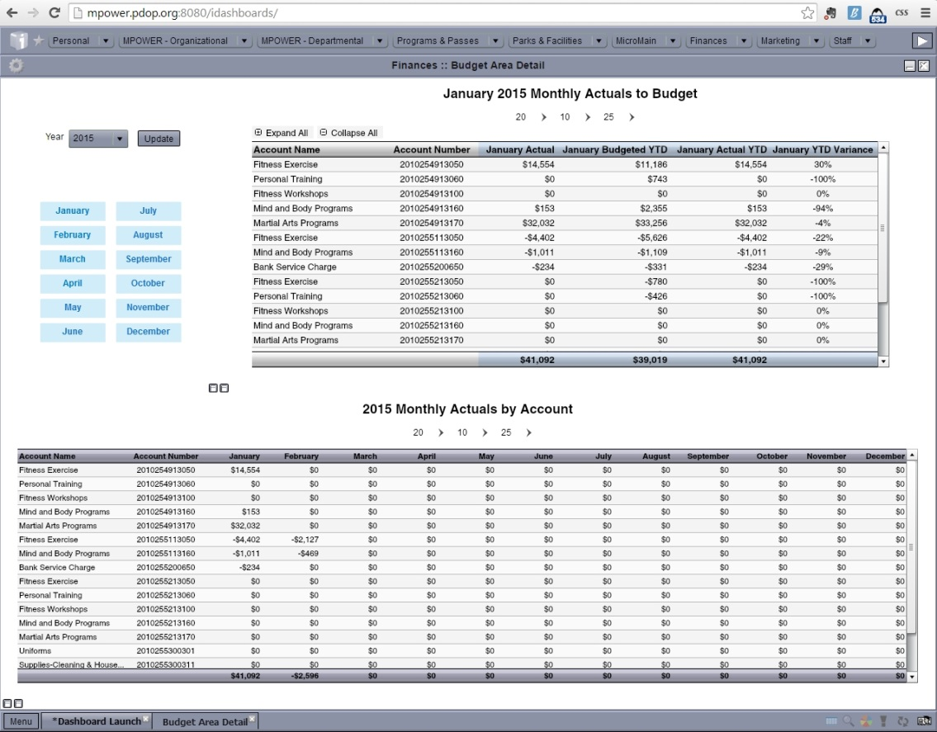

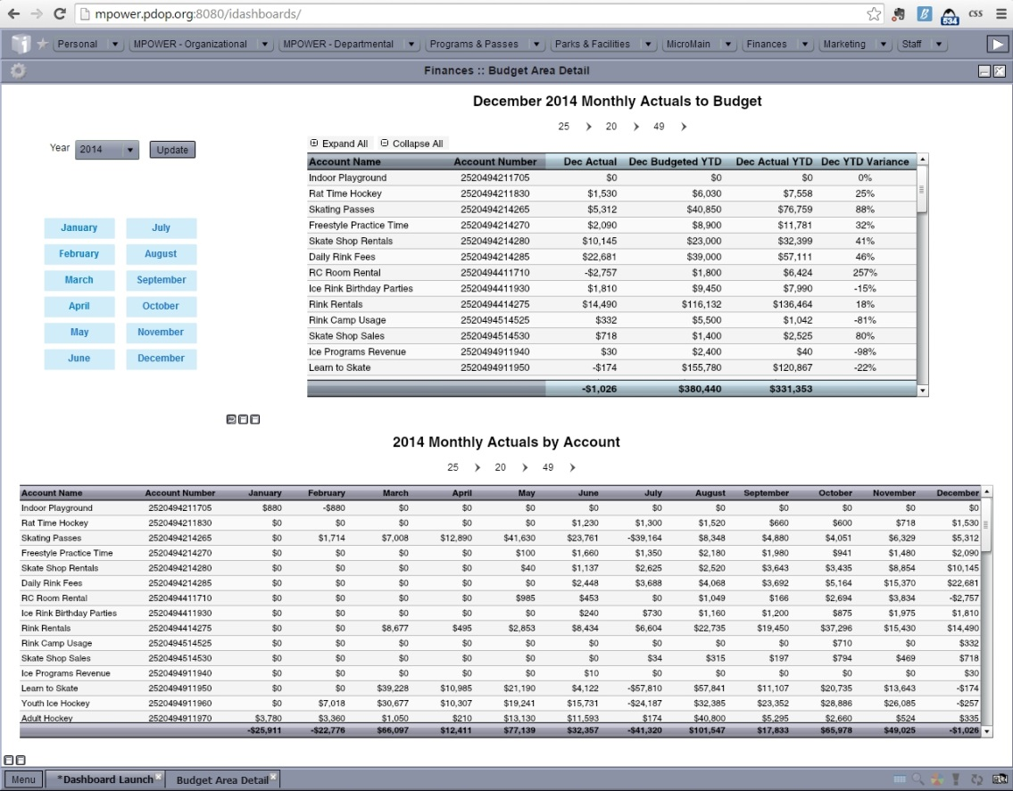

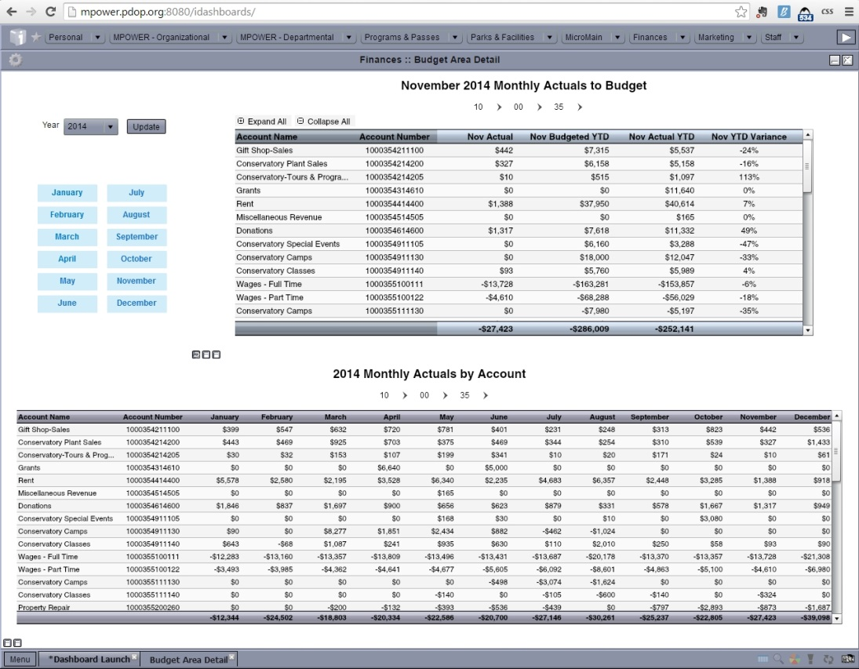

Agency Self Review: Met Not Met

Visitor Comments:

Visitor Evaluation: Met Not Met

5.5.1 - Supplemental/Emergency Appropriations Procedures
Standard: The agency shall have established procedures for requesting supplemental or emergency appropriations and fund transfers to meet circumstances that cannot be anticipated by prior fiscal planning efforts. Mechanisms of adjustment may include transferring funds from one account to another and/or requesting that additional funds be granted for agency needs.

Suggested Evidence of Compliance: Provide the supplemental/emergency appropriations procedures.
Agency Evidence of Compliance:

DPRAC - 2.15 Supplemental/Emergency Appropriations

Agency Self Review: Met Not Met

Visitor Comments:

Visitor Evaluation: Met Not Met

5.5.2 - Inventory and Fixed Assets Control
Standard: The agency shall have established procedures for inventory control of property, equipment, and other assets to prevent losses and unauthorized use, and to avoid both inventory excesses and shortages. There shall be a complete and current listing of agency assets.

Suggested Evidence of Compliance: Provide procedures for inventory and fixed asset control.
Agency Evidence of Compliance:

The Park District of Oak Park's Fixed Assets Policy¹ sets forth the assets controls in place at the Park District, including what information must be documented and the capitalization thresholds and amortization schedules. The control of each asset falls to the department under which the asset was purchased for.
Each year, during the audit process, the Park District books its capital assets in an AssetMaxx program² that syncs with the Park District's risk management agency, PDMRA. These procedures are documented in the Procedures for Fixed Asset Booking³. The AssetMaxx recording ending on December 31, 2013 shows all of the capital assets the Park District has currently booked.
Documentation:
- 05.05.02_Fixed-Assets-Policy.pdf
- 05.05.02_AssetMaxx-Report-Ending-12-31-13.pdf
- 05.05.02_Procedures-for-Fixed-Asset-Booking-and-Controls.pdf
Agency Self Review: Met Not Met

Visitor Comments:

Visitor Evaluation: Met Not Met

Visitation Report Summary for
Category 5.0 – Financial Management

Reviewed By: (Visitor Name)

Unmet Standards: (List the Standard # and Name)

Provide clarification for all unmet fundamental standards:

6.0 - Programs and Services Management
Note: Standards marked with a star () are fundamental standards,
and are required of all agencies seeking accreditation.

A program is a means to leisure and recreation as well as a vehicle to deliver benefits to participants. High-quality programming is a dynamic process that continues as the recreation experience unfolds.
A systematic and well-researched analysis should be completed in determining what programs and services should be provided by the agency. The public park and recreation program should be coordinated with related programs of other governmental, for-profit and non-profit organizations in the community, such as schools, voluntary agencies, and churches, to provide maximum coverage with a minimum of duplication, as well as to reduce competition.

The primary responsibility of the park and recreation professional is to provide programs by which leisure and recreation experiences and environments enhance the well-being and quality of life for participants. Certain program and service determinants give direction to what is provided and assessed. These determinants are: conceptual foundations of play, recreation, and leisure; agency philosophy, goals and objectives; constituent interests and desired needs; and community opportunities for the public. Program and service objectives must be benefits-focused. Many agencies put objectives in “SMART” format (specific, measurable, achievable, realistic, and timed) to assure that objectives are measurable and they use logic modeling to focus their objectives on outcomes and impacts.

The recreation programming plan includes all elements and services of the public park and recreation agency’s programming functions, including activity selection, type and scope of programs and outreach initiatives. While related to a master or comprehensive plan, the recreation programming plan shall be an outgrowth of other strategic and program forecasting tools.

Park and recreation agencies should have a program that educates the public about the intrinsic and extrinsic benefits that leisure (time, activity, experience) and participation in self-directed and leader-directed recreation activities provide. It should include the three (3) behavior domains: psychomotor (manipulation and coordination of physical skills and abilities), affective (interests, appreciations, attitudes and values) and cognitive (intellectual skills and abilities).

A leisure education program consists of six (6) components:
- Awareness of self in leisure;
- Appreciation of leisure;
- Understanding self-determination in leisure;
- Making decisions regarding leisure participation;
- Knowledge and use of resources for facilitating leisure; and
- Promoting social interaction.

Examples include:
- Cooperative agreements with local schools to develop classes, workshops or events to inform children and adolescents of leisure benefits.
- Community presentations regarding leisure benefits at libraries, senior citizen centers, special recreation associations, and at business and industry meetings.
- Distributing a “benefits” CD or website hyperlink to educate, publicize, and inform of agency programs and services through various social media outlets (Facebook, Twitter, etc.) and public cable TV channels.
- Organizing and categorizing agency publications and photos according to the benefits associated with targeted programs and services, e.g., benefits of nature walks for senior populations and benefits of outdoor play for children.
- Marketing and advertising the benefits message in agency telephone messages, employee newsletters, and policy manuals, on staff apparel, facility and vehicle signage.
- Including benefit statements in brochures and program descriptions so that prospective participants will see what they can gain from participating in programs.
- Including the question of “How have you benefited from this program?” in program evaluations, causing the participant to reflect on the benefits of the program.
- Including the benefits of programs and services on agency websites and in email/e-blasts, press releases and public service announcements.
- Conducting benefits-based program research studies.
- Conducting and reporting follow-up assessments and data analyses.

6.1 - Recreation Programming Plan
Standard: The agency shall have a recreation programming plan covering 3-5 years that is updated periodically and a current-year implementation plan. The plan shall address all programs and services of the agency’s programming functions, including activity selection, type and scope of programs and outreach initiatives.

Suggested Evidence of Compliance: Provide the current recreation programming plan and describe the update process. This plan shall address how the agency delivers services to persons of all ages and abilities, how it develops program offerings and it shall include the following elements:
  - Program objectives (6.2);
  - Program and service statistics (10.5);
  - Program and service determinants (6.1.1);
  - Recreation and leisure trends analysis (10.5.1); and
  - Community inventory (10.5.2).

Informational reference in the Management of Park and Recreation Agencies, (2010), 3rd Ed., Chapter 8 – Recreation Program Planning, pp. 137-138.
Agency Evidence of Compliance:

The Park District of Oak Park's Recreation Department has developed a 2015-2019 Recreation Programming Plan¹. The plan is redeveloped every 5 years with adjustments each year to include the latest Recreation Report and statistics as well as the annual outcomes for the plan objectives. The plan and its appendices include information about past performance, as well as future plans in each program area. It sets priorities with determinants to help ensure that the programs and services offered by the recreation programming team are well-suited for the community.
Documentation:
- 06.01.00_2015-2019-Recreation-Programming-Plan.pdf

Agency Self Review: Met Not Met

Visitor Comments:

Visitor Evaluation: Met Not Met

6.1.1 - Program and Service Determinants
Standard: A systematic and studied approach shall be taken in determining what programs and services shall be provided by the agency.

Suggested Evidence of Compliance: Provide documentation and examples demonstrating that the six (6) program and service determinants are used in providing programs and services. The programs and services provided by the agency shall be based on the
  - Conceptual foundations of play, recreation, and leisure;
  - Organizational agency philosophy, mission and vision, and goals and objectives;
  - Constituent interests and desired needs;
  - Creation of a constituent-centered culture;
  - Experiences desirable for clientele; and
  - Community opportunities.

Informational reference in the Management of Park and Recreation Agencies, (2010), 3rd Ed., Chapter 9 – Program Services and Event Management, pp. 155-159.
Agency Evidence of Compliance:

The recreation programming team has incorporated the six program and service determinants into a tool to assist staff in determining the best programs and services to offer the community. Information about the determinants, the tool, as well as examples of demonstrating use of the determinants and the tool are included in the Recreation Programming Plan¹.
Documentation:
- 06.01.01_Program-and-Service-Determinants-in-2015-2019-Recreation-Programming-Plan.pdf
Agency Self Review: Met Not Met

Visitor Comments:

Visitor Evaluation: Met Not Met

6.1.2 - Participant Involvement
Standard: The development of agency programs and services shall involve participants.

Suggested Evidence of Compliance: Describe the process and provide examples of how the agency obtains and utilizes participant input. Participants shall have involvement in:
  - Recommending policy;
  - Planning activities;
  - Conducting activities; and
  - Sponsoring activities.

Informational reference in the Management of Park and Recreation Agencies, (2010), 3rd Ed., Chapter 9 – Program Services and Event Management, pp. 176-177.
Agency Evidence of Compliance:

DPRAC - 5.7.1 Professional Affiliation Guidelines and Community Input in Planning and Development

Agency Self Review: Met Not Met

Visitor Comments:

Visitor Evaluation: Met Not Met

6.1.3 - Self-Directed Programs and Services
Standard: The agency shall offer self-directed recreation opportunities for individuals and groups to participate without leadership, under only general supervision. Examples include picnic facilities, tennis courts, roadways in scenic areas, bridle trails, self-guiding nature trails, and open playgrounds.

Suggested Evidence of Compliance: Provide examples of how the agency provides self-directed recreation opportunities, including a list of such opportunities.

Informational reference in the Management of Park and Recreation Agencies, (2010), 3rd Ed., Chapter 9 – Program Services and Event Management, p. 161.
Agency Evidence of Compliance:

The Park District of Oak Park offers a wide variety of self-directed programs and services including, but not limited to:
- Walking Paths
- Playgrounds
- Athletic Fields
- Outdoor Basketball Courts
- Dog Parks
- Outdoor Swimming Pools
- Splash Pads
- Indoor Ice Rink
- Outdoor Ice Rinks
- Sand Volleyball Court
- Tennis Courts
- Chess Tables
- Picnic Areas
A matrix¹ showing these opportunities in each Park District park & facility is included in each Park District brochure. Additionally, the public has the ability to search for the locations of these opportunities on the Park District's website².
Documentation:
- 06.01.03_Facility-Features-Matrix-in-Program-Guide.pdf
- Park District of Oak Park Online Park & Facility Search
Agency Self Review: Met Not Met

Visitor Comments:

Visitor Evaluation: Met Not Met

6.1.4 - Leader-Directed Programs and Services
Standard: The agency shall offer leader-directed recreation opportunities that provide recreation opportunities where participant involvement is directed by a leader, including skills instruction classes. Examples include tennis, crafts, dance; synchronized swimming performance; creative dramatics for children.

Suggested Evidence of Compliance: Provide examples of how the agency provides leader-directed recreation opportunities, including a list of such opportunities.

Informational reference in the Management of Park and Recreation Agencies, (2010), 3rd Ed., Chapter 9 – Program Services and Event Management, p. 161.
Agency Evidence of Compliance:
The Park District of Oak Park offers a wide variety of leader-directed recreation opportunities. These programs are run by a skilled leader to assist participants with their recreation experience. A quarterly brochure of program offerings is distributed to each household in Oak Park and are also available on the Park District's website. Examples of leader-directed programs include:
- Athletics classes (tennis lessons, soccer camps, instructional youth sports classes, etc.)
- Athletic leagues
- Fitness classes (strength training, cardio, Zumba, water fitness, etc.) and personal training
- Preschool
- Day camps
- Afterschool programs
- Ice skating and ice hockey instruction
- Swim lessons
- Book club for seniors
Additional current program offerings can be found on the Park District's website at http://registration.pdop.org.

Agency Self Review: Met Not Met

Visitor Comments:

Visitor Evaluation: Met Not Met

6.1.5 - Facilitated Programs and Services
Standard: The agency shall facilitate assistance to individuals and groups of individuals that provide or want to provide recreation programs and leisure services independently from the agency. An example of facilitated programs and services is an individual or group that wishes to start a community theater organization; the agency may help initially by providing a meeting place, some administrative help in publicity, and "seed money” with the intent that the organization will become self-sustaining. Demonstration projects may be utilized for this purpose.

Suggested Evidence of Compliance: Provide examples of how the agency provides facilitated recreation opportunities, including a list of such opportunities.

Informational reference in the Management of Park and Recreation Agencies, (2010), 3rd Ed., Chapter 9 – Program Services and Event Management, pp. 161-162.
Agency Evidence of Compliance:
As outlined in the mission, the Park District of Oak Park, "in partnership with the community," offers a variety of facilitated recreation opportunities. Staff work with many local organization to offer quality programs for the community. Depending on the relationship, the Park District may assist with marketing through inclusion in the quarterly brochure, use of Park District parks and facilities, assistance with completing volunteer background checks, and other support.
In order to ensure an equitable distribution of resources, the Park District created the PACT program. The PACT program categorizes community organizations requesting support from the Park District and provides facility use and other support according the guidelines¹ in the program. A current list of PACT organization is available on the Park District's website². Another example of an organization that the Park District supports is Oak Park Festival Theatre³, which receives financial support as well as use of one of the Park District's parks to house its outdoor productions of Shakespeare plays each summer.
Examples of facilitated programs and services include:
- youth baseball/softball organizations
- youth soccer organizations
- youth football organization
- adult tennis organization
- scout groups
- civic groups
- Oak Park Festival Theatre
Documentation:
- Park District of Oak Park PACT Program Guidelines
- List of current PACT participating organizations on Park District website
- 06.01.05_2015-Festival-Theatre-Agreement.pdf
Agency Self Review: Met Not Met

Visitor Comments:

Visitor Evaluation: Met Not Met

6.1.6 - Cooperative Programming
Standard: The agency shall enter into cooperative agreements with public, commercial, and nonprofit entities to provide programming.

Suggested Evidence of Compliance: Provide current examples of cooperative programming with documentation, such as Memoranda of Understanding (MOU), Memoranda of Agreement (MOA), or partnership agreements.

Informational reference in the Management of Park and Recreation Agencies, (2010), 3rd Ed., Chapter 6 – Partnerships, pp. 98-102; Chapter 7 – Planning for Strategic Management, p. 159.
Agency Evidence of Compliance:

DPRAC - 5.6.1 Coordinating Recreation Programs and Cooperative Relationships

Agency Self Review: Met Not Met

Visitor Comments:

Visitor Evaluation: Met Not Met

6.2 - Program Objectives
Standard: There shall be specific objectives established for programs and services that are reviewed periodically. Objectives shall be specific and measurable as to the actual outcome or impact desired by the program or service so that progress on meeting objectives can be evaluated (see standard 10.2 Outcomes Assessment). Objectives shall be defined by program area, such as nature, dance, music, sports, fitness, special events and they can be further defined into levels such as beginner, intermediate and advanced.

Suggested Evidence of Compliance: Provide measurable objectives for each program and service area and the last review.

Informational reference in the Management of Park and Recreation Agencies, (2010), 3rd Ed., Chapter 9 – Program Services and Event Management, pp. 165-172.
Agency Evidence of Compliance:

The Park District has specific defined metrics for overall programming at the Park District through the performance measurement program. Results are reviewed throughout the year and evaluated as part of the Performance Measurement Annual Report¹. All of the metrics that are tracked agency-wide are also able to be drilled down to area-specific results through the Park District's dashboards.
Additionally, overall programming objectives and defined objectives defined by the recreation programming team for each programming area are included in the Recreation Programming Plan². The objectives were last reviewed with the development of the 2015-2019 Recreation Programming Plan.
Documentation:
- 06.02.00_Program-Objectives-in-Recreation-Programming-Plan.pdf
- 06.02.00_Program-Metrics-in-Performance-Measurement-Report.pdf
Agency Self Review: Met Not Met

Visitor Comments:

Visitor Evaluation: Met Not Met

6.3 - Scope of Program Opportunities
Standard: The content of agency programs shall be related directly to stated program objectives and shall provide for individual differences of interests, abilities (mental, social, physical), and backgrounds. Activities selected shall be suited to and contribute toward fulfillment of the basic physical, emotional, social, and intellectual requirements of individuals. The agency should take into consideration the total community offerings; some opportunities may be offered by other organizations, private, public, and non-profit.

Suggested Evidence of Compliance: Provide a matrix or listing of programs by fields, demonstrating clearly how the agency provides opportunities for proficiency levels, socioeconomic levels, racial and ethnic backgrounds, ages, and genders.

Informational reference in the Management of Park and Recreation Agencies, (2010), 3rd Ed., Chapter 9 – Program Services and Event Management, pp. 163-165, 174-179.
Agency Evidence of Compliance:

DPRAC - 5.3.2 Comprehensive Year-Round Program Opportunities

Agency Self Review: Met Not Met

Visitor Comments:

Visitor Evaluation: Met Not Met

6.3.1 - Outreach to Diverse Underserved Populations
Standard: The agency shall proactively extend programs and services to residents who may be underserved in the community. To encourage participation in parks and recreation programs and services, agencies shall identify and address barriers that may limit access including physical, social and mental abilities and financial, geographic and cultural barriers. Financial barriers may be addressed through reduced fees and scholarships. Agencies should offer inclusionary support services to ensure access to programs and services for people of all abilities and socioeconomic status.

Suggested Evidence of Compliance: Identify underserved populations (provide methodology and data used for this analysis), describe specific barriers within the community that limit participation and provide examples of outreach programs and services offered by the agency to meet the needs of these populations and overcome barriers to access.

Informational reference in the Management of Park and Recreation Agencies, (2010), 3rd Ed., Chapter 8 – Recreation Program Planning, p. 139; Chapter 9 – Program Services and Event Management, p. 177.
Agency Evidence of Compliance:

The Park District strives to serve all residents and makes a special effort to identify and reach out to underserved groups including those with the following potential barriers:
a. Financial. Through 2010 Census data, the Park District of Oak Park knows that just under 6% of families (just under 1,300) in Oak Park live under the poverty level. The Park District has a scholarship program to assist these families. The Park District reaches out to the local school district and has attended school staff meetings in the past to explain the scholarship program. Additionally, the scholarship brochure¹ and application² were distributed through the school district's digital backpack and directly to families that are part of the school district's free and reduced lunch program. Efforts like these have led to an increase in the number of scholarships awarded in recent years as evidenced by reports³ from the Park District's registration software.
- 2014 - $32,363.00
- 2013 - $23,176.25
- 2012 - $9,947.50
b. Disabilities. The Park District is a member of the West Suburban Special Recreation Association (WSSRA). The Park District supports WSSRA financially⁴, providing a representative to serve on the Board of Directors⁵, and by providing park and facility space for some of their programs. This ensures that Oak Park residents have access to WSSRA programs in their community. The current WSSRA Program Guide⁶ shows the current program offerings (Oak Park residents are welcome to register for any WSSRA programs at locations in any community) as well as the locations of programs specifically in Oak Park⁷.
WSSRA also assists the Park District by providing inclusion services, from training⁸ for Park District staff on inclusion techniques to providing trained inclusion aides when additional support is needed.
c. Geographical. Despite having a population of over 50,000, Oak Park is only 2 square miles and all portions of the community are served by sidewalks. Therefore, there are not the same geographical barriers that may exist in other communities. However, in order to ensure that this is the case, the Park District routinely maps out target markets to learn where program participants reside within the community⁹. Through this analysis, the Park District has learned that when multiple location options are available, customers tend to choose one on the same side (north or south) of Oak Park in which they reside, but that this north/south barrier does not seem to stop anyone from registering if only one location is available (there is an equal distribution throughout the community). No other geographical trends have been identified.
Additionally, the Park District has looked at the issue of equity in geographical access to parks and playgrounds¹⁰. Through investigation, it has found that there are only a few very small gaps, mostly located along the perimeter of the Village of Oak Park that are more than 0.5 miles from a park or playground.
Recent examples of research in this area were included in the Park District's 2015-2024 Comprehensive Master Plan.
Documentation:
- 06.03.01_Scholarship-Brochure.pdf
- link to Park District of Oak Park 2015 Scholarship Application on Park District website
- 06.03.01_Scholarship-Reports.pdf
- 06.03.01_2014-Payments-to-WSSRA-for-Support-and-Inclusion.pdf
- 06.03.01_WSSRA-Board-of-Directors-in-Program-Guide.pdf
- 06.03.01_WSSRA-Program-Guide.pdf
- 06.03.01_Oak-Park-Program-Locations-in-WSSRA-Program-Guide.pdf
- 06.03.01_2014-Summer-Camp-Training-with-WSSRA.pdf
- 06.03.01_Program-Registration-Mapping-in-Comprehensive-Master-Plan.pdf
- 06.03.01_Access-to-Parks-Research-in-Comprehensive-Master-Plan.pdf
Agency Self Review: Met Not Met

Visitor Comments:

Visitor Evaluation: Met Not Met

6.4 - Community Education for Leisure Process
Standard: The agency shall have a process to educate the general citizenry about the use of leisure time and the outcomes, benefits, values, and positive impacts of leisure and recreation services. The process shall be periodically evaluated for effectiveness. Educating the public about leisure and recreation shall be ongoing and systematic and should be done in cooperation with the community, e.g., schools, other leisure agencies, business, industry, and commercial recreation establishments.

Suggested Evidence of Compliance: Provide examples of the methods utilized by the agency to educate the community on the benefits, values, and impacts of leisure and recreation services to a diverse range of participants and non-participants. Provide the last review of effectiveness.

Informational reference in the Management of Park and Recreation Agencies, (2010), 3rd Ed., Chapter 9 – Program Services and Event Management, pp. 172-174.
Agency Evidence of Compliance:

The Park District of Oak Park has implemented a number of strategies designed to educate the community about the use and benefits of leisure. For example:
- The Park District has created a document regarding the "Impact of Parks & Recreation¹" on the Oak Park community which is distributed to Park District partners, community leaders, reporters, citizen committee members and others to orientate and educate them.
- The benefits of parks and recreation are often included in program descriptions² included in the Park District's program guide.
- The Park District promotes the benefits of recreation on its website³.
- Through the Park District's Program & Event evaluation tool, customers are asked for quote about their experiences in our programs. These testimonials⁴ are used in Park District marketing efforts and in other areas to demonstrate the benefits of parks and recreation.
- The Park District used benefits language to promote summer camps on a flyer⁵ sent to every household in Oak Park as part of the Village of Oak Park FYI Newsletter.
Documentation:
- 06.04.00_Impact-of-Parks-and-Recreation-Document.pdf
- 06.04.00_Benefits-in-Program-Descriptions.pdf
- link to Benefits Promotion on Park District website
- 06.04.00_Testimonials-in-Program-Guide.pdf
- 06.04.00_Benefits-on-FYI-Flyer.pdf
Agency Self Review: Met Not Met

Visitor Comments:

Visitor Evaluation: Met Not Met

6.4.1 - Community Health and Wellness Education and Promotion
Standard: The agency shall have policies, procedures, or programs to educate and promote health and wellness in the community.

Suggested Evidence of Compliance: Provide the agency’s policies, procedures, or programs to educate and promote health and wellness in the community such as:
  - Physical activity;
  - Healthy food and beverage offerings;
  - Nutrition education;
  - Substance abuse prevention.
Also provide examples of implementation.
Agency Evidence of Compliance:

The Park District of Oak Park works to educate and promote health and wellness in the community.
One of the best examples includes the active programs provided by the Park District in each Program Guide. In fact, in the Spring 2015 Program Guide¹, the Park District offers 43 pages of activities that encourage the community to be more active through sports, fitness, martial arts, and other wellness-related programs.
Additionally, the Park District promotes self-guided physical fitness using Park District parks and facilities. For example, the Park District has created Walking Path Cards² that show the distances of walking paths available in Park District parks. This information is also posted on the Park District website³.
The Park District has Procedures for Snacks in Park District Programs⁴, which outlines healthier options for snacks to be served or shared with participants in Park District programs
When the Park District entered into a new Vending Agreement⁵ in 2014, attention was paid to making sure that healthy options were included in the offerings for facility visitors.
The Park District participates in a community-wide effort called "Wild About Wellness." The group has already created multiple resources, including a Healthy Snacking Guide⁶ and a Healthy Recipe Video⁷.
Documentation:
- 06.04.01_Active-Programs-in-Spring-2015-Program-Guide.pdf
- 06.04.01_Walking-Path-Distances-in-Parks.pdf
- link to Walking Paths page on Park District website
- 06.04.01_Procedure-for-Snacks-in-Park-District-Programs.pdf
- 06.04.01_Vending-Contract.pdf
- link to Wild About Wellness Healthy Snacking Guide
- link to Wild About Wellness Healthy Recipe Video
Agency Self Review: Met Not Met

Visitor Comments:

Visitor Evaluation: Met Not Met

6.5 - Participant and Spectator Code of Conduct
Standard: The agency shall have “code of conduct” guidelines for appropriate participant and spectator conduct at programs and events, and the agency shall proactively inform and remind staff, coaches, participants and spectators about the code of conduct.

Suggested Evident of Compliance: Provide the code of conduct for participants and spectators and describe how program participants, coaches, and spectators are informed of the code of conduct. The agency should collaborate with affiliate groups providing training for youth and coaches to inform and educate about the participant and spectator code of conduct.

Agency Evidence of Compliance:

The Park District of Oak Park provides a code of conduct to players, parents, and coaches for our youth sports leagues. The code is presented at coaches' training¹ and emailed to all the parents of the children participating in the leagues. Additionally, the code is displayed on the Park District's youth sports league page on the website². Parents are asked to review the information with their child and to have both sign an agreement that they will abide by the code³⁻⁴. While adult sports league participants are much less likely to have spectators present, player and spectator code of conduct is mentioned in the league manuals⁵⁻⁶.
The Park District also provides the code of conduct to the affiliate organizations and asks that they distribute to their participants. The training for the code of conduct is provided to the leadership of the affiliate groups at PACT meetings⁷. The code of conduct was introduced to the affiliate groups for the fall 2014 season. The affiliate groups are asked to provide copies to their participants as well as cover it during their coach’s trainings.
Documentation:
- 06.05.00_Coaches-Training-Review-of-Code-of-Conduct.pdf
- Link to Park District Youth Sports League page with Code of Conduct
- 06.05.00_Youth-Sports-League-Player-Parent-Code-of-Conduct.pdf
- 06.05.00_Ice-Hockey-Parent-Spectator-Player-Code-of-Coduct.pdf
- 06.05.00_Player-Spectator-Conduct-Expectations-Adult-Softball.pdf
- 06.05.00_Player-Spectator-Conduct-Expectations-Adult-Soccer.pdf
- 06.05.00_Affiliate-Meeting-August-2014.pdf
Agency Self Review: Met Not Met

Visitor Comments:

Visitor Evaluation: Met Not Met

Visitation Report Summary for
Category 6.0 – Programs and Services Management

Reviewed By: (Visitor Name)

Unmet Standards: (List the Standard # and Name)

Provide clarification for all unmet fundamental standards:

7.0 - Facility and Land Use Management
Note: Standards marked with a star () are fundamental standards,
and are required of all agencies seeking accreditation.

Physical resource planning is a process focusing on physical resources. The planning process conforms to the vision and mission statement of the controlling agency. Natural resources planning stretches across a continuum that has strict preservation at one end and complete modification at the other.

Informational reference in the Management of Park and Recreation Agencies, (2010), 3rd Ed., Chapter 11 – Physical Resource Planning, pp. 207-238.

The planning, development and management of physical resources are functions of all park and recreation managers, whether they are in the public, nonprofit, or for-profit sectors. Physical resources include natural undeveloped lands and waters, and developed areas including urban parks, special complexes (such as sports and aquatics), and buildings of various functions (such as fitness centers, community centers and interpretive centers.

Informational reference in the Management of Park and Recreation Agencies, (2010), 3rd Ed., Chapter 12 – Physical Resource Management, pp. 239-266.

Ready access to accurate land and facility records is a basic requirement for program planning and facility management. Floor plans with square foot areas for each program space allow programmers and facility managers to determine how to most efficiently use program spaces. Building plans and specifications are invaluable for facilities management and capital programming because they provide insight into the design, materials, and equipment used in construction. Information from these documents is often used to determine the remaining useful life of building systems. Grants to purchase parkland and construct recreation facilities from such programs as the 1965 Land and Water Conservation Act (LAWCON) and the 1978 Urban Park and Recreation Recovery Act (UPARR) place restrictions on use and disposition.

High-performing maintenance operations organizations ensure quality experiences through well-managed spaces and places. Customized systems’ approaches and solutions to operations management satisfy accreditation standards through the development, consistent use, and periodic review of management plans, policies, programs, and procedures as well as inspections and assessment schedules and records.

Informational reference in the Management of Park and Recreation Agencies, (2010), 3rd Ed., Chapter 13 – Management Operations, pp. 267-304.

7.1 - Parkland Acquisition Procedures
Standard: The agency shall have established policies and procedures for the acquisition of lands for park, recreation, conservation, and historical-cultural purposes that are backed by legal authority and periodically reviewed. This authority usually originates in state enabling acts, is delegated to local governments and is implemented through local charters and ordinances.

Suggested Evidence of Compliance: Provide policy and procedures for land acquisition, the citation of legal authority to acquire lands, and last review.

Informational reference in the Management of Park and Recreation Agencies, (2010), 3rd Ed., Chapter 11 – Physical Resource Planning, pp. 207-229.
Agency Evidence of Compliance:

The authority for Park Districts in the state of Illinois to acquire lands for park, recreation, conservation, and historical-cultural purposes comes from Article 8 of the State of Illinois' Park Code 70 ILCS 1205¹.
Park District Policy on Land Acquisition² grants authority to and sets guidelines for the Board when the acquisition of additional land is being discussed. When determining whether or not to acquire new land, the policy states that the Board should consider the following questions:
- Will the acquisition and prosed use of the land significantly enhance the recreation and leisure activities that the District can provide to residents?
- Is the acquisition, development, and maintenance of the land not inconsistent with the District's 5-Year Capital Projects Plan?
- Can the acquisition, development, and maintenance of the land be undertaken without violating Board fiscal and funding policies?
- If funding requirements cannot be met with currently available financing mechanisms, has public approval via voter referendum been obtained?
This policy is reviewed at least biennially by Park District staff and the Board as part of the regular review process of all Park District policies and was last re-approved in December 2014³.
The Procedures for Land Acquisition⁴ state that the discussion regarding the potential acquisition of land takes place during the Executive Session portion of a board meeting. Once the Board of Commissioners are ready to make a determination, they give direction to the Executive Director to take action on the acquisition during an open meeting.
Documentation:
- Park Code 70 ILCS 1205
- 07.01.00_Policy-on-Land-Acquisition.pdf
- 07.01.00_Policy-Manual-Approval-at-December-2014-Board-Meeting.pdf
- 07.01.00_Procedures-for-Land-Acquisition.pdf
Agency Self Review: Met Not Met

Visitor Comments:

Visitor Evaluation: Met Not Met

7.2 - Areas and Facilities Development Policies and Procedures
Standard: The agency shall have established policies and procedures for the development of park and recreation land and facilities that are reviewed periodically. Policies and procedures should consider market projections, applicable open space and design standards and coordination with overall planning for the jurisdiction.

Suggested Evidence of Compliance: Provide land development policies and procedures, with the last review.

Informational reference in the Management of Park and Recreation Agencies, (2010), 3rd Ed., Chapter 11 – Physical Resource Planning, pp. 230-236.
Agency Evidence of Compliance:

The development of park and recreation land and facilities are guided by District policies, plans, and procedures. Per the Park District's Park Master Plans Policy¹, all land controlled by the Park District shall serve an intended purpose which provides public benefit. Prior to committing to the development of a previously undeveloped space or redeveloping a park in a way which would significantly change its previous use and purpose, the Board of Commissioners will review and approve a Park Master Plan.
The policy further requires that the Park District will take into consideration recommendations and standards in planning documents along with other available information and community feedback to develop a park master plan. This includes current community plans, the Park District's comprehensive master plan including the Level of Service standards, equity maps, and other demographic projections and recreation trends. These steps are outlined in the Procedures for Park Master Planning Processes².
The policy also dictates that the Park District will undertake a thorough review of each master plan at least as often as every 10 years.
This policy was last reviewed as part of the overall policy manual review which was outlined in a Policy Manual Review Memo³ presented to the Board of Commissioners at the December 4, 2014 Committee of the Whole Meeting. The Memo Regarding Procedures Update⁴ was written regarding the recent update to the procedures.
Documentation:
- 07.02.00_Park-Master-Plans-Policy.pdf
- 07.02.00_Procedures-for-Park-Master-Planning-Processes.pdf
- 07.02.00_Policy-Manual-Review-Memo.pdf
- 07.02.00_Memo-Regarding-Procedures-Update.pdf

Agency Self Review: Met Not Met

Visitor Comments:

Visitor Evaluation: Met Not Met

7.2.1 - ADA Existing Facility and Site Access Audit
Standard: The agency shall complete an access audit of all existing sites and facilities. Pursuant to the US Department of Justice Title II regulation at 35.105, the agency must evaluate its existing facilities and sites against the most current final and enforceable Standard for Accessible Design.

Suggested Evidence of Compliance: Submit completed checklists, digital images and site reports as evidence of completion of the access audit.

Informational reference in the Management of Park and Recreation Agencies, (2010), 3rd Ed., Chapter 11 – Physical Resource Planning, pp. 226 and 236; Chapter 12 – Physical Resource Management, pp. 253 and 263; Chapter 13 – Management Operations, p. 288.
Agency Evidence of Compliance:

DPRAC - 3.2.6 Accessibility to People with Disabilities

Agency Self Review: Met Not Met

Visitor Comments:

Visitor Evaluation: Met Not Met

7.3 - Defense Against Encroachment Procedures
Standard: The agency shall have procedures for protecting park and recreation lands and facilities from encroachment. The procedures should include progressive steps to address escalated encroachment issues.

Suggested Evidence of Compliance: Provide the procedures regarding defense against encroachment.

Informational reference in the Management of Park and Recreation Agencies, (2010), 3rd Ed., Chapter 11 – Physical Resource Planning, pp. 208 and 224.
Agency Evidence of Compliance:

Given the urban environment of Oak Park, the Park District only operates developed facilities that are surrounded on all sides by existing streets, alleys, or residences. Because of this, encroachment usually takes the form of residents or park patrons attempting to use peripheral areas as parking places, or as buffer areas in which they attempt to plant flower or vegetable gardens. Regardless, the Park District takes all encroachment on park land seriously and follows the Policy on Encroachment and Easements¹ as well as the Procedure on Defense Against Encroachment² when a violation occurs.
Documentation:
- 07.03.00_Policy-on-Encroachment-and-Easements.pdf
- 07.03.00_Procedure-for-Defense-Against-Encroachment.pdf
Agency Self Review: Met Not Met

Visitor Comments:

Visitor Evaluation: Met Not Met

7.4 - Disposal of Lands Procedures
Standard: The agency shall have established procedures regarding the disposal of park and recreation lands to ensure that public recreational benefits are not diminished through the sale or transfer of parkland.

Suggested Evidence of Compliance: Provide the procedures for disposal of park and recreation land.

Informational reference in the Management of Park and Recreation Agencies, (2010), 3rd Ed., Chapter 11 – Physical Resource Planning, pp. 208, 210-213; Chapter 12 – Physical Resource Management, p. 250; Chapter 13 – Management Operations, pp. 286 and 290.
Agency Evidence of Compliance:

The Park District's authority to sell, lease, or exchange land comes from Section 7 of Article 10 of the Illinois Park Code (70 ILCS 1205)¹ which authorizes the Park District Board (in summary):
- To sell, lease, or give real estate to other government entities for public use,
- To exchange a property to a non-governmental entity for other real property of equal or greater value with the same or greater suitability for park purposes without additional cost to the Park District,
- To lease a property the Board deems is not required for park and recreational purposes to any individual or entity,
- To sell a property no longer needed or useful for park purposes by adopting a resolution by four-fifths vote and then have the sale approved by a majority of voters at a regular election.
Park District Sale of Real Estate and Excess Property Policy² grants authority to and sets guidelines for the Board regarding the sale of real estate, directing them to follow the current Illinois laws. The Procedures for Land Disposal³ further outline the requirements set out by current Illinois laws.
Documentation:
- link to Article 10 of Illinois Park Code
- 07.04.00_Sale-of-Real-Estate--Excess-Property-Policy.pdf
- 07.04.00_Procedures-for-Land-Disposal.pdf
Agency Self Review: Met Not Met

Visitor Comments:

Visitor Evaluation: Met Not Met

7.5 - Maintenance and Operations Management Standards
Standard: The agency shall have established maintenance and operations standards that are reviewed periodically for management of all park and recreation areas and facilities, including specialty facilities such as marinas, ice rinks, golf courses, zoological facilities, equestrian facilities, aquatic or athletic facilities, nature centers, where applicable. Parks, facilities and other recreational elements should be identified according to the intended use of the area, ranging from heavily used and high developed areas to those that are lightly used and less developed via a park classification or maintenance classification system. Each of these areas should be assigned an appropriate set of maintenance standards including both recommended frequency and acceptable quality.

Suggested Evidence of Compliance: Provide the maintenance standards for all parks, facilities and specialty areas, including evidence of park maintenance classification according to the intended use of the area, ranging from heavily used and high developed areas to those that are lightly used and less developed. Provide the most recent review or update.

Informational reference in the Management of Park and Recreation Agencies, (2010), 3rd Ed., Chapter 12 – Physical Resource Management, pp. 253 and 263; Chapter 13 – Management Operations, pp. 290-300.
Agency Evidence of Compliance:

As good stewards of the public trust, the Park District of Oak Park is committed to preserving and protecting the significant investment in capital and assets the citizens of Oak Park have made. The Park District has developed maintenance and operations standards for its grounds¹ and special facilities²⁻³. Each of these documents were updated in 2014 (exact date is listed on each cover sheet). Memos⁴⁻⁶ were written to share the updates with staff after the plans were completed.
Documentation:
- 07.05.00_Grounds-Operations-and-Maintenance-Plan.pdf
- 07.05.00_RCRC-and-Rehm-Pool-Operations-and-Maintenance-Plan.pdf
- 07.05.00_GRC-Operations-and-Maintenance-Plan.pdf
- 07.05.00_Grounds-Operations-Update-Memo.pdf
- 07.05.00_RCRC-and-Rehm-Operations-Review-Memo.pdf
- 07.05.00_GRC-Operations-Plan-Review-Memo.pdf
Agency Self Review: Met Not Met

Visitor Comments:

Visitor Evaluation: Met Not Met

7.5.1 - Facility Legal Requirements
Standard: There shall be a regular review of legal requirements related to facilities, such as licenses, sanitary regulations, fire laws, and safety measures, and inspections of adherence thereto. Special attention should be given aquatic facilities, child care facilities, concessions, kitchens, and zoos.

Suggested Evidence of Compliance: Provide a matrix showing a representative sample of facilities and the types of regulatory permits, licenses or inspections that are required including copy of last review or update.

Informational reference in the Management of Park and Recreation Agencies, (2010), 3rd Ed., Chapter 11 – Physical Resource Planning, pp. 208-210, 214-216, 225-227, 231; Chapter 12 – Physical Resource Management, pp. 251, 259, 263; Chapter 13 – Management Operations, pp. 267, 269, 286, 291.
Agency Evidence of Compliance:

In order to ensure the safety of Park District facilities, the following regular licenses, permits, and inspections are required. This matrix was last updated when it was added to the Procedures for Facility Licenses, Permits, and Inspections¹.
License/Permit/Inspection | Facilities
Oak Park Health Department | Pools: Rehm Pool, Ridgeland Common Recreation Complex
Oak Park Health Department | Concessions: Rehm Pool, Ridgeland Common Recreation Complex
Illinois Department of Child and Family Services (DCSF) | Preschool Facilities: Andersen Center, Barrie Center, Carroll Center, Field Center
Liquor Licenses | Special Rental Facilities: Cheney Mansion, Pleasant Home
State Fire Marshal Inspections | Andersen Center, Barrie Center, Carroll Center, Field Center, Fox Center, Longfellow Center
Backflow Preventer Inspection | Conservatory
Boiler Inspections | Barrie Center, Cheney Mansion, Conservatory, Field Center, Fox Center, Longfellow Center, Pleasant Home, Rehm Pool, Ridgeland Common Recreation Complex, Stevenson Center
Electrical Inspections | Andersen Center, Barrie Center, Carroll Center, Field Center, Fox Center, Longfellow Center
Elevator Inspections | Administration Building, Fox Center, Gymnastics & Recreation Center, Longfellow Center, Pleasant Home
Fire Alarm Inspections | All Facilities
Fire Extinguisher Inspections | All Facilities
Oak Park Fire Department Inspections | All Facilities
Park District Monthly Facility Inspection | All Facilities
Park District AED Inspections | All Facilities

Documentation:
- 07.05.01_Procedures-for-Facility-Licenses-Permits-and-Inspections.pdf
Agency Self Review: Met Not Met

Visitor Comments:

Visitor Evaluation: Met Not Met

7.5.2 - Preventative Maintenance Plan
Standard: There shall be a comprehensive preventative maintenance plan to provide periodic, scheduled inspections, assessment and repair, and replacement of infrastructure, systems and assets. This includes certifying, checking or testing for optimum operation based on applicable industry standards, local guidelines, city requirements and/or manufacturer's recommendation for maintenance and replacement of parks, with the intent to ensure that park assets are maintained for optimum use and safety and have the ability to reach or extend its full life cycle and expected return on investment.

Suggested Evidence of Compliance: Provide the preventative maintenance plan and examples of detailed preventative maintenance programs for identified parks, recreation areas and facilities with special attention given to playground equipment, aquatic facilities, pedestrian pathways, building infrastructure and other high impact assets, along with copies of completed, recent inspections and safety checks for a sampling of facilities/areas.
Agency Evidence of Compliance:

DPRAC - 3.2.3 - Regularly Scheduled Preventative Maintenance

Agency Self Review: Met Not Met

Visitor Comments:

Visitor Evaluation: Met Not Met

7.6 - Fleet Management Plan
Standard: The agency shall have an established fleet management plan comprised of an inventory of all vehicles, rolling stock and other major equipment and inspection and replacement schedules.

Suggested Evidence of Compliance: Provide the fleet management plan.

Informational reference in the Management of Park and Recreation Agencies, (2010), 3rd Ed., Chapter 13 – Management Operations, pp. 296-297, 299-300.
Agency Evidence of Compliance:

Park District vehicles are maintained through an agreement with the Village of Oak Park who maintains and follows their Fleet Service Standards of Maintenance¹ and original manufacturer's specifications to ensure proper maintenance of vehicles. The Village of Oak Park sends the Park District a Monthly Invoice for Fleet Services² for documentation of the inspections, preventative maintenance, and repairs that are made. Inventories of all Park District vehicles, including replacement dates, is kept in the Park District's Facilities and Equipment Replacement Schedule³.
Documentation:
- 07.06.00_Village-of-Oak-Park-Fleet-Service-Standards-of-Maintenance.pdf
- 07.06.00_Monthly-Invoice-for-Fleet-Services.pdf
- 07.06.00_Facilities-and-Equipment-Replacement-Schedule.pdf
Agency Self Review: Met Not Met

Visitor Comments:

Visitor Evaluation: Met Not Met

7.7 - Agency-Owned Equipment, Materials, Tools, and Supplies Policies and Procedures
Standard: There shall be policies and procedures for the management of and accountability for agency-owned equipment, materials, tools, and supplies, including procedures for purchase and distribution to authorized persons, proper training of appropriate personnel in use of equipment, safe and secure storage of equipment, and maintenance of all equipment in operational readiness and working order. Such property includes supplies, materials, tools, expendable items, vehicles, installed and mobile equipment, and personal wear items used by agency personnel.

Suggested Evidence of Compliance: Provide policy and procedures regarding agency-owned equipment and property.

Informational reference in the Management of Park and Recreation Agencies, (2010), 3rd Ed., Chapter 11 – Physical Resource Planning, pp. 213, 217, 229, 236; Chapter 12 – Physical Resource Management, pp. 251, 253-255, 259-259, 261, 264; Chapter 13 – Management Operations, pp. 267, 277-278, 282-284, 292-293, 295-300.
Agency Evidence of Compliance:

The Park District has many policies and procedures to ensure that expectations are clear for staff regarding the proper use of agency-owned equipment, materials, tools, and supplies.
The Park District Property Policy¹ outlines that Park District property may not be used by anyone for personal use. Further, it reinforces that equipment such as vehicles, desks, lockers, computers, etc., even when assigned to an employee, remains the property of the Park District and are subject to search at any time, as are any packages, bags, etc. that are carried to and from Park District premises. It also directs staff to immediately report loss, damages, or theft of Park District property.
The Park District's Proper Dress and Appearance Policy² indicates that the use of safety equipment and clothing may be required for certain jobs. It also covers expectations regarding employee uniforms, nametags and other Park District logo items. The Park District's Electronic Communication Policy³ describes expectations regarding the proper and safe use of technology, including computers, phones, software, e-mail, etc.
Safety Manual Section 9.00 - Training⁴ reinforces that proper training of all employees is required in the areas of safety and risk management, including orientations regarding safety and health rules, processes to report employee injuries, how to complete accident and incident reports, vehicle requirements, and reporting of unsafe conditions.
The Park District has many procedures concerning the proper use, maintenance and storage of equipment. Examples include:
- Procedures for Chainsaw Operation⁵
- Procedures for Chipper Operation⁶
- ​Procedures for Lift Truck Operation⁷​
The Park District's Travel and Vehicle Use Policy⁸ states the rules employees are expected to follow when conducting Park District business, both in a Park District and in a private vehicle. Procedures for Vehicle Operation⁹ instruct staff on how to safely and properly operate a Park District vehicle. In order to ensure that Park District drivers have the ability to safely operate a vehicle, an annual Driver's Challenge has been created. The Procedures for the Driver's Challenge¹⁰ explain the purpose and process to complete the Driver's Challenge.
Documentation:
- 07.07.00_Park-District-Property-Policy.pdf
- 07.07.00_Proper-Dress-and-Appearance-Policy.pdf
- 07.07.00_Electronic-Communication-Policy.pdf
- 07.07.00_Section-9.00-Training.pdf
- 07.07.00_Procedures-for-Chainsaw-Operation.pdf
- 07.07.00_Procedures-for-Chipper-Operation.pdf
- 07.07.00_Procedures-on-Lift-Truck-Operation.pdf
- 07.07.00_Travel-and-Vehicle-Use-Policy.pdf
- 07.07.00_Procedures-for-Vehicle-Operation.pdf
- 07.07.00_Procedures-for-the-Drivers-Challenge.pdf
Agency Self Review: Met Not Met

Visitor Comments:

Visitor Evaluation: Met Not Met

7.7.1 - Building Plans and Specifications
Standard: The agency shall have on file floor plans, specifications, and/or as-built drawings for major facilities constructed since 1965. These records contain information necessary for efficient programming, quality facility maintenance and effective capital project programming. Projects funded with funds from governmental grant programs such as LAWCON and UPARR place restrictions on use and disposition.

Suggested Evidence of Compliance: Provide evidence that plans and specifications for facilities with greater than 10,000 square feet of indoor space constructed since 1965 are on file.

Informational reference in the Management of Park and Recreation Agencies, (2010), 3rd Ed., Chapter 8 – Recreation Program Planning, pp. 139-141; Chapter 12 – Physical Resource Management, pp. 239, 243, 250-256; Chapter 13 – Management Operations, pp. 267, 276-275, 278-288, 299.
Agency Evidence of Compliance:

DPRAC - 3.5.3 Building Plans and Specifications

Agency Self Review: Met Not Met

Visitor Comments:

Visitor Evaluation: Met Not Met

7.7.2 – Land and Lease Records
Standard: The agency shall have records on file of all lands owned or property leased by or for the agency. Each record shall include ownership, leases, legal description, and easements and covenants that restrict use or disposition. The records shall also include date and manner of acquisition. The manner of acquisition can limit right to use and dispose of parkland, for example acquisitions funded with funds from governmental grant programs such as LAWCON and UPARR place restrictions. Gifts and bequests often contain restrictive covenants that reflect the desires of donors.

Suggested Evidence of Compliance: Provide evidence that land records for land acquired since 1965 are on file.

Informational reference in the Management of Park and Recreation Agencies, (2010), 3rd Ed., Chapter 11 – Physical Resource Planning, pp. 208-213, 216-217.
Agency Evidence of Compliance:

DPRAC - 3.5.1 Legal Descriptions and Plats of Survey

Agency Self Review: Met Not Met

Visitor Comments:

Visitor Evaluation: Met Not Met

7.8 - Environmental Sustainability Policy and Program
Standard: The agency shall have an established policy on environmental sustainability that states the agency position on energy and resource conservation. The policy should address sustainable product purchasing; reduction and handling of waste; wise use and protection of land, air, water and wildlife; and sustainable design/construction of buildings and facilities.

Suggested Evidence of Compliance: Provide the agency’s environmental sustainability policy and examples of projects and initiatives that demonstrate the agency’s commitment to implementation. Examples include ecosystem and green infrastructure plans/programs, capital improvements utilizing green/sustainable designs, carbon footprint analysis and reduction goals, internal/external communication and outreach programs.

Informational reference in the Management of Park and Recreation Agencies, (2010), 3rd Ed., Chapter 11 – Physical Resource Planning, pp. 210, 215-216, 226, 232-233, 236; Chapter 12 – Physical Resource Management, pp. 240, 247; Chapter 13 – Management Operations, pp. 286-295.
Agency Evidence of Compliance:

DPRAC - 3.5.5 Environmental Policy

Agency Self Review: Met Not Met

Visitor Comments:

Visitor Evaluation: Met Not Met

7.9 Natural Resource Management Plans and Procedures
Standard: There shall be natural resource management plans for environmentally unique or sensitive areas such as valuable wetlands, riverbanks and woodlands and there shall be environmental protection procedures, such as for erosion control, conduct of nature studies, wildlife and habitat preservation, and protection of water supply reservoirs and water recharge areas. Even if the agency does not own or control the natural resource, there shall be procedures to encourage and ensure environmental stewardship through volunteer steward programs and/or interpretive education and other learning opportunities. The agency should work with other agencies to meet and promote environmentally sound maintenance and land management standards.

Suggested Evidence of Compliance: Provide the natural resource management plan(s) and procedures and examples of outreach and education.
Agency Evidence of Compliance:

DPRAC - 3.5.7 Conservation of Natural Resources

Agency Self Review: Met Not Met

Visitor Comments:

Visitor Evaluation: Met Not Met

7.9.1 - Recycling and/or Zero Waste Plan
Standard: There shall be a recycling and/or zero waste plan for park and recreation facilities and administrative offices that is systematically monitored and periodically reviewed. The plan shall also include an educational component for both users and employees. The recycling and/or zero waste plan should include all major products suitable for recycling in the given region with an emphasis on making the recycling process easy and convenient for park and recreation users.

Suggested Evidence of Compliance: Provide a description of the recycling and/or zero waste plan for facilities and administrative offices and provide the last review with statistics on the amounts of materials recycled or the percent of total waste recycled for the most recent reporting period.

Informational reference in the Management of Park and Recreation Agencies, (2010), 3rd Ed., Chapter 13 – Management Operations, pp. 290-292.
Agency Evidence of Compliance:

The Park District has created a Recycling & Zero Waste Plan¹ to work towards increasing the reduction, reuse, and recycling of waste throughout the agency. The document includes an analysis of the current state, including recycling statistics, currently accepted material, challenges and on-going efforts by the Park District. A list of current educational and partnership efforts with staff and the community is included as well as suggestion for increased opportunities for the future.
Documentation:
- 07.09.01_Recycling-and-Zero-Waste-Plan.pdf
Agency Self Review: Met Not Met

Visitor Comments:

Visitor Evaluation: Met Not Met

7.10 - Maintenance Personnel Assignment Procedures
Standard: The agency shall have procedures for the assignment of competent personnel with clearly defined duties for routine maintenance, repairs, and improvement of areas, facilities, and equipment, including responsibility for general cleanliness and overall attractiveness. Effective maintenance of grounds and facilities requires the selection, training, and supervision of workers in a wide variety of tasks ranging from seasonal laborers to skilled trades. Supervisory staff must be able to focus on maintenance management, such as workload control, as well as supervise the technical details of maintenance work.

Suggested Evidence of Compliance: Provide examples of methods used by the agency to assign staff.

Informational reference in the Management of Park and Recreation Agencies, (2010), 3rd Ed., Chapter 12 – Physical Resource Management, pp. 254 and 259; Chapter 13 – Management Operations, pp. 284 and 295.
Agency Evidence of Compliance:

The task of assigning competent maintenance personnel begins with hiring and training competent personnel. Park District Maintenance Job Descriptions¹ demonstrate the variety of supervisors and workers the Park District employees, including the required and recommended skills with each position, to ensure quality parks & facilities. Trainings are offered on a variety of topics specific to park & facility maintenance to ensure that staff . Examples include Hearing Protection Training², Driver's Challenge³, Driving Backup Training⁴, Ergonomics & Back Safety Training⁵, Lifting, Ladder Use, and Chop Saw Use Training⁶, and Statements of Admission Training⁷.
Supervisory staff are responsible for workload control and assigning work orders to technicians, specialists, and seasonal maintenance staff. Procedures for Assigning Maintenance Personnel⁸ outlines the areas that each supervisor and their corresponding staff will be responsible for. This division allows for more specialization of skills. The Procedures on Work Order Assignments in MicroMain⁹ describes the process to assign and complete work orders in the Park District's maintenance work order software.
Documentation:
- 07.10.00_Park-District-Maintenance-Job-Descriptions.pdf
- 07.10.00_Hearing-Protection-Training.pdf
- 07.10.00_Drivers-Challenge.pdf
- 07.10.00_Driver-Backing-Training.pdf
- 07.10.00_Ergonomics-and-Back-Safety.pdf
- 07.10.00_Lifting-Ladder-Safety-Chop-Saw-Training.pdf
- 07.10.00_Statements-of-Admissions-Training.pdf
- 07.10.00_Procedures-for-Assigning-Maintenance-Personnel.pdf
- 07.10.00_Procedures-on-Work-Order-Assignments-in-MicroMain.pdf
Agency Self Review: Met Not Met

Visitor Comments:

Visitor Evaluation: Met Not Met

7.11 - Capital Asset Depreciation and Replacement Schedule
Standard: The agency shall have an established depreciation and replacement schedule for all park and recreation capital assets including buildings, facilities, and equipment that have predictable life cycles. Schedules should identify the useful life of each element and the associated costs of replacement. Capital asset depreciation and replacement schedules, including projected costs of replacement, should be reflected in the agency’s financial plan.

Suggested Evidence of Compliance: Provide the capital asset depreciation and replacement schedule.

Informational reference in the Management of Park and Recreation Agencies, (2010), 3rd Ed., Chapter 11 – Physical Resource Planning, pp. 208, 213-215, 217-218, 220, 225-259, 231; Chapter 12 – Physical Resource Management, pp. 240 and 247; Chapter 13 – Management Operations, pp. 289 and 294.
Agency Evidence of Compliance:

DPRAC - 3.2.4 - Facilities and Equipment Replacement Schedule

Agency Self Review: Met Not Met

Visitor Comments:

Visitor Evaluation: Met Not Met

Visitation Report Summary for
Category 7.0 – Facility and Land Use Management

Reviewed By: (Visitor Name)

Unmet Standards: (List the Standard # and Name)

Provide clarification for all unmet fundamental standards:

8.0 - Public Safety, Law Enforcement, and Security
Note: Standards marked with a star () are fundamental standards,
and are required of all agencies seeking accreditation.

Laws and ordinances provide the foundation for controlling activities and behavior within the jurisdiction of the agency. General municipal codes, laws and ordinances and state and federal laws are applicable to parks and recreation areas and facilities. However, these laws generally have broad application and lack specificity as they relate to the control and management of parks and recreation areas and facilities. Special laws and ordinances may be enacted to specifically address and guide public use and behavior and may delegate authority to issue and enforce permits, licenses, rules and regulations applicable to parks and recreation areas and facilities.

Agency staff are first-in-line to gain compliance with ordinances, rules and regulations. Regardless of whether the agency employs law enforcement officers or contracts for law enforcement services, agency staff have responsibility to educate patrons on the proper use of parks, recreation areas and facilities. However, when patrons fail to comply, enforcement becomes the responsibility of sworn law enforcement officers.

For agencies relying on the services of law enforcement officers from other jurisdictions or departments, it is essential that formalized liaison relationships be established between agency staff and the official law enforcement organization.

Particular attention should be given to national, state and local emergency plans and procedures directed toward large-scale natural disasters, such as earthquakes, tornadoes, hurricanes, forest fires, and floods. Plans should include evacuation procedures, inventories and locations of equipment and materials, displacement plans for facility residents and activities, and provision of psychological aid for staff affected by emergencies.

8.1 - Codes, Laws, and Ordinances
Standard: Public safety and law enforcement within parks and recreation areas and facilities shall be governed by codes, laws, and ordinances, some of which may be enacted specifically for the control and management of parks and recreation areas and facilities. The codes, laws and ordinances shall be posted or readily available to park patrons.

Suggested Evidence of Compliance: Provide documentation of the codes, laws, and ordinances that pertain specifically to areas and facilities under the jurisdiction of the agency and describe how they are posted or otherwise readily available to park patrons.

Informational reference in the Management of Park and Recreation Agencies, (2010), 3rd Ed., Chapter 2 – Management and the Law, pp. 19-22.
Agency Evidence of Compliance:

The Park District Board of Commissioners has approved¹ a set of Rules and Regulations Governing the Use of Park Facilities². These rules and regulations are posted in multiple locations on the Park District website³ for the public to reference.
Documentation:
- 08.01.00_Rules-Approval-at-December-2014-Board-Meeting.pdf
- 08.01.00_Rules-and-Regulations-Governing-Uses-of-the-Park-Facilities.pdf
- Examples of Park Rules on Park District Website (below)
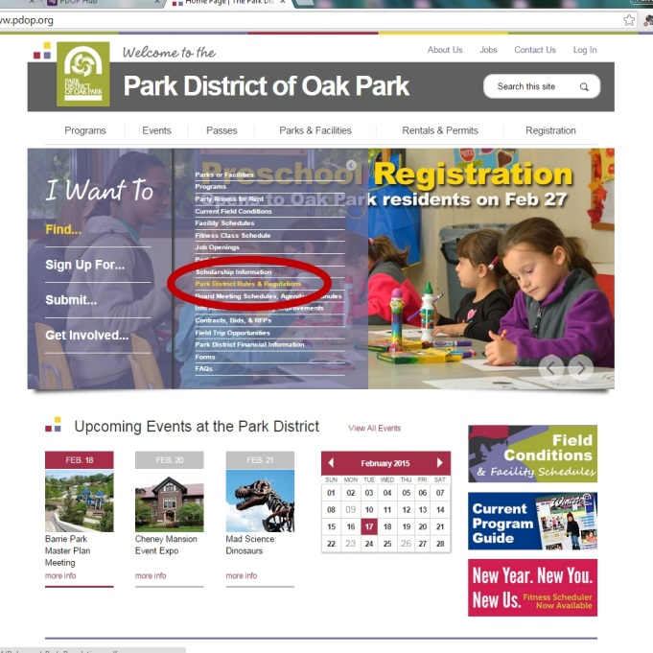

In the "I Want to" Navigation

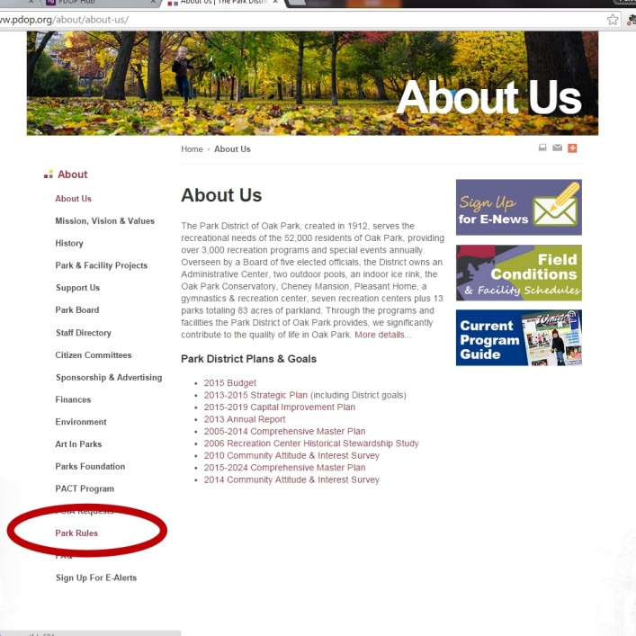

On the "About Us" page

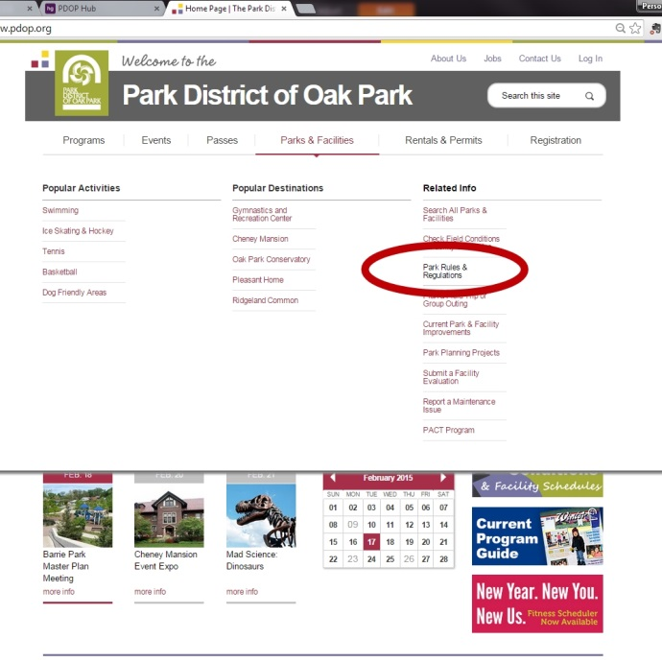

Under "Parks & Facilties" and "Related Info" in the main navigation

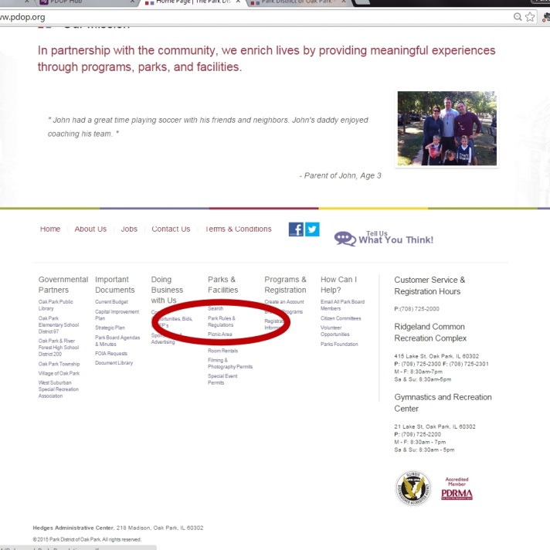

In the footer, under "Parks & Facilities"

Agency Self Review: Met Not Met

Visitor Comments:

Visitor Evaluation: Met Not Met

8.1.1 - Staff Liaison to Law Enforcement Officers
Standard: There shall be established liaison assignments for agency staff to the official law enforcement officers providing public safety and law enforcement service to the agency.

Suggested Evidence of Compliance: Provide current documentation of staff liaison assignment(s) with the law enforcement authority responsible for enforcement of laws and ordinances within the parks and recreation areas and facilities.

Informational reference in the Management of Park and Recreation Agencies, (2010), 3rd Ed., Chapter 22 – Law Enforcement and Security, p. 604.
Agency Evidence of Compliance:

In order to safely and effectively operate District services and facilities and administer all applicable laws, codes, rules, and regulations, the Park District of Oak Park and the Village of Oak Park Police Department have developed a strong partnership. The designated District liaison to the Police Department is the Superintendent of Building and Grounds, Mike Grandy, as evidenced by a memo¹ sent by the Park District's Executive Director to the Village of Oak Park Police Department's Deputy Chief.
Documentation:
- 08.01.01_VOP-Police-Point-of-Contact-Letter.pdf
Agency Self Review: Met Not Met

Visitor Comments:

Visitor Evaluation: Met Not Met

8.2 - Authority to Enforce Laws by Law Enforcement Officers
Standard: The authority of law enforcement officers to enforce laws and ordinances pertaining specifically to activity within parks, recreation areas, and facilities shall be clearly established to ensure that enforcement actions are upheld. Authority to enforce laws and ordinances within parks and recreation areas and facilities must be established through assignment within the agency, by contract with another agency, or by policy of the government jurisdiction in which the agency operates.

Suggested Evidence of Compliance: Provide documentation that establishes the authority of law enforcement officers to enforce laws and ordinances within parks, recreation areas, and facilities.

Informational reference in the Management of Park and Recreation Agencies, (2010), 3rd Ed., Chapter 22 – Law Enforcement and Security, pp. 606-612.
Agency Evidence of Compliance:

The Park District has an intergovernmental agreement¹ with the Village of Oak Park which grants responsibility to the Village of Oak Park Police Department and Health Department's Animal Control to issue citations and prosecute violators in accordance with Park District rules and regulations.
Documentation:
- 08.02.00_VOP-Police-Department-IGA.pdf
Agency Self Review: Met Not Met

Visitor Comments:

Visitor Evaluation: Met Not Met

8.3 - Law Enforcement Officer Training
Standard: Law enforcement officers with the authority to enforce laws within areas and facilities under the jurisdiction of the agency must have proper training in order to carry out their roles and responsibilities.

Suggested Evidence of Compliance: Provide a summary of the current training program for law enforcement officers having jurisdiction within the parks and recreation agency, including provision for refreshers and updates.

Informational reference in the Management of Park and Recreation Agencies, (2010), 3rd Ed., Chapter 22 – Law Enforcement and Security, pp. 612-616.
Agency Evidence of Compliance:

The Village of Park Park Police Department provides a variety of training for its officers. Every officer must attend and graduate from a specific Police Academy¹ training program in order to be sworn in and certified as a police office in Illinois. Additionally, officers at the Village of Oak Park Police Department are given on-going training² about issues that may arise in parks, including annual training on Park District Code³ and how to issue a citation for park violations as well as other topics such as the homeless and animal control.
Documentation:
- 08.03.00_Cook-County-Sheriff-Police-Academy-Training-Schedule.pdf
- 08.03.00_2014-VOP-Police-Department-Inservice-Training-Schedule.pdf
- 08.03.00_E-mail-from-VOP-Regarding-Review-of-Park-Code.pdf
Agency Self Review: Met Not Met

Visitor Comments:

Visitor Evaluation: Met Not Met

8.4 - Public Information on Laws, Ordinances, Rules, Regulations, and Policies
Standard: Agency staff shall participate in educating and informing the public on laws, ordinances, rules, regulations, and policies that apply to parks and recreation areas and facilities. This role shall be established through policy directive.

Suggested Evidence of Compliance: Provide documentation that defines the role of agency staff in providing public information and education on laws, ordinances, rules, regulations, and policies. Provide examples of education and provision of information.

Informational reference in the Management of Park and Recreation Agencies, (2010), 3rd Ed., Chapter 22 – Law Enforcement and Security, pp. 616-617.
Agency Evidence of Compliance:

Per Park District Policy on Enforcement of Park & Facility Rules¹, Park District staff have a responsibility to educate and inform the public on laws, ordinances, rules, regulations, and policies that apply to parks and facilities. The Park District has worked to give these rules directly to customers when possible, such as on park permit confirmations². Staff also communicates these rules using several methods including the quarterly program guide³, in multiple spots on the Park District website⁴, and park signage⁵.
Additionally, employees are given tools to help aid in the in-person education of rules, including park rule cards⁶ that can be handed out to the public by staff that include information on rules that need to be enforced most frequently. Additionally, staff are issued a Park District Rules Booklet⁷ for easy reference when working in a park or facility or at a special event.
Documentation:
- 08.04.00_Policy-on-Enforcement-of-Park-Facility-Rules.pdf
- 08.04.00_Permit-Issued-with-Park-Rules.pdf
- 08.04.00_Rules-in-Quarterly-Program-Guide.pdf
- screenshots of Rules on Park District website (below)
- photos of Park Signage with rules (below)
- scan of Park Rule Cards (below)
- 08.04.00_Park-District-Rules-Booklet.pdf
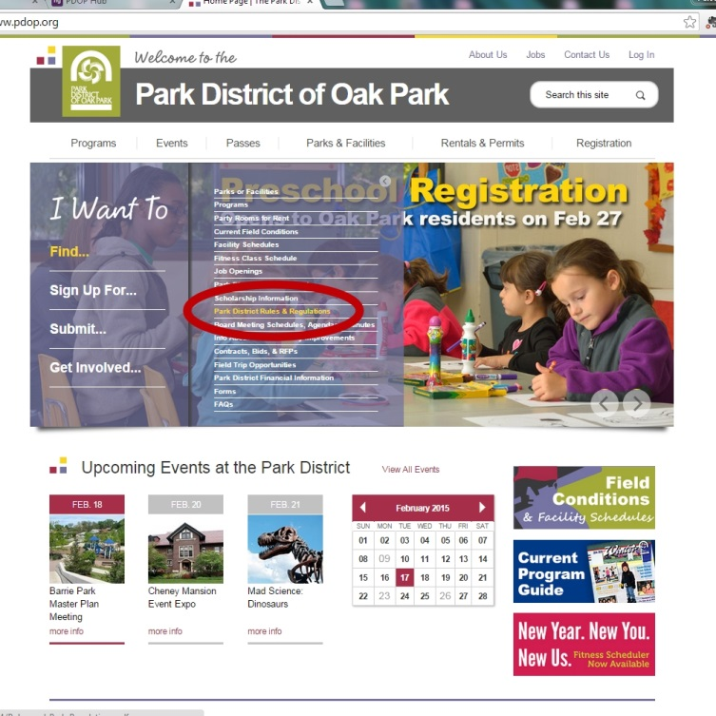
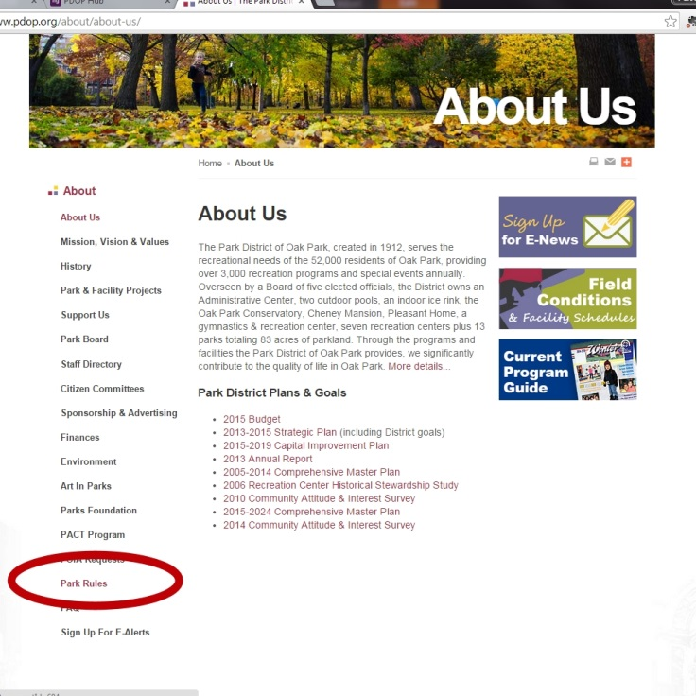
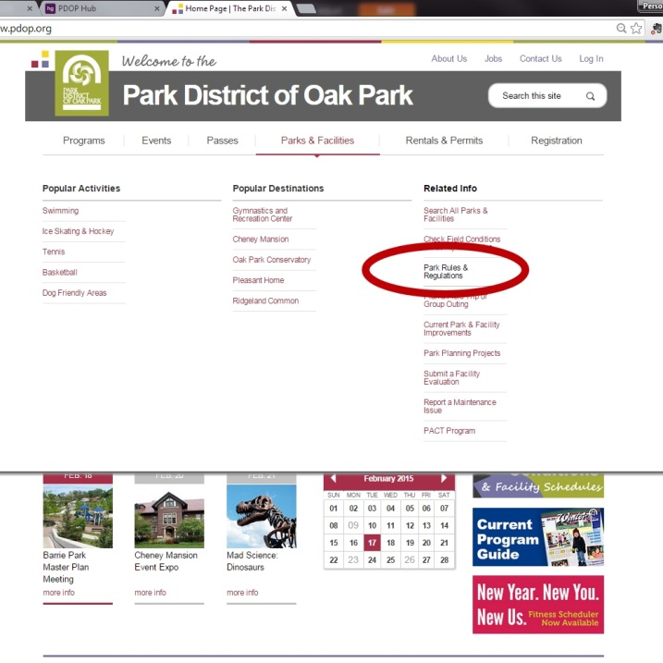
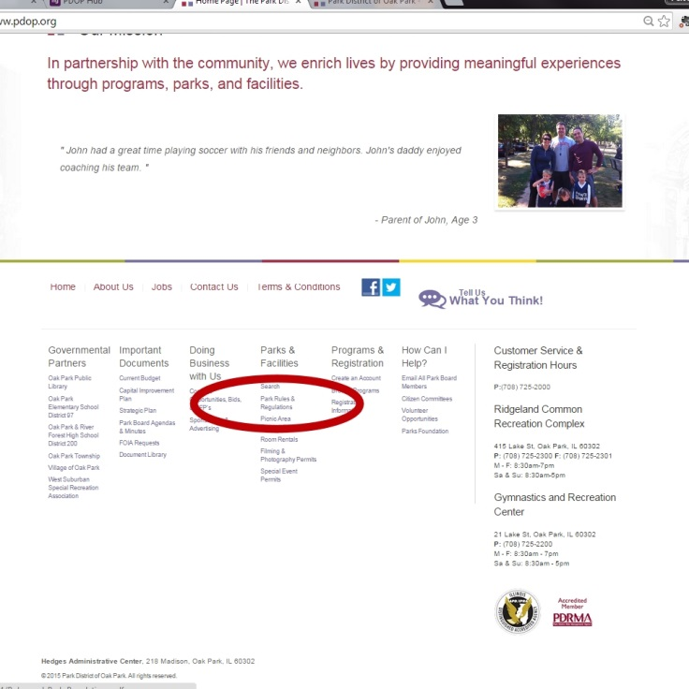
Examples of Park Rules on Park District website
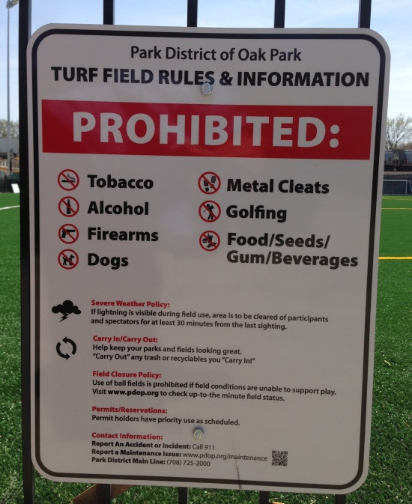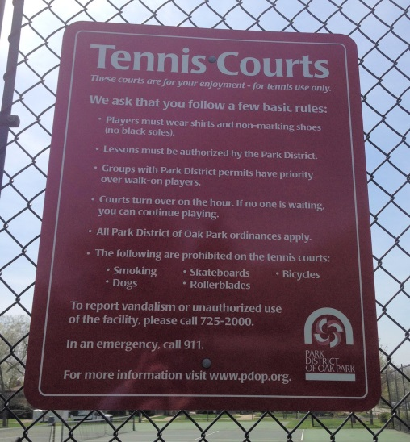
Examples of Park & Facility Rule Signage
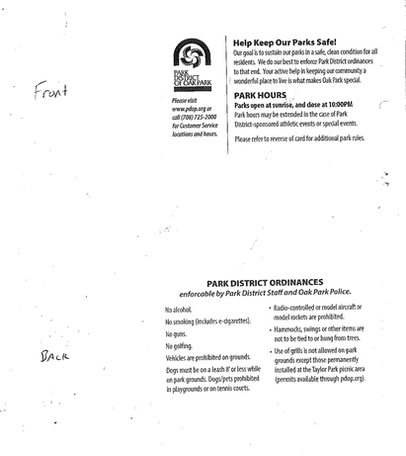
Park Rules Cards

Agency Self Review: Met Not Met

Visitor Comments:

Visitor Evaluation: Met Not Met

8.4.1 - In-Service Training for Staff on Public Safety and Law Enforcement
Standard: Agency staff shall understand their role in public safety and law enforcement and relationships with law enforcement officers having jurisdiction within parks and recreation areas and facilities. The purpose of this training to ensure that staff understand where their authority ends and when an incident should be referred to law enforcement. In-service training shall be extended to front line staff such as lifeguards and park attendants to assure they are fully prepared to respond to law-enforcement incidents.

Suggested Evidence of Compliance: Provide documentation of most recent in-service training for agency staff, defining their role in public safety and law enforcement, including agendas and attendance rosters

Informational reference in the Management of Park and Recreation Agencies, (2010), 3rd Ed., Chapter 22 – Law Enforcement and Security, p. 614.
Agency Evidence of Compliance:

It is the goal of the Park District to provide training and resources to staff to ensure a quality and safe experience for both staff and the community. One component of this training covers policies and procedures related to public safety and law enforcement. Because of the variety of staff, programs, parks, and facilities in the park system, aspects of training in this area are covered throughout the year in various settings.
All staff receive a general overview of situations where police may need to be called, including specifically, Violence in the Workplace, Critical Incident Communication, and Suspicious Individuals, as part of the Orientation Presentation1 led by the HR & Safety Risk Manager.
An in-service training² was conducted in association with an All-Staff meeting. This topic is also covered at specific trainings related to each area at the Park District either as its own separate training, or for seasonal operations, often as a portion of a larger training plan, including Pool Staff Training3, Ice Rink Staff Training4, Community Center Staff Training5, and Camp Staff Training6. Additionally, the Park District conducts Lock-down Drills⁷ in cooperation with the Oak Park Police Department throughout the year.
Documentation:
- 08.04.01_Orientation-Presentation.pdf
- 08.04.01_In-Service-Law-Enforcement-Relationship.pdf
- 08.04.01_Rink-Supervisor-In-Service.pdf
- 08.04.01_Community-Center-Supervisor-Training.pdf
- 08.04.01_Camp-Staff-Training.pdf
- 08.04.01_Lock-Down-Exercise-with-Police.pdf
Agency Self Review: Met Not Met

Visitor Comments:

Visitor Evaluation: Met Not Met

8.4.2 - Handling of Disruptive Behavior Procedures
Standard: There shall be established procedures for agency staff on response to disruptive behavior at agency areas and facilities. Procedures shall identify the role of staff in intervention when an incident occurs, documentation of behavior and delineation of law enforcement roles in handling behavioral issues.

Suggested Evidence of Compliance: Provide current procedures regarding handling of disruptive behavior.

Informational reference in the Management of Park and Recreation Agencies, (2010), 3rd Ed., Chapter 22 – Law Enforcement and Security, pp. 620-624.
Agency Evidence of Compliance:

DPRAC - 5.9.1 Behavior Management Policy Procedure

Agency Self Review: Met Not Met

Visitor Comments:

Visitor Evaluation: Met Not Met

8.4.3 - Traffic Control, Parking Plans, and Crowd Control
Standard: The agency shall coordinate with the official law enforcement agency having jurisdiction on large-scale events hosted or facilitated by the agency that require planning and coordination of traffic, parking and crowd control. Plans shall specifically define the roles of the event sponsor, agency staff, and the law enforcement agency regarding traffic layouts at the venue, traffic routes and personnel assignments.

Suggested Evidence of Compliance: Provide a recent example of coordination with law enforcement on traffic control, parking plans and crowd control for activities and events hosted or facilitated by the agency.

Informational reference in the Management of Park and Recreation Agencies, (2010), 3rd Ed., Chapter 22 – Law Enforcement and Security, pp. 624-637.
Agency Evidence of Compliance:

The Park District has developed an overall plan and procedures for addressing traffic, parking, and crowd control at large events¹. In Oak Park, the responsibility for traffic and crowd control measures falls to the organizer of the event, including securing permits for street closures, developing traffic plans, and planning for traffic enforcement by assigning staff or volunteers and/or hiring police officers to assist.
For example, at the Park District's largest annual event, the Frank Lloyd Wright Races, a staff member is assigned as Race Marshal, which includes responsibilities² for:
- communicating equipment and personnel needs from the Village of Oak Park Public Works & Police Department, including meeting with both
- ensuring course map is accurate
- ensuring that parking restriction signage is created and displayed in an appropriate time frame before the event
- ensuring that lead and trail vehicles are coordinated, properly labeled and trained in order to protect race participants while on the closed streets
- supervises course security assignment, including assignment of security at intersections, and training of the security staff and volunteers
A Course Security Map³ has been developed to show where volunteers, staff, and police are stationed throughout the course. This not only assists course security in knowing where to go, but also assists emergency response efforts if course security reports an incident.
Communication and coordination with the police took place before, during, and after the event as evidenced by examples of e-mail chains regarding Initial Coordination with Police⁴, Officer Commitment and Pre-Race Inspection⁵, and Post-Race Communication and Evaluation⁶.
Signage and Race Information Handouts⁷ were developed and posted to assist with crowd control. Parking information was included on the race website's FAQ, as well as mentioned in the Pre-Race Participant Email⁸ that was sent to all participants before race weekend.
Documentation:
- 08.04.03_Procedures-for-Traffic-Parking-and-Crowd-Control.pdf
- 08.04.03_Race-Marshal-Responsibilities.pdf
- 08.04.03_FLW-Route-Security-Map.pdf
- 08.04.03_Initial-Coordination-with-Police.pdf
- 08.04.03_Officer-Commitment-and-Pre-Race-Inspection.pdf
- 08.04.03_Post-Race-Communication-and-Evaluation.pdf
- 08.04.03_Race-Information-Handouts.pdf
- 08.04.03_Pre-Race-Email-to-Participants.pdf
Agency Self Review: Met Not Met

Visitor Comments:

Visitor Evaluation: Met Not Met

8.4.4 - Handling of Evidentiary Items Procedures
Standard: Procedures shall be established that guide agency staff in the preservation and handling of evidence until transferred to the appropriate law enforcement authority. Procedures shall be established in coordination with the appropriate law enforcement agencies to define staff roles in ensuring that evidentiary items are preserved until the proper law enforcement agency assumes command of the scene.

Suggested Evidence of Compliance: Provide the procedures defining the role and responsibility of agency staff in the discovery, preservation and handling of evidentiary items.

Informational reference in the Management of Park and Recreation Agencies, (2010), 3rd Ed., Chapter 22 – Law Enforcement and Security, pp. 622-623.
Agency Evidence of Compliance:

The Park District has established Procedures regarding Responding to the Scene of a Crime¹, which includes the handling of evidentiary items. These procedures are included in the Park District's General Security Plan². Responsibility for preserving the scene and/or the evidence falls to the employee until law enforcement arrives. If possible, staff should not disturb the scene or items and should instead just work to ensure no public or staff enter the area. Guidelines are also are given for what staff should do if the evidence must be moved because the scene cannot be secured as well as special consideration if drugs or weapons are found.
Documentation:
- 08.04.04_Procedures-for-Responding-to-Scene-of-a-Crime.pdf
- 08.04.04_General-Security-Plan.pdf
Agency Self Review: Met Not Met

Visitor Comments:

Visitor Evaluation: Met Not Met

8.5 - General Security Plan
Standard: The agency shall have a comprehensive general security plan addressing areas, buildings and facilities under its jurisdiction that is updated periodically. Plans for each major area, building or facility should be available at each site. The general security plan may be a compilation of security plans from each major area, building or facility. Hazardous or flammable materials storage areas should be clearly identified in plans and at each specific site. Signage at each site should be installed in accordance with the unified signage system. To be effective, the security plan should be updated when a new area, building or facility is added, security systems are modified or when legislation requires change.

Suggested Evidence of Compliance: Provide the agency’s general security plan or compilation of security plans from each major area, building or facility with the most recent review or update. At a minimum, these plans should include:
- Locking key systems and associated assignments;
- Alarm system and assignment of security codes;
- Opening and closing procedures;
- Fire alarm and fire suppression systems;
- Emergency evacuation procedures; and
- Critical incident response procedures.

Informational reference in the Management of Park and Recreation Agencies, (2010), 3rd Ed., Chapter 22 – Law Enforcement and Security, pp. 627-637.
Agency Evidence of Compliance:

The Park District has developed a General Security Plan¹ to outline security procedures and practices related to agency parks and facilities. Specifically, the plan addresses:
- Preventative security measures
- Enforcement of Rules, Regulations, Ordinances, and Laws by staff and law enforcement
- Facility access measures, including locks and alarm systems
- Facility security measures, including communication systems, security camera, and fire alarms and fire suppression systems
- Traffic and parking control procedures
- Hazardous chemicals information related to the Park District's HAZCOM Plan2
- Opening and closing procedures
- Responding to the scene of a crime
- Emergency Evacuations
- Emergency Action Plans for critical incident response
The General Security Plan was last reviewed and updated in January 2015 as evidenced by the memo regarding General Security Plan Update³ and posted on The Hub for staff viewing.
Documentation:
- 08.05.00_General-Security-Plan.pdf
- HAZCOM-Plan.pdf
- 08.05.00_General-Security-Plan-Review.pdf
Agency Self Review: Met Not Met

Visitor Comments:

Visitor Evaluation: Met Not Met

8.6 - Emergency Management Planning
Standard: The agency shall be aware of emergency operations planning within their jurisdiction and its role in emergency management systems. Roles may vary depending on the scope of services provided by the agency and the location of its facilities. Recreation agencies, having roles in emergency management systems within their local jurisdiction, shall be aware of the applicable operations plan. The agency’s specialized staff, buildings and equipment may be integral to the plan and may be deployed in the event of a large-scale emergency. The U. S. Office of Homeland Security provides guidance and support for the preparation and maintenance of emergency management plans.

Suggested Evidence of Compliance: Provide the applicable emergency management plan with the most recent date of approval. If, due to security concerns, the emergency management plan is not available for public review, provide the emergency management plan table of contents.

Informational reference in the Management of Park and Recreation Agencies, (2010), 3rd Ed., Chapter 22 – Law Enforcement and Security, pp. 634-637.
Agency Evidence of Compliance:

DPRAC - 4.9.8 Emergency Operations Manual

Agency Self Review: Met Not Met

Visitor Comments:

Visitor Evaluation: Met Not Met

8.6.1 - In-Service Training for Staff on General Security and Emergency Management
Standard: Through in-service training, agency personnel shall understand their role in ongoing security and emergency management. In-service training should inform staff of their role in response to critical incidents and emergencies and provide specific procedures for routine operations.

Suggested Evidence of Compliance: Provide documentation of in-service training programs on general security and emergency management, including a dated outline of the presentation topics and a roster of participants.

Informational reference in the Management of Park and Recreation Agencies, (2010), 3rd Ed., Chapter 22 – Law Enforcement and Security, p. 636.
Agency Evidence of Compliance:

The Park District of Oak Park offers programs and services in a wide-variety of settings. The topic of security and emergency management, including specifically, Violence in the Workplace, Critical Incident Communication, and Suspicious Individuals, is introduced to each employee as part of the Orientation Presentation¹ led by the HR & Safety Risk Manager. Specific training related to each area at the Park District is then provided to staff, either as its own separate training, or for seasonal operations, often as a portion of a larger training plan, including Pool Staff Training², Rink Supervisor In-Service³, Community Center Staff Training⁴, and Camp Staff Training⁵. Beginning in 2015, the Park District will also be conducting lock-down exercises⁶ with the Oak Park Police Department to train staff and assess readiness for this type of emergency situation. The agendas for each will be similar to the Gymnastics & Recreation Center Lock Down Exercise⁷.
Documentation:
- 08.06.01_Orientation-Presentation.pdf
- 08.06.01_Pool-Staff-Training.pdf
- 08.06.01_Rink-Supervisor-In-Service.pdf
- 08.06.01_Community-Center-Supervisor-Training.pdf
- 08.06.01_Summer-Camp-Staff-Training.pdf
- 08.06.01_2015-Lock-Down-Exercise-Calendar.pdf
- 08.06.01_GRC-Lock-Down-Exercise.pdf
Agency Self Review: Met Not Met

Visitor Comments:

Visitor Evaluation: Met Not Met

8.6.2 - Emergency Risk Communications Plan
Standard: There shall be a communications plan that is reviewed and updated periodically, to accurately and effectively communicate with the public and experts during a catastrophic event that attracts significant media attention, such as a health emergency, terrorist attack, earthquake or storm. The crisis communication plan shall delineate individuals responsible for communicating with the press, chain of command on notifying proper people of the incident and communicating status updates.

Suggested Evidence of Compliance: Provide a copy of the Emergency Risk Communications Plan and the most recent review.

Informational reference in the Management of Park and Recreation Agencies, (2010), 3rd Ed., Chapter 22 – Law Enforcement and Security, pp. 634-637.
Agency Evidence of Compliance:

DPRAC 1.10.4 - Dealing with Catastrophic Incidents

Agency Self Review: Met Not Met

Visitor Comments:

Visitor Evaluation: Met Not Met

8.6.3 - Care and Shelter Procedures
Standard: There shall be procedures to coordinate with agencies designated to provide care and shelter to those in need during disasters or emergencies.

Suggested Evidence of Compliance: Provide procedures to coordinate with agencies designated to provide care and shelter during emergencies.
Agency Evidence of Compliance:

The Park District has agreements with a variety of agencies within the community to provide care and shelter to those in need during disasters or emergencies. When assistance with a community-wide emergency is needed, the Village of Oak Park takes the lead in coordinating the response effort and in notifying the Park District of the situation. In some situations, it is as simple as the Park District posting flyers in its facilities notifying patrons of locations of warming or cooling shelters¹. In more extreme community emergencies, Park District facilities have been designated to serve as the mortuary, as referenced in the Village of Oak Park Emergency Operation Plan², which includes the procedures community leadership should follow in the case of such an event.
Additionally, the Park District's Ridgeland Common Recreation Complex is a designated shelter for the nearby Oak Park River Forest High School³ in the event that the school needs to be evacuated due to an emergency.
Documentation:
- 08.06.03_Cooling-and-Warmer-Centers-Flyers.pdf
- 08.06.03_Village-of-Oak-Park-Emergency-Operation-Plan---Annex-1-Mortuary-Services.pdf
- 08.06.03_Emergency-Location-Agreement-with-OPRFHS.pdf
Agency Self Review: Met Not Met

Visitor Comments:

Visitor Evaluation: Met Not Met

Visitation Report Summary for
Category 8.0 – Public Safety, Law Enforcement, and Security

Reviewed By: (Visitor Name)

Unmet Standards: (List the Standard # and Name)

Provide clarification for all unmet fundamental standards:

9.0 - Risk Management
Note: Standards marked with a star () are fundamental standards,
and are required of all agencies seeking accreditation.

A comprehensive risk management plan is essential to minimize legal liabilities and personal injuries. The agency shall implement approaches for identification and control of risks based on the specific needs of the agency. There is no prescriptive method for identification of all risks suitable for all entities; the method and tools used will vary. Risk management is an on-going process that must be systematically evaluated for effectiveness and adjustments made as appropriate. Responsibilities must be assigned and structure set in place to implement an effective plan. The analysis shall include the direct costs (staffing, insurance, prevention) and indirect costs (time lost from work by injured employees, damage to equipment and facilities, failure to provide services and loss of income).

In some cases, the risk management plan and function may occur outside the park and recreation agency by another government authority. Special cooperative arrangements should be in place with other public departments and agencies, private contractors, and community organizations.

9.1 - Risk Management Policy
Standard: The agency shall have a policy for risk management that sets direction and gives appropriate authority for implementing operational practices and procedures that is approved by the proper authority.

Suggested Evidence of Compliance: Provide the risk management policy including indication of approval by the proper authority.

Informational reference in the Management of Park and Recreation Agencies, (2010), 3rd Ed., Chapter 21 – Risk Management, pp. 579-598.
Agency Evidence of Compliance:

DPRAC - 4.9.4 Safety Policy Statement/Procedure

Agency Self Review: Met Not Met

Visitor Comments:

Visitor Evaluation: Met Not Met

9.1.1 - Risk Management Plan and Procedures
Standard: The agency shall have an established risk management plan and operating procedures that are reviewed periodically, accessible to all agency personnel and approved by the proper authority that encompasses analysis of risk exposure, control approaches and financial and operational impact for the agency The plan shall analyze the programs/services offered and facilities/areas managed for personal injury and financial loss potential and identify approaches to manage such injury, loss, and business and operational impact.

Suggested Evidence of Compliance: Provide the current risk management plan with approval by the proper authority, the most recent review, and indication of how the plan and procedures are available to staff. The risk management plan shall reflect all three phases of risk management:
  - Identification and assessment;
  - Response strategies; and
  - Management planning.

Informational reference in the Management of Park and Recreation Agencies, (2010), 3rd Ed., Chapter 21 – Risk Management, pp. 583-596.
Agency Evidence of Compliance:

The Park District's approach to risk management has two major components. First, the Park District undergoes a Loss Control Review every 3 years through the Park District Risk Management Agency (PDRMA). The Loss Control Review is essentially a third-party audit and serves as a measuring tool to identify how the Park District's risk management operations are measuring against industry standards. The review assesses administration, aquatics, ice rink, park maintenance, recreation, and special recreation. Risk management consultants conduct the process with Park District staff to evaluate, develop, maintain, and enhance risk management best practices over a minimum of three visits.
The second component is made up of the Park District's Safety Policies¹ and Safety Manual² that communicates risk exposure to staff and risk prevention and response procedures and establishes an internal safety committee made up of staff representatives throughout the Park District. The Safety Manual and safety policies are updated at least every two years and approved by the Board of Commissioners. All staff have access to the policies and the manual through The Hub.
Documentation:
- 09.01.01_2013-Loss-Control-Report.pdf
- 09.01.01_Safety-Policies-and-Procedures.pdf
- 09.01.01_Safety-Manual.pdf
- 09.01.01_Safety-Policies-and-Manual-Approval.pdf
- Screenshot of The Hub (below)

Agency Self Review: Met Not Met

Visitor Comments:

Visitor Evaluation: Met Not Met

9.1.2 - Accident and Incident Report Procedures
Standard: There shall be established procedures for accident and incident reporting and analysis of accident and incident reports. There shall be an accident/incident report form available to all employees. Data shall be obtained in an appropriate manner to support planned and coordinated accident prevention programs within the agency.

Suggested Evidence of Compliance: Provide the accident/incident form(s) and the procedures for documenting and analyzing accidents and incidents. The accident/incident form(s) shall include identification information (who), specific location of accident (where), and description of accident in terms of sequence of activity (what).

Informational reference in the Management of Park and Recreation Agencies, (2010), 3rd Ed., Chapter 21 – Risk Management, pp. 583-589.
Agency Evidence of Compliance:

DPRAC - 4.9.7 Written Accident Investigation and Follow Up

Agency Self Review: Met Not Met

Visitor Comments:

Visitor Evaluation: Met Not Met

9.1.3 - Personnel Involvement and Training
Standard: The agency risk management function shall involve and train personnel at all levels on risk management procedures.

Suggested Evidences of Compliance: Demonstrate how personnel at all levels are involved and trained regarding risk management.

Informational reference in the Management of Park and Recreation Agencies, (2010), 3rd Ed., Chapter 21 – Risk Management, pp. 594-596.
Agency Evidence of Compliance:

DPRAC - 4.9.6 Employee Knowledge of Safety Policy/Procedure & Manual

Agency Self Review: Met Not Met

Visitor Comments:

Visitor Evaluation: Met Not Met

9.2 - Risk Manager
Standard: A specific position within the agency shall be designated with risk management responsibility and authority to carry out the policies established for risk management.

Suggested Evidence of Compliance: Provide the position description that includes responsibility for risk management.

Informational reference in the Management of Park and Recreation Agencies, (2010), 3rd Ed., Chapter 21 – Risk Management, pp. 582-583.
Agency Evidence of Compliance:

DPRAC - 4.9.1 Risk Management Representative
Agency Self Review: Met Not Met

Visitor Comments:

Visitor Evaluation: Met Not Met

9.3 - ADA Compliance and Face-to-Face Resolution
Standard: There shall be a policy or procedure available to all members of the public and staff which address issues pertaining to ADA compliance, either in a written or electronic format.

Suggested Evidence of Compliance: Provide a written policy or procedure available to the public and staff that outlines the steps to resolve questions, concerns, or complaints of accessibility along with a reasonable timeline for completion and have a process for face-to-face meetings is in place.

Informational reference in the Management of Park and Recreation Agencies, (2010), 3rd Ed., Chapter 12 Physical Resource Management, p. 253; Chapter 13 – Management Operations, p. 287; Chapter 16 – Human Resource Employment, p. 400; Chapter 21 – Risk Management, pp. 584-588.
Agency Evidence of Compliance:

Should a member of the public feel that he or she has been unable to access a Park District facility, program, or service because of lack of accessibility or has been discriminated against because of a disability, the individual should fill out and submit an ADA Complaint Form¹. The Instructions for Filing an ADA Complaint² outline the steps to resolve accessibility complaints, including timelines for completion of all steps. The process includes the opportunity for the complainant to have a face-to-face meeting with both the Director of Human Resources as well as the Executive Director if needed or requested in order to resolve the complaint. Both of these documents are available on the Park District website and accessible to both the public and staff.
Documentation:
- 09.03.00_ADA-Complaint-Form.pdf
- 09.03.00_Instructions-for-Filing-an-ADA-Complaint.pdf
- link to ADA Complaint Instructions & Form on Park District website
Agency Self Review: Met Not Met

Visitor Comments:

Visitor Evaluation: Met Not Met

Visitation Report Summary for
Category 9.0 – Risk Management

Reviewed By: (Visitor Name)

Unmet Standards: (List the Standard # and Name)

Provide clarification for all unmet fundamental standards:

10.0 - Evaluation, Assessment, and Research
Note: Standards marked with a star () are fundamental standards,
and are required of all agencies seeking accreditation.

Evaluation and research are systematic processes that park and recreation professionals use to better understand the impacts of their efforts on the communities they serve. What is learned through evaluation and research is used to demonstrate the value of what is provided and to learn how to make improvements. Analyses of reliable data and qualitative information are essential to track progress in implementing master plans and strategic initiatives. Products of evaluation, measurement, and research become important components to support planning, development and programming decisions.

Benchmarking is the process of making comparisons to the processes, programs, and services of other providers. Comparisons are most frequently made to other park and recreation agencies, but benchmarking can be done also with business and non-profit organizations. The National Recreation and Park association developed PRORAGIS, which is a tool to capture uniform data on park and recreation agencies across the nation. PRORAGIS is the only national benchmarking tool for the park and recreation profession. As such, it can be successful as a reliable research tool only with broad participation from park and recreation agencies.

10.1 - Systematic Evaluation Processes
Standard: The agency shall have systematic processes for evaluating programs, facilities and services and operational efficiency and effectiveness.

Suggested Evidence of Compliance: Describe what is evaluated and the methods and frequency of evaluation of programs facilities and services. Evaluation is the process of determining the effectiveness of current practice and procedures.

Informational reference in the Management of Park and Recreation Agencies, (2010), 3rd Ed., Chapter 23 – Evaluation and Action Research, pp. 641-647.
Agency Evidence of Compliance:

The Park District of Oak Park evaluates services and operations both through standardized agency-wide evaluations as well as more in-depth reports and evaluations.
The Park District currently has the following evaluations, which are distributed to customers and staff on an on-going basis throughout the year.
a. Program & Event Evaluation. This evaluation¹ addresses the participants' experience attending a program or event, including the registration process, location, program content, instructor/staff, price, and overall experience. This evaluation is available online for program and event participants to fill out via a link on our website. Additionally, staff e-mail the evaluation to a sample of participants from the Park District's registration system. Evaluations are also collected by staff who will visit program sites with a tablet and ask for responses in person.
b. Park & Facility Visit Evaluation. This evaluation² addresses the visitors' experience during a recent visit to a park or facility, including reason for visit, amenities used, park/facility appearance, convenience, staff, safety, cleanliness, parking, and overall experience as well as questions about specific features at the park or facility such as playgrounds, athletic spaces, pools, etc. This evaluation is available online for park and facility visitors to fill out via a link on our website. The link to the evaluation is also posted in various Park District facilities via QR codes that encourage visitors to complete the evaluation in spots where they may have a few spare moments (while waiting in line, lobbies, etc.). Additionally, staff e-mail the evaluation to a sample of facility pass holders from the Park District's registration system. Evaluations are also collected by staff who will visit parks and facilities with a tablet and ask for responses in person.
c. Customer Service Evaluation. This evaluation³ addresses the customers' experience with the service provided by the Park District, including the facilities and tangibles, reliability, responsiveness, customer care, and customer confidence. This evaluation is available online for customers to fill out via a link on our website. At different points in the year, the link to the evaluation is also included on customer receipts that are given to customers after completing a transaction with the Park District. The link to the evaluation is also posted in various Park District facilities via QR codes near customer service desks. Additionally, staff e-mail the evaluation to a sample of customers from the Park District's registration system who have recently completed a transaction with the Park District.
d. Staff Training Evaluation. This evaluation⁴ addresses staff's experience attending a training, including training content, presenter, setting, and other logistics. This evaluation is e-mailed to every Park District staff member that attends a training with the Park District, including both internal and external training.
e. Internal Customer Service Evaluation. This evaluation⁵ addresses staff's experience with the service provided by other departments within the Park District, including approachability, communication, skills and knowledge, accountability, courtesy, responsiveness, understanding, processes, professionalism, innovation, and effectiveness. This evaluation is e-mailed to a random sample of Park District staff on a monthly basis.
Responses from all of these evaluations are reviewed in a variety of different ways. Staff monitor the number of responses received to ensure that enough have been collected. The responses are displayed live on dashboards as part of the Park District's performance measurement program and are available to staff at all time. Staff can view the results as an overall agency average and can drill down to view results for an individual program area, park/facility, or department. They can also view results over time so that they can see fluctuations in customer and staff satisfaction and respond to trends. These results are viewed and discussed by management staff on a quarterly basis at performance measurement meetings. Evaluation results reports can also be set up to be automatically e-mailed to staff.
Besides the on-going evaluation processes mentioned above, the Park District also does more comprehensive evaluations of various programs, parks and facilities which are usually completed on an annual basis. Examples of these reports include:
- Performance Measurement⁶
- Program Participation⁷
- Aquatics⁸
- Gymnastics⁹
- Frank Lloyd Wright Races¹⁰
- Conservatory Operations¹¹
Documentation:
- 10.01.00_2014-Program-and-Event-Evaluation-Summary.pdf
- 10.01.00_2014-Park-and-Facility-Visit-Evaluation-Summary.pdf
- 10.01.00_2014-External-Service-Evaluation-Summary.pdf
- 10.01.00_2014-Staff-Training-Evaluation-Summary.pdf
- 10.01.00_2014-Internal-Service-Evaluation-Summary.pdf
- 10.01.00_2014-Performance-Measurement-Report.pdf
- 10.01.00_2014-Program-Participation-Report.pdf
- 10.01.00_2014-Aquatics-Report.pdf
- 10.01.00_2014-Gymnastics-Report.pdf
- 10.01.00_2014-Frank-Lloyd-Wright-Races-Report.pdf
- 10.01.00_2014-Conservatory-Operations-Report.pdf
Agency Self Review: Met Not Met

Visitor Comments:

Visitor Evaluation: Met Not Met

10.1.1 - Responsibility for Evaluation
Standard: The agency shall assign specific responsibility for managing elements of the evaluation program, including planning, training, evaluation, and analysis.

Suggested Evidence of Compliance: Provide job descriptions for the person(s) (staff or consultants) responsible for supporting and monitoring evaluation processes, including planning, training, evaluation, and analysis. If consultant services are used, provide the current contracts or service agreements. The documentation should also include the resumes of persons providing the service, including experience and training.

Informational reference in the Management of Park and Recreation Agencies, (2010), 3rd Ed., Chapter 23 – Evaluation and Action Research, p 644.
Agency Evidence of Compliance:

The Project Manager¹⁻² is responsible for managing the Park District's evaluation processes, including the agency's customer and staff satisfaction surveying systems, performance measurement programs, and other evaluation programs such as the annual park report card. The Project Manager sets up the software for staff use, determines measurement methods and goals for the agency, provides training for staff, and conducts evaluation and analysis of the evaluation efforts, including the creation reports. In order to manage such programs, the Project Manager has had training in project management and also advanced training in many software programs, including surveying software, dashboards software, and GIS software.
Documentation:
- 10.01.01_Project-Manager-Job-Description.pdf
- 10.01.01_Bobbi-Nance-Resume.pdf
Agency Self Review: Met Not Met

Visitor Comments:

Visitor Evaluation: Met Not Met

10.1.2 - Staff Training on how to Evaluate Programs, Services, and Facilities
Standard: The agency shall provide training on how to evaluate programs, services and facilities for personnel involved in managing facilities and delivering programs and services.

Suggested Evidence of Compliance: Provide examples of recent evaluation trainings completed by the agency, including curriculum content, training dates and participant lists. Examples of training subjects could include but are not limited to qualitative and quantitative measurement, identification of applicable evaluation tools, data analysis and use of findings.

Informational reference in the Management of Park and Recreation Agencies, (2010), 3rd Ed., Chapter 23 – Evaluation and Action Research, p. 644.
Agency Evidence of Compliance:

The Park District provides on-going training for staff who are responsible for evaluation of programs, facilities, and services. An initial introductory training covering the use of the surveying software and performance measurement program is held for new full-time staff responsible for program or facility management as part of the Orientation Checklist¹. Users of the Park District's surveying software, SurveyGizmo, all have access to videos² and webinars³ on topics such as good survey design, software tips and tricks, advice on getting better survey responses, and analyzing and reporting on the results. The Park District has also provided Specialized Training with SurveyGizmo⁴ for key staff.
Because much of the evaluation taking place at the Park District is related to the performance measurement program, an Initial MPOWER Kick-Off Training⁵ was offered as well as Additional MPOWER Training⁶ for staff covering how to use the dashboards and apply the data.
Documentation:
- 10.01.02_Orientation-Checklist.pdf
- Screenshot of SurveyGizmo videos below
- Screenshot of SurveyGizmo webinars below
- 10.01.02_Specialized-Training-with-Survey-Gizmo.pdf
- 10.01.02_Initial-MPOWER-Kick-off-Training.pdf
- 10.01.02_Additional-MPOWER-Training.pdf
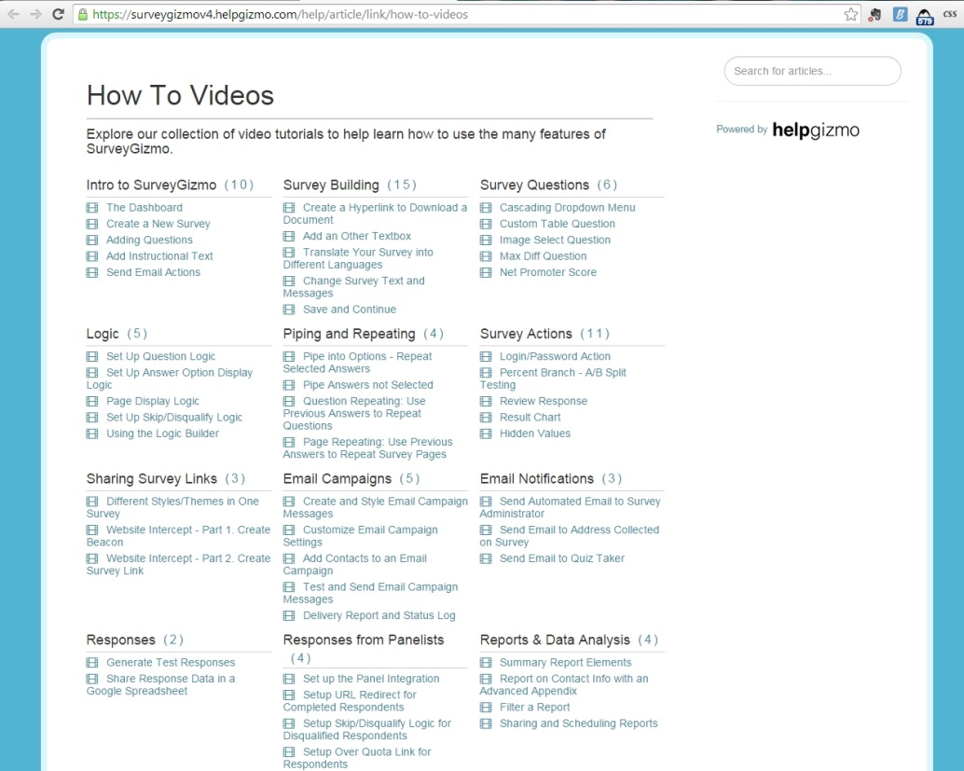

Agency Self Review: Met Not Met

Visitor Comments:

Visitor Evaluation: Met Not Met

10.2 - Outcomes Assessment
Standard: The agency shall use evaluation results to assess the outcomes of park and recreation programs, services, and facilities and assess the operational effectiveness of the organization. Outcomes show the relationship between resource inputs and the resulting impacts and benefits of the outputs. Outcomes are measurable changes in behaviors, attitudes, knowledge, conditions or skills.

Suggested Evidence of Compliance: Provide examples of how evaluation results are used to determine levels of performance and effectiveness in the organization and how evaluation are used to determine if specific programs, services or facilities are achieving planned or projected results.

Informational reference in the Management of Park and Recreation Agencies, (2010), 3rd Ed., Chapter 8 – Recreation Program Planning, p. 151; Chapter 9 – Program Services and Event Management, pp. 167-171; Chapter 23 – Evaluation and Action Research, p. 642.
Agency Evidence of Compliance:
The Park District uses evaluation results to assess whether or not its programs and services are achieving the desired outcomes. Many of these outcomes are tracked through the Park District's performance measurement program, with the results analyzed as a whole through the annual Park District Performance Measurement Report¹.
Additionally, the Park District uses other forms of outcome assessments to determine if participants are meeting program objectives as designated in the Park District's Recreation Programming Plan². Outcome assessments come in the form of evaluation results, skill development assessments, and other documentation of outcomes through participation. Results from these assessments are also used to help staff determine if any adjustments are needed to the class curriculums.
Documentation:
- 10.02.00_2014-Performance-Measurement-Report-Draft.pdf (final report to be completed by March 15 after financial year is closed out)
- 10.02.00_Outcomes-Assessment-in-Recreation-Programming-Plan.pdf
Agency Self Review: Met Not Met

Visitor Comments:

Visitor Evaluation: Met Not Met

10.3 - Performance Measurement
Standard: The agency shall have a procedure for tracking and monitoring data trends and measuring performance against targets linked to achievement of goals and objectives.

Suggested Evidence of Compliance: Provide performance targets and measurement in use by the agency. Describe the process and frequency of performance measurement and cite examples for how the results have been used by the agency to affect decisions. The measures may include data gathered from the following qualitative and quantitative sources:
- Recreation and demographic trends;
- Needs assessment;
- Community inventory;
- Surveys;
- Program and service statistics;
- Inspections;
- Customer feedback;
- Program evaluation;
- Risk management reports; and
- Budget and financial reports.

Informational reference in the Management of Park and Recreation Agencies, (2010), 3rd Ed., Chapter 11 – Physical Resource Planning, pp. 222-224; Chapter 23 – Evaluation and Action Research, p. 656.
Agency Evidence of Compliance:

The Park District has developed a comprehensive performance measurement program named MPOWER, the name of which highlights the two main goals of the program:
- To "empower" staff to make better decisions using data; and
- To emphasize the power that of performance measures in moving the agency forward.
The Park District currently tracks and monitor 29 agency performance measures. Each measure is linked to chart or graph on live dashboards¹ that all full-time staff and key part-time staff have access to. The dashboards are directly connected with all of the District's major software programs, including Vermont Systems (program registration, sales, and facility management), MSI (finances, accounting, and human resources), TimeClock Plus (payroll), MicroMain (maintenance work orders), SurveyGizmo (surveys), and Google Analytics (website). This set-up allows staff to see up-to-the-minute results of performance measures in nearly all cases, allowing for much more accurate and quicker decision-making. It also allows staff to take advantage of trends more quickly instead of waiting for an end-of-the-year report when it may be too late to respond. When results are tracked outside of these software programs, data is updated on the dashboards by staff on a monthly basis.
Staff are expected to view the dashboards on a regular basis to monitor the agency progress, incorporate them into team meetings, and use the data when making decisions, and refer to the dashboard when creating reports for the Board of Commissioners or the public. Alerts have been incorporated into the dashboards to automatically notify staff when targets have been reached or when minimum thresholds have not been met so that they can be addressed immediately. Additionally, the District's management staff meet on a quarterly basis to review the current dashboard results and discuss one to two measures that require specific attention and more detailed analysis. An annual report² with the status of the performance measures is created at the end of each year and presented to the Board of Commissioners. In January 2015, the Park District also went the additional step to begin posting charts from its dashboards on its website for the public to view.
The MPOWER program was rolled out in January 2014, but has already had an impact on District decision-making. Some examples include:
- The Revenue Facilities Department noticed that Program & Event Evaluation results showed that figure skating program participants felt more negatively about the price of the programs than the other programs offered by the department. The staff investigated and found that when viewed alongside other comparable programs, the program fees were higher. Although the department may not lower figure skating prices, they are considering not raising them in 2015.
- In response to lower than expected scores in regards to Staff Training Satisfaction, the agency promoted a part-time employee in the Human Resources Department to full-time in order to provide better focus to the District's overall staff training program.
- When the opportunity arose due to a position vacancy, a specific part-time position was dedicated to developing programs and events for seniors due to the noticeable level of seniors served as compared to other age groups in our community.
- Noticing a downward trend in wellness program participation, management staff made a concerted effort to increase awareness, which resulted in an increase in several of the programs in the second half of 2014.
Documentation:
- Screenshots of Performance Measurement dashboards (below)
- 10.03.00_2014-MPOWER-Report.pdf (final version to be uploaded after fiscal year closes out in mid-March)
- link to Public Charts on Park District website
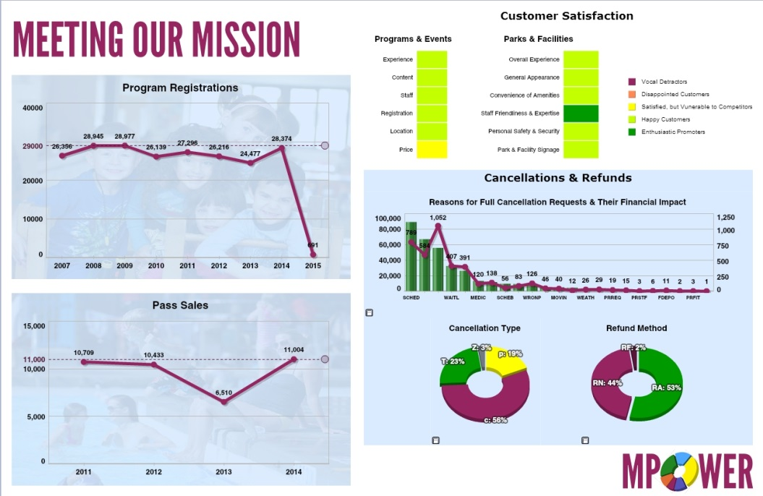
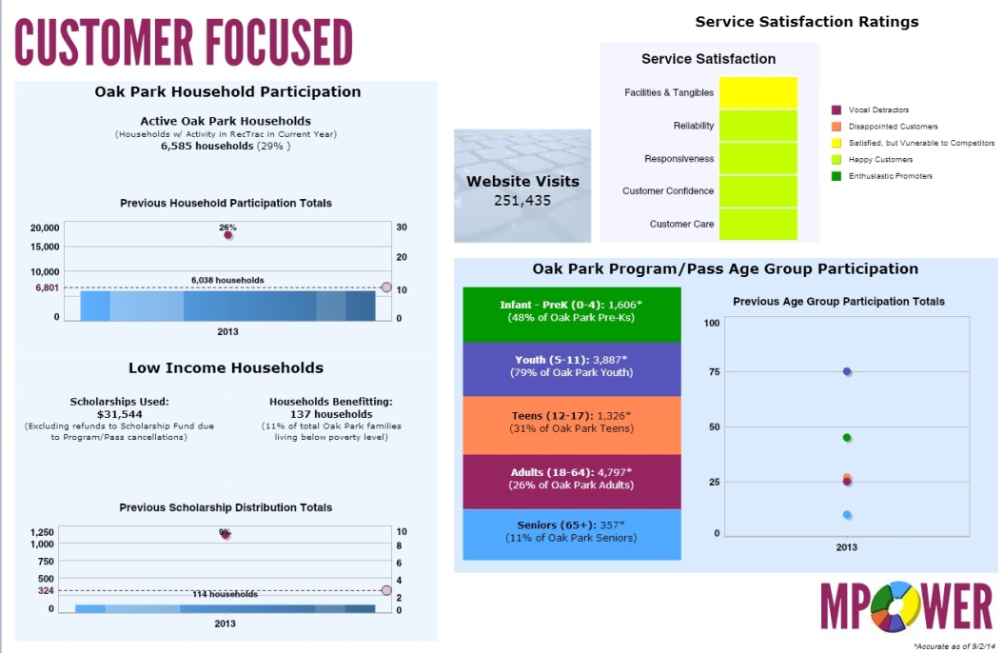
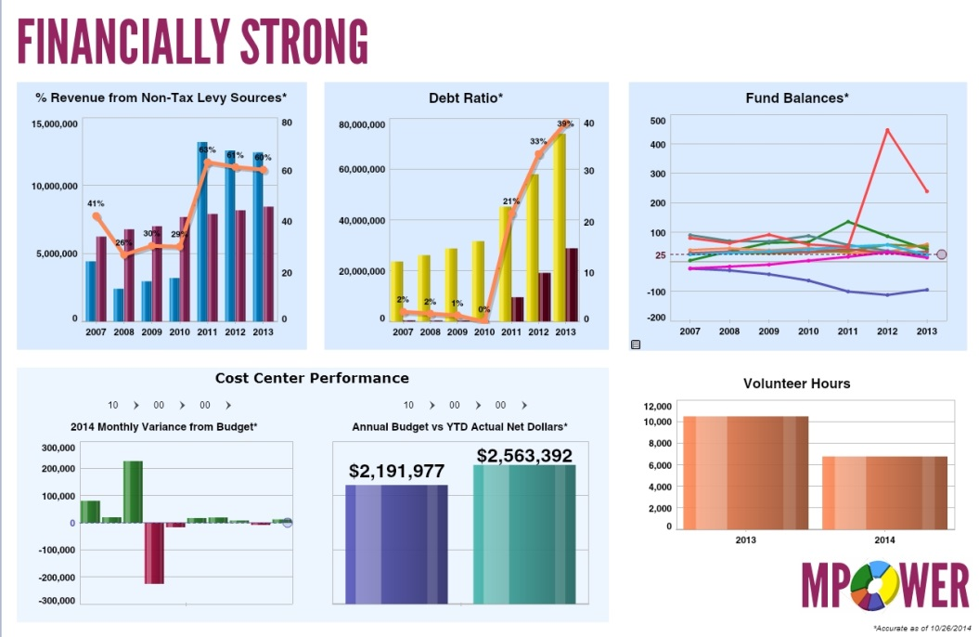
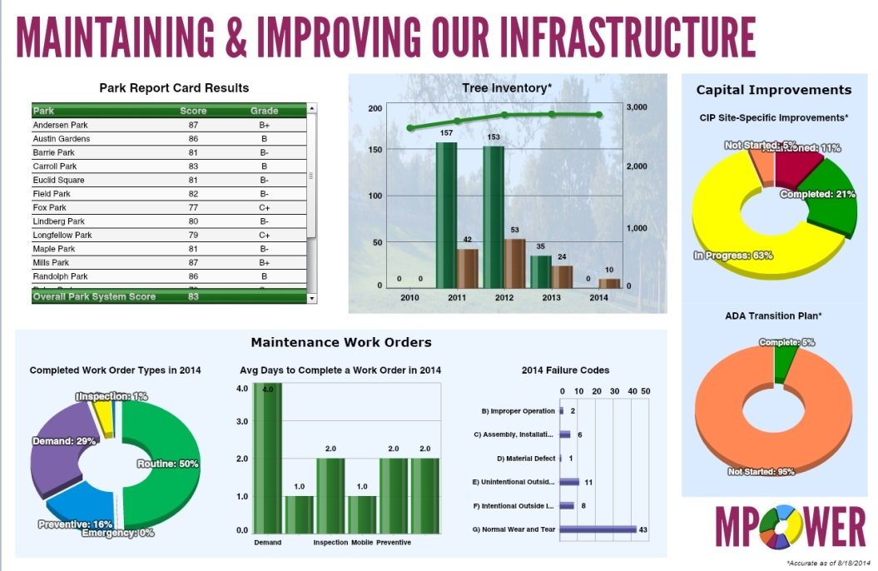
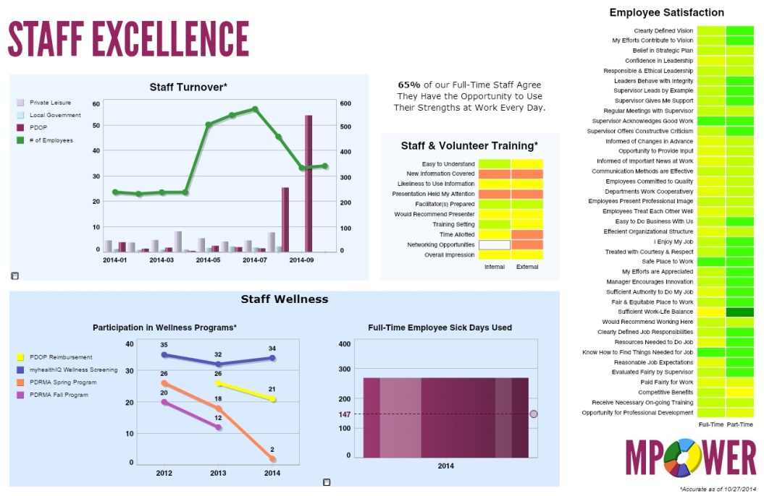
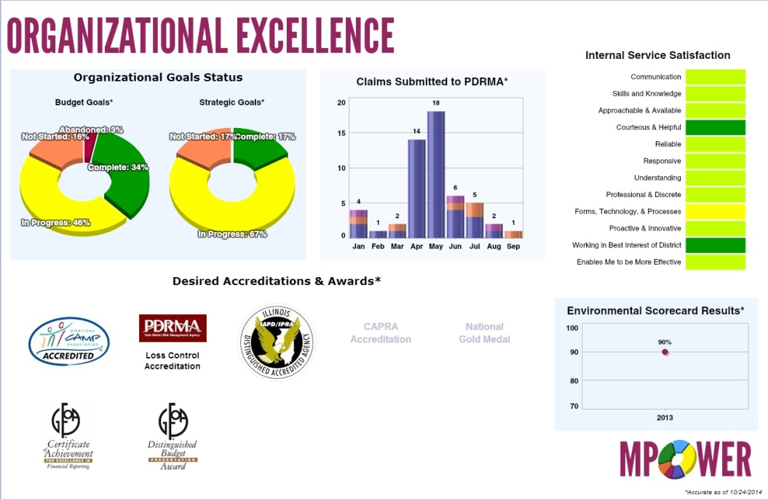
Screenshots of District MPOWER Dashboards (Live Demonstration Available on-site)

Agency Self Review: Met Not Met

Visitor Comments:

Visitor Evaluation: Met Not Met

10.3.1 - Level of Service Standards
Standard: The agency shall have level of service (LOS) standards for provision of land, facilities and services within the jurisdiction. LOS standards are a type of performance measure associated with equitable provision service, such as the number of facilities per 1,000 residents in a service area or facilities available within a designated travel distance or travel time, e.g. percent of population that have a park within a 10 minute walk. LOS standard can also address other dimensions of equitable access, such as connectivity, maintenance and affordability, e.g. percent of parkland connected to the trail network.

Suggested Evidence of Compliance: Provide the LOS standards and describe how LOS standards are used to establish facility and service priorities.

Informational reference in the Management of Park and Recreation Agencies, (2010), 3rd Ed., Chapter 11 – Physical Resource Planning, pp. 223-224.
Agency Evidence of Compliance:

Oak Park's geographical boundaries and population pose open space challenges unique to most communities in the United States. According to the 2010 US Census, Oak Park has over 52,000 residents in 4.7 square miles making it one of the Top 100 most densely incorporated places in the United States, ranking even high than urban areas like Miami, Florida and Washington DC. Because of this, the Park District is unable to rely on traditional standards to plan for parks and facilities and has adopted its own Level of Service (LOS) standards¹.These standards are updated at least every 10 years in conjunction with the development of the Park District Comprehensive Plan using results from a needs assessment, benchmarking results, and knowledge of the practical and physical constraints of Oak Park.
The Park District's Park Master Plans Policy² requires that these planning documents and standards are be taken into consideration during park and facility master planning processes, which occur for each park site a minimum of every 10 years.
Documentation:
- 10.03.01_LOS-in-Comprehensive-Master-Plan.pdf
- 10.03.01_Policy-on-Park-Master-Plans.pdf
Agency Self Review: Met Not Met

Visitor Comments:

Visitor Evaluation: Met Not Met

10.4 - Needs Assessment
Standard: The agency shall periodically conduct an assessment of assets and needs to identify existing and projected gaps in service and determine land, facility and service priorities. Need assessments are used to help determine priorities for developing services with the agency. Needs assessments can use a variety of methods to obtain input from the community, including focus groups, advisory boards, forums, and surveys.

Suggested Evidence of Compliance: Provide the current needs assessment, describe the procedural steps in conducting the assessment, describe the frequency of updates, and describe the use of the assessment in agency planning.

Informational reference in the Management of Park and Recreation Agencies, (2010), 3rd Ed., Chapter 5 - Organization Structure and Administrative Operations, p. 107; Chapter 8 – Recreation Program Planning, pp. 133-134; Chapter 11 – Physical Resource Planning, p. 228.
Agency Evidence of Compliance:

DPRAC - 5.5.1 Comprehensive Needs Assessment and 5.5.2 Needs Assessment Study to assess and determine the recreation needs and interests of its population

Agency Self Review: Met Not Met

Visitor Comments:

Visitor Evaluation: Met Not Met

10.5 - Program and Service Statistics
Standard: The agency shall collect and analyze statistics on its programs and services for evaluation and future program and service development.

Suggested Evidence of Compliance: Provide examples of statistics collected, describe the frequency of updates, and describe how the agency makes use of the information.

Informational reference in the Management of Park and Recreation Agencies, (2010), 3rd Ed., Chapter 11 – Physical Resource Planning, pp. 226-227; Chapter 15 – Public Relations, Marketing, and Customer Service, pp. 370-372; Chapter 23 – Evaluation and Action Research, pp. 660-663.
Agency Evidence of Compliance:

DPRAC 5.4.1 - Maintaining Statistics for Recreational Needs & 5.4.2 - Evaluation of Services & Information Reporting

Agency Self Review: Met Not Met

Visitor Comments:

Visitor Evaluation: Met Not Met

10.5.1 - Recreation and Leisure Trends Analysis
Standard: The agency shall assess periodically societal and local recreation and leisure trends and determine how those trends impact existing and projected user populations.

Suggested Evidence of Compliance: Provide trends analysis, describe frequency of updates, and describe linkage to agency goals and objectives.

Informational reference in the Management of Park and Recreation Agencies, (2010), 3rd Ed., Chapter 23 – Evaluation and Action Research, p. 644.
Agency Evidence of Compliance:

A recreation trend analysis¹ is prepared as part of development of the Park District's comprehensive master plan, which occurs every 10 years. The most recent version of this plan was completed in 2014 for implementation beginning in 2015. The analysis includes data on national trends as well as information specific to the Oak Park community. It becomes part of the research that shapes the plan recommendations and objectives² created for the Park District that result in a mix of one-time and on-going goals for the Park District over the next decade.
Documentation:
- 10.05.01_Recreation-Trend-Analysis-in-Comprehensive-Master-Plan.pdf
- 10.05.01_Objective-Implementation-Matrix-in-Comprehensive-Master-Plan.pdf
Agency Self Review: Met Not Met

Visitor Comments:

Visitor Evaluation: Met Not Met

10.5.2 - Community Inventory
Standard: The agency shall compile a complete and current inventory of parkland and recreation facilities, programs and services in the service area, including those provided by the agency and those offered by schools and other alternative public, private, non-profit providers.

Suggested Evidence of Compliance: Provide a complete and current inventory of parkland, programs and services available in the community, describe the frequency of updates, and describe how the agency makes use of this information.

Informational reference in the Management of Park and Recreation Agencies, (2010), 3rd Ed., Chapter 8 – Recreation Program Planning, pp. 129-130.
Agency Evidence of Compliance:

As part of the Park District's comprehensive master planning processes, which takes place every 10 years, the Park District completes an inventory of parks and recreation facilities as well as programs and services provided by the Park District and other providers in Oak Park. The most recent version, the 2015-2024 Park District of Oak Park Comprehensive Master Plan¹ included such an inventory². This inventory, along with level of service standards and equity mapping is used by the Park District Board of Commissioners and staff in determining the numbers and locations of new parks, park amenities, and/or recreation facilities.
Additionally, as part of comprehensive master planning process, staff also updated the inventory of recreation services offered throughout Oak Park, both by the Park District and other public, non-profit, and private service providers. This information is included in the Recreation Programming Plan³, which is updated every 5 years. This information is used by programming staff to identify new opportunities for programs and services in the community as well as potential partners. It is also used by staff to help avoid duplication of services.
Documentation:
- 10.05.02_2015-2024-Comprehensive-Master-Plan.pdf
- 10.05.02_Community-Inventory.pdf
- 10.05.02_Recreation-Programming-Plan.pdf
Agency Self Review: Met Not Met

Visitor Comments:

Visitor Evaluation: Met Not Met

10.5.3 - PRORAGIS
Standard: The agency shall create an online profile and enter operating data into PRORAGIS, the national park and recreation database.

Suggested Evidence of Compliance: Provide a copy of the agency Custom Report from the PRORAGIS database.
Agency Evidence of Compliance:

The Park District is an early adopter of data-related technology, including PRORAGIS¹. Information from across the Park District is gathered and entered for analysis and comparison purposes.
Documentation:
- 10.05.03_2014-PRORAGIS-Custom-Report.pdf
Agency Self Review: Met Not Met

Visitor Comments:

Visitor Evaluation: Met Not Met

10.6 - Research Investigation
Standard: The agency shall conduct at least one experimental exploration or research investigation each year related to park and recreation operations. These are demonstration or pilot projects where performance data are collected before and after the test to determine effectiveness.

Suggested Evidence of Compliance: Provide a report on a current or recent experimental or demonstration research project designed to improve a product or to test a new process or procedure, including methods used and research findings; provide brief descriptions of other research investigations undertaken over the past five (5) years.

Informational reference in the Management of Park and Recreation Agencies, (2010), 3rd Ed., Chapter 23 – Evaluation and Action Research, pp. 658-659.
Agency Evidence of Compliance:

The Park District often implements new ideas in order to better serve the community and places a heavy emphasis on measuring results. Examples of recent investigations include:
2014 - Identification Requirement at Basketball Courts
Due to fights and negative behavior on Park District basketball courts, staff tested a new protocol which required individuals 17 years or old to show identification and sign-in to participate at one of the basketball court sites. Over the course of the summer, incidents decline once the process was implemented. A Sport Court Report¹ was completed to document the results.
2013 - Dashboard Use
In order to better monitor the agency's performance, the Park District investigated methods to display agency-wide performance measures, including the current annual report, monthly Excel spreadsheets, Excel charts, and dashboards. The Park District tested several options, including dashboard software. Staff collaborated with a software provider to conduct several trials with dashboards and the Park District determined that the dashboards would be the best option. Software was installed in 2013 and the Park District began tracking many measures to determine the Park District's baseline performance levels. The software was rolled out to staff in 2014. Many improvements in performance were observed, including program registration, pass sales, and overall Oak Park household participation.
Measure | 2012 | 2013 | 2014
Program Registrations | 26,216 | 24,477 | 29,369
Pass Sales | 10,721 | 7,011 | 11,811
Household Participation | not tracked | 26% | 30%
2012 - Athletic Field Study
Park District athletic fields are in high demand by a variety of sports user groups and limited in number as the Park District only has a total of 82 acres which includes parks, facilities, and fields. The Park District conducted a study to understand how many hours each field was being permitted as well as to identify best practices for field maintenance. The study provided recommendations on field maintenance practices as well as recommendations for adding synthetic turf to the Park District portfolio. The Park District implemented the recommendations which have led to better field conditions through overseeing and adding irrigation and an aggressive aerification process. Additionally, the Park District has already added two synthetic turf fields to its system. The Athletic Field Usage Report² demonstrates that with the changes, the Park District was able to initially lower the usage on the fields and then better align use with recommendations in the second year.
2011 - Online Rentals
In 2011, the Park District examined its rental process. Staff realized that all rental processes required customers to contact the Park District to determine the availability of the facility they were interested in and then to physically fill out a form and in many cases, come into a Park District facility to complete a rental application. Staff decided to improve this process and began by adding facility calendars for some facilities to the Park District website so that customers would have access to check availability online before filling out an application. Based on the success of this, staff decided to expand this by developing electronic rental processes to allow residents to reserve facilities online. The following spring, staff made picnic areas and community centers available for online rental. It was well received, but required additional promotion of this new feature. The Park District has added gymnastics parties to the rental options in 2013 and pool and rink parties in 2014. The results for online rentals are as follows:
Online Rental Type | 2011 | 2012 | 2013 | 2014
Picnics & Parties | 0 | 19 | 92 | 146
Community Center Rentals | 0 | 71 | 127 | 138

The number of online rentals as well as revenue generated has increased. Additionally, the residents have appreciated the ease. This change in process has proven successful and staff will continue to identify additional rentals to add to the website.
2010 - Carry In/Carry Out Program
The Park District's Green Advisory Committee (GAC) recommended educating sports teams about the importance of recycling as well as reducing the amount of trash disposed of at parks. The committee met with representatives of Oak Park Youth Baseball and Softball and got their support to educate t-ball league parents and participants. Signs were posted at five fields promoting the program. Additionally, trash cans were moved further away from the ball fields to reduce the convenience. In 2011, the GAC reviewed the results of the initiative with Park District staff and found the reduced refuge resulted in fewer overflowing trash receptacles on or near the field. the program was expanded to including all OPYBS locations. Based on its added success, the program was again expanded to eventually include all youth sports leagues at all Park District athletic fields.
Program Reach | 2009 | 2010 | 2011 | 2012 | 2013
Sports Participants | 0 | 240 | 1,600 | 3,700 | 4,000
Documentation:
- 10.06.00_Sport-Courts-Operations-Report.pdf
- 10.06.00_Athletic-Field-Use-Report.pdf
Agency Self Review: Met Not Met

Visitor Comments:

Visitor Evaluation: Met Not Met

10.6.1 - Quality Assurance
Standard: The agency shall monitor and evaluate the quality of its programs, services and facilities from the user perspective. Examples include but are not limited to customer comment cards, secret/mystery shopper surveys, user satisfaction surveys, program evaluations and focus groups.

Suggested Evidence of Compliance: Provide recent examples of methods used to collect, monitor and evaluate quality assurance data from users.

Informational reference in the Management of Park and Recreation Agencies, (2010), 3rd Ed., Chapter 15 – Public Relations, Marketing, and Customer Service, pp. 370-372.
Agency Evidence of Compliance:

The Park District of Oak Park utilizes numerous methodologies to regularly solicit and monitor user feedback in regards to programs, facilities, and services. Where ever possible, this feedback is made available to staff immediately and is viewed on an on-going basis so that staff can respond to trends immediately.
a. External Service Evaluations
On an on-going basis, external users are asked to complete evaluations¹⁻³ related to their experience in District programs, at District parks and facilities, and also with overall service provided by the District. Responses are collected in a variety of ways, with staff soliciting results through e-mail and in-person on tablets. Additionally, users have the ability to access the evaluations through advertised links and QR codes in the District’s seasonal program guide, on the website, and on signage in facilities. Results from these surveys updated daily on the District’s dashboards and are monitored as part of the overall MPOWER performance measurement program so that all staff have access to the most up-to-date results and can respond immediately to any trends they may observe. More detailed reports with additional comments are available to staff on a regular basis through the District’s surveying tool. These metrics are made available to the Board of Commissioners on a regular basis through a quarterly MPOWER report.
The evaluation tools have also been designed to serve as a direct communication tool between users and the staff. When a customer indicates that a service problem has occurred, an e-mail is automatically sent to the appropriate staff member notifying them of the issue so that they may contact the customer to address the problem.
b. Online Presence
The District continuously receives inquires and suggestions from the community via the Department’s website and social media sites. Messages received through the District’s “Contact Us” website form⁴ are forwarded to the appropriate staff member for a timely response. The Communications & Marketing team regularly encourages community with the community via the District’s Facebook and Twitter pages and answers questions and responds to comments from followers of the pages. Staff also monitor customer review websites such as Yelp for feedback on parks and facilities.
c. Community Survey
In 2014, the District contracted with the consulting firm, Public Research to conduct a community needs assessment⁵. The purpose of the survey was to guide the District in the future development of programs, facilities, and services. The survey results demonstrated that:
- 90% of citizens indicated that they were satisfied with the Park District
- 91% of citizens rated the overall quality of programs and events as good or excellent
- 90% of citizens rated the overall quality of the parks as good or excellent
It is the District’s policy that a community-wide survey is distributed at least once every 5 years, although it has been conducted more frequently in the past when citizen feedback was requested by the Board of Commissioners on major issues.
Documentation:
- 10.06.01_2014-Program-and-Event-Evaluation-Summary-Report.pdf
- 10.06.01_2014-Park-and-Facility-Visit-Evaluation-Summary-Report.pdf
- 10.06.01_2014-Park-District-Service-Evaluation-Summary-Report.pdf
- Park District of Oak Park online Contact Us form
- Park District of Oak Park 2014 Community Needs Assessment
Agency Self Review: Met Not Met

Visitor Comments:

Visitor Evaluation: Met Not Met

Visitation Report Summary for
Category 10.0 – Evaluation, Assessment, and Research

Reviewed By: (Visitor Name)

Unmet Standards: (List the Standard # and Name)

Provide clarification for all unmet fundamental standards:

Overall Visitation Team Summary

Agency Strengths
The visitation team identified the following item(s) as being particular strengths of the agency:

Agency Preparedness
The visitation team assessed the preparedness of the agency in conducting the accreditation process (i.e., document accuracy and completeness, staff awareness, file system organization):

Standards
- The visitation team identified the following standard(s) as unmet:

- Provide clarification for all unmet fundamental standards:

- Number of standards met:
- Number of fundamental standards not met:
- Number of non-fundamental standards not met:
Total must equal 151
Other Concerns Related to Maintaining Accreditation
The visitation team identified the following item(s) as areas of general concern related to the agency’s ability to maintain accreditation:

Signatures of Visitors

The Visitation Team attests to its findings contained within this report.

1) ________________________________________________________ __________
Team Chair Signature Date

2) ________________________________________________________ __________
Visitor Signature Date

3) ________________________________________________________ __________
Visitor Signature Date

Affirmation by Commission

The Lead and Second Reviewer, assigned by the Commission, have reviewed this report and approve its release to the agency.

1) ________________________________________________________ ___________
Lead Reviewer Signature Date

2) ________________________________________________________ ___________
Second Reviewer Signature Date

Standard | Original Notation | Current Notation | Rationale for Change
Optional Section (if applicable)
The following standard notation(s) have been modified by the Lead and Second Reviewer, as approved by the respective visitor(s), since the original drafting of this report:

