|  |  |
| --- | --- |
|  | http://devresults.com/Web/Images/Footers/4.gif |

# Partner Reporting Guidelines

Log in to the DevResults site (something.devresults.com) using your email address and password provided. If you do not have a password but you know you have an account, click the **Reset my password** button; a new password will be emailed to you.

Once you log in, you’ll see the Partner Dashboard:

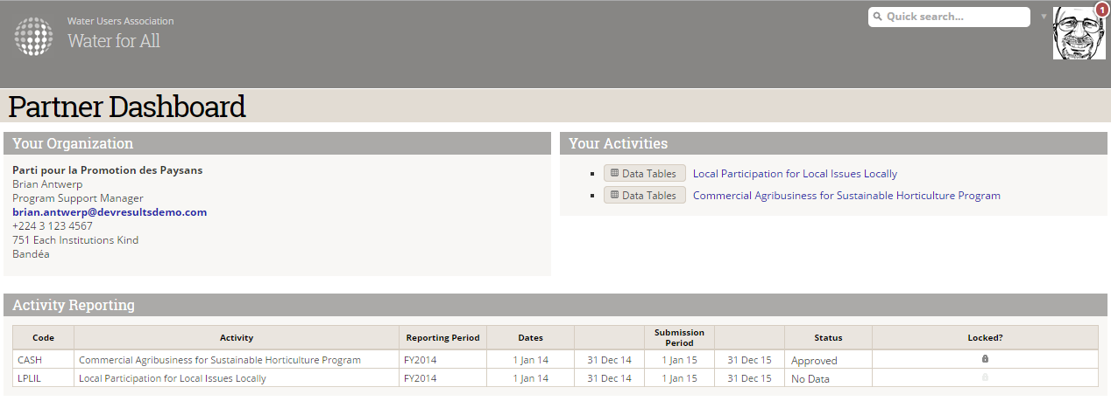

There are two ways you may need to enter data: via **Activity Reporting** or via the **Data Tables** in **Your Activities**. Data table data can be added at any time; Activity Reporting data is only visible and enter-able during the Submission Period dates.

In both scenarios, you can enter individual results directly in the user interface or upload Excel templates containing your data in bulk.

For detailed, step-by-step instructions with screenshots, see the following resources:

### Activity Reporting

**Directly entering data online**: <http://help.devresults.com/report-indicator-results-online-partners>

**Uploading data in an Excel template**: <http://help.devresults.com/report-indicator-results-excel-partners>

**Answering Narrative Questions**: <http://help.devresults.com/report-narrative-results-partners>

### Data Tables

**Entering data directly into a table online**: <http://help.devresults.com/entering-data-table-data-online-partners>

**Entering data by uploading a spreadsheet**: <http://help.devresults.com/entering-data-table-data-via-excel-partners>