|  |  |
| --- | --- |
|  | http://devresults.com/Web/Images/Footers/4.gif |

# Pito

Pito is the DevResults reporting tool, named after Pito Salas, considered the father of the Pivot Table.

To access Pito, log in to the DevResults site (something.devresults.com) using your email address and password provided. Once you log in, in the upper left corner, hover over Dashboard and click on **Pito.**

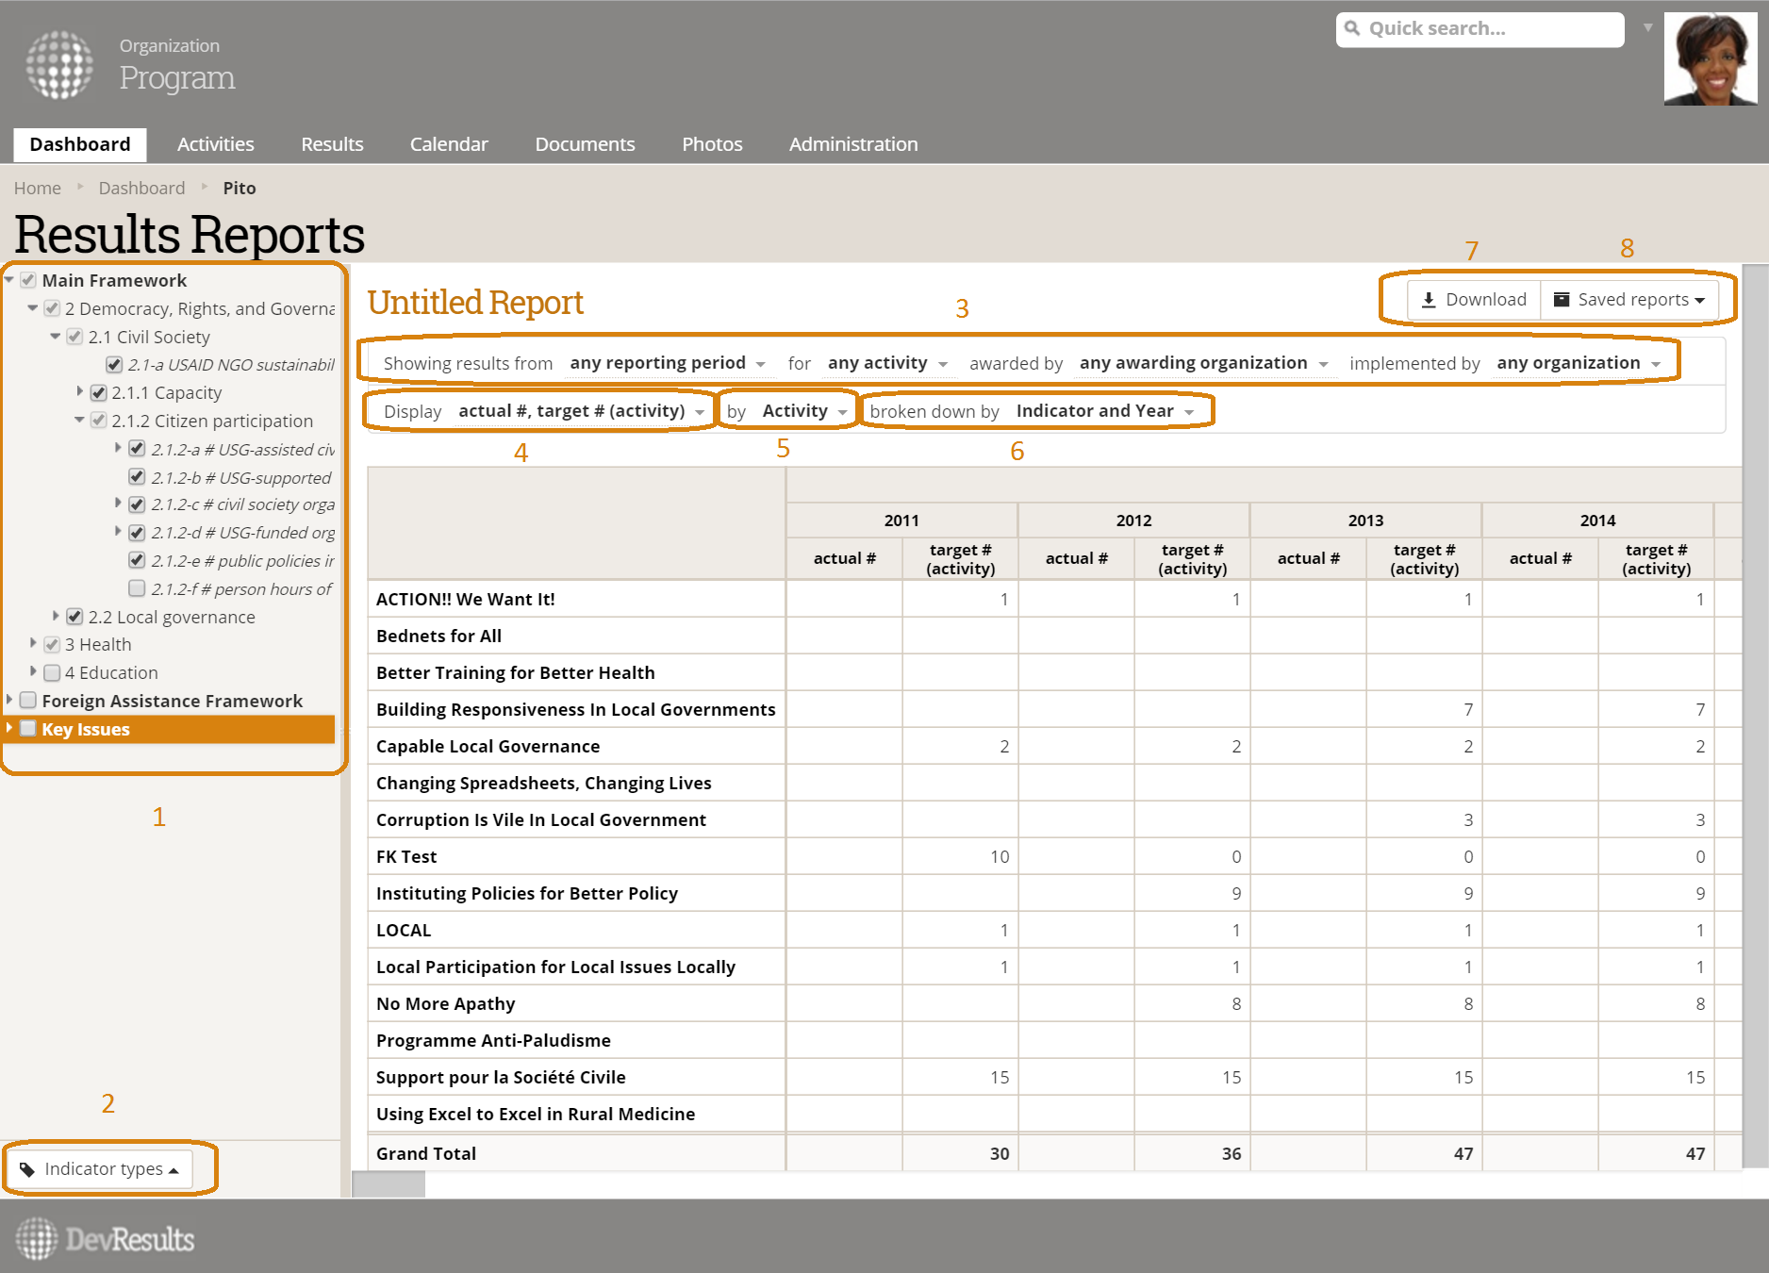

The **Framework Tree** **(1)** allows you to select the indicators you want to see in your report.

The **Indicator Types** **button** **(2)** filters the indicators displayed in the framework tree by tag and type

The **Showing results from** **dropdowns** **(3)** filter the data by reporting period, activity, and organization.

The **Display** **dropdown** **(4)** allows you to select whether you see actuals, targets, or both.

The **by** **dropdown (5)** defines the rows you want to see in your report.

The **broken down by** **dropdown (6)** defines the columns you want to see in your report.

The **Saved reports button (7)** lets you save your current report and view your/your colleagues’ saved reports.

The **Download button (9)** will download your current report into an Excel file.

### For complete instructions with screenshots: <http://help.devresults.com/help/article/link/pito-reports>