Closing the Week Checklist

For Closing the Current Week in Enterprise

When to Use this Checklist
This checklist is meant to be a helpful tool to review all back office (payroll and billing) processes have been complete so you can close the week. Closing the week archives the current week’s transactions and allows you to move the weekend bill date (current processing week) forward in your system.
Check out our Knowledge Base at http://kb.tempworks.com/help/back-office for more information.

Checklist
Review all the following items before closing the week
Time Entry
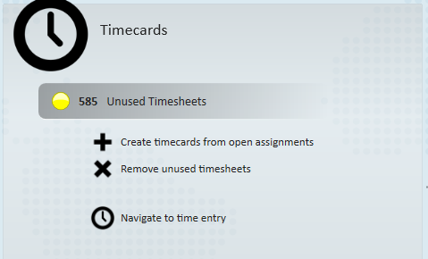
Double check the following items:
☐ Run the Missing Timecards report or navigate to Time Entry to review all timecards that do not have time on them
☐ Review what hours or timecards have been sent to you from your customers or employees have been entered in time entry
☐ If you use WebCenter timecards or Buzz Timecard Entry, make sure there are no more timecards that should be added to a proofing session this week
☐ If you are using TempWorks TimeClocks, make sure all approved time has been pushed into a proofing session

Proofing
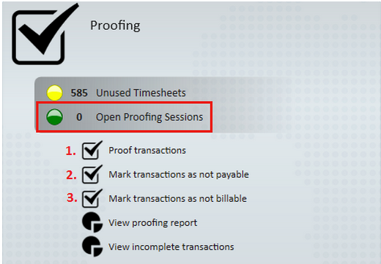
Double check the following items:
☐ Double check that there are no open proofing sessions (check the green light or select proof transactions)
☐ Review transactions that are not payable and approve them under “Mark transactions as not payable”
☐ Review transactions that are not billable and approve them under “Mark transactions as not billable”

Payroll
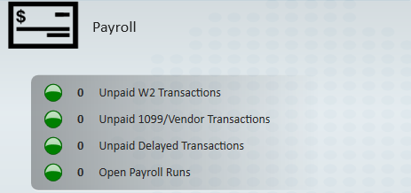
Double check the following items:
☐ Ensure there are no Open Payroll Runs (green light)
☐ Make sure all W2 transactions have been paid (green light)
☐ Make sure all 1099/Vendor transactions have been paid (green light)
☐ If using our VMS, review the delayed transactions to pay your vendors (green light)
☐ Double check all necessary Authority checks been completed this week
☐ Double check that you have pulled your ACH files for electronic payments and uploaded them to your bank
☐ Double check that you have pulled any Pos Pay files you need and uploaded them to your Bank
☐ Make sure there are no open paycard funding runs (green light)

Invoicing
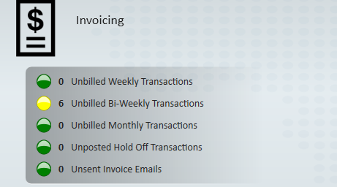
Double check the following items:
☐ Make sure all weekly transactions have been billed (green light)
☐ Make sure all Bi-Weekly transactions have been billed (green light)
☐ Make sure all Monthly transactions have been billed (green light)
☐ Make sure all off cycle bi-weekly or monthly transactions have been held off/posted (green light)
☐ Make sure all applicable invoices have been emailed
☐ Confirm all your AR posting batches are fully posted

The Final Check:
☐ Review the incomplete transactions to triple check that all non-WebCenter transactions have been proofed, paid, invoiced, and posted.

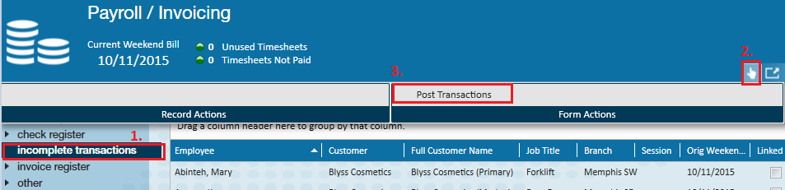
Now you are ready to close the week! Click here to go to the Knowledge Base Article.

