Beyond University
HRCenter Minor for Recruiters

How Do I Use This Course Book?
This guide will walk you through the HRCenter courses specifically for those service reps, recruiters, or staffing specialist that will be processing online applications.
If your team is utilizing HRCenter for online applications and onboarding, then you will want to have your team walk through these courses.
We recommend first taking the Beyond orientation videos if you have not used Beyond before.
Table of Contents
How Do I Use This Course Book? 1
Road Map 1
The Applicant Process 2
The Service Rep Process 4

Road Map
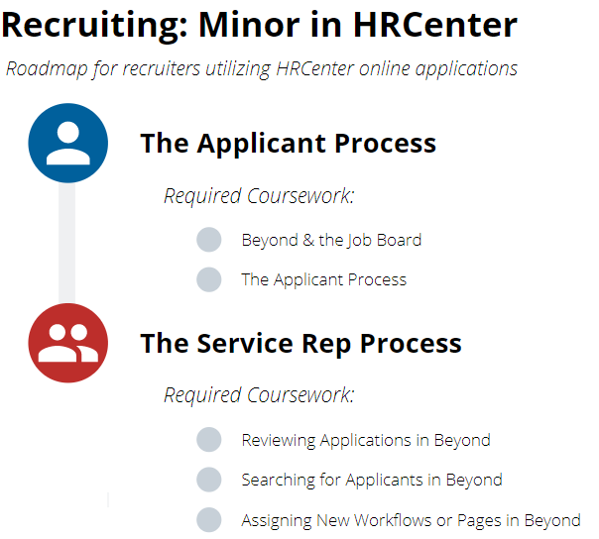
Here is a quick overview of the topics we’ll cover

The Applicant Process
The following HRCenter courses review the process and options from the Applicant’s perspective
Beyond & the Job Board Time: 10 minutes
Description: This course will walk through what the TempWorks Job Board looks like for applicants and how to post orders from Beyond on the Job Board.
Complete the following before continuing:
- Watch the Video
- Take the Quiz
Homework:
☐ Review an order in Beyond and locate the Job Board Options.
☐ Review the related articles at the bottom of the page
Question | Answer
Who will be responsible for posting jobs to the Job Board?

Will there be a quick link from your website to the Job Board/HRCenter?

What information is included in the application for the applicant to fill out?

☐ Ask your team the process questions below:

The Applicant Process Time: 6 minutes
Description: This course will walk through HRCenter from the applicant’s prospective. It provides an overview of how an applicant will register and fill out an application. This video includes a brief overview on how applications can be organized.
Complete the following before continuing:
- Watch the Video
- Take the Quiz
Homework:
☐ Talk with your manager to see if you can practice walking through an HRCenter
☐ Review the related articles at the bottom of the page
Question | Answer
How long does your application take to complete? (on average)

Is there more than one workflow an applicant can choose from?

What information is included in the application for the applicant to fill out?

☐ Ask your team the process questions below:

The Service Rep Process
The following HRCenter courses review the process and options from the
Reviewing Applications in Beyond Time: 9 minutes
Description: This course will walk through how to review applicants who applied via HRCenter and see what information they have completed. We will discuss options for reaching out to applicants that are in progress, unlocking applications as needed, and signing onboarding documents.
Complete the following before continuing:
- Watch the Video
- Take the Quiz
Homework:
☐ If you completed an application in the previous video, find it and review the information
☐ Review the related articles at the bottom of the page
Question | Answer
What does your team’s onboarding process look like? Do you have an interview process?
What are reasons to reject an application or applicant?
☐ Ask your team the process questions below:

Searching for Applicants in Beyond Time: 5 minutes
Description: This course will review how to utilize the onboarding search to find, review, and reach out to applicants who have applied online.
Complete the following before continuing:
- Watch the Video
- Take the Quiz
Homework:
☐ Find the onboarding search and practice searching
☐ Review the related articles at the bottom of the page
☐ Ask your team the process questions below:

Question | Answer
Who will review online applications on your team? Will it be scheduled out?
How will you reach out to your applicants? (Email, phone, text)
What workflows can applicants select from when filling out the application online?

Assigning New Workflows or Pages in Beyond Time: 10 minutes
Description: This course will discuss the options you have to send a new employee additional onboarding documents or additional information to fill out.
Complete the following before continuing:
- Watch the Video
- Take the Quiz
Homework:
☐ Talk with your team about when you assign new workflows and pages
☐ Review the related articles at the bottom of the page
☐ Ask your team the process questions below:
Question | Answer
What are some common workflows or pages that you will be assigning to employees?
Will you need to assign customer specific workflows or pages?
Will you ever need to assign en masse?

