Search Committee Instructions for PeopleSoft Talent Acquisition Manager (TAM)
Reviewing Applicants
- Log Into TAM using https://kb.uwss.wisconsin.edu/ . Once you get to the UW-Shared Services page,
  - Click on the on the left of the navigation bar and click on HRS Administration

  - Your username and your password if asked.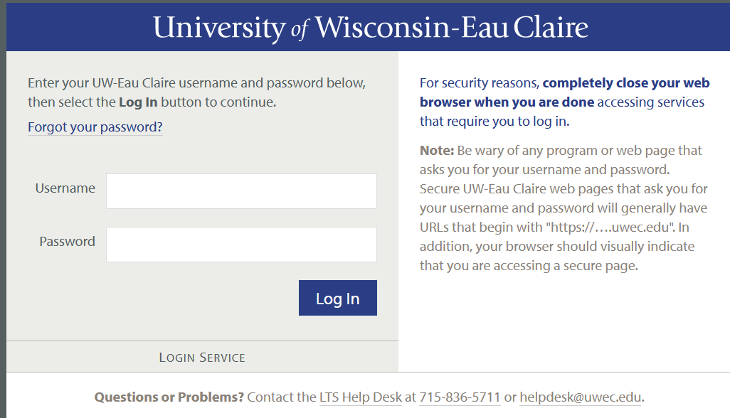

  - Next, click on HRS PeopleSoft. 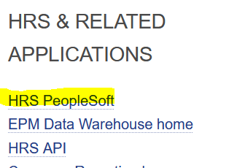

  - Enter your DUO code if asked.
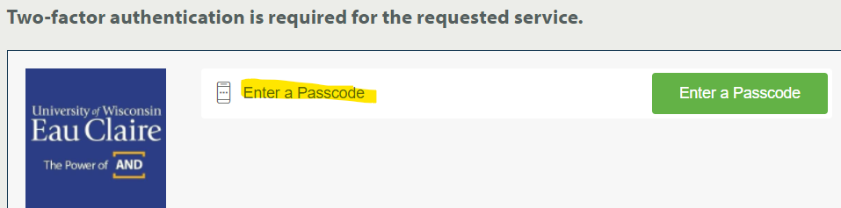

- Locate the Main menu by clicking on the Navigation button (top right).

- From the Main Menu, click Recruiting and Search Job Openings 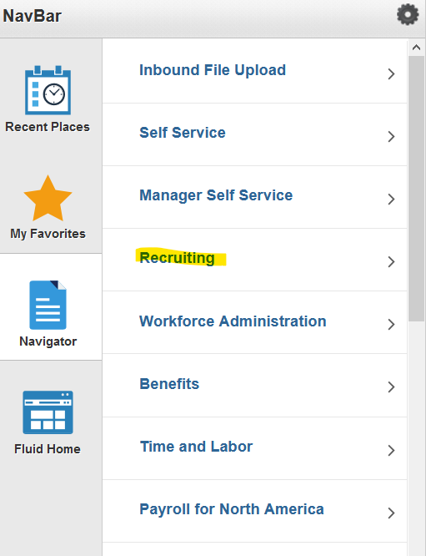 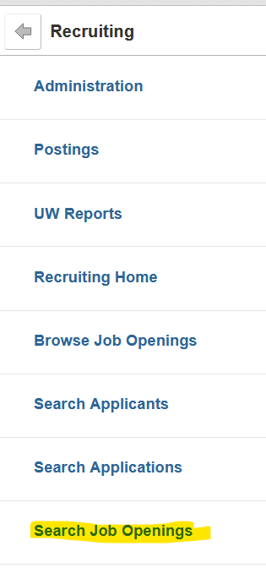

- Search for the job opening you want – you can use the Job Opening ID (TAM#), Status, or click search and the full list of open searches will be listed.

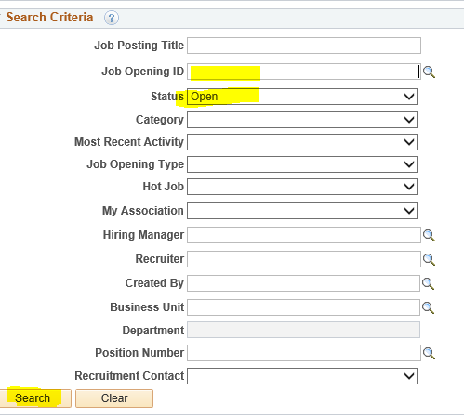

- Locate the job title and click on it to access the applicants and job details.
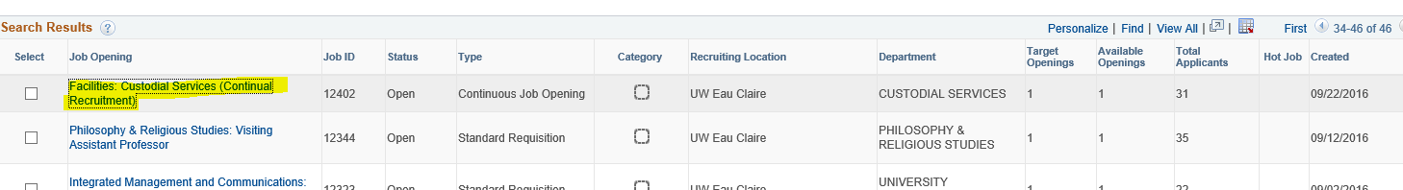

- Once the job is open, you can review the applicant information by clicking on:
  - the Application icon to view all applicant information (including any attachments)
  - The Resume icon 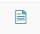 to view only the resume

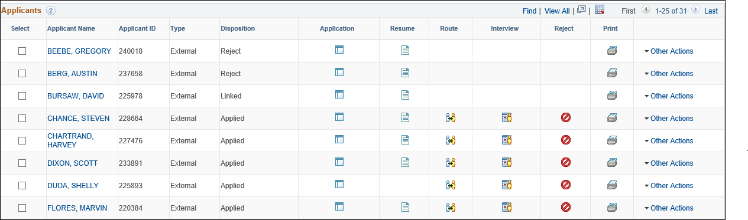
If the Route, Interview, and Reject boxes are empty, this candidate has been reviewed and removed from consideration (rejected).
Names Removed to preserve confidentiality

Names Removed to preserve confidentiality

If the icon is missing, this means the applicant did not submit or attach a resume.

- Once you have reviewed the applicant’s information and documents click to view the next applicant.

