## CONNECTWISE INTEGRATION2013.1



# 

### DISCLAIMERS

* Intermedia’s ConnectWise integration utilizes the MSP Connector add-on (<http://www.connectwise.com/connectwise-msp-connector.php>). It is an additional module (outside the ConnectWise PSA software) that you would need to purchase from ConnectWise. If you do not have access to the MSP Connector, many screens (such as the management tab within companies) will not be available.
* The integration utilizes the revamped Managed Device API (introduced in ConnectWise release v2011.3).
* Intermedia’s ConnectWise integration is based on ConnectWise’s MSP integration flow (<http://link.brightcove.com/services/player/bcpid57636680001?bctid=86951768001>).

### CONNECTWISE TERMINOLOGIES

* Agreement: service contracts between you and your customers; (examples of different types of agreements: managed services, maintenance, equipment rental, software assurance, professional services, hosting and block time)
* Additions: each agreement can contain one or more additions; each addition corresponds to a billable item (product, description of the products, total quantity, unit cost, unit prices etc.)
* Agreement Setup table: lists all types of agreements; in our case, it is used to create a new agreement type
* Management IT Setup Table (requires MSP connector): defines items required for setting up the MSP Integration; in our case, the table is used to create a new manage solution type
* Managed Devices Integration Setup Table (requires MSP connector): lists all managed solutions; in our case, it is used to create a custom Intermedia managed solution (which links to all Intermedia products)
* Product Setup table: contains the master list of all products

### INTEGRATION SCOPE

Via the MSP integration flow, Intermedia will be able to push accounts, and update product table and agreement additions in ConnectWise. The three major functions are:

* Export accounts: check whether end-user accounts (on Intermedia side) exist in ConnectWise as companies
  + If company already exists in ConnectWise, link the company to the Intermedia account
  + Otherwise, create the company in ConnectWise (using information in Intermedia)
* Export billable items: export billable items into ConnectWise’s product table
* Export product count: update addition counts within agreements

### INTEGRATION BENEFITS

* Eliminate the need to manually enter products and update agreement addition counts

### INTEGRATION FLOW

The integration is based on ConnectWise’s MSP integration flow; this means that you must properly set up the managed solution inside ConnectWise before the auto export process can be used. The following steps will have to be performed inside ConnectWise manually:

* Creating integrator login: allow Intermedia to communicate with ConnectWise
* Setting up Product table: create a new product type
* Setting up Agreements table: create a new agreement type
* Setting up UOM table: create a new UOM type
* Setting up Category table: create a new Category type
* Setting up Sub-Category table: create a new Sub-Category type
* Setting up Manage IT table: create a new managed solution type
* Setting up managed device integration: make sure the applicable products are associated with the custom agreement type

The whole integration flow is shown in the flow diagram below:

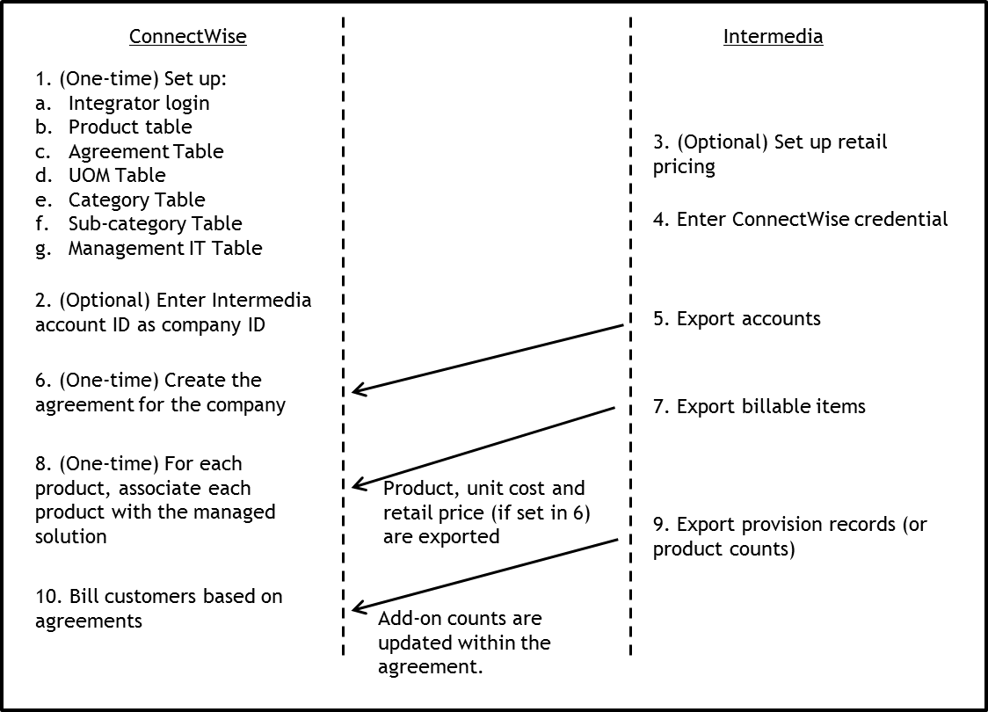

1. **(One-time) ConnectWise setup:** If using Connectwise version 2013.1, you will need to search for each setup table.
   1. **Set up the Integrator Login Table**

An integrator login credential needs to be established communication with ConnectWise

SETUP>Setup Tables

Category: General

Table: Integrator Login

* Create Intermedia login credential

See Image below for which API to ENABLE.

* Once created, you should see Intermedia integrator login in the Integrator Login table

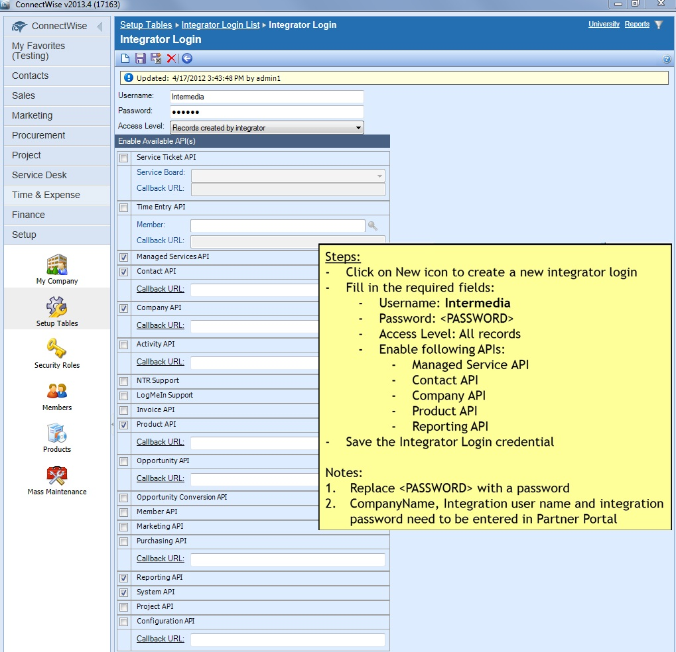

* 1. **(One-time) Set up the Product Table:**
* Setup a new product type inside the Product Table

SETUP>Setup Tables

Category: Products

Table: Product Type

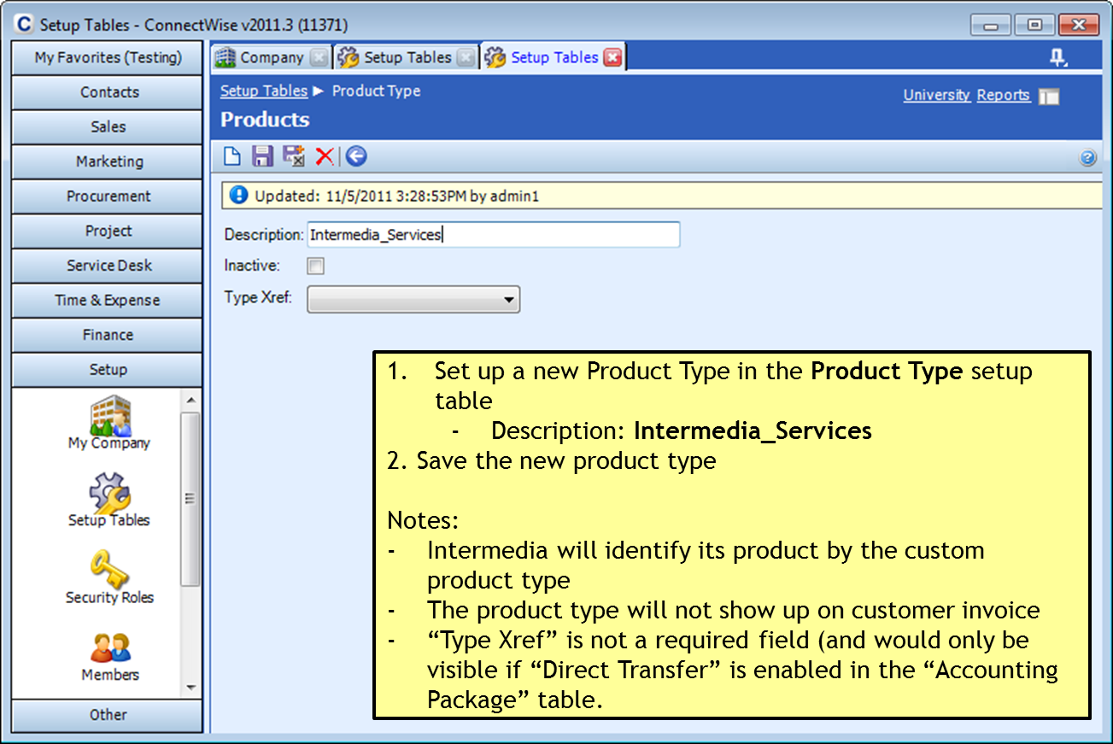

* 1. **(One-time) Set up the Agreement Table: Please note, that Intermedia does not advise partners on how to setup the agreements. For more information on how to setup an agreement for your billing needs, please contact Connectwise.**
* Setup a new agreement type inside the Agreement Table

SETUP>Setup Table

Category: Agreements

Table: Agreement Type

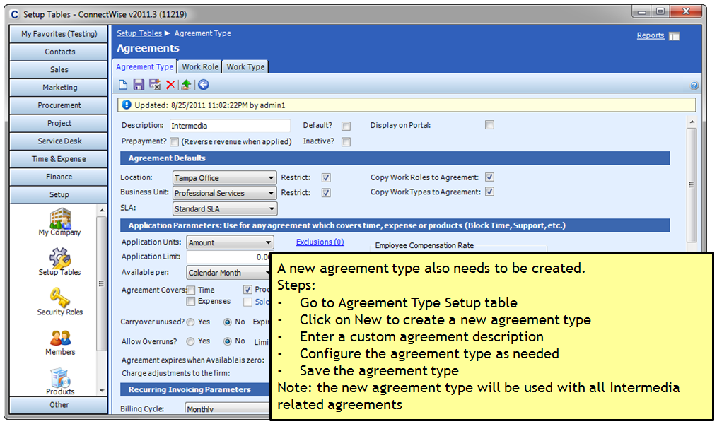

* 1. **(One-time) Set up the UOM Table:**
* Setup a new UOM type

SETUP >Setup Table

Category: Product

Table: UOM

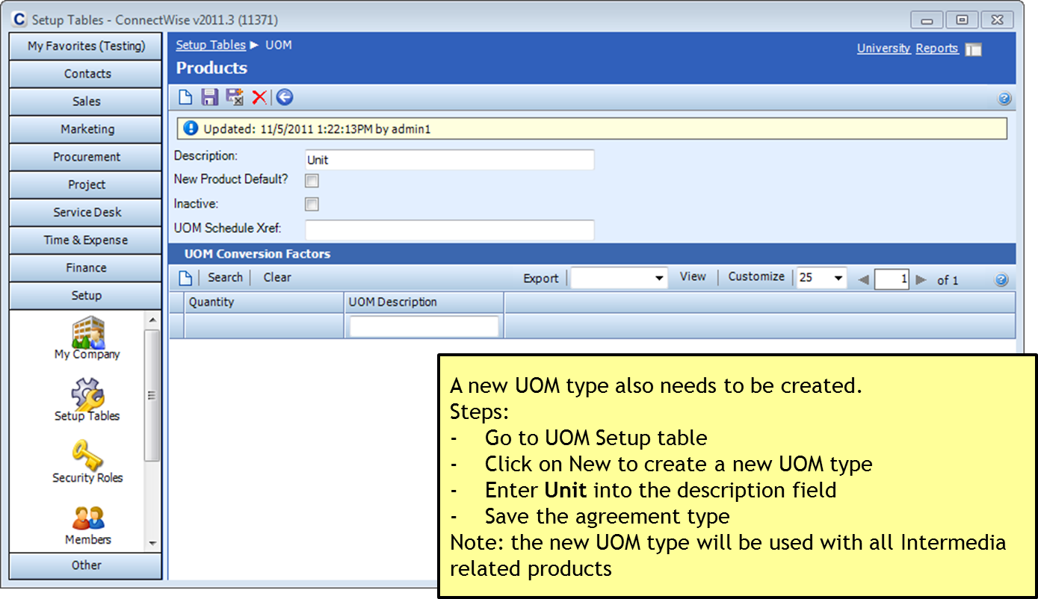

* 1. **(One-time) Set up the Category Table:**
* Setup a new category type

Setup>Setup Tables

Category: Product

Table: Category

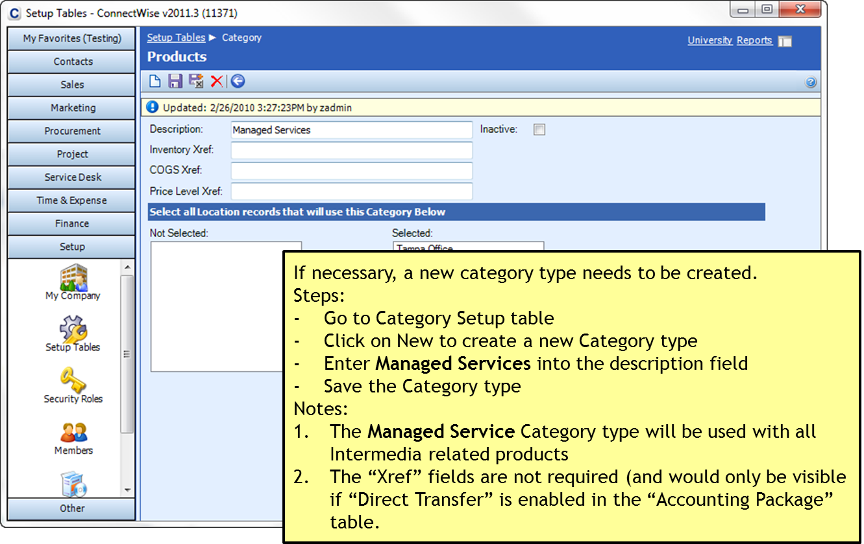

* 1. **(One-time) Set up the Sub-Category Table:**
* Define a new sub-category type

Setup>Setup Table

Category: Products

Table: Sub-Category

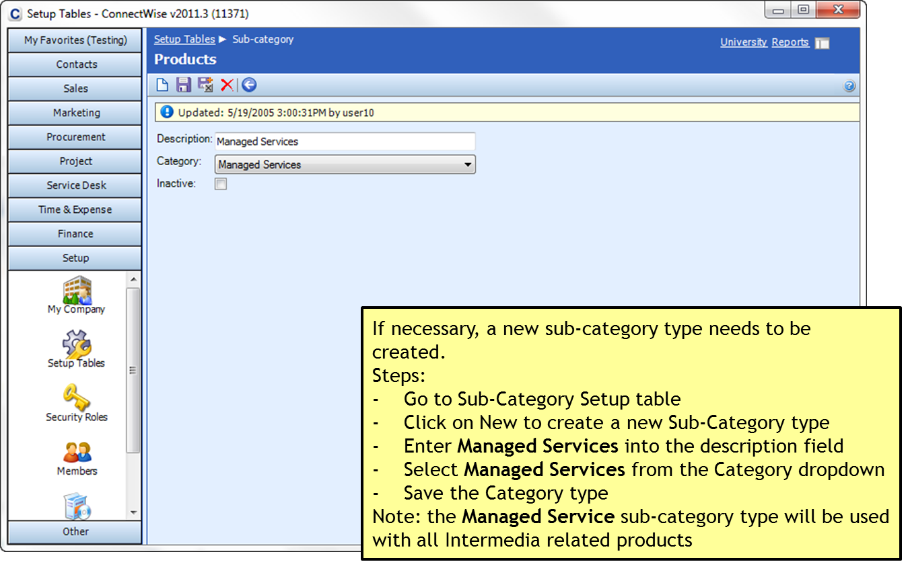

* 1. **(One-time) Set up the Management IT Table:**
* Define a new management solution

SETUP>Setup Table

Category: Company

Table: Management IT

CUSTOME SOLUTION NAME MUST BE: “Intermedia”

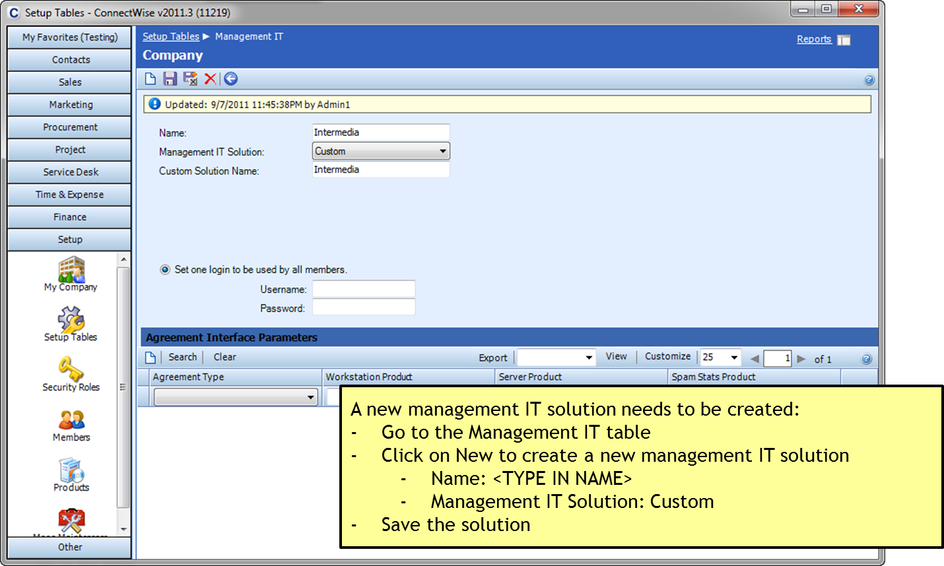

**Step 2 is found under Company – Company>Company Search**

1. **Enter Intermedia Account ID in ConnectWise:**

Enter the sub-account ID as Manage ID inside ConenctWise. If the company does not exist inside Connectwise, please create the company and proceed.

CONTACTS>Company>Management

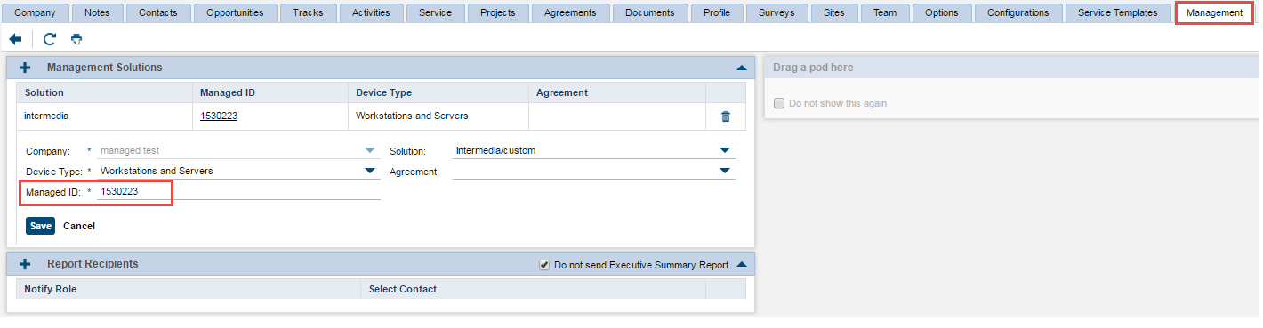

1. **(Optional) Set up Retail Prices:**

* Retail prices (if set-up inside partner portal) can be exported to ConnectWise as well

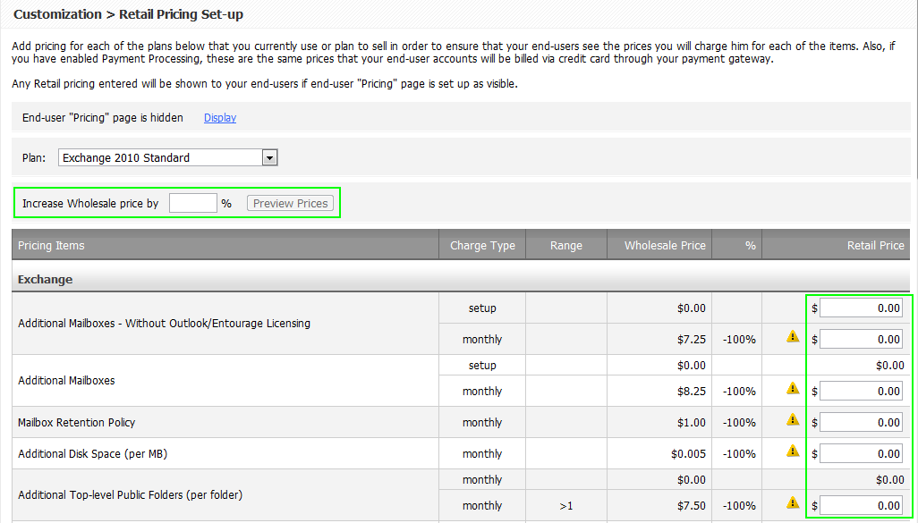

**IMPORTANT: Before retail prices can be exported from the Intermedia’s partner portal, it is important to note that each unique item (item with the same wholesale price) would need to have the same retail price. If customer-specific or plan-specific prices are needed, then please update the prices inside ConnectWise (see Limitations and Recommendations section for explanation).**

1. **Enter ConnectWise Credential:**

* Enter ConnectWise login credential in the Export to ConnectWise page

These fields should match the same Company ID, Login, and Password that you use for logging into Connectwise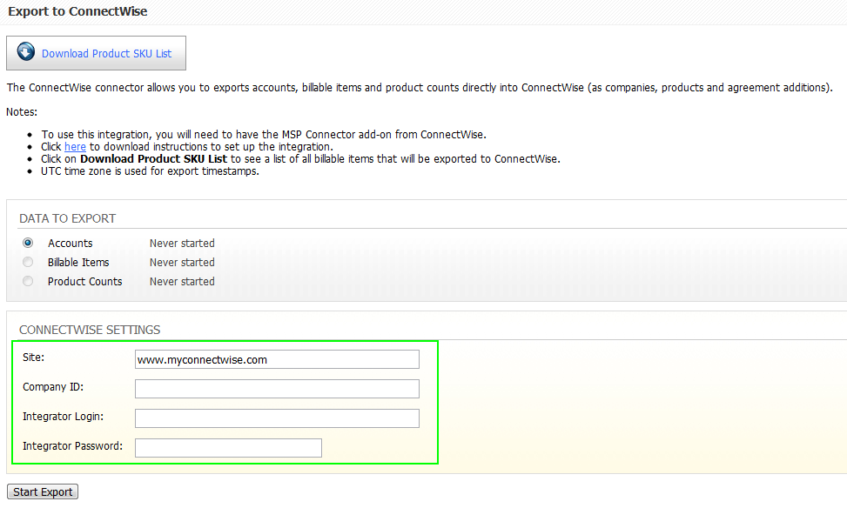

1. **(Optional) Create Agreement for Companies: Please note, that Intermedia does not advise partners on how to setup the agreements. For more information on how to setup an agreement for your billing needs, please contact Connectwise.**

* If needed, create an agreement (of the same agreement type created earlier) for each company.

Contacts>Company>Sub-Account>Agreement

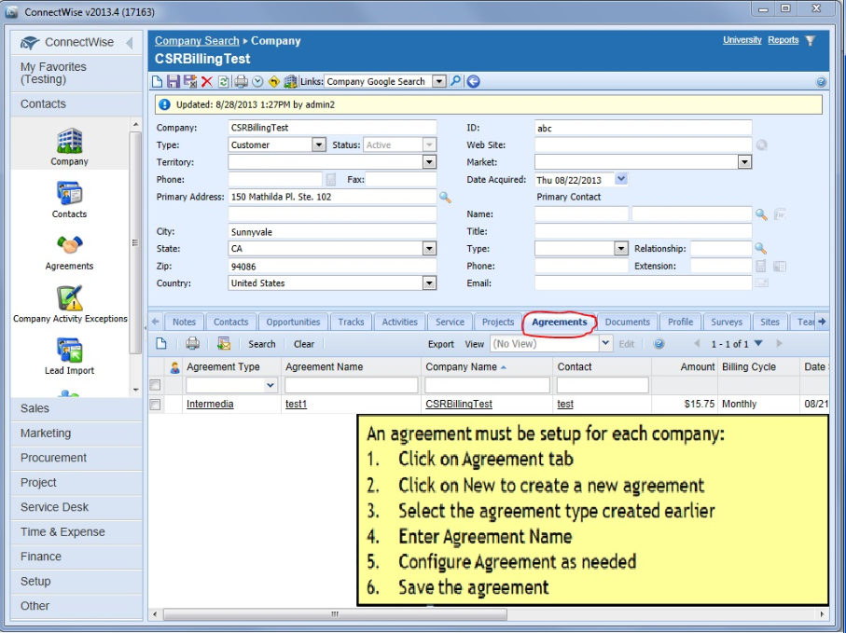

1. **Export Billable Items:**

* Export billable items into ConnectWise as products (in Products Setup Table)

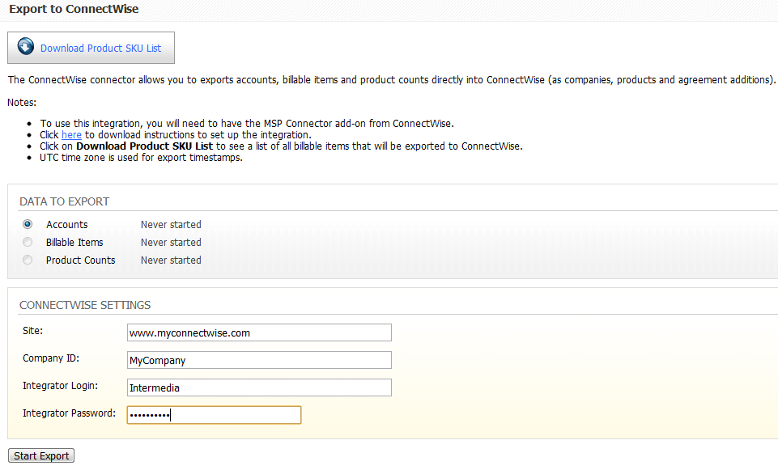

Notes:

1. Products have the following naming convention <PRODUCT_SKU>_<UNIT_PRICE>. The product descriptions are listed in the product SKU sheet (downloadable from the page).
2. Each billable item is only exported into ConnectWise once. If you want to charge the same item (same product, same plan) differently to different customers, then you can manually change the price of the addition
3. Additional SKU(s) that are added later can be manually created in Connectwise.
4. If you have modified the descriptions and the pricing, if you perform another Export Billable Items, the system will change all of your entries back to the default settings.
5. **(One-time) Associate Products with Managed Solution:**

* Each product has to be associated with the custom managed solution (created in step 4)

SETUP>Setup Tables>Managed Devices Integration>Solution>Cross-Reference

Category: Company

Table: Managed Devices Integration

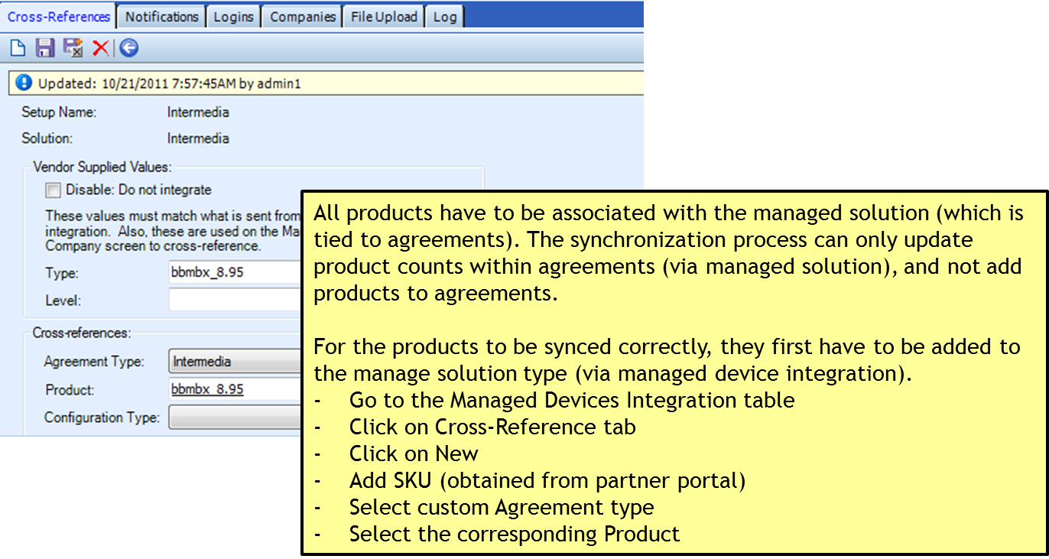

Tips:

You can perform a Product Count (step 9) before cross-referencing all the SKU(s). This will bring the recognized SKU(s) to the Cross-Reference page. Make sure that all billable SKU(s) are being brought to the cross-reference page. To double check that all the SKU(s) are being brought to the cross reference page. Please use the Exportable Billing Report in the Partner Portal. Check those SKU(s) to the ones on the cross-reference page. Once you have verified the SKU(s) are accounted for, proceed with your cross-referencing.

Tips cont.

Intermedia provide SKU(s) to be used if you would like to charge your customers a setup fee. The SKU that represent a setup fee will be represented with an ‘O’ meaning One-Time. Also note that the Setup or One-Time SKU(s) will not show in the Exportable Billing Report in the partner portal.

Here is an example:

MXS10C01SUNO_0 - This is a setup fee for mailboxes

MXS10C01SUNR_7.25 – This is a recurring charge for a mailbox

There are more tips and advice on how to double check, that products counts are being exported correctly under LIMITATIONS AND RECOMMENDATIONS.

1. **Export Product Counts:**

* Update additions in agreement



Note: Current product counts, at the moment of the export, are exported to ConnectWise (as agreement additions)

1. **Generate Invoice:**

* Invoice can be generated inside ConnectWise based on the updated agreements

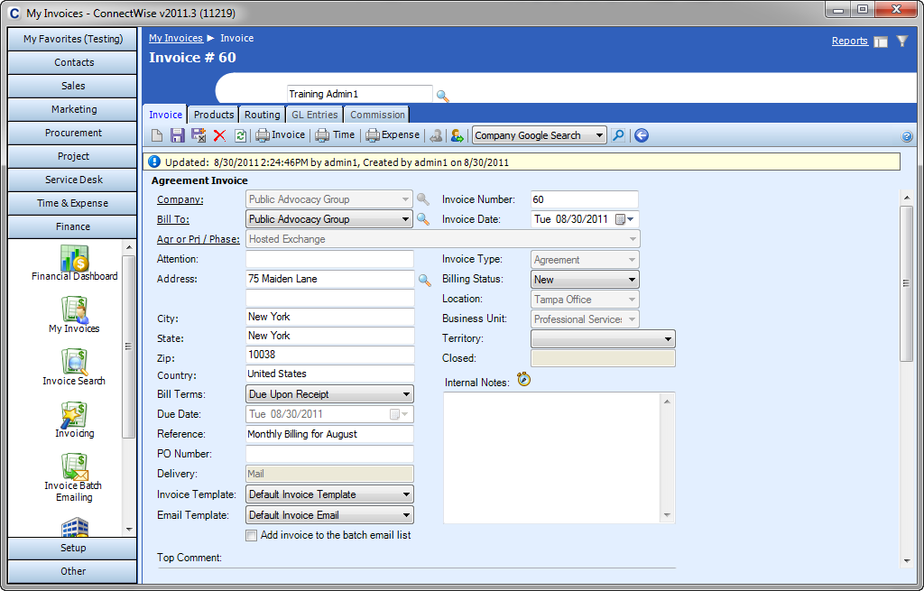

### SETUP TABLES CHECKLIST:

The following table lists all the Setup tables that need to be configured and their recommended parameters:

|  |  |  |  |
| --- | --- | --- | --- |
| Tables | Parameters | Values | Comments |
| Integrators Login | Username | Intermedia |  |
|  | Password | <PASSWORD> | Set own password |
|  | Access Level | All records |  |
|  | Enable Available API(s) | Managed Service API | Requires MSP connector;  Used to sync additions |
|  |  | Contact API |  |
|  |  | Company API | Used to sync accounts |
|  |  | Product API | Used to sync products |
|  |  | Report API |  |
| Product Type | Description | Intermedia_Services | Cannot be changed; will not show up on invoices |
|  | Inactive | Unchecked |  |
|  | Type Xref | Unchecked | Not required; will only show up if you have the QuickBooks plugin(?) |
| Agreement Type |  |  | Define the agreement type as needed |
| UOM | Description | Unit | Used to sync products |
| Management IT | Descriptions | <DESCRIPTION> | Enter own description |
|  | Management IT Solution | Custom |  |
|  | Custom Solution Name | <SOLUTION> | Enter own solution |

**LIMITATIONS and RECOMMENDATIONS**:

Before you proceed with the integrations, you should be familiar with the following:

* **MSP Connector:** the integration utilizes the MSP Connector add-on. It is an additional module (outside the ConnectWise PSA software) that you would need to purchase from ConnectWise.

Recommendation: contact ConnectWise for more information on the MSP connector.

* **Account Export**: During the account export process, Intermedia queries the CompanyID fields for known Intermedia accounts. If a match is found, the ConnectWise company is linked to the Intermedia account (the link is established by capturing and storing ConnectWise’s internal company identifier). If there is no match, then a company would be created inside ConnectWise.

Recommendations:

* To avoid duplicate company entries in ConnectWise, enter Intermedia accountID into the appropriate CompanyID fields. Once the initial link has been established, Intermedia accountID can be removed.
* If you want to delete a company within ConnectWise, make sure to delete it from the Company Recycle bin (Mass Maintenance Screen > Company Recycle Bin) as well. Otherwise, you might get an error during the account export process.
* If you want to export an account from Intermedia to ConnectWise, make sure you have filled out the company information correctly (including the country). Without the country information, ConnectWise would throw an exception and your account export would fail.
* **Billable Item Export and Retail Prices:** each distinct billable item (that has the same unit cost) is exported as one product. For example: BlackBerry costs $9.00/device on all 2010 plans, therefore only one BlackBerry product (with the $9.00 unit cost) would be exported into ConnectWise. It is important to keep this in mind if you are setting retail prices inside the partner portal. Each distinct billable item (that has the same unit cost) would need to have the same retail price as well. Back to our BlackBerry example, you would have to set the same retail price for BlackBerry, regardless of the 2010 plan.

Recommendation: To set plan-dependent (or even company-dependent) prices:

* Leave retail prices empty in the partner portal; only product costs would exist in ConnectWise.
* Adjust the addition prices in individual agreements (click into each addition and adjust the price).
* **Product Count Export and Billing Reconciliation:** the product count export process exports the current account states, at the moment of export (e.g. the number of Exchange mailboxes and BlackBerry devices that this account has at the moment of export); in another word, only absolute quantities are exported (Intermedia cannot export partial units). This has two implications:
  + All installations, regardless of the purchase dates, are exported equally.
  + Products that are deleted prior to the product count export are not exported.

Recommendation: To ensure billing accuracies, billing reconciliation should be performed prior to invoices are generated. To perform billing reconciliation, compare the ConnectWise addition counts vs. quantities reported by the Exportable report (found inside the Partner Portal). Based on the results of the billing reconciliation, adjust addition counts as needed in ConnectWise.

### SUPPORTED PLANS:

Currently Only Data Plans are Supported. Hosted PBX 2.0 is not support as this time for integration.