Open enrollment season is here! Please complete your FSA enrollment by following these instructions.

Flexible Spending Account (FSA) open enrollment will be available during these dates: / / - / /

1
Go to sentinelgroup.com and select “I am an Individual.”
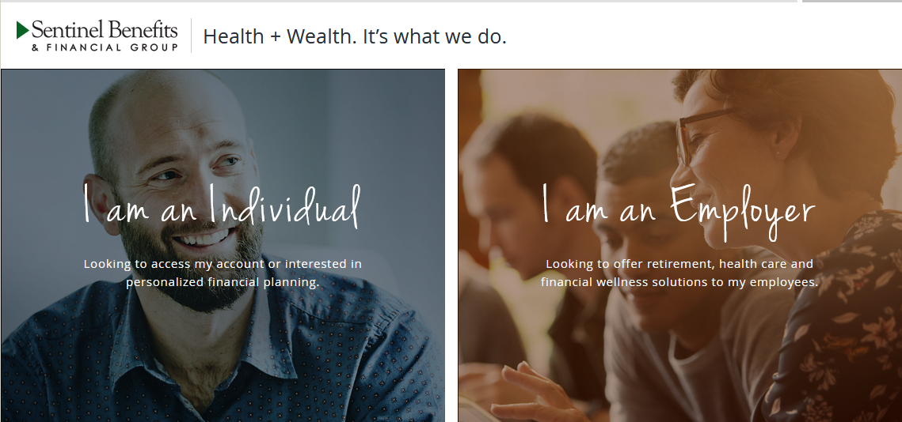
2111
Select “FSA, HSA, HRA, COMMUTER ACCOUNTS” from the Login dropdown menu.

3
On the login page, enter your Username and Password. If you have never logged in before, click on “Create your new username and password” under “New User?”

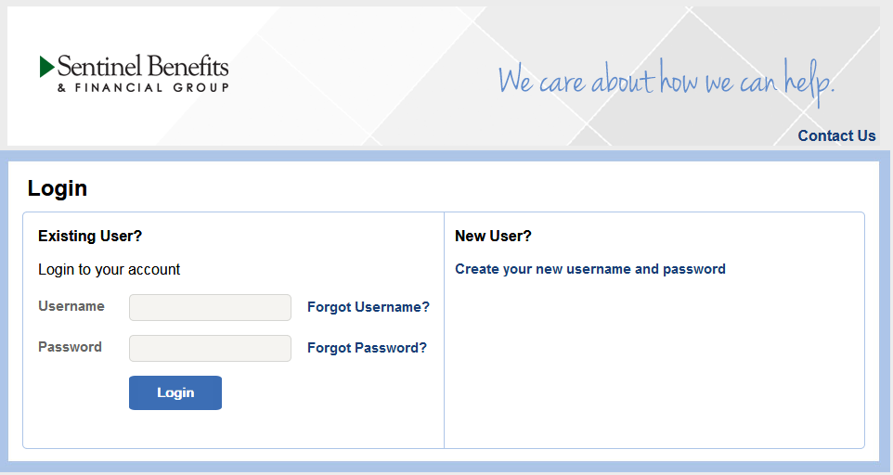
4
Once you have logged in, click “Enroll Now” in the middle of the Home page.

5
Click on “Begin Your Enrollment Now” at the top right-hand portion of the page and walk through the enrollment steps:

- Step 1: Confirm your personal information and provide any fields that are missing
- Step 2: Choose the benefits in which you will be enrolling for the upcoming plan year
- Step 3: Select your debit card preferences (if applicable)
- Step 4: Enter your election amount(s)
- Step 5: Select your preferred reimbursement method
- Step 6: Confirm all information and hit “Submit” at the bottom of the page
- Step 7: Print your enrollment confirmation

You will have the entire open enrollment window to revise your election. You can do so by logging into your account during this period of time and clicking on “Update Enrollment” in the middle of the home page.

6
Access your online account using the credentials you set up previously. In your online account you will have access to:

- View your available balance(s)
- Submit claims
- Manage your debit card
- Update your reimbursement method
- Link claims from your healthcare account
- And more!
Visit us online at sentinelgroup.com

