|  |
| --- |
| CFP Software Ltd |
| CFPwinMansdb  Charge Interest  On Arrears |
|  |

|  |
| --- |
|  |

# Contents

Contents 2

Introduction 3

Breakdown of Features 4

Setting up Charge Interest on Arrears 5

Base Rates 5

User Defaults 6

Bank Base Rate 6

Grace Period 7

Interest charge from due date 7

Percentage above base rate 7

Minimum Percentage 7

Suppress Print/Email 8

VAT on Interest 8

Simple / Compound 8

Apply Fixed Charge 8

Calculating Interest 9

Simple or Compound 10

Applying Charge Interest on Arrears 11

Posting interest 13

Introduction 13

Receipt Screen 13

Postings – Interest on Arrears 16

Posting Interest 18

Apply Fixed Charge 19

Reports 20

Interest Reports 20

Pre-existing reports 21

Merge Codes 22

Limitations 22

# Introduction

Version 4.1 of CFPwinMan onwards introduces the ability of charging interest on arrears. The interest can be calculated using formulas which take into account the current bank base rate, with additional percentages and grace periods should they be required. The system will be able to report on the interest due as at any date without the need to actually post the invoices, merge codes have been introduced which enable letters to be produced detailing these figures.

A separate way of charging interest is also available, whereby a fixed charge can be applied to each individual invoice which is in arrears as a one off posting. This will also take into account any grace periods which are in effect.

Each tenancy or tenant can adopt its own individual settings for charging interest using any of the above features or methods.

# Breakdown of Features

* The user has the ability to choose how interest is calculated using either a Simple or Compound formula, an explanation of each of these methods is given in this document.
* Bank base rates can be entered with commencement dates against any relevant banks in user defaults, these figures are used by the formulas which calculate the interest.
* The ability to specify a minimum percentage to be used for calculating interest is given.
* The ability to specify a percentage to be charged on top of the current bank base   
  rate is also provided.
* Each liable client can be configured with an individual charge rate and grace period.
* Once a grace period has expired, interest can be charged for the period starting after this date, or from the due date of the invoice.
* The option to charge VAT on interest is available based on the VAT settings of the invoice type.
* Users will be able to specify at property level which methods are used for calculating interest and also which particular invoice types will be chargeable. Therefore any tenancies or tenants residing in this property will adopt these settings.
* A default template detailing all aspects of how interest is to be charged can be configured in user defaults, to be applied to any property at the tick of a box.
* A form has been provided to give the user an overall view of all liable clients, including how much interest is currently outstanding, as well as how much is owed for any given date.
* Users will be able to post interest as at any date from either the above form or from the individual receipt screen of the tenancy or tenant.
* Where interest invoices have already been posted the system will be able to post new   
  interest invoices taking into account what has already been raised to give an accurate   
  figure of what is due.
* The system will prompt or where necessary warn users prior to receipting, that   
  interest may be due.
* Merge codes have been created to aid in the provision of notices to liable clients, detailing the interest owed as at today’s date.
* A detailed or summarised report can be created to give an overview of any interest which is posted or pending, these reports can be filtered by specific landlords, properties, tenancy or tenants.
* A separate way of charging interest is also available, whereby a fixed charge can be applied to each individual invoice which is in arrears as a one off posting. This will also take into account any grace periods which are in effect.

# Setting up Charge Interest on Arrears

## Base Rates

Before getting started with configuring the settings that affect how the Interest will be calculated,   
the user must first enter the current base rate for any banks which hold the accounts to which   
interest is to be charged for.

Users can enter User Defaults and select the button labelled **Banks** to reveal the below form.

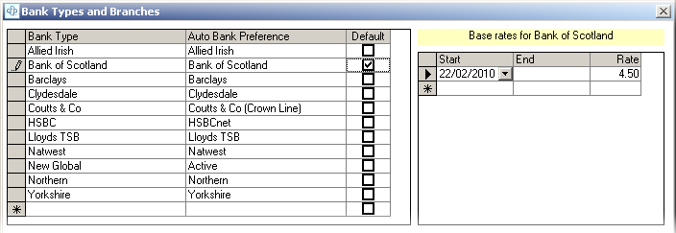

The user must first select the relevant bank from the left window, the right window is then available for entering the current base rate. The start date will need to be filled in, followed by the current bank base rate.

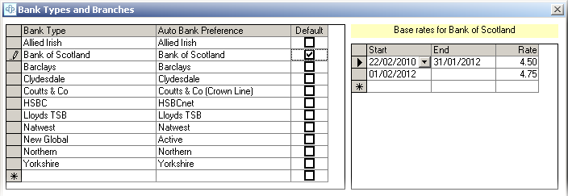

As new base rates come in to affect, the user will need to revisit this form and enter the new base rates together with a commencement date, an end date for the previous period will automatically be filled in.

Existing entries can be modified should the need arise.

Any invoices due for interest that have been outstanding for a period that spans across two base rates will be calculated accordingly.

Once the user has configured all the relevant banks in this way the **Save & Exit** button can be selected to continue with the changes.

## User Defaults

To turn on the ability to charge interest on arrears, the user must go to **User Defaults** > **Preferences** > **Property Lease Details** and place a tick in the **Charge Interest on Arrears** selection box.

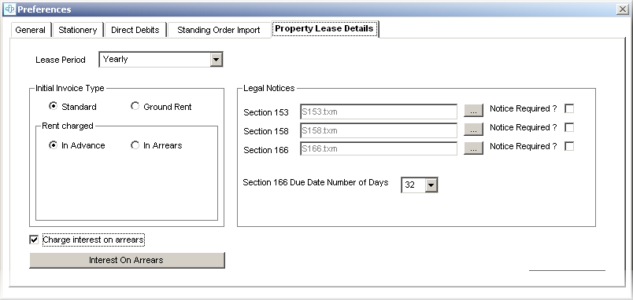

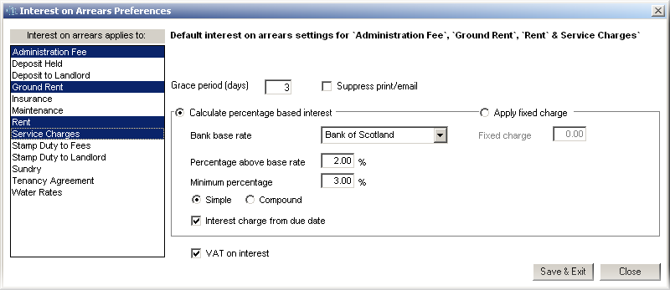The **Interest on Arrears** button will then become available for selection.   
  
Selecting this button will reveal the **Interest on Arrears Preferences** form. This form is used as a default template, the settings entered here will be suggested when enabling charge in arrears at property level, the settings can then be overridden for the property (at property level) should this be required.

Invoice Type  
The left window panel is used to select which invoice **types** the interest is to be raised against.

Bank Base Rate  
The bank whose base rate is to be used in calculating the formula can be chosen in the dropdown here.

Grace Period  
Users can choose a period of time in days that should be exceeded before an invoice becomes liable for interest, this can be achieved by entering the number of days in the **Grace Period** box.



Interest charge from due date   
Once the **Grace Period** has expired, the option to charge interest on a daily basis from the due date is available, by placing a tick in the **Interest charge from due date** selection box. Leaving this box deselected signifies that the user would like to charge interest on a daily basis starting the day after the grace period expires.

Percentage above base rate  
The formula which is used to calculate interest will initially use the bank base rate for the specified bank in order to come to a figure, users can then enter a percentage to be charged above this base rate, this can be entered into the **Percentage above base rate** box.



Minimum Percentage   
Users can also specify a **Minimum Percentage**, this ensures that whatever the bank base rate is, the percentage specified here will be the minimum rate used for charging interest.

Suppress Print/Email  
The **Suppress print/email** selection box can be selected should the user wish to prevent printouts and email correspondence from being produced when posting interest invoices, this can be overridden at the point of posting. Despite this setting an invoice will be placed in the history log to reflect an interest posting.

VAT on Interest  
Users who wish to charge VAT on interest invoices can place a tick in the **VAT on interest** box. VAT will be charged at the same rate the invoice type is configured for - *See the VAT & Disbursements section of* ***User Defaults*** *for this information****.***

Simple / Compound  
For users wishing to apply percentage based interest, a choice of two formulas is available, the **Calculating Interest** section of this user guide will detail how each of these formulas work.

Apply Fixed Charge  
Users who wish to charge a one off fixed charge for each invoice which is in arrears, can place a dot in the **Apply fixed charge** selection box, the required charge amount can then be entered. See the **Apply fixed charge** section of this user guide for more information on this feature.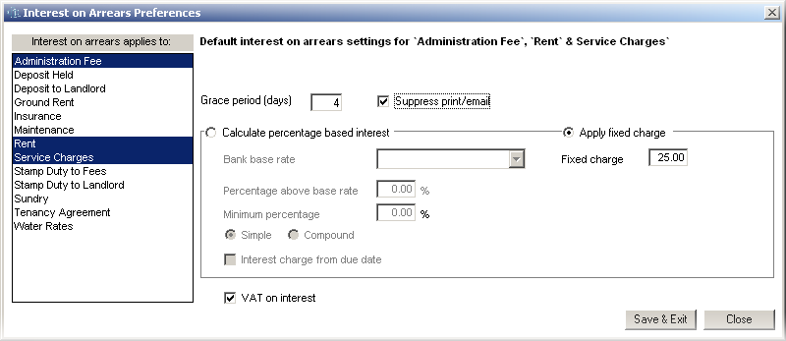

## Calculating Interest

The Interest on arrears form enables the user to choose between a **Simple** or **Compound** formula for calculating the interest, this section details how each of these formulas are calculated.



Whether the Simple or Compound formula is chosen the system will still follow the same rules for processing arrears interest. These rules are as follows.

* If a base rate has changed during the period for which an invoice has been outstanding, the system will be able to recognize this fact and calculate the correct percentage for each given time frame, these figures will be rolled into one figure to reflect an accurate amount due.
* If an item which is in arrears has had an interest invoice posted in the past, the system is able to recognize this fact and calculate interest for the time which has passed since the last posting, even if the previous interest invoice has been receipted.
* If an invoice has been partially receipted during the time in which it has been outstanding, the system will take the amounts and dates of these payments into account when processing its calculation.
* If an interest invoice has been reversed by the raising of a credit note, the system will take this into account and re-process its calculation as if the interest invoice had not been posted.

### Simple or Compound

To give a better understanding of how the formulas are put together the points below give a breakdown of each part of the formula.  
 **Time (t)**Is the number of days that have passed from the due date of the invoice **OR** the number of days after the end of the grace period, should a grace period be in place (and the user has chosen to **NOT** charge from the due date of the invoice).  
  
**Rate (r)**Is the sum of the (**Bank** **base rate** plus the **Percentage above base rate**) or the **minimum percentage**  
should this be greater.  **Principle Amount (p)**Is the outstanding figure *at the point of the calculation*. This is because payments may have been received in the past, for which interest has already been applied.

|  |  |
| --- | --- |
| **The Simple formula is:** Interest = Pr(t/365) | **The Compound formula is:**  Interest = (P(1 + r/365)t)-P |

##### Example

* An invoice of £5000 is three days overdue.
* The bank base rate is 3%, the percentage above base rate is 2%. So the rate is 5%.
* Vat is not charged on interest
* Grace period is not in place

|  |  |
| --- | --- |
| **Simple** 5000 x 0.05 x (3/365) = £2.05 | **Compound** (5000x(1+0.05/365)3)-5000 = £2.06 |

# Applying Charge Interest on Arrears

To enable the ability to charge interest on arrears for a tenancy and/or its tenants, the user must first visit the **Property Information screen** and then select the **Lease Details** button.

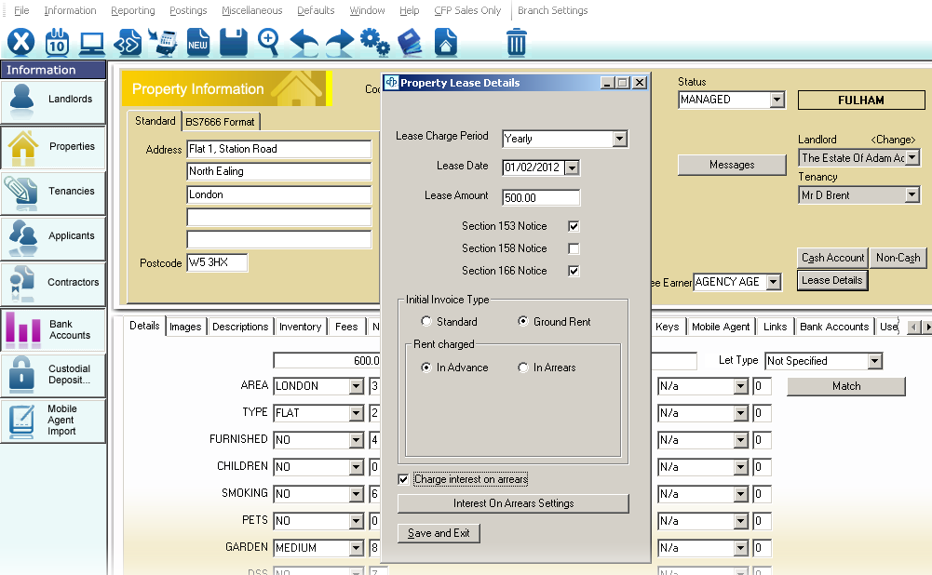

**Charge Interest on Arrears** can then be selected to reveal the **Interest on Arrears Settings** button.

Upon selecting this button the **Interest on Arrears Preferences** form will then load, the defaults settings will be shown as configured in user defaults, see the **User defaults** section of this guide on how to set up the template.



All of the above settings can now be overridden to be brought in line with the property lease details.

Once the user is satisfied that the settings on this form reflect that of the lease details for the property, the **Save & Exit** button can be selected to confirm the changes.

For users of the service charge module, setting up these details on the head property and selecting **Save & Exit** will prompt a message asking if the Units should inherit the specified settings.

From this point forward the system will check all of the property’s tenancy and tenant invoices, to identify whether they qualify for an interest charge.

*In the above example the invoice type would need to be either a Rent, Ground Rent, Service Charge or   
Admin fee and must be at least four days older then the receipt date in order to qualify.*

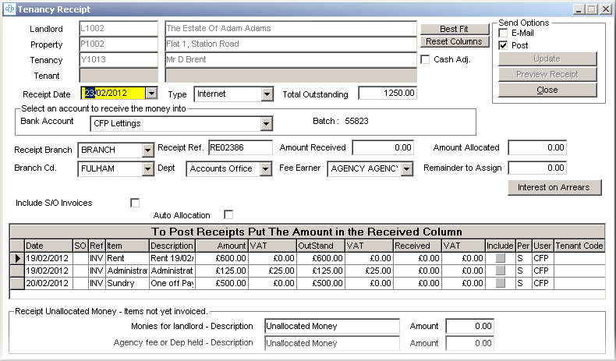

When the system identifies outstanding invoices which qualify for interest, the tenancy or tenant receipt screen will reflect this point by showing an **Interest on Arrears** button in the top right corner.

# Posting interest

## Introduction

The user can use the following steps to inform the liable client how much is owed on a specified date. It is recommended (though not essential) that interest invoices are raised on the day for which the liable client pays, otherwise should the client fail to pay on time for any reason, extra interest invoices would need to be raised for the days following the missed payment. This could lead to situations where a number of invoices are produced where one invoice would suffice.

*Note: Should the above situation arise, the ability to raise credit notes for existing interest invoices is available, an interest invoice covering the full period can then be raised in place of the reversed interest invoices.*

Users have the ability to calculate and post interest as at any date, whether past, present or future.   
There are two places provided which allow users to calculate or post interest, either the **Receipt screen** for the liable client, or from the **Interest on Arrears** form, accessible from the **Postings** menu heading.

## Receipt Screen

The user can choose to back date or forward date interest by adjusting the **receipt date** on this form.



As soon as the system detects that interest is due, the **Interest on Arrears** button will be displayed.

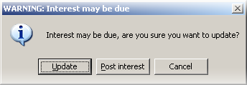If the user attempts to receive monies on a receipt screen, where interest invoices could potentially be raised, a message box will appear signifying that interest may be due, the user can choose to update anyway, or instead proceed to the **Post interest** screen.

Selecting the **Post Interest** button on this message box or the **Interest on Arrears** buttonon the receipt form launches the **Post Interest on Arrears** form.

This form shows any items which qualify for interest in white, items which   
do not qualify are shown in grey.

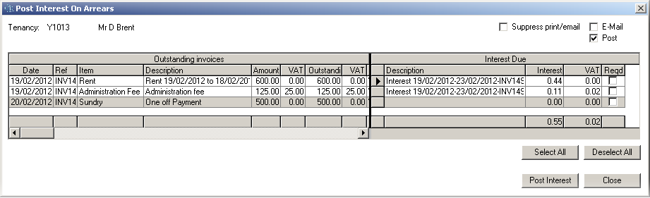

The left window reflects the details of the outstanding invoices whereas the right window details the interest which has been calculated against the outstanding amounts.

Users who wish to inform clients of the interest due, at the specified date can obtain these figures independently or as a total from this right window.

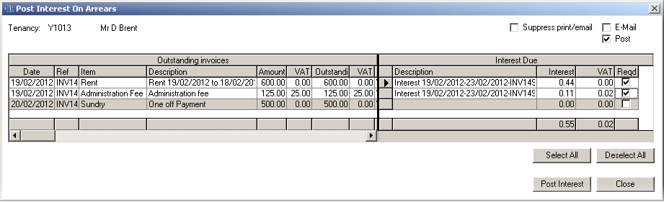

Users who wish to post interest invoices, first need to identify which invoice items they require by placing a tick in the **Reqd** tick box alongside the invoice, the use of a **Select** or **Deselect all** button is provided for mass selections.

Each selected item will have a suggested **description**, reflecting the date range and invoice number, this text can be modified should the user require it.

The user can then choose whether an **Email** or **Post** (Printout)is required at the point of posting the invoice. Once the user is satisfied that the required items are selected and the descriptions and send methods are correct, the **Post Interest** button can be selected to post the interest.

One invoice will be created containing all of the selected items. The invoice will be stored in the history log *(unless the user has instructed user defaults to not place invoices in history)*.

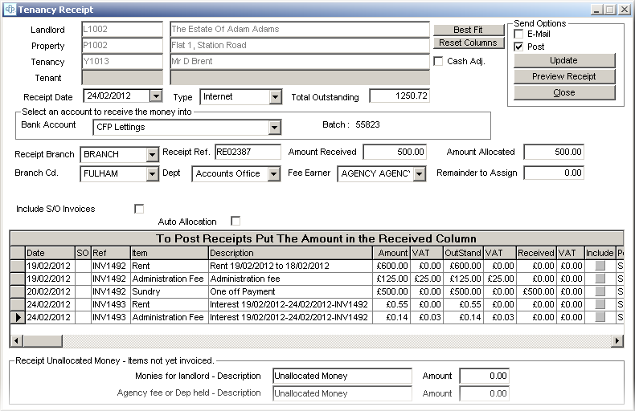

For each selected item that makes up the posted invoice, an individual invoice line will appear on the receipt screen. These Interest invoices will inherit the same invoice type as the original invoice for which interest was posted against. The above example shows this (as described below).

|  |  |  |  |  |  |  |  |
| --- | --- | --- | --- | --- | --- | --- | --- |
| **Original Invoice** | | | | **Corresponding Interest Invoice** | | | |
| **Date** | **Ref** | **Item** | **Description** | **Date** | **Ref** | **Item** | **Description** |
| 19/02/2012 | 1492 | Rent | Rent 19/02 to 18/02 | 24/02/2012 | 1493 | Rent | Interest 19/02 – 24/02 - INV1492 |
| 19/02/2012 | 1492 | Admin | Administration Fee | 24/02/2012 | 1493 | Admin | Interest 19/02 – 24/02 - INV1492 |

At this stage should a client wish to pay some (but not all) outstanding monies, the monies which are received should be used to satisfy the interest invoices before the original invoices. The reason for this is because interest cannot be issued against interest invoices as time goes by, however interest will continue to be accumulated against the original invoices.

Users may find that for whatever reason the interest invoices are not paid on the day they are raised.  
If this is the case then either the existing interest invoices can be reversed by raising a credit note and   
re-raised on the day the liable client pays, or an additional Interest invoice can be raised for the days which have elapsed since the last interest posting.

## Postings – Interest on Arrears

The other method of posting interest is carried out on the **Interest on Arrears** form, available from the **Postings** menu heading.

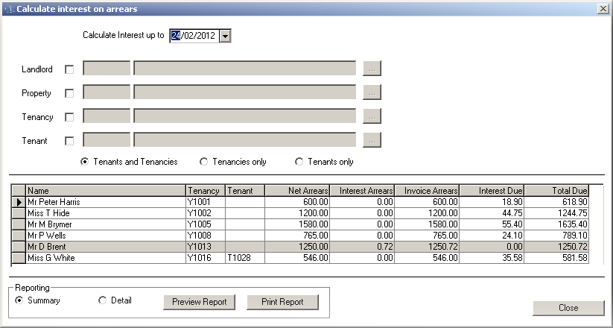

This form gives the user an overall view of exactly how much money (whether interest is owed or not) is owed, for a particular date, for all tenancies and tenants who have charge interest enabled on the property lease details form. The liable clients will only show if invoices (of any kind) exist on the relevant receipt screens.

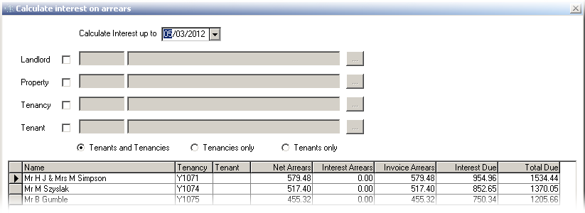The ability to forward or back date interest calculations is available by entering a date into the **Calculate interest up to** box. *Users will be able to post interest invoices on this selected date if required.*

The ability to filter the results on show by Landlord, Property, Tenancy or Tenant is available.   
By selecting a landlord or property, the system will automatically show all dependencies relating to the specified record. A separate filter section allows the user to show only tenants or tenancies in the list.

Any liable clients who have interest due will be shown in white, if invoice(s) are outstanding but no interest is due, the tenancy or tenant will instead be shown in grey.

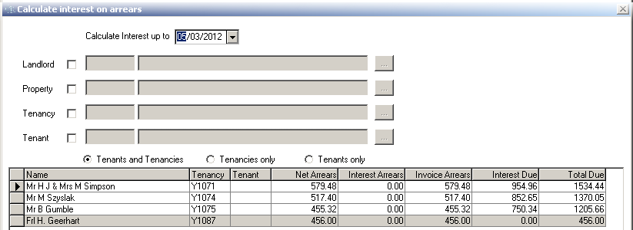

|  |  |
| --- | --- |
| Net Arrears The **Net Arrears** figure reflects all invoices *excluding* any previously invoiced interest | Interest Arrears **Interest Arrears** reflects interest that has  already been invoiced but is still outstanding |
| Invoice Arrears **Invoice Arrears** is the total of all outstanding invoices, the same as **Net Arrears** plus **Interest Arrears** | Interest Due **Interest Due** reflects the calculated interest that has not been invoiced as at the specified calc date. *A new merge code has been implemented to report this figure (see merge codes for a breakdown)* |

#### Total Due

**Total Due** adds together **Interest Due** and **Invoice Arrears** to give an overall view of outstanding monies the liable client owes as at the specified date

### Posting Interest

Should the user require to review or post interest for a particular client, the ability to achieve this is obtained by double clicking the corresponding line to drill into the **Post Interest on Arrears** form.

This form shows any items which qualify for interest in white,   
items which do not qualify are shown in grey.



The left window reflects the details of the outstanding invoices whereas the right window details the interest which has been calculated against the outstanding amounts.

Users who wish to inform clients of the interest due, at the specified date can obtain these figures independently or as a total from this right window.



Users who wish to post interest invoices, first need to identify which invoice items they require by placing a tick in the **Reqd** tick box alongside the invoice, the use of a **Select** or **Deselect all** button is provided for mass selections.

Each selected item will have a suggested **description**, reflecting the date range and invoice number, this text is available to be modified should the user require it.

The user can then choose whether an **Email** or **Post** (Printout)is required at the point of posting the invoice. Once the user is satisfied that the required items are selected and the descriptions and send methods are correct, the **Post Interest** button can be selected to post the interest.

One invoice will be created containing all of the selected items. The invoice will be stored in the history log *(unless the user has instructed user defaults to not place invoices in history)*.

# Apply Fixed Charge

Instead of using bank base rates and additional percentages to charge interest, a simpler approach of charging fixed amounts is available. The interest is processed as a one off charge for a fixed amount.

With **Charge Interest on Arrears** enabled in user defaults *(see user defaults section of this manual)*the user must then visit the **Property Lease details** button available on the relevant property form.   
  
After enabling the property for charging interest the user can then set up the interest preferences   
as shown below:

Should a grace period be required the ability to enter one is provided.

To enable the fixed charge method a dot should be placed in the **Apply fixed charge** option.

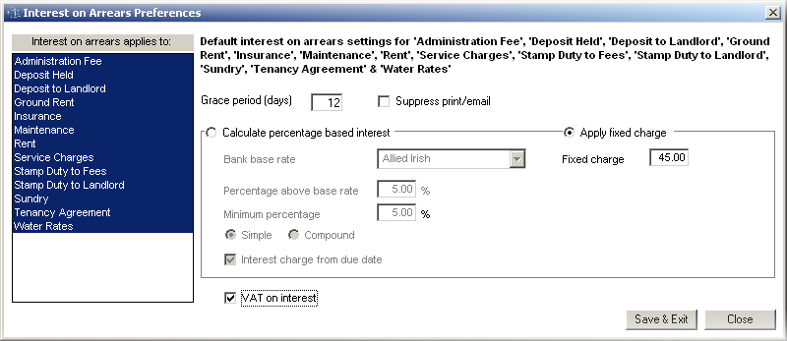

The Invoice types that interest is to be raised against, must be selected

The user must decide whether VAT is to be charged on the interest postings.

The user can enter the amount they wish to charge in the **Fixed Charge** box.

Once the user is satisfied with the settings, **Save** & **Exit** can be selected to confirm the changes.

The fixed charge can be applied to each outstanding invoice type, providing they qualify for charging interest. Example (using the above settings) if a tenant is 30 days late for paying both Rent and Deposit, an amount of £90 will be charged, £45 of which will be invoiced as rent and £45 will be invoiced as deposit.

From this point forward the interest can be posted using the methods described in the **Posting Interest** section of this user manual.

# Reports

## Interest Reports

Two reports detailing interest are provided on the **Interest on Arrears** form, available from the **Postings** menu heading.

The user has the ability to produce a basic summary report containing everything shown on this form,   
the report takes into account any filters should these be enabled.

To produce this basic report the user can place a dot in the **Summary** option. The ability to either Preview or Print the report is then available. An example of this report is shown below:

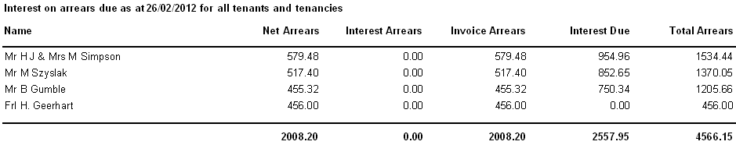

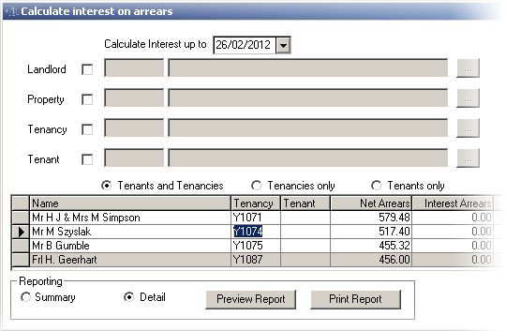  
A more informative report is available, providing the same information as above but broken down by invoice type.

This report can be obtained by placing a tick in the **Detail** option, the user once again has the ability to either Preview or Print the report.

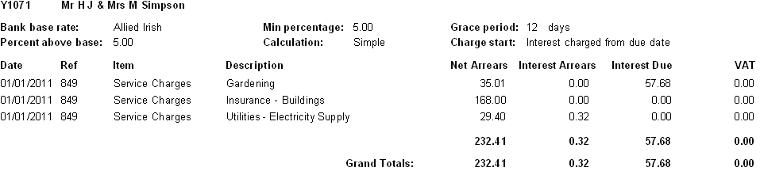An example of this report is shown below:

## Pre-existing reports

The pre-existing **Standard** or **Age Debtors** reports obtained by visiting **Reporting > General > Invoicing and arrears > Invoice arrears** show whether a tenant or tenancy *may* have interest outstanding. Due to the ever changing value of interest due, the actual values are not reported here.

**Standard** example shown below:

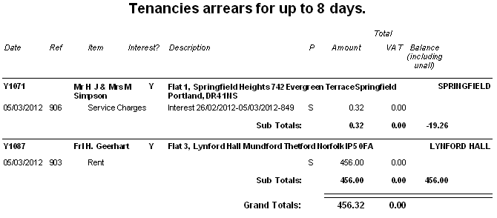

**Age Debtors** example shown below:

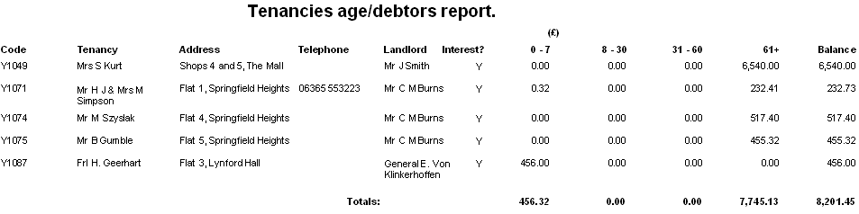  
Fast Track receipts

Fast track receipts by nature was designed to be as fast as possible, introducing the ability to calculate interest on fast track would have slowed down the process considerably, it is for this reason that the ability to calculate interest has been withheld from this form.

* Fast track receipts does not attempt to calculate or post interest.
* Should the user attempt to launch fast track receipts where monies are due for   
  interest, a message box will be shown informing the user of this fact.
* Any tenancies or tenants who have interest due will then be   
  shown in RED (for tenancy) or ORANGE (for tenant) to highlight this fact.

# Merge Codes

A number of merge codes have been created in order to provide the user with the ability to report on how interest is calculated, as well as the ability to show interest due as at today’s date.

The merge codes are shown below:

#### Property Merge codes:

|  |  |
| --- | --- |
| <<PINTBASERATE>> | The name of the bank whose base rate is used to calculate the interest |
| <<PINTPERCENTABOVEBASE>> | The percentage charged above the base rate - used to calculate interest |
| <<PINTMINPERCENT>> | The minimum percentage rate that will be charged |
| <<PINTGRACEPERIOD>> | The grace period before interest becomes applicable |

#### Tenancy Merge codes:

|  |  |
| --- | --- |
| <<TYINTDUE>> | The tenancy interest due as at the date of the letter |

#### Tenant Merge codes:

|  |  |
| --- | --- |
| <<TINTDUE>> | The tenant interest due as at the date of the letter |

#### Example Letter:

An example letter aimed at a tenant who is due interest is shown below.

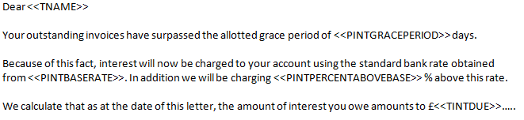

# Limitations

**Direct Debit** and **Standing Order** Invoices will not qualify for charging interest.

For users of the service charge module, any schedules that have **Instalment plans**   
enabled will find that interest will be due on the full amount.

# 