Sending a Decline Email via TAM
WORDING:
Dear Applicant:
We very much appreciate your interest in the [position title] position in the [department name] and the time invested both in the application process and in the interview.
There was a very strong pool of candidates, yourself included, which made for a difficult decision. While we enjoyed learning about you, we have selected another candidate for this role.
We hope that you will continue to monitor our employment web site for other positions that may be of interest to you or utilize your knowledge and skills.
Thank you for your interest in UWEC and best wishes in your future job searches.
[Supervisor name]
[Department]

TAM INSTRUCTIONS:

Selecting Applicants
- Locate the Applicant for which you are sending correspondence by accessing the Job Opening or Application. See KB TAM - Search for Job Opening or By Application or TAM - Recruiting Home Page, for additional information.
- Locate the row of the applicant to whom you are sending the email. Click Other Actions > Applicant Actions > Send Correspondence.
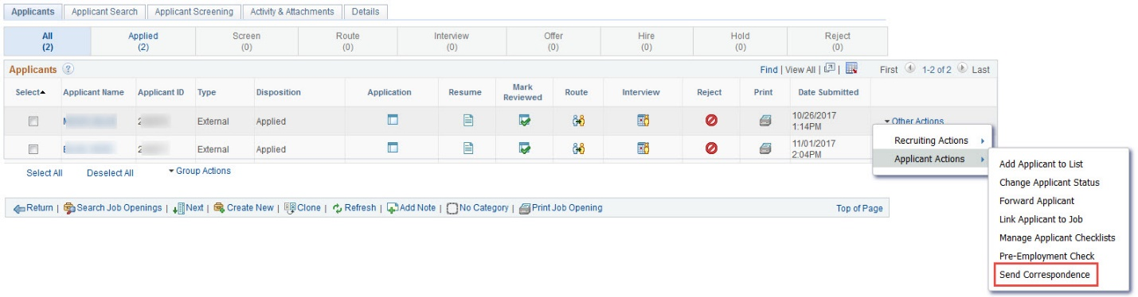
NOTE: To send an email to multiple applicants, you would select those applicants and use the Group Action field to initiate the email correspondence.
- Check the boxes next to the applicants you want to send correspondence.
- Click Group Action > Applicant Actions > Send Correspondence
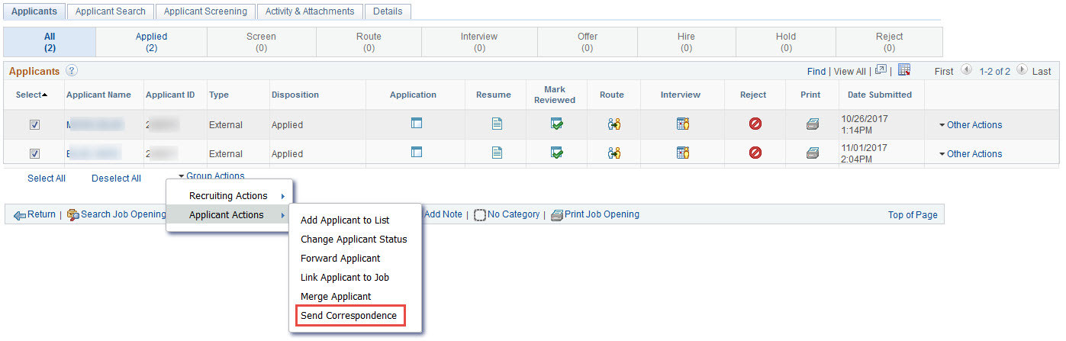

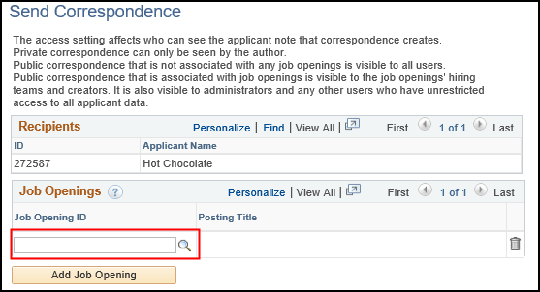
Sending Email

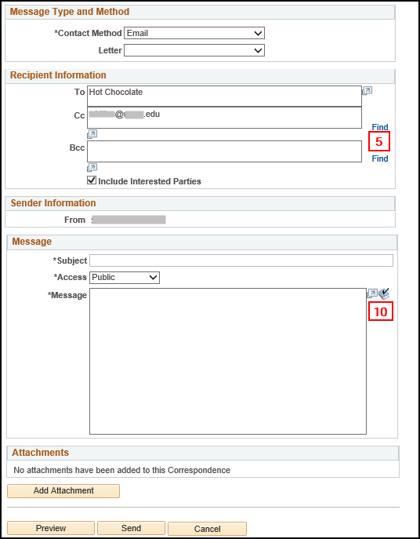

- Enter a Job Opening ID if one is not already populated. Note: A job opening ID must be added if using Send Correspondence to ask the final candidate the required questions per UPS Operational Policy TC 1: Recruitment.
  - The system will automatically populate the job opening ID if the user is initiating Send Correspondence within/associated with a job opening.
  - An applicant contact note will be created for tracking within TAM. Including a job opening ID will tie the communication note to that specific recruitment. Then viewing the note is restricted to only those Recruiters and TA Coordinators associated with the specific job opening.
- The Contact Method defaults to Email.
- The To field already shows the applicant or applicants whom you selected. You cannot modify this field.
TAM will send the email to the applicant's preferred email address. If the applicant record does not include a preferred email address, you will receive an error when you send the email.
  - NOTE: If you are sending the correspondence to multiple applicants, all names appear together. However, the system sends separate correspondence to each applicant and the applicants do not see the other names in the To field of the email they receive.
- Enter any additional UW employee recipients using the Cc or Bcc fields.
  - To look up recipients, click the Find link.
  - You can find employees using their empl ID or Name (First Name Last Name).
  - If multiple email addresses appear, click the box next to the one(s) to use.
  - Click the Add Selected button. The selected employee(s) now appears in the designated field (Cc or Bcc).
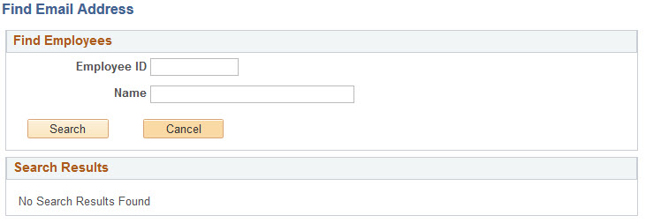
- Include Interested Parties box is selected by default.
  - Leave this box checked to include individuals marked as interested parties on the Manage Applicant page, to include others in the correspondence, they can either add them in the Manage Applicant Interested Party area, or CC or BCC them when creating the correspondence. NOTE: This is not the Interested Parties section on the Assignments page.

- Enter the email's Subject information.
- In the Access box, select Public or Private.
  - leave the access as Public if all users with security can see the message (Preferred)
  - change the access to Private if only the sender to see the note

- Enter the Message text you want to send.
NOTE: If copying & pasting from MS Word documents that include special characters they must either be retyped in the message after pasting, or first pasted into NotePad. Otherwise Microsoft's special characters will appear as upside down question marks to the applicant. Examples, bullet points, apostrophes, quotation marks, space hyphen space combinations.
- Click the Spell Check button to use the spell check.
- Click on the Add Attachment button to add any attachments from your computer files.
- Click the Preview button to preview your email message.
  - You cannot make changes on this page.
  - Click the Return button.
- Click the Send button.

