A close up of a logo

Description generated with very high confidence

Access your strata information online!

Login to your online portal to view important contacts, property data, and financials at any time.

You'll be able to view and download documents and reports relevant for your property - perfect for tax time or whenever else you need them.

A hand holding a cell phone

Description generated with very high confidence

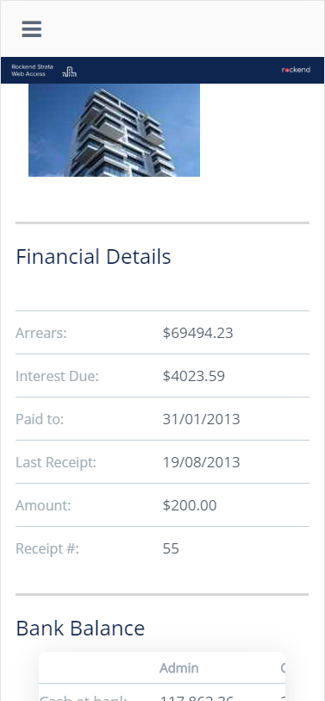

A close up of a sign

Description generated with high confidenceA picture containing object

Description generated with very high confidence­

View scheduled and previous meetings

View important property and financial data anytime.

Access your property information 24/7

Recover your login details if you forget

Directly contact our business from the portal

Quick tip: You can login to the portal at any time by going to **[insert web address]** and entering your username and password.

A close up of a logo

Description generated with very high confidenceA close up of a logo

Description generated with very high confidenceA close up of a logo

Description generated with very high confidence

Adding the portals on an **iPhone**

1. Open the Safari web browser (please note: this will not work on Google Chrome browser)
2. Navigate to the portals website by going to **[Insert Web Address]**
3. Select the share icon Related image
4. Select the ‘Add to Home Screen’ icon in the bottom row of Icons (you may need to swipe left on the bottom row) 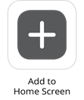
5. Input a name for your icon
6. Click ‘Add’ in the top right corner

You will now be able to access your portals homepage with a single click of the icon. Simply enter your access code and password to log in.

Adding the portals on an **Android** device:

1) Open the Google Chrome web browser

2) Navigate to portals website by going to **[Insert Web Address]**

3) Select the menu icon in the top right corner 

4) Select ‘Add to Home Screen’

5) Input a name for your icon

6) Click ‘Add’

You will now be able to access your portals homepage with a single click of the icon. Simply enter your Access Code and Password to log in.

Available on:

Add the portals to the home screen of your smart phone