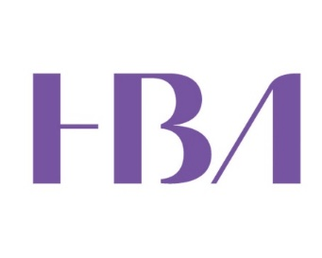
Set-Up Form
Making the Most of Your HBA Membership
V0352019

- Please submit this form no less than 6 weeks prior to the event date.

Forms submitted less than 30 days prior to an event may require your chapter president’s approval.

Send completed form to events@hbanet.org
Chapter/Affiliate location: (for a full list of chapters/affiliates, visit http://www.hbanet.org/chapters)

Event date: Start time: End time: Time Zone:
Event title: Making the Most of Your HBA Membership
Event short description
Join us to learn about all the exciting opportunities that your HBA membership provides.

Event description
Join us to learn about all the exciting benefits and opportunities that your HBA membership provides. Whether you are brand new to the HBA or a longtime member looking to get more involved, you will learn how to make the most of your HBA membership, updates on upcoming programs, and news about your HBA region and local chapter. Learn how to leverage your HBA involvement and experience the positive impact it can have on your career.
Event location and/or Dial-in information
Name of venue:
Address: City/state/zip:

Conference Call Number: Pin Number (if applicable):

Special instructions (e.g., parking information):
Speakers (if applicable)
Name:
Title:
Company:
Email (not published):

Registration information
Event is open to: HBA Members and nonmembers
Online registration deadline:
Onsite (walk-in) registration:

Capacity
Is capacity limited? Space is limited to registrants.

- Chapter contact for event: Name: Email: Phone:

