

Version: 2
Date: 27 November 2019

Contents
CareRight Billilng and Claiming Overview 5
Type of Claim 5
Broad Billing Categorisation 6
Preconfigured Data Prior Billing 7
Practise Billing / Medical Specialist 8
Invoicing 8
Invoices and Credits Screen – Patient Record 9
Scenario 1 9
Scenario 2 9
Scenario 3 10
Perform an OPV 10
How to raise an Invoice 10
Paying in Full (immediately after raising the Invoice) 11
Printing an Invoice 11
Printing of Today’s Invoices /Receipts 11
Claim an Invoice 12
Reversing an Invoice 12
Paying a Gap 12
How to take a payment after the Invoice has been raised / for multiple line items 12
How to receipt a payment (and claim) – invoice raised separately 13
Guarantor - Medicare Bulk Bill or DVA 14
Health Fund (online enabled) 15
Private Patient 16
Other 3rd Party (and non online health funds) 17
Accounts 18
Account 18
How to create an account (super user) 18
Private Accounts set up 18
Medicare / DVA Accounts set up 19
Health Fund Accounts set up 20
Workers Compensation Legal Accounts set up 21
How to adjust the billing rate for a Private Account 22
How to raise an invoice from the accounts page (existing Account) 22
Editing Invoices 24
Editing Line items 24
How to add DVA White Card specified condition detail to an existing invoice 24
Receipting 25
Payments 25
How to receipt a payment (and claim) – at the time of invoice 25
Pay Gap 26
How to receipt a payment (prepayment of excess / co-pay etc) 28
Payment Allocations 28
Payment made for /across multiple invoices 28
How to allocate a prepayment to a Health Fund invoice 29
Adjustments 31
Adjusting a Line item 31
Reversals 31
How to reverse a payment allocation and reverse an invoice 31
How to Reverse an Invoice Payment 32
Raising a Refund 33
Claiming 34
Manual Batch Payments 34
Automated Claim Payments 34
Claiming Scenarios 34
Medical Specialist 34
Day Hospital 34
Day Hospital with xx 35
Reviewing Claims 35
Claiming – FAQ /Trouble shooting. 39
Resolving problems with a batch claim 39
Wrong patient billed & paid 39
Service claim denied (eg duplicate) 39
Variation between price claimed and price paid 39
Unpaid due to referral issue (eg missing/ expired): 40
Advanced 42
Invoices and Credits – Location 42
Invoices and Claims – Location 42
Invoices and Claims – Dashboard 42
Claims ?? 43
Manual ERA (Electronic Remittance Notice) Payments?? 43
Day Hospital Billing 45
Day Hospital Billing & Receipting Process 45
In Hospital Claim – Thelma / e-healthwise / Eclipse 50
In Hospital Claim – CareRight / Eclipse 51
Banking / Reconciliation 52
Banking 52
Daily Banking (even if not done daily) 52
Check Account Balance 52
Run Ledger Report 52
Running a report 52
How to Process Banking 53

CareRight Billing and Claiming Overview

Type of Claim
Manual Claiming Paper based | Scenario | Claim Process | Claim Form

Paper based Batch Generation

IHC – Full HC21 Form Generation
Electronic Claiming | Scenario | Claim Process | Claim Form
Bulk Billing (Medicare & DVA) |  | Medicare Online | Medicare/DVA
PCI (Patient Claims Interactive) |  | Medicare Online | Medicare
IMC (Inpatient Medical Claims) |  | Eclipse | Healthfunds
IHC (Inhospital Claims) | Day stay | Clintel/eclipse | Healthfund/ DVA
 |  | HC21 | Healthfunds/DVA
IHC (Inhospital Claims) | Multi stay | Thelma/eclipse | Healthfunds/DVA
 |  | HC21 (manual) | Healthfunds/DVA

Broad Billing Categorisation

General / Practice | Scenario | Claim Process | Claim Form

Professional Attendances (Consultations)

Diagnostic Imaging

Diagnostic Procedures

Therapeutic Procedures (Surgery)

Pathology Services

Assistant Billing (Providing assistance during surgery)

Assistant Billing (Receiving assistance during surgery)

Anaesthetics Billing

Out of Hospital (Outpatient)

Billing Medicare, DVA or Private Patients.

Out of Hospital billing covers all billing not directly associated with a hospital admission.

In Hospital (Inpatient

Billing Health Funds or Private Patients.

In Hospital billing covers the following billing scenarios:

Medical Specialist InPatient Medical Claims.

Hospital Accommodation, Theatre and Bundled Services claims.

3rd Party Billing

Non MBS billing to 3rd parties like legal firms and direct patient billing

billing other hospitals

Preconfigured Data Prior Billing

Locations
- A location represents the financial entity that you wish to group billing activities on.
- You can use different locations for invoicing and the receipting of payments.
- Each location has its own banking process.
- Locations are configured per business requirements and independent of Medicare claiming requirements.

Service Locations
- A Location can have one or more Service Locations
- A Service Location represents the different locations that a provider provides services.
- A Service Locations may be external to the business running CareRight, for example local public or private hospitals the doctor uses.
- Service Locations are mostly defined based on Medicare registration details for claiming purposes.

Accounts
- Accounts are the financial record for the relationship between a patient, a guarantor and the financial reporting provider.
- The account structure chosen affects reporting options.
- Accounts can be put on hold, sent to debt collectors and closed.

Provider
- Provider can be used in two ways for Billing.
  - As the Provider on an account, called Financial Provider.
  - As the Provider on an invoice, called Service Provider.
- Financial Provider is used for reporting and account management based on business process.
- Service Provider is assigned to an invoice based on who did the work from a claiming perspective. (Controlled via Medicare/DVA etc.).

Guarantor
- The entity responsible for paying an invoice.
- Can be:
  - Patient
  - Patient guardian/parent etc.
  - Medicare/DVA
  - Health Fund
  - WorkCover/Accident Authority.
  - Legal 3rd Party (e.g. Law Firm)
- In built smarts to manage claiming to Health Funds, Medicare, DVA following applicable rules.
- Claims to any third party can be managed as batches.

Practise Billing / Medical Specialist
Patient Summary Screen and Billing. How your patient summary configuration affects billing.

Creating an Invoice
- Create invoice and auto create/allocate patient account. How this works and when I should use it.
- Create patient account manually. What are my options and when should I use it.
- Billing the Patient
  - PCI Claims
- Billing Medicare (Bulk Billing)
  - Batching
  - Online / Offline processes
- Billing DVA (Bulk Billing)
  - Batching
  - Online / Offline processes
- Billing a Health fund for Doctor services (IMC)
  - Handle different gap scenarios
- Billing a Health Fund for Hospital Services
  - OEC
  - Excess/Co-payments/Gap
  - Paydown gap
  - IHC Claims
- Billing third-parties (not already listed)
  - Batching

Patient Summary
Ensure a patient has the following information recorded against their summary:
- Government Benefits
- Medicare
- Pensions
- Department of Veterans Affairs.
- Health fund

Invoicing
There are 5 major types of invoices that can be raised in CareRight.
- Medicare Bulk Bill or DVA
- Heath Fund
- Private
- Other – 3rd Party (Workers Compensation)
- In Hospital Claims

- Invoices must contain one or more Items.
- Items represent available goods and service that can be billed.
- Items can be:
  - MBS
  - Custom
  - Smart code
- MBS Items know how the need to be claimed and interact with other MBS Items on the same invoice.
- Custom codes are user defined for billing non-MBS Goods and Services.
- Smart codes are special Items defined in the system for working with complex claiming scenarios easily like assistant billing or anaesthetist billing.
- Invoices know how to apply multiple procedure rule.
- Invoices handle management of gaps, excesses and co-payments.

Invoices and Credits Screen – Patient Record
To access the Invoices & Credits screen against a Patient Record

- Search for the Patient
- Select Invoices and Credits the left side menu

The Invoices & Credits screen has the following sub-menus:
- Today (defaults to this sub-menu screen)
  - Today’s Invoices
  - Today’s receipts
  - Today’s Refunds
- Unpaid
  - Unallocated Credits
  - Private Unpaid Invoices - list of items being paid for by the patient
  - Health Fund & 3rd Parties Unpaid Invoices -- list of items being claimed, with outstanding amounts for the patient to pay
  - Medicare & DVA Unpaid Invoices - - list of items being claimed, with outstanding amounts for the patient to pay.
- Estimates
  - Current Estimates
  - Archived Estimates
- All
  - Displays All Invoices

From the Invoices and Credits screen you can:
- Raise an Invoice (New Invoice button)
- Take a payment for an Invoice (Payment from Patient button)
- Take a deposit (New Deposit button)
- Print Invoices/ Receipts (Print selected button)

A payment can also be recorded and allocated to a line item on an issued invoice.

Scenario 1
- Invoice is raised for a patient (Health fund / 3rd party etc)
- Claim is made successfully
- Patient pays gap?
- Invoice printed

Scenario 2
- Invoice is raised for a patient, it’s a private account (no cover)
- Patient pays in full and receipted
- Invoice Printed

Scenario 3
- Invoice is raised for a patient (DVA / Medicare)
- Claim is processed – bulk billed
- Patient doesn’t need to pay anything
- Invoice is printed.

Perform an OPV
Patient checks with Medicare or veteran affairs or health funds
Scenarios where a patient has Medicare details and health fund details entered:

OPV will check with Medicare & Healthfnd

How to raise an Invoice
- Go to Patients and select/search the required patient
- Select Invoices and Credits the left side menu
- Select New Invoice Button
- Fill in all details regarding Guarantor, Location and Provider
- Select New Invoice button
- If a Referral is required for the service, select the Referral details
- Update any other details as required
- Select Create Invoice
- The Invoice screen will display
- Scroll down to the New Line items section
- Select the Item Number from the Drop down
- Select Add line item to Invoice (this will populate the line items section)
- For additional line items, repeat the process (steps xx)
- Once all items are added, select Create Invoice button
- Invoice will be created

Once an invoice has been created you can:
- Edit
- Reverse
- Pay in Full
- Pay Gap
- Print
- Claim

These buttons are displayed under the patient banner on the Invoice screen.
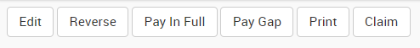

Paying in Full (immediately after raising the Invoice)
- Select the Pay in Full button (at the top of the page, under the patient banner)
- The Payment screen will display
- In the Transaction section, select the Method of payment and amount
- If the payment is being made by multiple methods (e.g. credit card & cash) select the Advanced button
- This allow a split payment to be entered.
- Select Add Transaction to Receipt
- Once all payment methods are entered
- Select ‘Create Receipt’ or ‘Receipt and Claim’ button.
- A successful message will display (green – receipt created & paid)

Now that the invoice has been paid it can be claimed (if relevant) or printed.

Printing an Invoice
Once the Invoice has been raised and then Paid you can print it

- Select Print button at the top of the screen
- The Invoice will either Auto print or download for printing depending on your settings.
- If set to download, a dialogue box will display
- Select View the Result and a PDF will be created
- Open the PDF and print.
- If the Auto print option is set, the PDF will display on screen
- Select the Print button

Printing of Today’s Invoices /Receipts
- The current "Patient > Invoices & Credits" screen will become a second tab called "Unpaid" with a new tab called "Today" being the first tab.
- The new "today" tab will list all invoices, receipts and refunds with a date of the current day. In front of each item will be a checkbox. If the item is an invoice, receipt or refund on a private account or health fund account the checkbox will be checked.
- There will be a button called "Print Selected". When pressed the pdf's for all selected items will be combined to one PDF and returned to the page to display embedded in the page. A download link will be provided under the embedded copy.
- The "today" screen will have the "Payment from Patient" button like the "Unpaid" tab, after completing the process the user should be returned to the tab they started from.
- The "today" screen will show:
- A warning and list any unallocated credits if they exist.
- A warning will be displayed if the patient has any other unpaid private account invoices.
- An information message will be displayed if the patient has unpaid invoices on non-private accounts.

Claim an Invoice
Once the Invoice has been raised and then Paid you can Claim it

- Once the From the Patient record, select the invoice to pay gap on.

- Select the Claim button (at the top of the page, under the patient banner)
- This will display the Claims screen
- Select Patient Claim Interactive button (top right of the screen)
- An Inpatient Medical Claim options screen will display
- Select / Update relevant fields
  - Alternate Address
  - Alternate Banking Details
  - Automatically Accept Claim (this should be checked)
- Select Patient Claim Interactive button
- A successful message will display (green)
- The Medicare Request screen will display with the information about the claim

Reversing an Invoice
This would usually be done because xxx
- From the Patient record, select the invoice to be reversed.
- Select the Reverse button (at the top of the page, under the patient banner)

Paying a Gap
- From the Patient record, select the invoice to pay gap on.
- Select the Pay Gap button (at the top of the page, under the patient banner)
- The Payment screen will display
- In the Transaction section, select the Method of payment and amount
- If the payment is being made by multiple methods (e.g. credit card & cash) select the Advanced button
- This allow a split payment to be entered.
- Select Add Transaction to Receipt
- Once all payment methods are entered
- Select Create Receipt or Receipt and Claim button.

How to take a payment after the Invoice has been raised / for multiple line items
If a patient is needing to pay an invoice directly,

- Select Payment from Patient
- A list of outstanding line items will display.
- Each item will show:
  - Invoice number - unique system generated number
  - Item number - the procedure item code
  - Service Date
  - Billed amount - the procedure amount being billed
  - Paid amount - either the amount paid by the fund, the patient, or both
  - Patient Gap amount - this is the amount the patient will need to pay to settle the account
  - Due amount - amount due by either the patient or the fund.
- The patient may wish to make payments over a number of items listed, therefore enter the amounts being paid for each line item under the Allocate field. Outstanding amounts will be pre-populated (assuming the patient is paying in full), therefore ensure you remove the Allocate amounts if these items are not being paid for at that stage.
- Select the Combined Payment button
- The Receipt and Transaction will display
- Enter the Transaction Method
- Enter the credit amount (i.e. the payment amount) – this may already be populated.
- Select Create Receipt button

The transaction will display in the Today’s Receipts menu and the Receipt can be printed.

How to receipt a payment (and claim) – invoice raised separately
Alternative, if paying an invoice that was previously raised:
Go to Invoices & Credits:
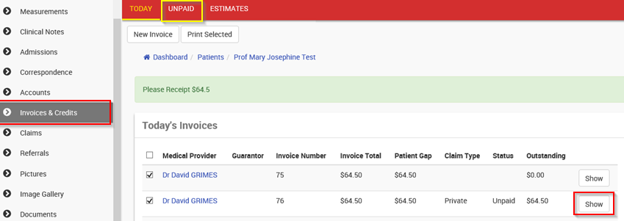
Click ‘unpaid’
Click Show on the invoice to pay
Click ‘Pay in full’ (as per above process)

Raising Invoices
There are 5 major types of invoices that can be raised in CareRight

Type | Explanation | Sample Account Name
- Medicare Bulk Bill or DVA | Invoice sent direct to Medicare/DVA on behalf of the patient with payment being made directly to the practice | MP - Medicare
- Health Fund | Invoice sent to health fund on behalf of patient with payment by fund being made directly to the practice. Co-payment made by patient to the practice. | JK - Fund - Medibank Private Gapcover
- Private patient | Invoice sent to patient or parent/guardian. May be paid on the spot. Patient may use invoice to manually claim from Health Fund | MP - Private - Private
- Other 3rd party | Invoice sent to third party (eg legal firm or Workers Compensation Agent) who are responsible for payment of the account | JK - W. Comp - WorkCover SA
5. In Hospital Claims | Invoice for hospital services sent to health fund | WH - Fund - BUPA

To raise an invoice, follow these steps:-
- Search for relevant Patient
- If a referral is required confirm that one is available by clicking ‘Referrals’ on sidebar and if none active then create new referral
- Click on Invoices and Credits
- Select the ‘New Invoice’ button

Depending on the type of invoice being raised (and therefore the account type selected) the process is slightly different from here on. If appropriately configured, all invoice types except ‘Other 3rd Party’ can be claimed online. Online claims must consist entirely of MBS items.

Guarantor - Medicare Bulk Bill or DVA
For Guarantor of Medicare:

- Select Service Location
- Select Service Provider
- Select Account provider (this can be set to default to Service Provider value
- Select New Invoice button
- Select Referral or relevant Invoice Override Code
- Fill in any other relevant information
- invoice date, will be today’s date by default (this can only be overwriten with super user permissoins), select relevant service date
- If Service Location is an Inpatient or Procedure Centre location, then a ‘Default Hospital Settings’ section will need to be filled in (see Inpatient / Procedure Centre section)
- Select ‘Create Invoice’
- Entering line items - For each item on the invoice
  - Set the ‘Date of Service’ if the item wasn’t given/performed today
  - Enter the item number (or select from pop-up list
  - If necessary, enter the time the item was given/performed
  - Set units if required
  - If there are other details about the item to enter click on ‘Other Line Item Values’ and enter the details in the appropriate field of either the ‘Medicare Online’ or ‘Administration’ sections
  - Click ‘Add Line Item to Invoice’ buttom
- To remove an item click the ‘remove’ button next to the item in the ‘Line Items’ section
- If there are multiple procedures in the item list an ‘Apply MPR’ button will appear to allow the Multiple Procedure Rule
- Once all items have been added and all their details are correct click the ‘Create Invoice’ button
- The invoice is now ready to be included in your next batch for the location it is linked to ( see batch claiming)

Health Fund (online enabled)

- Select Service Location
- Select Service Provider
- Select Account provider (this can be set to default to Service Provider value
- Select New Invoice button
- Select Referral or relevant Invoice Override Code
- Fill in any other relevant information
- invoice date, will be today’s date by default (this can only be overwriten with super user permissoins), select relevant service date
- If Service Location is an Inpatient or Procedure Centre location, then a ‘Default Hospital Settings’ section will need to be filled in. If Service Location is an Inpatient or Procedure Centre location type then a ‘Default Hospital Settings’ section will appear. These should have the correct values by default (which for most funds are the values “Agreements’ and ‘Verbal’ but for Medibank Private are ‘Scheme’ and ‘Not Obtained’) (see Inpatient / Procedure Centre section)
- Select ‘Create Invoice’
- Entering line items - For each item on the invoice
  - Set the ‘Date of Service’ if the item wasn’t given/performed today
  - Enter the item number (or select from pop-up list
  - If necessary enter the time the item was given/performed
  - Set units if required
  - If there are other details about the item to enter click on ‘Other Line Item Values’ and enter the details in the appropriate field of either the ‘Medicare Online’ or ‘Administration’ sections. Patient Co-payment and excess amounts are entered here in the ‘Patient Contribution’ section..
- Click ‘Add Line Item to Invoice’
- To remove an item click the ‘Remove’ button next to the item in the ‘Line Items’ section
- If there are multiple procedures in the item list an ‘Apply MPR’ button will appear to allow the Multiple Procedure Rule
- Once all items have been added and all their details are correct click the ‘Create Invoice’ button
- The invoice is now ready to be submitted or you could enter/allocate a payment to it before sending
- To submit the invoice, click the ‘Claim’ button
- In the resulting window click the ‘Inpatient Medical Claim’ button top right

Private Patient
- Select Service Location
- Select Service Provider
- Select Account provider (this can be set to default to Service Provider value
- Select New Invoice button
- Select Referral or relevant Invoice Override Code
- Fill in any other relevant information
- invoice date, will be today’s date by default (this can only be overwriten with super user permissoins), select relevant service date
- If Service Location is an Inpatient or Procedure Centre location type then a ‘Default Hospital Settings’ section will appear but you can skip it
- Click ‘Create Invoice’
- Entering line items - For each item on the invoice
  - Set the ‘Date of Service’ if the item wasn’t given/performed today
  - Enter the item number (or select from pop-up list
  - If necessary enter the time the item was given/performed
  - Set units if required
  - If there are other details about the item to enter click on ‘Other Line Item Values’ and enter the details in the appropriate field of either the ‘Medicare Online’ or ‘Administration’ sections
  - Click ‘Add Line Item to Invoice’
- To remove an item click the ‘Remove’ button next to the item in the ‘Line Items’ section
- If there are multiple procedures in the item list an ‘Apply MPR’ button will appear to allow the Multiple Procedure Rule
- Once all items have been added and all their details are correct click the ‘Create Invoice’ button
- At this stage you can click either the ‘Pay In Full’ or ‘Pay Gap’ buttons to process the appropriate payment
- If you then click the ‘Claim’ button you will be able to submit the claim on behalf of the patient directly to Medicare. The payment if the claim by Medicare can be in the following forms:-

Invoice paid in full and patient has their bank account registered with Medicare | Payment of rebate is made directly into patient’s bank account
Invoice paid in full but patient doesn’t have their bank account registered with Medicare | Payment of rebate is made by cheque sent to the patient’s registered Medicare address and payable to the patient
Invoice is not paid in full (applies if invoice has not been paid at all or is partially paid) | Payment of rebate is made by cheque sent to the patient’s registered Medicare address and payable to the practitioner
- To submit the claim click the ‘Patient Claim Interactive’ button top right of the screen

Other 3rd Party (and non online health funds)
- Select Service Location
- Select Service Provider
- Select Account provider (this can be set to default to Service Provider value
- Select New Invoice button
- Select Referral or relevant Invoice Override Code
- Fill in any other relevant information
- invoice date, will be today’s date by default (this can only be overwriten with super user permissoins), select relevant service date
- If Service Location is an Inpatient or Procedure Centre location type then a ‘Default Hospital Settings’ section will appear but you can skip it
- Click ‘Create Invoice’
- Entering line items - For each item on the invoice
  - Set the ‘Date of Service’ if the item wasn’t given/performed today
  - Enter the item number (or select from pop-up list
  - If necessary enter the time the item was given/performed
  - Set units if required
  - If there are other details about the item to enter click on ‘Other Line Item Values’ and enter the details in the appropriate field of the ‘Administration’ section. The only relevance of the ‘Medicare Online’ is the linking to an admission
  - Click ‘Add Line Item to Invoice’
- To remove an item click the ‘Remove’ button next to the item in the ‘Line Items’ section
- If there are multiple procedures in the item list an ‘Apply MPR’ button will appear to allow the Multiple Procedure Rule
- Once all items have been added and all their details are correct click the ‘Create Invoice’ button
- Generally you would then click the ‘Print’ button and generate a PDF of the invoice to then email the 3rd party.

Accounts

Account
CareRight is intuitive in building accounts based on the selected information when raising an Invoice from the Invoices and credits screen however you can create accounts from the Accounts screen.
- Search for the Patient
- Select Accounts the left side menu

From the Accounts screen you can perform the following functions:
- Create New Account
- Create New invoice
- Create Invoices against an existing Account (Invoice button)
- Review the existing Account (Enquires button)
- Create an Estimate against an existing Account (Estimate button)

How to create an account (super user)
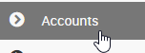
- Open a patient record
- Click ‘Accounts’ (left-hand menu)
- Click ‘New Account’
- Select the type of Account to create (based on who is responsible for paying invoices)
  - Private – consult / outpatient billing;
  - Health Fund – for Day Hospital admissions and IMC billing;
  - DVA/ Medicare – Veteran / Bulk Bill accounts
  - Legal
  - Workers Compensation
- For Private Accounts – select the Rate for the provider (refer to provider’s rates list or fee estimate for guidance), OR
- For DVA/ Medicare Health Fund – select appropriate guarantor
- Select the Medical Provider – usually the doctor providing the service
  - use Day Hospital provider for Day Hospital accommodation accounts

- Click ‘Create Patient Account’

Private Accounts set up
- Open a patient record
- Click ‘Accounts’ (left-hand menu)
- Click ‘New Account’
- Select the type of Account to create (based on who is responsible for paying invoices)
  - Private – consult / outpatient billing;
- The Account screen will display with the following fields

Field Name | Description | Examples
Rates (Private accounts only) | Private patients can be divided into 5 categories and charged different rates for the same service based on that category | Private - Private may be charged the full price but a Private - Pensioner will be changed a discounted rate
Medical Provider | Choose Medical provider - usually the doctor providing the service | Magus Polan
Location | Choose location | Clintel Clinic
All services are taxable supplies  (check box) | If checked will automatically add GST to all items invoiced on this account
Claimant (only for Private)
If different to patient (i.e Parent / carer) – OPV Button
Given Name
Family Name
Medicare number
Mediare IRN
Date of Birth
Address
City
Postcode
State
Phone
Notes
P Acc Notes72

Medicare / DVA Accounts set up
- Open a patient record
- Click ‘Accounts’ (left-hand menu)
- Click ‘New Account’
- Select the type of Account to create (based on who is responsible for paying invoices)
  - DVA/ Medicare – Veteran / Bulk Bill accounts
- The Account screen will display with the following fields

Field Name | Description | Examples
Details
Guarantor | The entity responsible for the payment of the account (gathered from the Guarantors table in The Specialist). Only those guarantors relevant to the selected account type are displayed as options | Medibank Private
Medical Provider | Choose Medical provider | Magus Polan
Location | Choose location | Clintel Clinic
Notes
P Acc Notes | Fill in any relevant account notes.

Health Fund Accounts set up
- Open a patient record
- Click ‘Accounts’ (left-hand menu)
- Click ‘New Account’
- Select the type of Account to create (based on who is responsible for paying invoices)
  - Health Fund – for Day Hospital admissions and IMC billing;
- The Account screen will display with the following fields

Field Name | Description | Examples
Details
Guarantor | The entity responsible for the payment of the account (gathered from the Guarantors table in The Specialist). Only those guarantors relevant to the selected account type are displayed as options | Medibank Private
Medical Provider | Choose Medical provider - use Day Hospital provider for Day Hospital accommodation accounts
Location | Choose location | Clintel Clinic
Guarantor Details
Bank | Bank that issues cheques used by the guarantor to make payments. Increasingly redundant as more payments are made by direct deposit | AN
Branch | Branch that issues cheques used by the guarantor to make payments. Increasingly redundant as more payments are made by direct deposit | Flinders St, Melb
P Acc Surgery | Date the aftercare period for the most recent procedural item ends. Some procedural items have an included aftercare period and this field is used to track when that expires and warn you if you try to raise an invoice in that period that should be covered as part of that aftercare. | 24/05/2015
Notes
P Acc Notes | Fill in any relevant account notes.

- Click ‘Create Patient Account’

Workers Compensation Legal Accounts set up
- Open a patient record
- Click ‘Accounts’ (left-hand menu)
- Click ‘New Account’
- Select the type of Account to create (based on who is responsible for paying invoices)
  - Workers Compensation –
  - Legal –
- The Account screen will display with the following fields

Field Name | Description | Examples
Details
Guarantor | The entity responsible for the payment of the account (gathered from the Guarantors table in The Specialist). Only those guarantors relevant to the selected account type are displayed as options | Medibank Private
Medical Provider | Choose Medical provider | Magus Polan
Location | Choose location | Clintel Clinic
Employer Details
Employer | Name of the Employer | Acme Cleaning Company
Date | Date the incident the claim relates to | 17/3/2015
Claim No. | Reference number for the claim | RC67389
Notes | Any relevant notes
Guarantor Details
Bank | Bank that issues cheques used by the guarantor to make payments. Increasingly redundant as more payments are made by direct deposit | AN
Branch | Branch that issues cheques used by the guarantor to make payments. Increasingly redundant as more payments are made by direct deposit | Flinders St, Melb
P Acc Surgery | Date the aftercare period for the most recent procedural item ends. Some procedural items have an included aftercare period and this field is used to track when that expires and warn you if you try to raise an invoice in that period that should be covered as part of that aftercare. | 24/05/2015
Notes
P Acc Notes | Fill in any relevant account notes.

How to adjust the billing rate for a Private Account
This is generally only completed by a super user.

- Open a patient record
- Click ‘Accounts’ (left-hand menu)
- Select the correct account to adjust and click 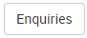
- Click ‘View’ on the left-hand menu 
- Click ‘Edit’ under the banner bar
- Select the new rate from the ‘Rates’ dropdown 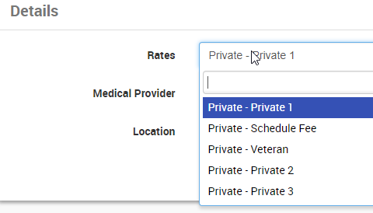
- NOTE: you can also adjust the location or provider on this screen
- Click 

How to raise an invoice from the accounts page (existing Account)
This is generally only completed by a super user.

- Open a patient record
- Click ‘Accounts’ (left-hand menu)
- Select the correct account to raise the invoice against and click ‘Invoice’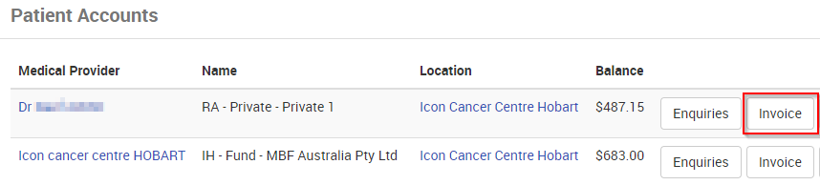
  - HINT: You can create a new account by clicking ‘New’
- Click ‘Create Invoice’ 
- Confirm correct Referral and Service Location, then click
- Confirm the invoice details (especially Schedule Fee rate, patient gap), then add an item:
  - Search by typing in the item number or select from the drop-down 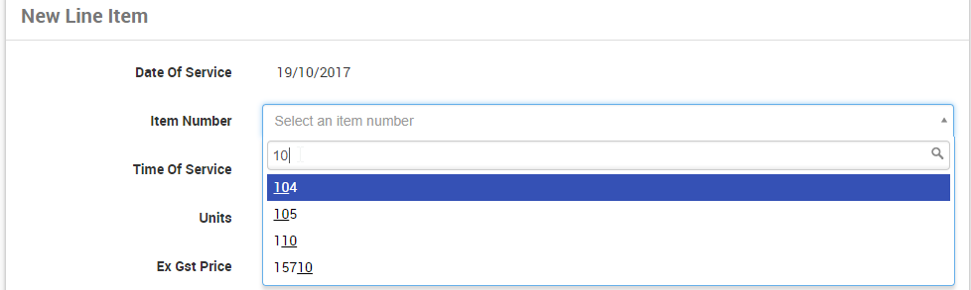
  - Confirm item information is correct, then click ‘Add line item to Invoice’ 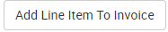
  - Add more line items if required, then click
- Summary details of the invoice will then be displayed: 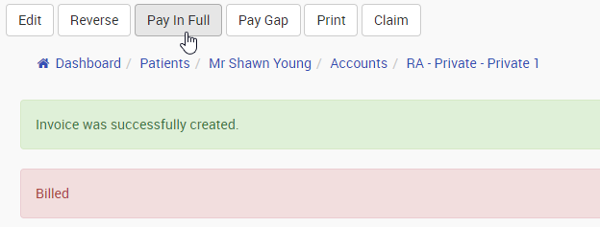
- Now, process accordingly (Pay/ Print/ Claim) – by clicking the button under the banner bar

Editing Invoices
Once an Invoice is raised and not sent / not paid?? It can be edited.

The following aspects of an Invoice can be edited:
- The main body of the Invoice
- Individual line Items

Editing Line items
Access a Patient record
Select Invoice and Credits
Select revleant invoice, select Show
Scroll down to Line items section
Select the edit button for the line item to be altered.
The Line Item will display and the Medicare Online & Administration sections can be modified

How to add DVA White Card specified condition detail to an existing invoice
- Open a patient record
- Click ‘Accounts’ (left-hand menu)
- Click Enquiries on the DVA account
- ‘Show’ the invoice to record the specified condition detail against 
- Confirm this is the correct invoice, then click ‘Edit’ 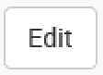 under the banner bar
- Scroll down to the ‘Medicare Online’ section and enter the ‘DVA Disability Text’

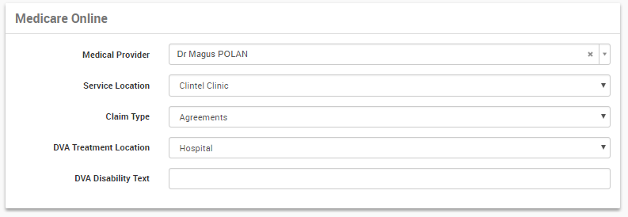
- Click ‘Update Invoice’ at the bottom of the form
NOTE: currently this text will NOT display on the 'Treatment Service Voucher' printout, but WILL transmit to DVA in the batch claim

Receipting

Payments
- Payments can be received as:
  - Cash
  - Cheque
  - EFTPOS/credit Card
  - Bank Transfer
- Payments are recorded as receipts
- Receipts can handle multiple payment types and monetary values on the one receipt.
- Receipts can pay off multiple Invoices
- Partial Payments are accepted.

- Patient Payments (single Patient)
  - Single invoice
  - Multiple invoice
- Patient Payments (Multiple Patient)
- Healthfund or Third party payments
- Reversing receipts
- Managing allocations

Payments can be entered from several screens in CareRight capturing the following options:
- Pay In Full immediately after raising an invoice
- Paying after an invoice is raised
- Pay an amount for multiple invoices
- Pay a Deposit before invoices are raised

How to receipt a payment (and claim) – at the time of invoice
Open a patient record and raise an invoice per above
Once the invoice is raised, note the options underneath the banner bar
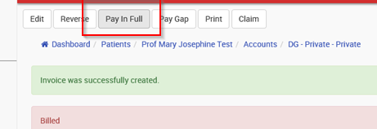
Click ‘Pay in full’ to pay the full invoice amount (which will also allow electronic claiming)
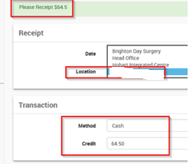
The amount to receipt will display, along with the banking location and method of payment
- Make sure you choose the correct BANKING location
- Choose the method of payment
- Click Receipt & Claim (unless claimed using Tyro, or no medicare)
  - NOTE: the Advanced button allows split payment types – for example cash and credit card on a single receipt
  - Once you have entered all the information then press the Create Receipt button to complete the receipt. If the receipt is paid in full, the allocations will be automatically created.

  - NB If the total of the payments does not match the amount of the invoice then you will not be allowed to complete the receipt until the correct total of payments has been achieved.

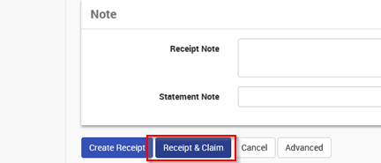
You will then be taken to the Patient Claims Interactive screen:
- Click ‘Patient Claims Interactive’ to process
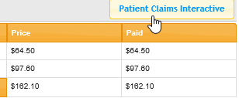

NOTE: to access the ‘Claim ID’ if ever needed for medicare communication, follow the above steps to get to the Claims screen, then ‘view’ the item in question> click ‘Show request history’ and you will see the ‘Request ID’ – click on this to see the ‘Claim ID’

Pay Gap

This option is exactly the same as Pay In Full but the default amount of the transaction will be any gap between the scheduled rebate and the amount of the invoice. Also the required total for the transaction is that gap amount. Again, allocations will be made automatically based on the gap amount of each item on the invoice.

An alternative way of entering a receipt is from the Enquiries screen.

Follow these steps to raise a receipt:
- From the patient record, click Accounts
- Click Enquiries for the required account
- Click Receipt

You will be presented with the same screen as Pay in Full except there will be no default amount for the payment. Also there is no target total of the payments so when you press Create Receipt you will complete the receipt and be returned to the Summary view in the Enquiries screen.

How to receipt a payment (prepayment of excess / co-pay etc)
- Open a patient record
- Click ‘Accounts’ (left-hand menu)
- Select the correct account to receipt the payment (eg Health Fund account) & click Enquiries
- Click Receipt
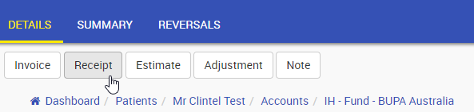
- Confirm the correct Day Hospital location (for banking), choose the payment method and enter the amount to receipt
- Click Create Receipt

Payment Allocations
Once payments have been made, they need to be allocated to the outstanding invoiced line item(s). Note this is only if the exact invoice amount has not been paid.

From the main patient record, click on the Invoices & Credits menu.
- From the Details view, click the allocate button next to the relevant Unallocated Credit
- From the Summary view, click the Show button next to the relevant Receipt/Adjustment and then click the Allocate button

NB If in option 2 you instead see a Reverse Allocations button it means that the Receipt/Adjustment has already been allocated. That’s why option 1 is generally easier to work from.

Payment made for /across multiple invoices
After raising an invoice, if you use the 'Pay Gap' or 'Pay in Full' buttons then the receipt can ONLY be for the corresponding amount of the invoice just raised and will allocate accordingly.

If receipt is to be for a different amount and/or needs to be allocated (even partially) to another invoice then you need to go back to the 'Enquires' view of the account (either by clicking the bread-crumb with the account title or clicking 'Enquiry Summary' link on the sidebar) and then click the 'Receipt' button.
- After raising a receipt, the 'Allocate' button has 2 options:
- Allocate it invoices in <account name> - use this if the money is to be allocated only to invoices in this account
- Allocate to any invoice for <patient name> - use this option if allocations are needed to invoices on other accounts for this patient
- If a receipt has been incorrectly entered then it needs to be reversed and then re-entered
- To print or allocate a receipt that has previously been entered:
- Find the required patient
- Click on 'Accounts' in the sidebar
- Click the 'Enquiries' button next to the appropriate account
- If the highlight is 'Details' then click 'Enquiries Summary' in the sidebar
- Click the 'Show' button next to the applicable receipt
- Click the 'Print' or 'Allocate' button as required

How to allocate a prepayment to a Health Fund invoice
- From above, go to the Summary view of the account, find the receipt entry and click Show
- Click Allocate
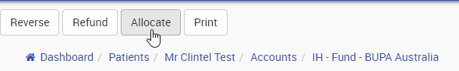
- Find the correct Invoice & line item to allocate against and enter/ check the allocation value
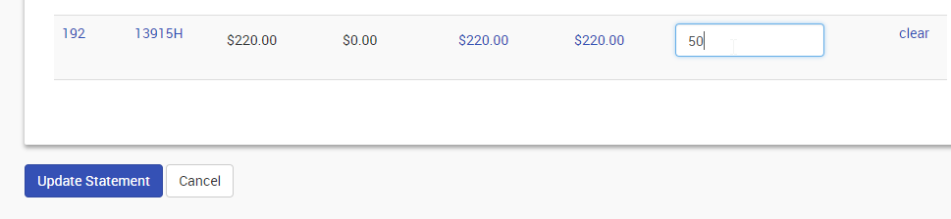
- Click Update Statement

Deposit taking
- Paying down invoices with deposits
  - Paying down single invoice
  - Paying down multiple invoices
- Taking deposits for Health Insured patients
- Taking deposits for self-funded patients
- Reversing deposits

Field Name | Description | Examples
Receipt (only appears if allocating a receipt)
Date | The date of the receipt
Credit | The total value of the receipt
Statement Note | An note that was entered to print on the receipt

Field Name | Description | Examples
Adjustment (only appears if allocating an adjustment
Debit | The amount of the adjustment if it was a debit
Credit | The amount of the adjustment if it was a credit
Date | The date of the adjustment
Adjustment Type | The type of adjustment which was assigned when it was created | Write off (Credit)  Dishonoured Cheque (Debit)
Note | An note that was entered to print on the adjustment

Field Name | Description | Examples
Allocate (one of these for each item that hasn’t been paid in full)
Line Item | Details of the item including item number, invoice number, service date & price | Item: 23 Invoice: 30 Service date: 21/04/2015 Cost: $45.0
Date | The date of the allocation
Paid | How much will be allocated to this item

The total of the amounts in the Paid field MUST equal the total of the Credit field for Receipts or the applicable Credit/Debit field for Adjustments. If it doesn’t then the allocation will not complete.
When you click the Update Statement button those allocations will be written to the items and their Paid and Balance amounts updated while the Receipt/Adjustment will be removed from the Unallocated Credits section of the Details view of Enquiries.

Adjustments
An adjustment is where the balance of the Account needs to be changed but no payment has been received.
Reasons can include (but are not limited to):
- Wrong price having been charged on an invoice which cannot be reversed because it has been submitted online
- A discount or penalty has been applied
- A banked payment needs to be refunded.

An adjustment can be performed against
- a Line item or
- xxxx

Adjusting a Line item
- Access a Patient record
- Select Invoice and Credits
- Select relevant invoice, select Show
- Scroll down to Line items section
- Select the Adjustment button for the line item
- The Adjustment screen will display
- You can adjust for the reasons such as: (Adjustment Types are configurable)
  - Discount (credit)
  - Write off (credit)
- Update the Line item values, select Create statement button
- The Line Item will now display the adjusted value.

Reversals
A Reversal may be made for the following reasons:

A reversal can be made against:
- Invoice – No payments associated.

How to reverse a payment allocation and reverse an invoice
To reverse an Invoice, you must first reverse / unallocated a payment allocation

- Open a patient record
- Click ‘Accounts’ (left-hand menu)
- Select the correct account that the invoice payment relates to & click Enquiries
- Click Summary Tab
- Find the transaction in Summary View and click Show
- The Transaction /Allocations summary will display
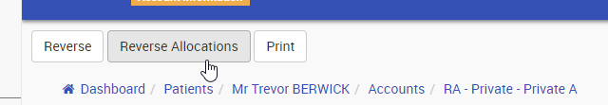
- Check that you have the correct payment allocation / Line Item & select the Reverse Allocation button (at the top of the screen)
- At this point the allocation can be used for another invoice, or left in credit
- From the Account Summary view, you can now Show the Invoice to reverse
- Check that you have the correct Invoice & click Reverse:
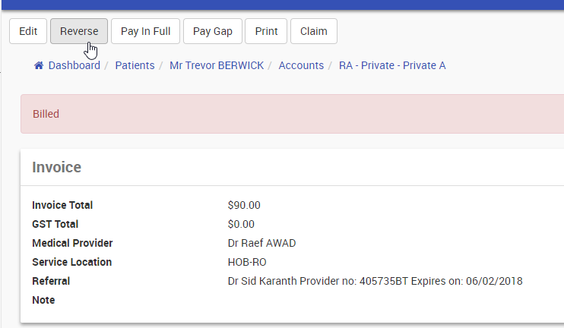
- When done correctly, you will see this:
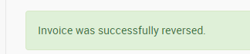

How to Reverse an Invoice Payment
To reverse an invoice payment (if there was a problem with the payment process). This could be because the payment was made by more than one method and captured incorrectly or eftpos declined?
- Open a patient record
- Click ‘Accounts’ (left-hand menu)
- Select the correct account that the invoice payment relates to & click Enquiries
- Click Summary Tab
- Find the transaction in Summary View and click Show
- find the Invoice in Account Summary View and click Show
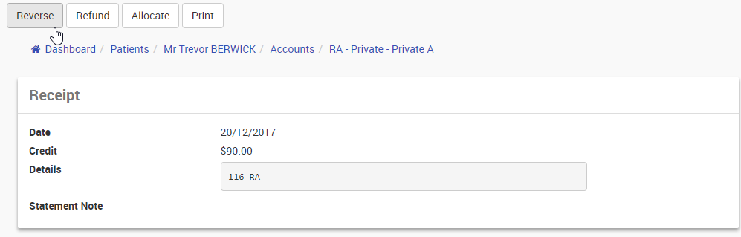
- Check that you have the correct Invoice & select Reverse button (at the top of the page)
- A green message will display “Receipt was successfully reversed”
- You can now reprocess the payment or reverse the Invoice.

Raising a Refund

Claiming
- Manual / Paper Based claiming supported.
  - Batch generation
  - In hospital Claim (IHC) full HC21 form generation.
- Electronic Claiming Supported for:
  - Medicare Bulk Billing
  - DVA Paperless
  - Inpatient Medical Claim (IMC)
  - In hospital Claim (IHC)
  - PCI

Manual Batch Payments
- Pay down multiple invoices across multiple patients with one receipt.
- Partial paydowns allowed.
- Write On over payments easily with guided process.
- Write off under payments easily with guided process.

Automated Claim Payments
- Automated process pays down paid claims.
- No user intervention required on fully paid claims.
- Rejected claims handled allowing for resubmission after correction.
- Write On over payments easily with guided process.
- Write off under payments easily with guided process.

- Identifying claims not yet sent
- Identifying Admissions without claims
  - Identifying admissions that are ungrouped
- Identify claims with problems
  - Identify nature of problem and resolution
  - Correcting and resubmitting claims
- Identifying claims part-paid
  - Writing on/off variations
- Batch finalisation
  - Apply adjustments to batches
  - Removing unpaid claims from batches
  - Finalising a batch

Claiming Scenarios

Medical Specialist
Bulk Billed
PCI (Patient Claim Interactive)
IMC (Inpatient medical Claim)

Day Hospital
Bulk Billed
PCI (Patient Claim Interactive)
IMC (Inpatient medical Claim)
IHC (either CR/Eclipse or Thelma/ Eclipse)

Day Hospital with xx
Bulk Billed
PCI (Patient Claim Interactive)
IMC (Inpatient medical Claim)
IHC (either CR/Eclipse or Thelma/ Eclipse)

Medicare bulk claim
- Dashboard, Locations
- Batch claims
- Create batch claims
- Raised Batches
- Send.
- Enter password (same as CareRight log in)
- Errors will have a message and the error highlighted in Red.
- 1 – 2 working days, pay down, appear on patient record.

Reviewing Claims
- Dashboard> Locations>
- Select Location by Clicking "Show"
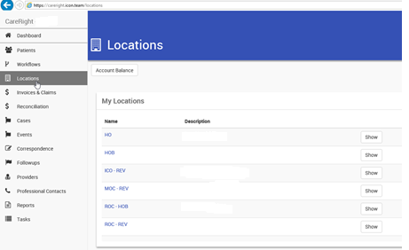
Select ‘Batch Claims’ from the left-hand menu
By default you will see all unbatched invoices. Click on ‘Online Batch Claims’
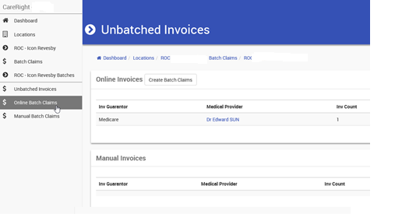

You will see Online Batches and their status (Raised, Sent, Processed, Problem). Paid batches will move to ‘Archive’
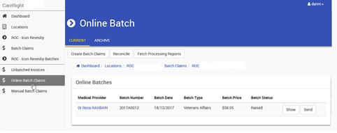
Click ‘Create Batch Claim’ – this will add any raised DVA / Bulk Bill invoices to new batches
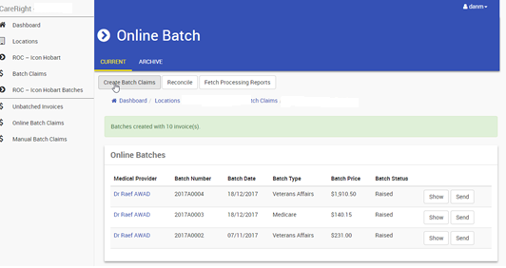
All raised invoices will now be created in Batches by provider and Type (DVA or Medicare)
Send each Batch when ready
Enter your CareRight password and click send
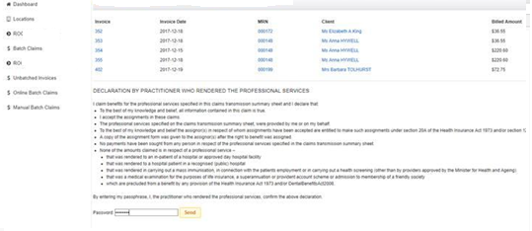
You will receive a message of whether the batch has been sent successfully:
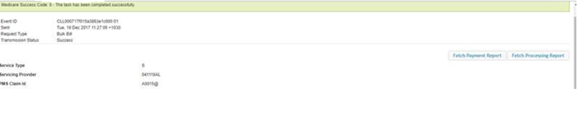
Or not (with the error message of what to fix):
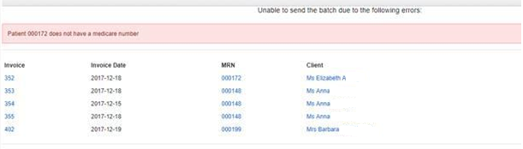

You can now return to the Location> Batch Claims> Online Batches screen to review status:
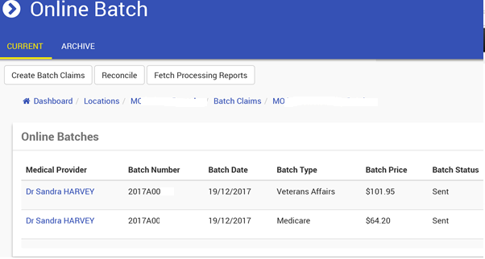
NOTE: CareRight will fetch processing reports daily and update the status

For Problem Batches
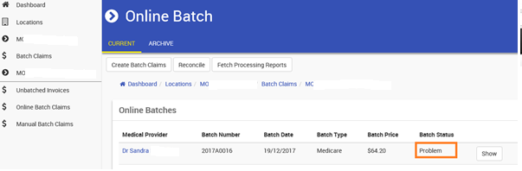Click Show
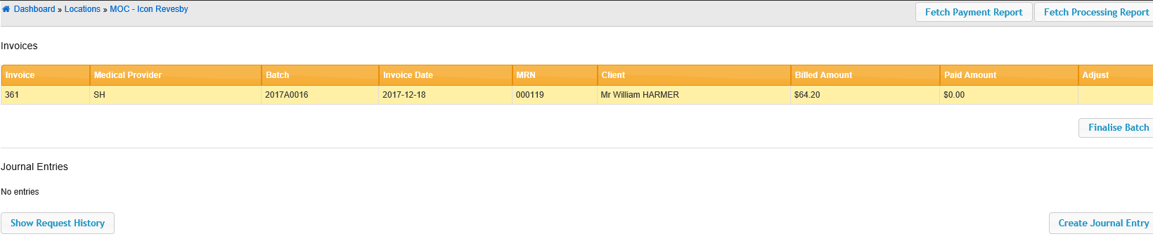Click Show Request History
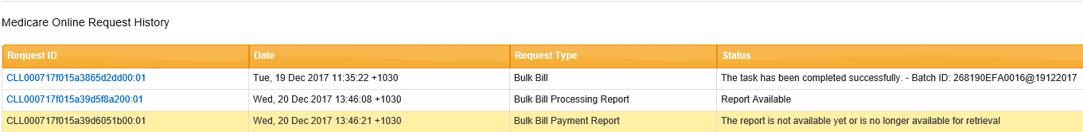Click on the Blue Hyperlink for the Report Available Selection to identify issue with the claim

Claiming – FAQ /Trouble shooting.
Medicare has confirmed that my claim has been paid but it has not been receipted in CareRight.

?? Confirm with Medicare, check bank account, processed Mediare/Payment from Patient?”

How soon after a claim has been assessed by Medicare is it paid and when does CareRight allocate the payment to the invoice

Depends on claim type:
  - IMC - Medicare assess and hand to health fund - typically within 24 hours the health fund indicates that that they intend to pay (via the processing report), but it can be many weeks before they indicate to Medicare (and then Medicare communicate with CareRight) that they have paid (via payment report)
  - Bulk Bill / PCI - typically within 24 hours

When does the amount paid get updated in the invoices screen.

As soon as the payment report from Medicare is processed

By default, the system checks for reports at the following times:
- Bulk Bills - normally 8:00am
- IMC - 7:05am and 3:05pm

For Batch Claims; when do the claims move from Current to Archive?

A batch is marked as complete when:
- All items are paid in full via the automated payment process above
- Or when manually marked as complete

In what situations does CareRight assign the batch status of Problem?

When an error code is received from medicare in the processing report

Is there any way to see what the problem is without having to check the processing report?

Not at present - you need to check the processing report.

Resolving problems with a batch claim
Wrong patient billed & paid – refund payment and reverse an invoice
- Await detail from Clintel on method to refund
Service claim denied (eg duplicate) – removing an invoice & manually reconcile
Variation between price claimed and price paid – adjust
Unpaid due to referral issue (eg missing/ expired): 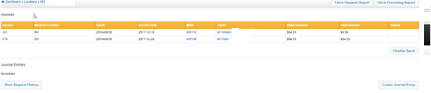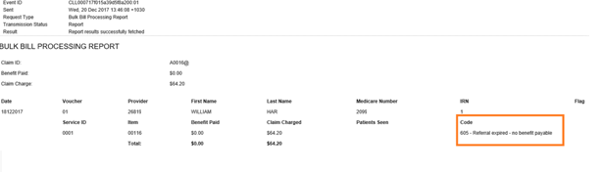
- Fix referral in the patient record & ensure linked to the invoice
- Go back to the batch claim & show the claim
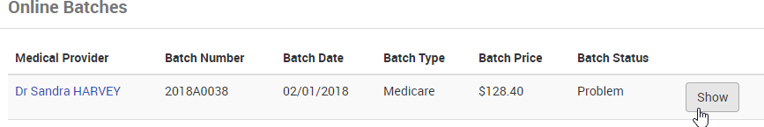
- Finalise batch (this will remove the unpaid invoice & reconcile paid invoices)
- Go back to Online Batch Claims
  - See the unclaimed item in its own new batch
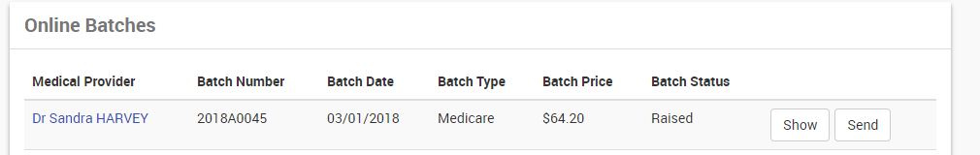
  - Send as usual
If a single invoice only was unpaid, and this invoice is then raised in a new batch, once the existing batch is finalised this will be an ‘empty batch’ – request history will show the original detail

Advanced
The above is a broad category breakdown of the invoice and claim types. The next level to venture into (and not covered yet) are:
- Referrals and referral based claims. Self assigned referral types
- Self deemed services
- Requested items
- Diagnostic imaging
- IHC and breakdown of types and components, e.g. certificates, casemix.
- Healthfund agreements (agreed gap, max gap, no gap
- Health fund contracts
- Service Text usages (.e.g same procedure on claim for multiple sites)
- Assistant Billing (as assistant)
- Assistant Billing (as primary)
- Anaesthetic billing
- … more

Invoices and Credits – Location
- From the CareRight dashboard
- Select Location, and relevant location
- Select Invoices and Credits.

Invoices and Claims – Location
The Invoices and Claims screen accessed from the Main CareRight dashboard provides summary of All claims and their status s for a selected location.

- From the CareRight dashboard
- Select Location, and relevant location
- Select Invoices and Claims.

Invoices and Claims – Dashboard
The Invoices and Claims screen accessed from the Main CareRight dashboard provides summary of All claims and their stats across all locations

It breaks the information down by r Medicare / DVA/ Health Funds claims:
- Bulk Billed
- IMC
- IHC
- Other / Private

For all Invoices and Claims with the following Status:
- Unsent
- Unpaid
- Part Paid
- Problem

From this screen you can access:

Claims ??
- Select the Claims button
- The Claims dashboard report will display, this shows all invoice claims and their status
- Form this screen you can access the following:
  - Status
  - Exceptions
  - Reconcile
  - IMC Processing Reports
  - IHC Processing Reports
  - Payment Reports
  - OEC Repots
  - Filter the Report by date

Manual ERA (Electronic Remittance Notice) Payments??
- Select Manual ERA Payment button
- The Medicare Payment Reports screen will display
- It details the following information:
  - Deposit Date
  - Payer Name
  - Payment Reference
  - Amount
  - Remittance Advice
  - Processed
- From this screen you can allocate the amount.
- Select the Allocate button
- The Medicare era reports screen will display, detailing all information about the specific claim.

?? why does this need to happen ? what is the scenario for this to occur??

Day Hospital Billing

Day Hospital Billing & Receipting Process

For day hospitals there are additional complexities for lbillin due to hospital accomodation charges

Can raise Invoices directly from an Admissions

OEC process.

- Search for & open Patient record
- Click on Accounts
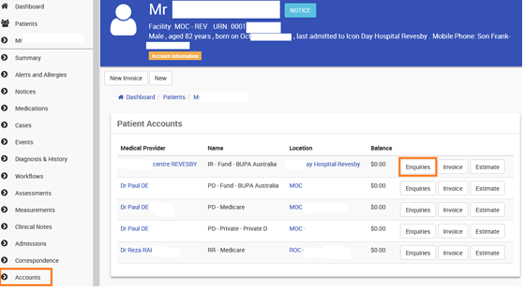
- Click Enquiries on the Accomodation Account for the Day Hospital
- Firstly, check the Unallocated Credits section to see if patient has prepaid their Excess, Gap or Copayment
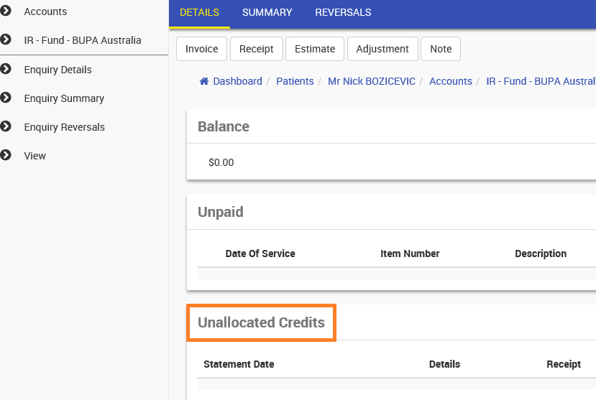
  - If credit is available for use, notate the $ amount for credit to be applied to today’s invoice
- Click Invoice located under the blue Patient banner bar – this will commence a new invoice for the accomodation
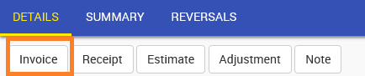
- Select the Day Hospital provider to raise invoice for

- Click
  - Referral not required for Accommodation invoices
- Service Location = ‘DH’ service location for ACCOMODATION billing (only one will appear)
- Date = Defaults to today’s date (do not change this date, this will be automatically updated by the admission selection)
- Default Hospital Settings – Select Admission date from drop down window appropriate for the invoice
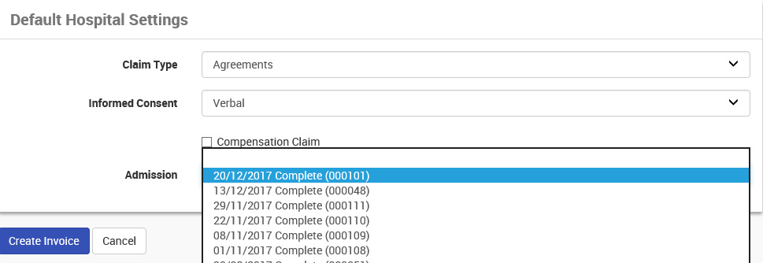
- Admission date will update Date of Service (admission must be selected first)
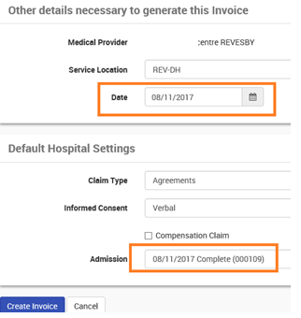
- Click
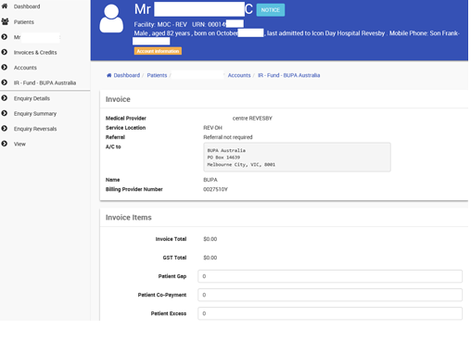
If Excess or Copay payable enter amount to be paid for today in the appropriate field. ie Patient Excess
- Validate that the Account rate you have selected is correct ie. A/C to fund (IHC) & Fund name
- Enter Item number ie. 13918H to search & select
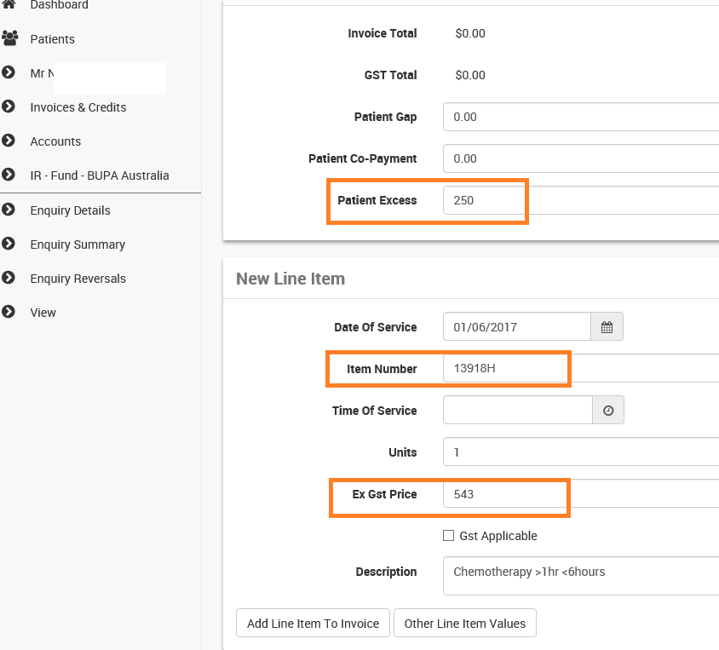
- Validate the fee is populated and matches your health fund contracted service agreed rates
- Click Add Line Item to Invoice

- Line Items will appear in the middle section of the screen
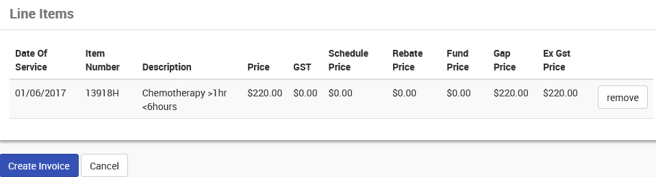
- Check line item has been billed correctly, if any errors, click remove
- If additional items to be billed for today’s service ie. Prosthesis or High Costs Drugs, complete the New Line
Item section ie. BX327 or HCD etc.
- If no items to be added, click 
- You will be alerted that the Invoice was successfully created.
- Click Print to print invoice (once IHC is electronic – click Claim tab)
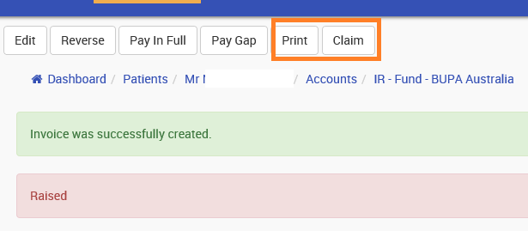
- (Print HC21 with additional billing and coding information ready for submission to the health fund.)
  - Currently unable to do this – has been logged with vendor
- If there is a prepaid excess / copay / gap to allocate, now complete this step

If service delivered is classified as Nil Insured or an Outpatient Fee account is to be paid on the day of service:
- Patient to Pay in Full click “Pay in Full”
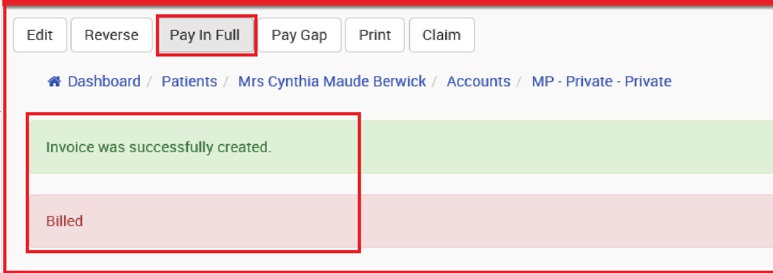

- Select Method of Payment ie Cash, Credit or Cheque and complete required fields
- A Receipt Note can be entered if required
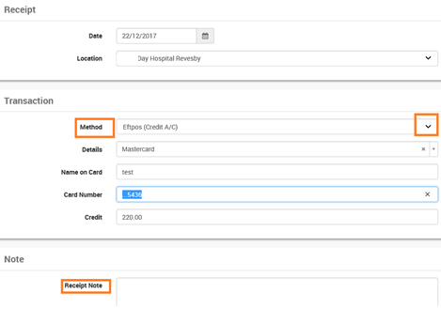
- Click Create Receipt 

In Hospital Claim – Thelma / e-healthwise / Eclipse

- Select Service Location
- Select Service Provider
- Select Account provider (this can be set to default to Service Provider value
- Select New Invoice button
- Select Referral or relevant Invoice Override Code
- Fill in any other relevant information
- invoice date, will be today’s date by default (this can only be overwriten with super user permissoins), select relevant service date
- As Service Location is an Inpatient or Procedure Centre location type then a ‘Default Hospital Settings’ section appears. These should have the correct values by default (which for most funds are the values “Agreements’ and ‘Verbal’ but for Medibank Private are ‘Scheme’ and ‘Not Obtained’).
- Select required completed admission
- Click ‘Create Invoice’
- Entering line items - For each item on the invoice
  - Set the ‘Date of Service’ if the item wasn’t given/performed today and you failed to set the invoice date above
  - Enter the item number (or select from pop-up list)
  - Enter the time the item was given/performed
  - Set units if required
  - If there are other details about the item to enter click on ‘Other Line Item Values’ and enter the details in the appropriate field of either the ‘Medicare Online’ or ‘Administration’ sections. Patient Co-payment and excess amounts are entered here in the ‘Patient Contribution’ section..
  - Click ‘Add Line Item to Invoice’
- To remove an item click the ‘Remove’ button next to the item in the ‘Line Items’ section
- If there are multiple procedures in the item list an ‘Apply MPR’ button will appear to allow the Multiple Procedure Rule
- Once all items have been added and all their details are correct click the ‘Create Invoice’ button
- The invoice is now ready to be submitted or you could enter/allocate a payment to it before sending
- To submit the invoice click the ‘Claim’ button
- In the resulting window click the ‘Inhospital Claim’ button top right
- In the resulting window
  - Accept the declaration
  - Classify the items (Accommodation/Theatre/Miscellaneous/Bundled)
  - If it is the first time this item has been used in an IHC for the fund you will need to fill in the number of information segments required (subsequent use of item number will auto populate these fields)
  - Click ‘Next’ button
- The resulting window displays all the data fields required for the IHC - fill in any that are not marked as ‘Optional’ and then click the ‘Prepare’ button
- This will highlight all field that fail to verify
  - If there are set values for a field they will appear in a pop-up list as soon as you start typing in the field
  - Data entered here does not currently auto-copy back into the relevant admission record for statutory reporting (eg HCP, VAED, ISCOS)
- Once all required fields are populated properly click the ‘Save’ button
- The window now gives a link for downloading the file that you then need to submit through eHealthWise

In Hospital Claim – CareRight / Eclipse

Banking / Reconciliation

Banking
- Banking process per location to reconcile receipts with actuals.
- Guided process with dedicated printed forms for banking.
- Integrated security to prevent unauthorised alterations to banked receipts.

Daily Banking (even if not done daily)
- Banking when splitting on providers
- Banking when not splitting on providers
- Banking direct deposits separately
Reconciliation
- Finding payments
- Managing Unallocated Credits

Check Account Balance
- Go to Dashboard
- Select Locations
- Select Account Balance button at top of screen
- The Account Balance screen will display
- This is the outstanding monies to a date (default to today, or can be selected date)

Run Ledger Report

Running a report
- Click Reports
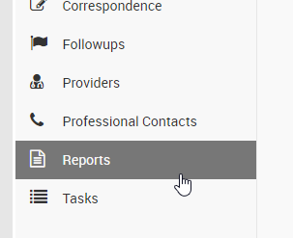
- Select the desired report by clicking on the report name
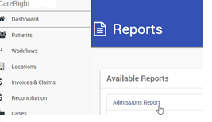
- Tick or untick data fields (if required) – usually leave as is
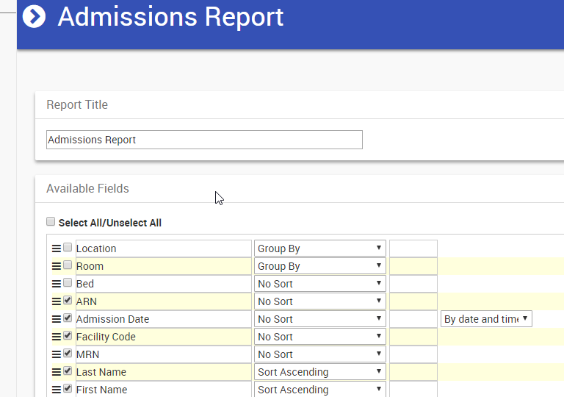
- If required, you can modify details such as available fields, date range, or add filters
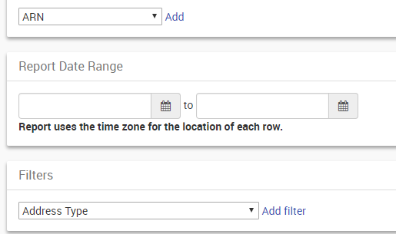
- Finally, specify the format (such as HTML, PDF, Excel, etc) – HTML displays on screen
- Click RUN

How to Process Banking
Payments which have been received.
Totals –
Process Banking.

Print Practice copy
Receipts – total income
Banking – what to take to bank.
Can use this to double check, the amounts are correct that have been processed i.e do I need to reverse payments because it wasn’t cash it was eftpos.
Print Bank copy – only cash transactions/ cheques.

- Go to the Dashboard
- Click Locations
- Select your location by clicking Show
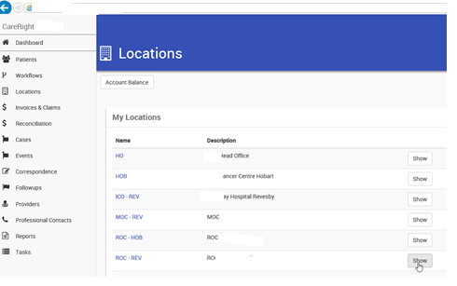
- Click Banking on the left-hand menu
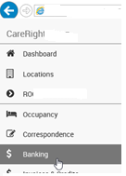
- CHECK the totals displayed on the screen (Cash, Cheques, Cards) – fix any errors before proceeding
- HINT: you can PRINT the Bank and Practice Copy before processing, as an additional check
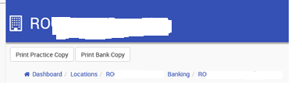
- Click Process Banking and Print Practice / Bank Copy if required
- NOTE: you can access Previous Banking from the left-hand menu for historical records

