PORTAL INTRODUCTION

A Quick “How-To” Guide

# Viewing + Paying Invoices

## Dashboard

This is the first thing you will see when logging in, known as the “Dashboard” portal section.

* From here you may quickly view invoices and make payments using the prominent tiles.
  + The tiles will link to the same “Open Invoices” portal segment.
* Using the three bar menu, you may change your password, logout, or “change companies” if applicable.

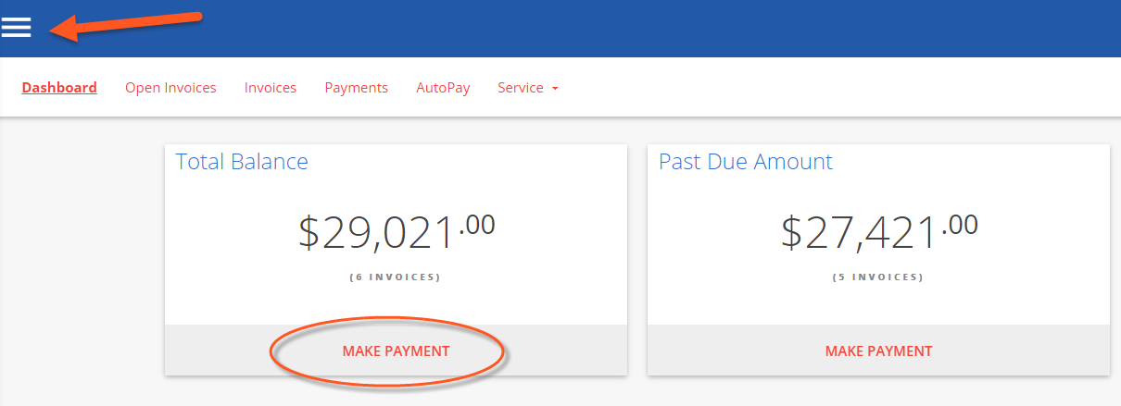

## 

## Open Invoices

Click the “OPEN INVOICES” menu option:

* All currently open invoices in our system are listed here. Please let us know if items are missing!
  + If needed, you may conveniently sort & filter with the three bar button.
  + Select the items you wish to pay, and click “Pay Selected”.

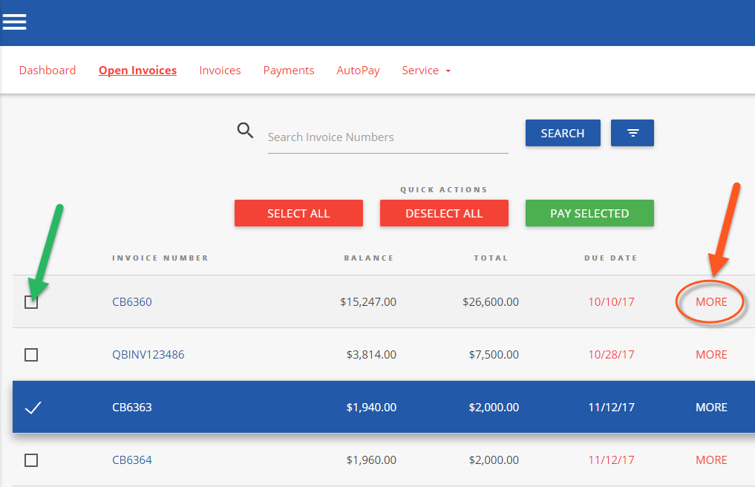

Clicking “MORE” on any invoice will display a details window:

* Please “VIEW” to see the specific line items in PDF format
  + The PDF will open in a new browser tab
    - (Encountering issues? Try using Google Chrome! Or temporarily allowing pop-ups)
  + You may print/save the PDF as desired
  + Click on “Comment” to send us an inquiry regarding a particular invoice

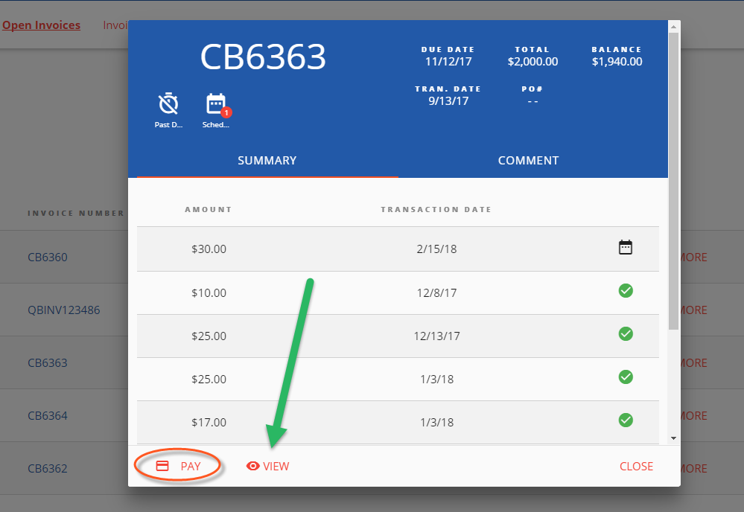

To Process a payment:

* Select the checkbox of one (or multiple) invoice(s). Click “PAY SELECTED” 
  + A dialog will appear: please select a payment method on file, or add a new entry.
    - Partial payment amounts can be entered in the top right corner!
    - You have the option of splitting payments up with multiple payment methods.

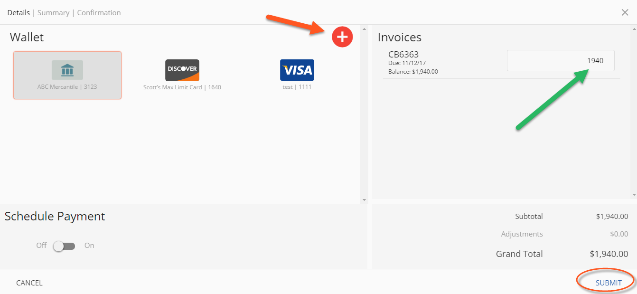

Advanced Payment Options:

* + Selecting the “Schedule Payment” switch to “ON” offers the ability to pick a specific payment date, using the Date Picker.
    - This is not an “auto-pay”, but rather a one-time payment for the future.

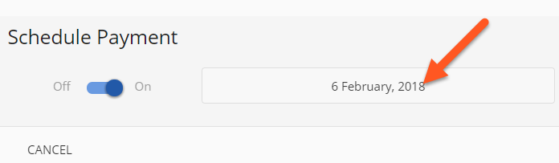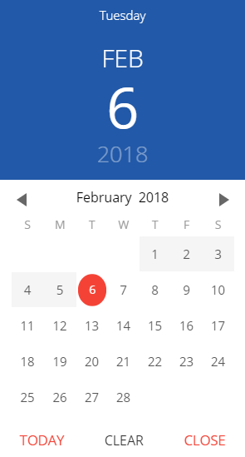

Clicking “SUBMIT” will give you a chance to review your actions.

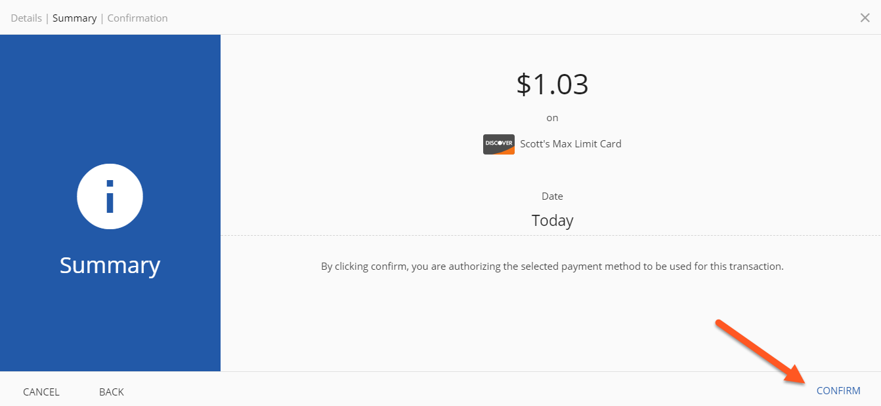

Clicking “CONFIRM” will yield a payment success or failure screen

* + An email receipt will be sent to your login email address.
    - You may send any additional receipts using the “Add Email Receipt” field.
  + If the payment is scheduled for the future, the receipt will show the scheduled payment date.

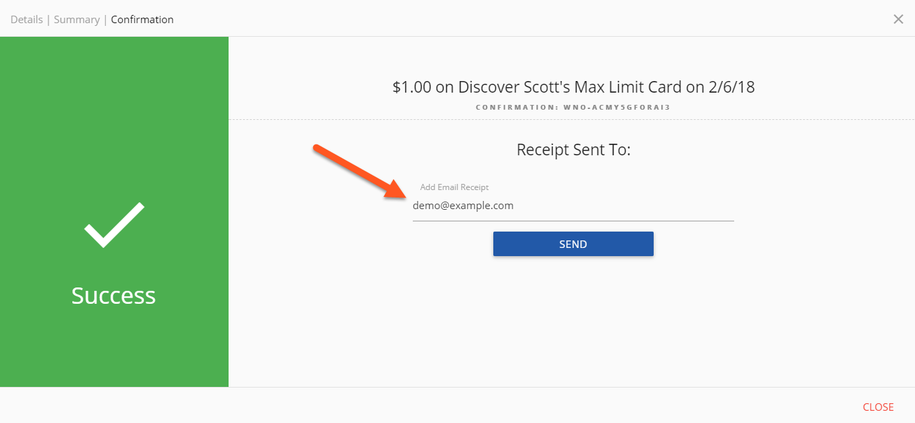

## Invoice History

Click on the “Invoices” menu option:

* Click “MORE” on previously issued and archaic invoices
  + You may again view specific details, or print & save the PDF
  + The page numbers on the right, and search box can help narrow the results

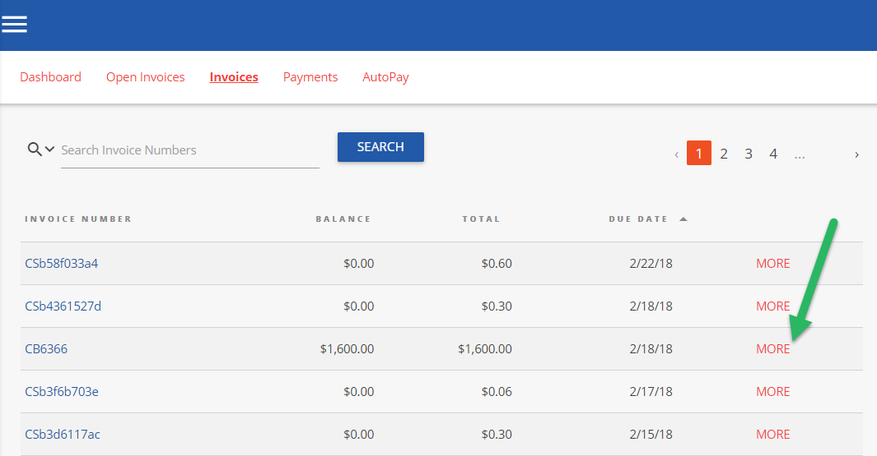

## Payments

Click on the PAYMENTS menu option:

* + View all currently pending, future scheduled (including AutoPay) or past historic payments

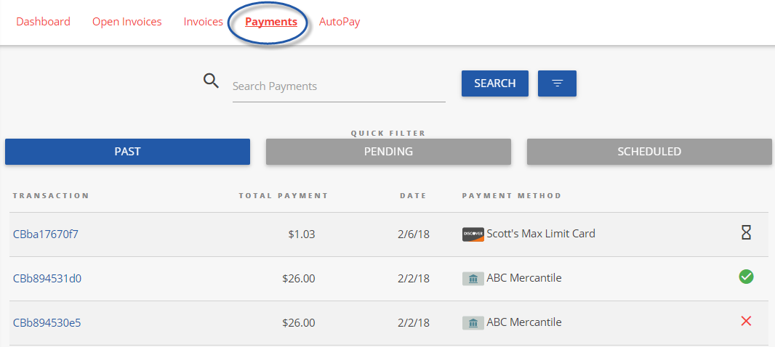

## 

## 

## AutoPay

Click on the AUTOPAY menu option:

* + Click “NEW”, and expand to reveal the available options
  + Configure your preferences in 5 steps, as per the example image below
    - Note: You can have more than one “AutoPay” Rule/Condition at a time!
    - With the below “less than $” example, “one-off” type invoices can also be paid automatically!

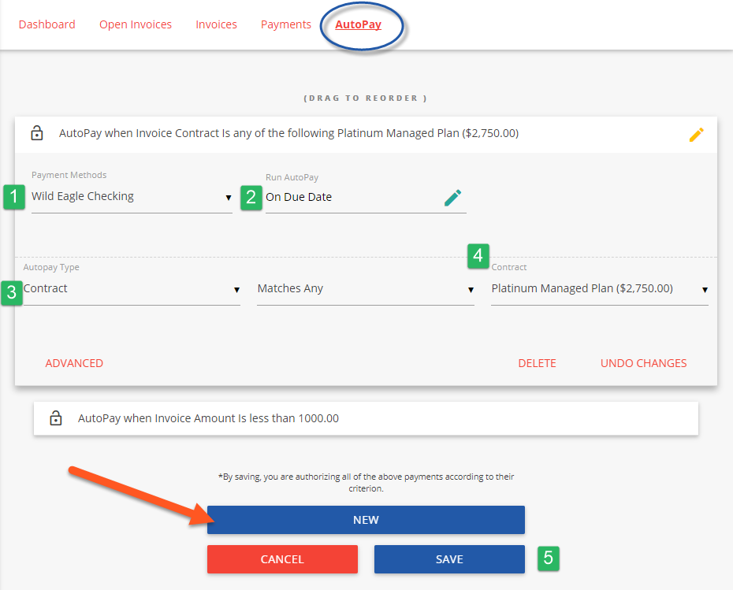

1 - Select the payment method you want this rule to follow

2 - “On Due Date” will pay invoices matching the criteria on the date they are due (not created)

3 - Select “Contract” or “Amount”

4 - Pick the recurring service agreement you would like to be auto-paid

5 - Save your changes!

## Service

Click on the “Service” menu option:

* + Creating a new service ticket is easy as 1 2 3!
  + You may also view historic tickets with the “Closed” filter.

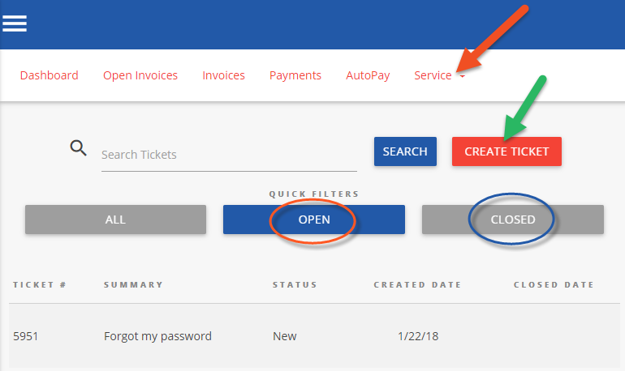

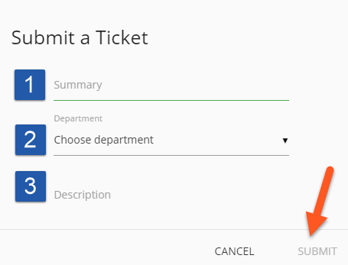

## Mobile

Mobile device navigation:

* + The top menu bar is replaced by the lower right button, but functions nearly the same.

