User Guide for League and Regional Administrators

1.0 Providing Access 2
1.1 How to request access as a League or Regional Administrator 2
1.2 How to grant access to others in your league 2
1.3 How to grant access to the nominated club admins 4
2.0 Creating Folders for Clubs to store Documents 6
3.0 Finding/Checking and Deleting Player Declarations and Club Documents 8
4.0 Keeping track of new submissions - Reporting 11

1.0 Providing Access
Due to the sensitive nature of the documents, access is tightly controlled. As a default no individual at a league or regional level has access until it is provided to them by their State Body.

Access is based on a hierarchical system, where a state administrator provides access to a league or regional administrator. Access can only be provided by administrators that have access already. For example, a State administrator can provide access to the league administrator within their State or Territory. That league administrator can then provide access to other administrators within the same league as well as clubs administrators within their league.

Please Note: Club administrators don’t have the ability to provide access to other administrators within their club.

1.1 How to request access as a League or Regional Administrator
At the start of the season a League or Regional Administrator needs to request access from their appropriate State or Territory Administrator. In most cases that will be the following people

AFL VIC - Keith Whitford or Darryl Collings
AFL NSW / ACT -
AFL QLD -
AFL NT -
AFL TAS -
SANFL -
WAFC -

The State administrator will then enable your access. Once you have access then you are able to provide access to other league and club administrators in your league . If you are an administrator of a Regional Commission (eg AFL Barwon) you will need to request access for each individual league that sits under your Regional Commission (eg Bellarine Football League, Geelong Football League, Geelong & District Football League etc.).

Please note: To be granted access you will need to have a SportsTG Passport account and that account will need to be linked to the leagues that you manage.

1.2 How to grant access to others in your league
To grant access to others in your league follow these steps.
Step 1 - Login to your Leagues Footyweb database
Step 2 - Go to user management. Settings > User Management

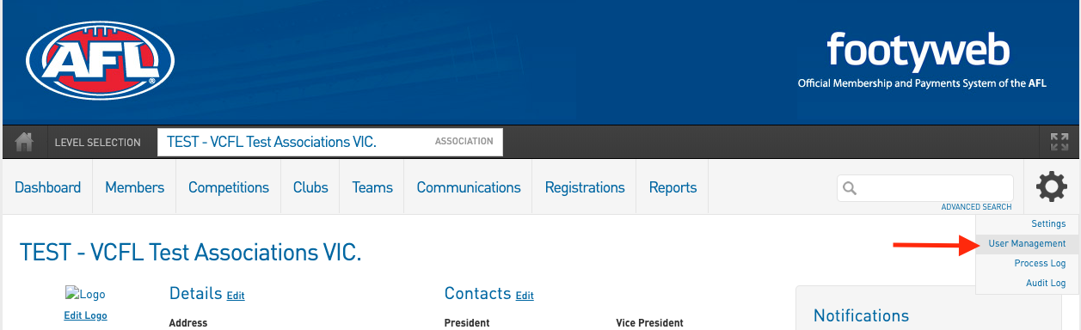

Step 3 - Scroll down to the bottom of the page and enter in the administrators email address and tick the Contracts/Salary Cap Access box, and click add.

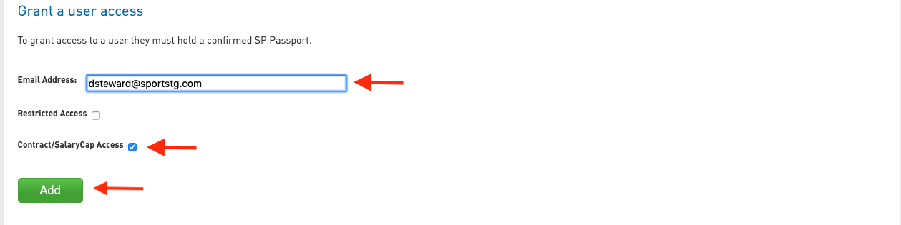

Please Note: if the administrator has already been granted access you will need to delete their user access and add it again, this time with the ‘Contracts/Salary Cap Access’ box ticked.

Once given access the administrator will be able to see a ‘Contracts’ sub-menu item under the ‘Members’ menu

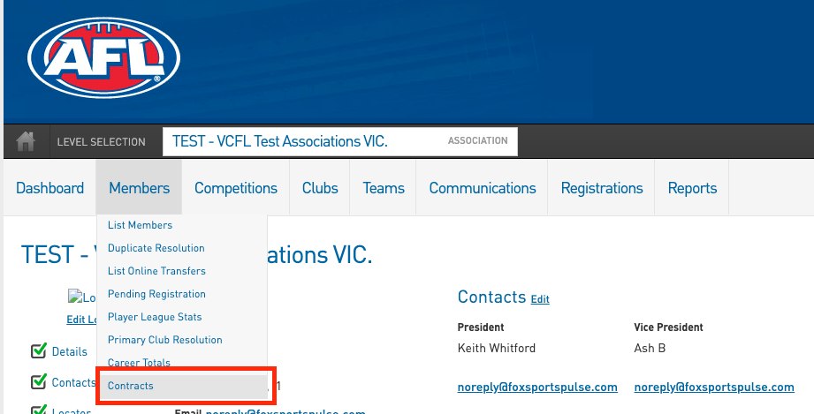

1.3 How to grant access to the nominated club admins
Step 1 - Login to your Leagues Footyweb database
Step 2 - Navigate down to the club who you want to enable access. Clubs > List Clubs

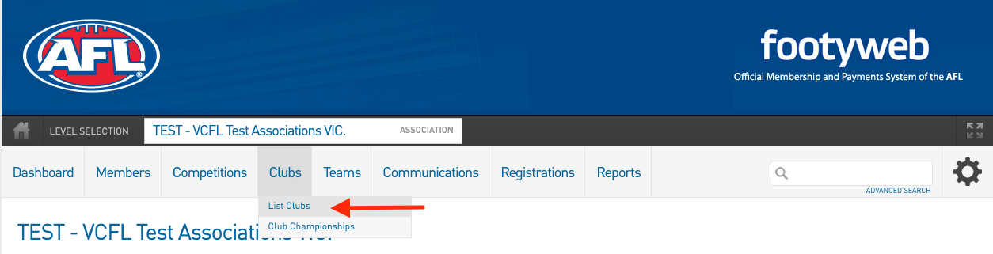

Step 3 - Click on the club you want to access

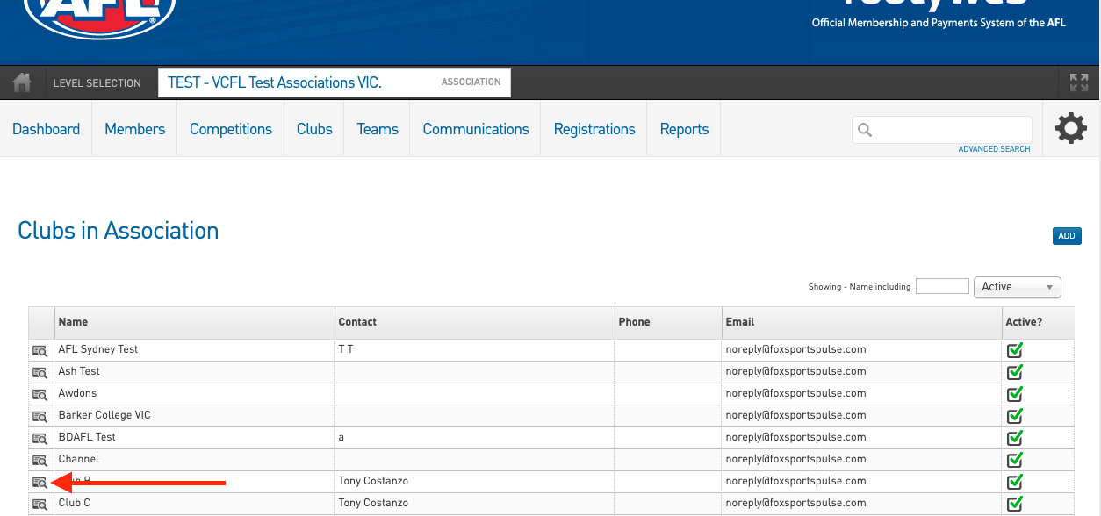

Step 4 - Once at the club level go to user management. Settings > User Management

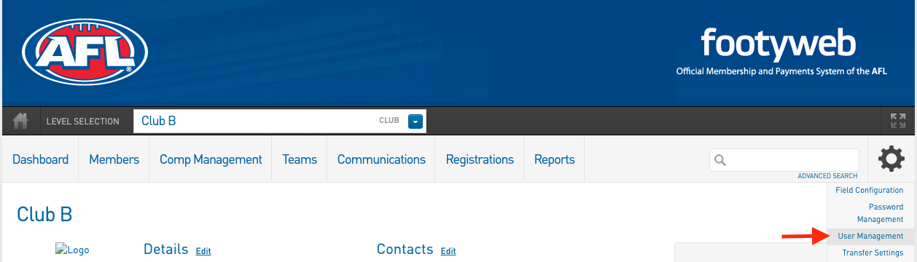

Step 5 - Scroll down to the bottom of the page and enter in the administrators email address and tick the Contracts/Salary Cap Access box, and click add.

Please Note: if the administrator has already been granted access you will need to delete their user access and add it again, this time with the ‘Contracts/Salary Cap Access’ box ticked.

Once given access the administrator will be able to see a ‘Contracts’ sub-menu item under the ‘Members’ menu

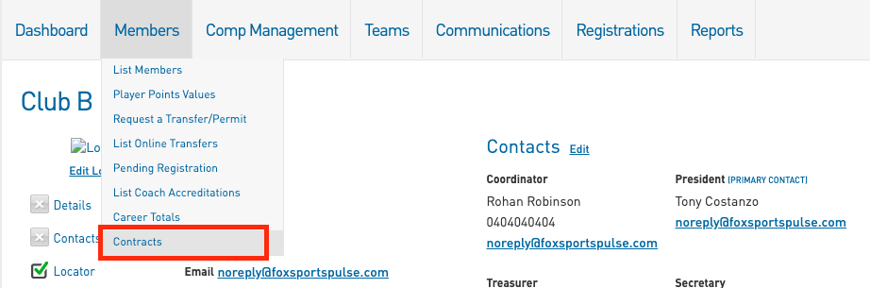

2.0 Creating Folders for Clubs to store Documents
Please Note: As league / Regional Administrators you will need to create folders for each of your clubs so that they can upload their Player Declarations and their Club APP documents. You will need to do this for each club that is required to submit documents to the league.

Step 1 - Drill down to the club level

Step 2 - Navigate to the Contracts section for the individual Club - Members > Contracts.

Step 2 - Create a Folder that you will upload documents to. Click the ‘Add’ button

Please Note: You should create 2 folders (one for Player Declarations and one for Club APP Documents)

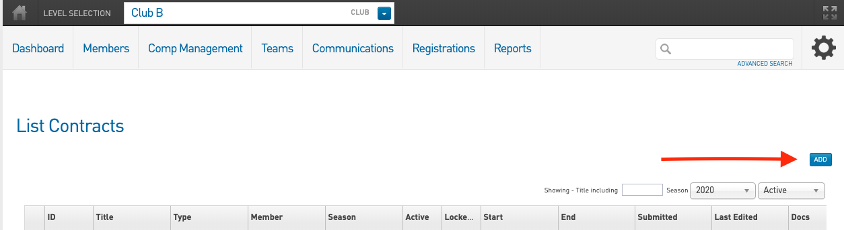

Step 3 - Fill out the relevant fields with the information required and click on update contract submission.

Member Name - Leave Blank
Contract Season - Select the current season (2020)
Contract Name - The specific naming convention is - Club Name Season Year Document Type. For example ‘Richmond Tigers 2020 Player Declarations’ or ‘Richmond Tigers 2020 Club APP’
Contract Type - Select the relevant type. If you are loading up your Player Declarations then select the contract type of Player Declarations
Contract Start Date - Select an appropriate date
Contract End Date - Usually will be 31st of October of the current year, but depends on when your season finishes
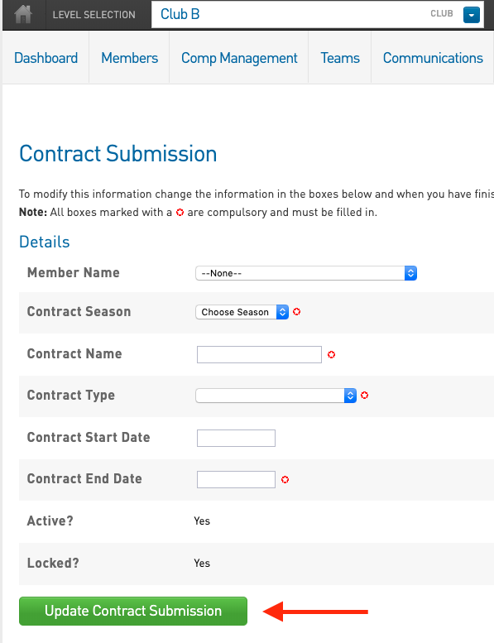

Step 4 - Repeat this step until you have created 2 folders (one for each document type)

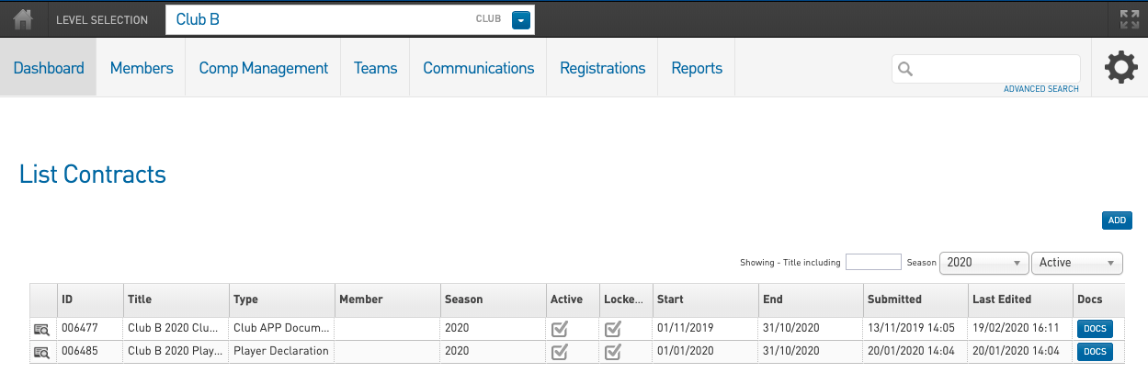

3.0 Finding/Checking and Deleting Player Declarations and Club Documents
Step 1 - Navigate to the Contracts section - Members > Contracts. You can do this at the League level or the specific club level

Step 2 - Use the Season and Active Filter to find the folders that are relevant for the year. For example if you want to find all clubs APP budget folders for 2020. Set the season filter to 2020 and type into the title search field ‘APP Budget’. This will bring up all the folders that have been set for 2020 and have the APP Budget in its name/title.

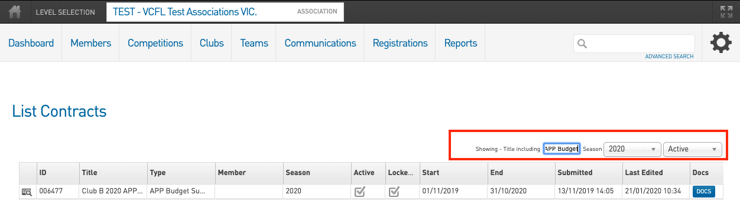

Step 3 - Once you have found the correct folder. Click on the ‘Docs’ button to view the documents within the folder.

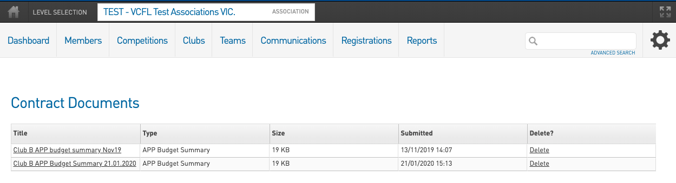
Step 4 - To download the document, click on the title of the document. This will start the download process. Once the document is finished downloading you will be able to access it via your download folder on your computer.

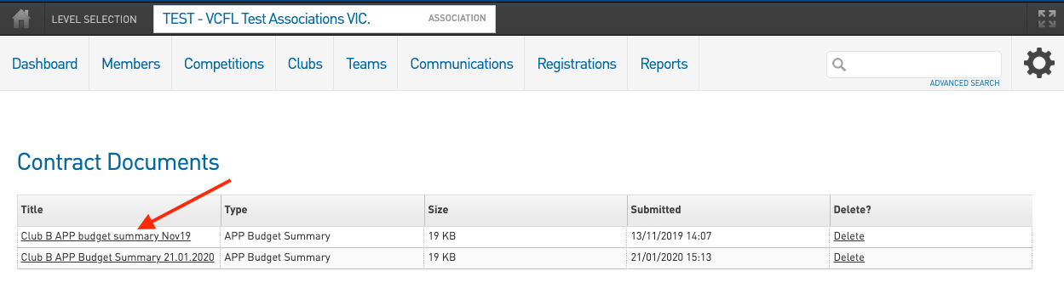

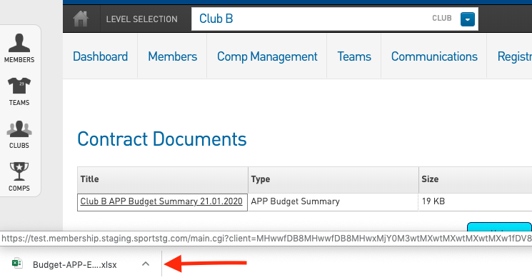

Step 5 - To delete the document, click on the delete link of the document. This will start the delete process.

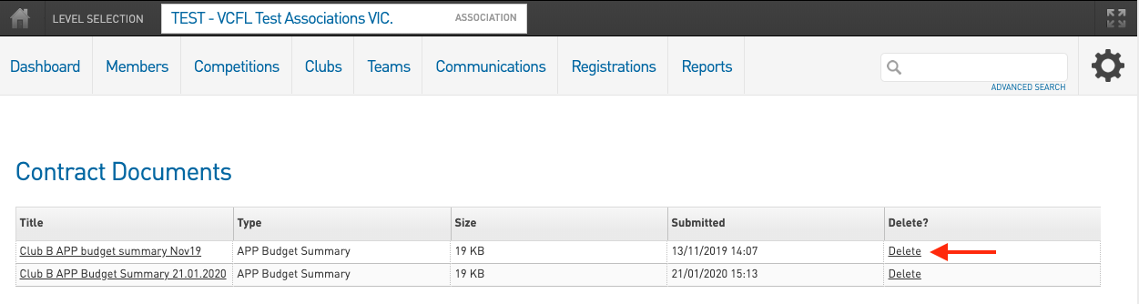

You will need to confirm you want to delete the document via the pop up box. If you don’t want to delete the document please select the ‘Cancel’ option.

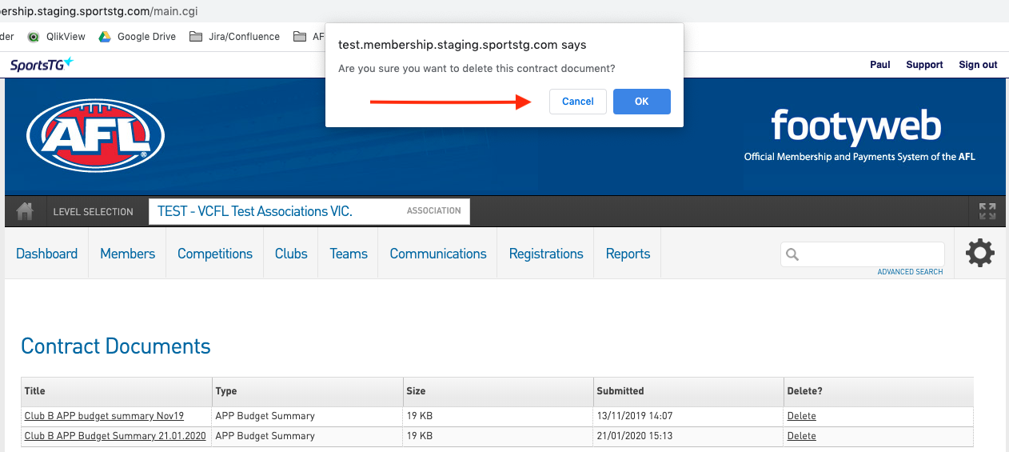

4.0 Keeping track of new submissions - Reporting
Step 1 - Go to Reports

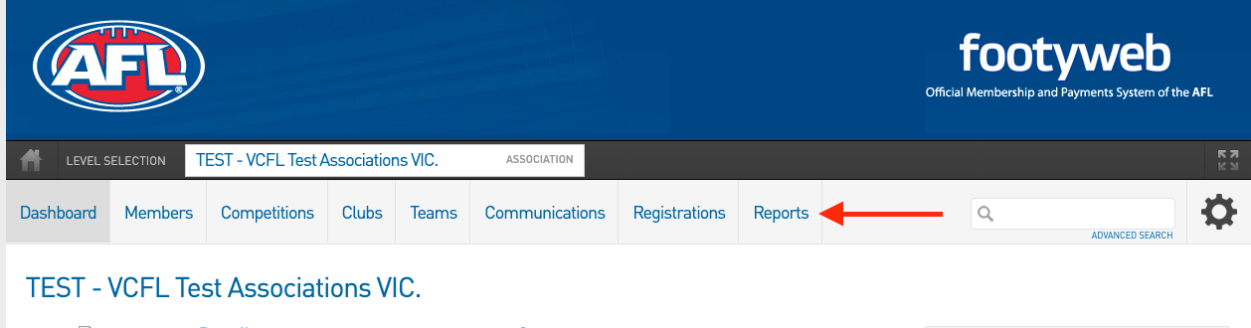

Step 2 - Click on Contracts Report option

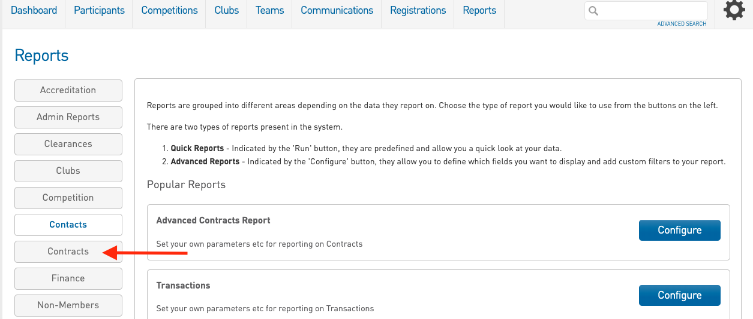

Step 3 - Click on the ‘Configure’ button
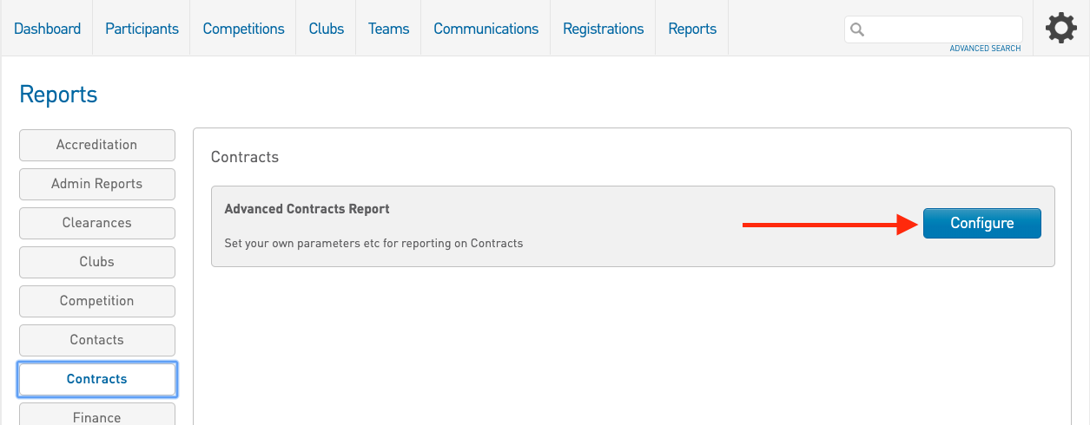
Step 4 - Select the appropriate fields and apply filters if need be

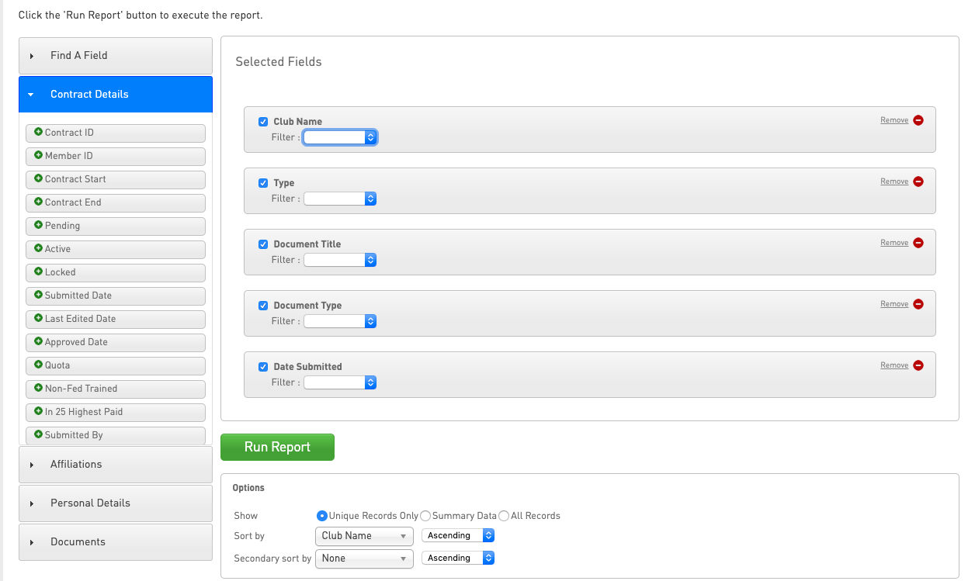

Recommend fields are:
Club Name
Type
Document Title
Document Type
Date Submitted

It is suggested that you set up a report using the above fields and then set a filter on the Date Submitted field to be ‘More than’ 1st Jan 2020. The sort by club name and secondary sort to Date submitted. Save this report. This will allow you to monitor document submissions as they come in with the most recent submission of each club appearing at the bottom of their list.

