User Guide for Club Administrators

1.0 Providing Access 2
1.1 How to request access as a Club Administrator 2
2.0 Adding Player Declarations 4
3.0 Adding Non Declared Player Statements 6
5.0 Adding Club Documents - APP Budget 8
6.0 Adding Club Documents - APP Actual 10
6.0 Checking/finding Player Documents and Club Documents 12
6.1 Filtering folders by season and name 12
6.2 Viewing/Downloading all Documents 13
6.3 Deleting Documents 14

1.0 Providing Access
Due to the sensitive nature of the documents, access is tightly controlled. As a default no individual at Club level has access until it is provided to them by their League or Regional Administrator.

Only League and Regional Commission administrators who have permission can then provide access to Club administrators within their league or region.

Please Note: Club administrators don’t have the ability to provide access to other administrators within their club.

1.1 How to request access as a Club Administrator
At the start of the season a Club Administrator needs to request access from their appropriate League or Regional Administrator. Once approved the League or Regional administrator will then enable your access. Club Administrators will know they have access as they will be able to see the ‘Contracts’ sub-menu item under the ‘Members’ menu.

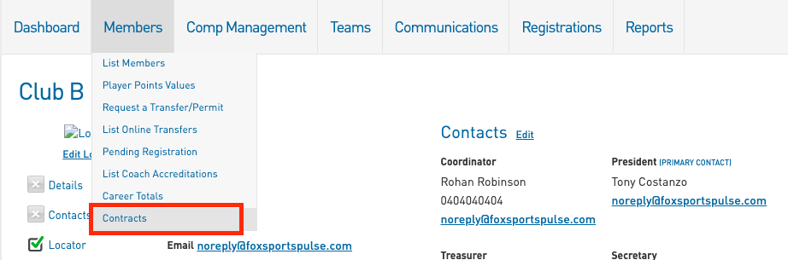

Please note: To be granted access you will need to have a SportsTG Passport account and that account will need to be linked to the Club that you manage.

2.0 Adding Player Declarations
Step 1 - Navigate to the Contracts section - Members > Contracts.

Step 2 - Upload documents to the Player Declaration folder (you created this in section 2.0). Go to Members > Contracts > Click on the ‘Docs’ button for the Player Declaration Folder

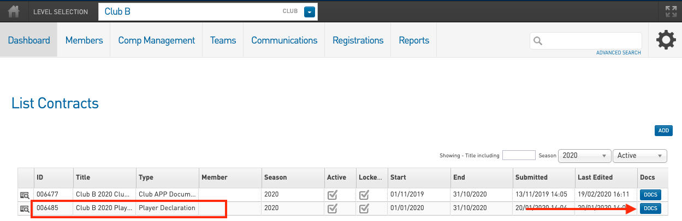

Step 3 - Upload documents by filling out the fields and selecting a file to upload

Document Name - The specific naming convention is - Club Name Document Type Date Added. For example ‘Richmond Tigers Player Declarations 20.01.2020’
Document Type - Select the appropriate document type dependent on the documents you are uploading
Choose file - click this button to upload a document from your computer.
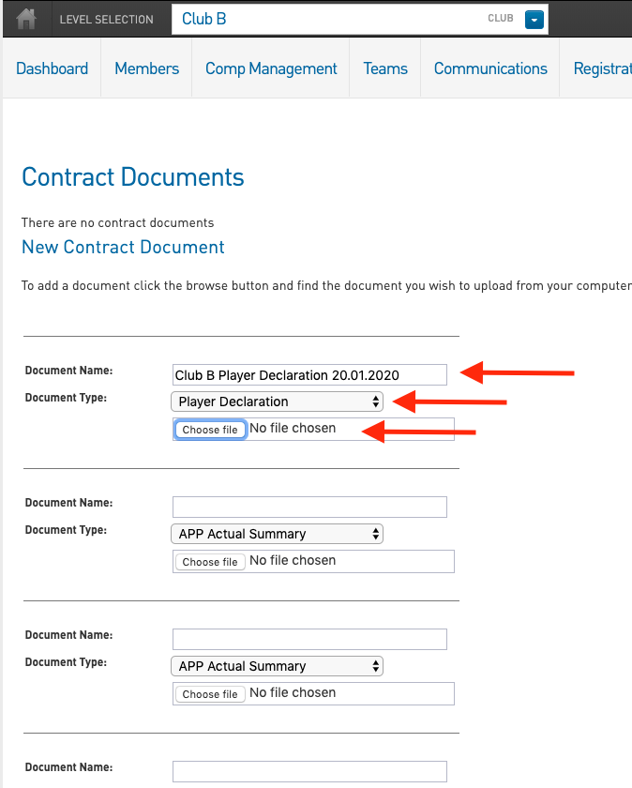

Step 4 - Scroll down to the bottom of the page and click upload. You can upload 6 files at a time and can add more documents when needed. For example if you need to submit 24 player declarations you can repeat steps 1-6 four times or you could create 1 document that combined the 24 player declarations and then upload that once.

3.0 Adding Non Declared Player Statements

Step 1 - Navigate to the Contracts section - Members > Contracts.

Step 2 - Upload documents to the Club APP Document Folder. Go to Members > Contracts > Click on the ‘Docs’ button for the Club APP Document Folder

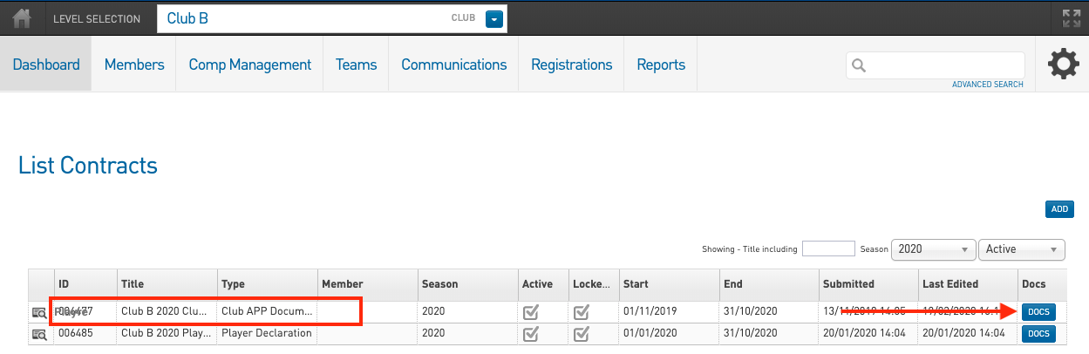

Step 3 - Upload documents by filling out the fields and selecting a file to upload

Document Name - The specific naming convention is - Club Name Document Type Date Added. For example ‘Richmond Tigers Non Declared Player Statements 20.01.2020’
Document Type - Select the appropriate document type dependent on the documents you are uploading
Choose file - click this button to upload a document from your computer.

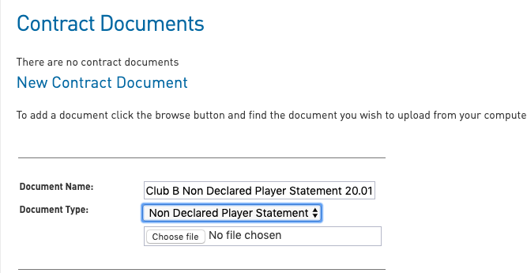

Step 4 - Scroll down to the bottom of the page and click upload. You can upload 6 files at a time and can add more documents when needed. For example if you need to submit 24 documents (1 for each player) you can repeat steps 1-6 four times or you could create 1 document that combined the 24 Non Declared Player Statements and then upload that once.

5.0 Adding Club Documents - APP Budget
Step 1 - Navigate to the Contracts section - Members > Contracts.

Step 2 - Upload documents to the Club APP Document Folder. Go to Members > Contracts > Click on the ‘Docs’ button for the Club APP Document Folder

Step 5 - Upload documents by filling out the fields and selecting a file to upload

Document Name - The specific naming convention is - Club Name Document Type Date Added. For example ‘Richmond Tigers APP Budget 20.01.2020’
Document Type - Select the ‘APP Budget Summary’ document type
Choose file - click this button to upload a document from your computer.

You can upload up to 6 documents at a time.

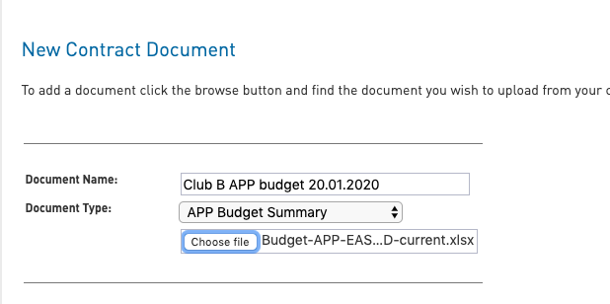

Step 6 - Scroll down to the bottom of the page and click upload.

Once the document is uploaded it will appear in the Document page

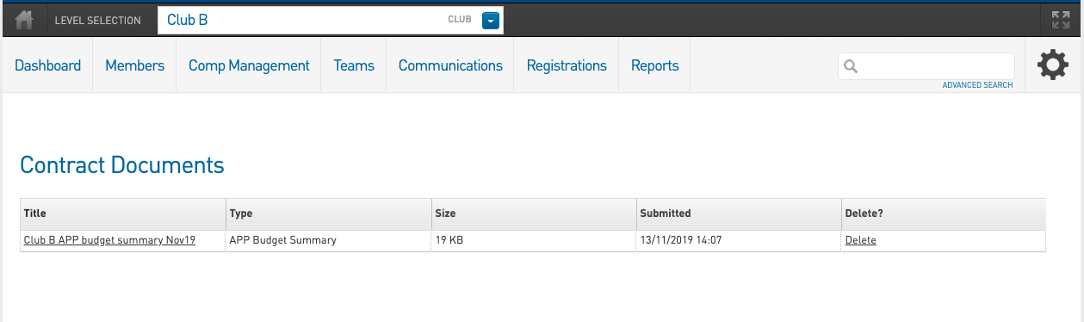

Please note: If you need to update the APP Budget or Actual document then you just repeat steps 1-6 of the ‘Adding Club Documents’ instructions and upload it as an updated version in the same folder. There is no need to create a new folder. That way all the versions of the documents are in one area.

6.0 Adding Club Documents - APP Actual
Step 1 - Navigate to the Contracts section - Members > Contracts.

Step 2 - Upload documents to the Club APP Document Folder. Go to Members > Contracts > Click on the ‘Docs’ button for the Club APP Document Folder

Step 5 - Upload documents by filling out the fields and selecting a file to upload

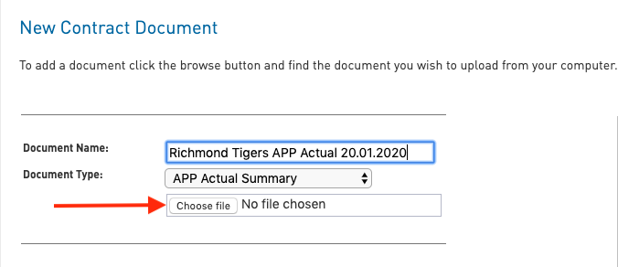
Document Name - The specific naming convention is - Club Name Document Type Date Added. For example ‘Richmond Tigers APP Actual 20.01.2020’
Document Type - Select the ‘APP Actual Summary’ document type
Choose file - click this button to upload a document from your computer.

You can upload up to 6 documents at a time.

Step 6 - Scroll down to the bottom of the page and click upload.

Once the document is uploaded it will appear in the Document page

Please note: If you need to update the APP Budget or Actual document then you just repeat steps 1-6 of the ‘Adding Club Documents’ instructions and upload it as an updated version in the same folder. There is no need to create a new folder. That way all the versions of the documents are in one area.

6.0 Checking/finding Player Documents and Club Documents
To make sure that you have uploaded the correct documents or to access them from the system follow the steps below:

6.1 Filtering folders by season and name
Step 1 - Navigate to the Contracts section - Members > Contracts.

Step 2 - Use the Season and Active Filter to find the folders that are relevant for the year.

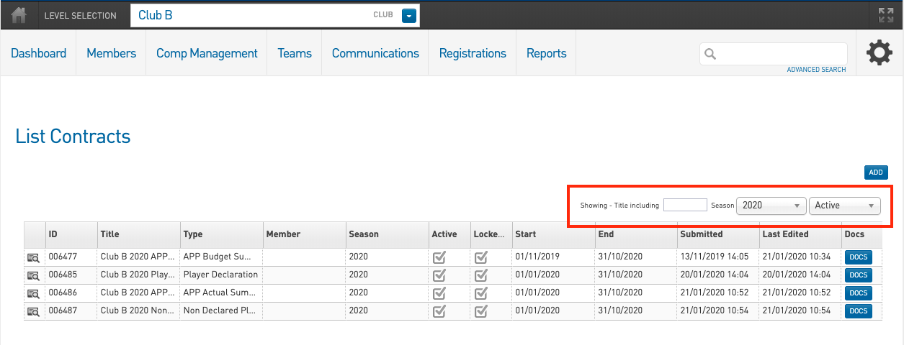
Please note: Once the end date of the folder is reached then the folder will be marked as inactive.

6.2 Viewing/Downloading all Documents
To view a document you have to download it.

Step 1 - Navigate to the Contracts section - Members > Contracts.

Step 2 - Find the relevant folder for the documents you want to view. You can do this by using the filters as outlined in section 5.1

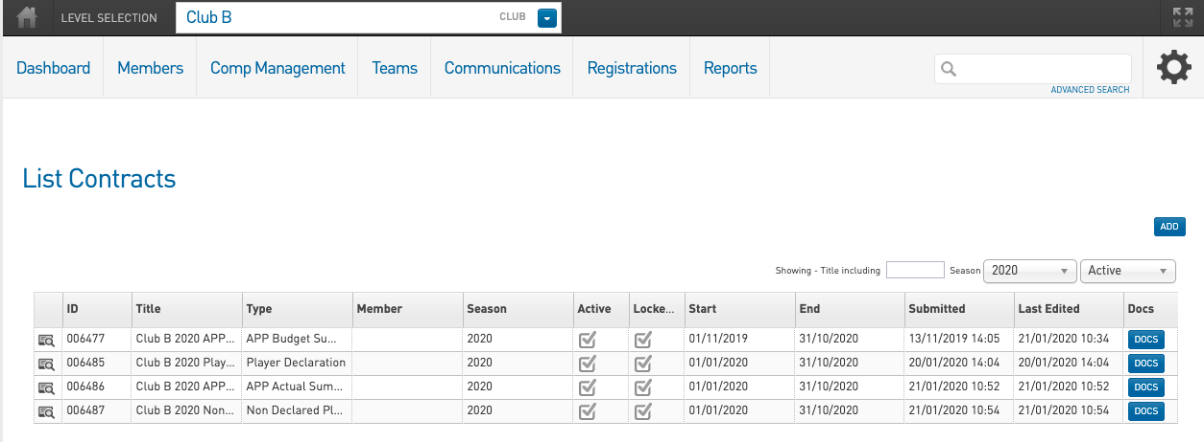

Step 3 - Click on the ‘Docs’ button for the relevant folder. For example if you want to view Non Declared Player Statements you would click on the ‘Docs’ button for the ‘Non Declared Player Statements’ folder.

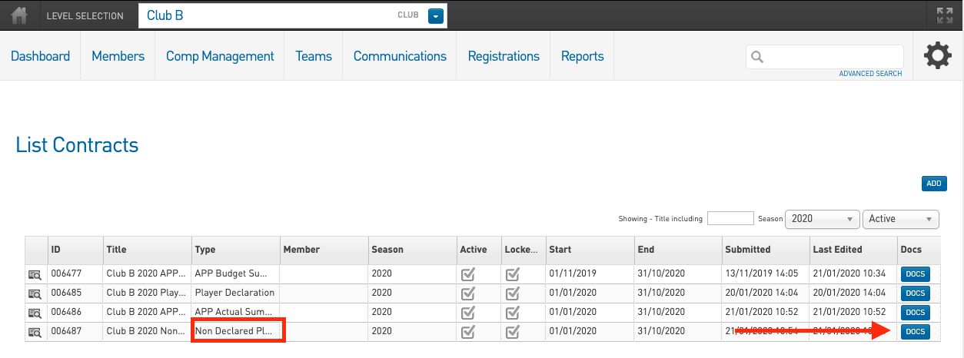

Step 4 - Click on the ‘Title’ of the document and this will initiate the download, once downloaded the file will appear at the bottom of the screen and will be placed in the download folder on your computer (not within Footyweb)

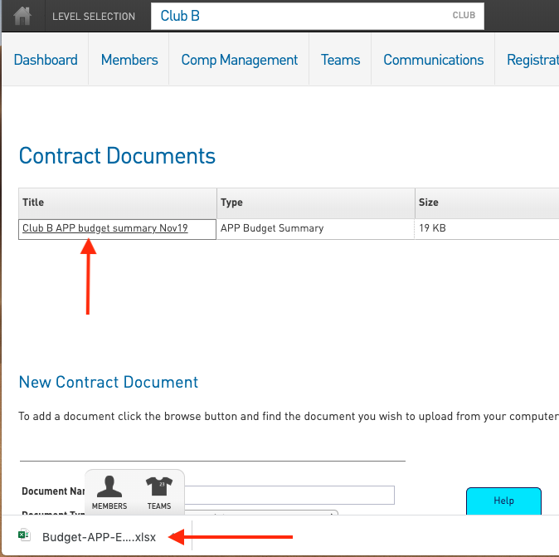

Please note: The system records the time and person that downloaded the file in your audit log.

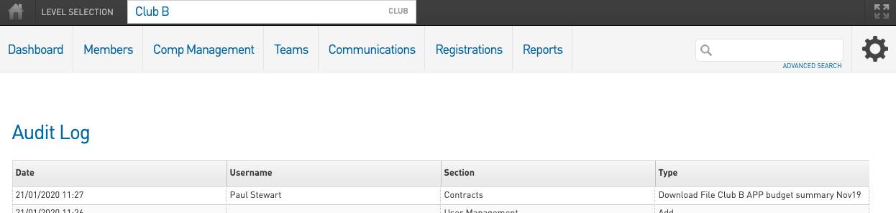

6.3 Deleting Documents
Please note: Club Administrators can not delete any documents, if you have uploaded the incorrect document then please upload the correct document and inform your league or regional administrator of the mistake.

