How to: Online Election
A quick guide for Clubs and Societies at LUU

Online elections are an easy way to hold an AGM/EGM for your society. This guide will show you how to set up an election, nominate yourself, vote and, importantly, how to encourage people to vote.

How do I set up an online election?

If you would like to set up an election online, please contact Activities@leeds.ac.uk. The Admin team will be able to create the election, set the nomination period (the time when people can nominate themselves) and set the voting period (the time when people can vote). The Admin team will also be the ones to approve the nominations, which will allow people to vote for candidates.

How do I nominate myself?

First, you will need to login to the LUU website (at the top next to the search bar).

Then, you will need to ‘login to vote.’
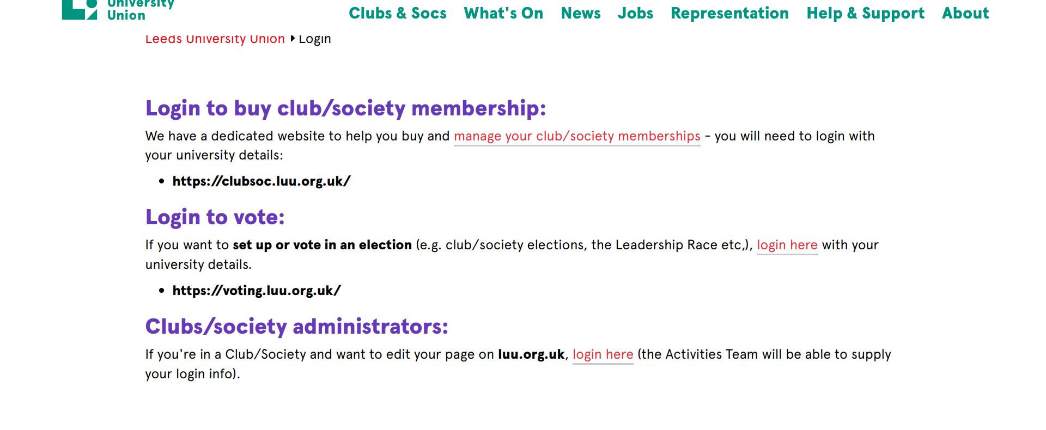
Once you login as a student, find your election. To stand for committee, choose an available position.
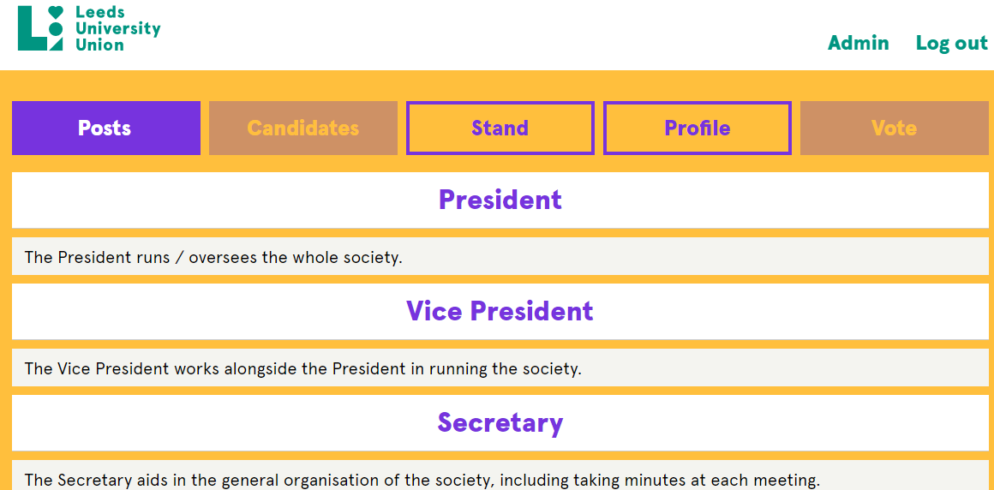
Once you have chosen the position you would like to run for, you can choose to ‘stand.
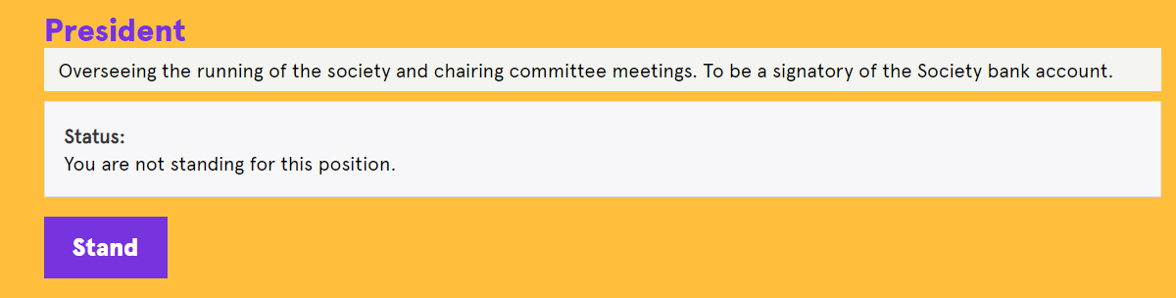
You are then able to upload a picture or manifesto.
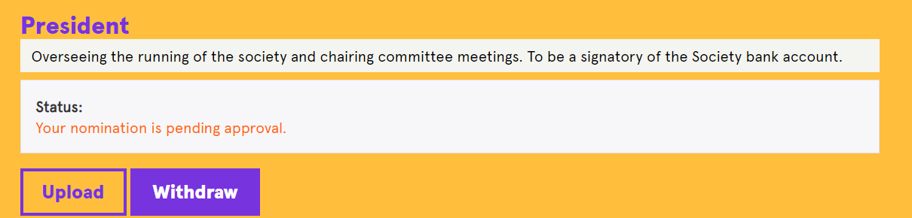

How do I vote?

You can vote by following the same steps as above, but instead you go to ‘vote’ (next to ‘profile’ along the top).

You can then vote for whoever you want to become a committee member. If there is more than one candidate for a single position, you can rank your preference and click submit. You only have one vote per candidate, but it will transfer to your next preference if your first preference is lowest ranked.

You can also vote to ‘re-open nominations’ (RON) if you are not satisfied with the current candidates. If this is successful, the election will be rescheduled.

Who can vote?

You can only vote in an election (online or in person) if you are a current student at the University of Leeds AND a full member of the society.

How do I encourage people to vote?

If you are used to holding your AGMs in person, it can seem tricky to ensure the vote hits quorum online. We recommend that you try to make the process as interactive as possible.

Use platforms like Facebook and Instagram to promote the AGM, try to spread the word and give reminders to your members (when the AGM is, where to find it, how to vote etc.) Social media is a really great way to keep in contact with your members, so if you haven’t utilised it yet now is the time.

You can also hold Q&As with the candidates to let your members find out more about them. This could be done through Instagram Stories or by inviting members to an online video call, where candidates could answer members’ pre-selected questions.

