FOOT CARE – CHARTING FORM

Community Name: | Client Name: | Date:

Observations:
Medial View Lateral View
Right LEFT Right LEFT
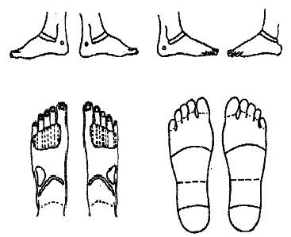
☐ Corns
☐ Calluses
☐ Puffiness/swelling
☐ Change in tissue texture
☐ Unusual color or rashes
Dorsal (Top) View Plantar (Bottom) View
LEFT Right Right LEFT
☐ Scars or past injuries
☐ Current injuries & bruises
☐ Bunions
☐ Hammer toes
☐ Ingrown nails
☐ Warts
☐ Other

Comments:

Date | Progress Note
a

