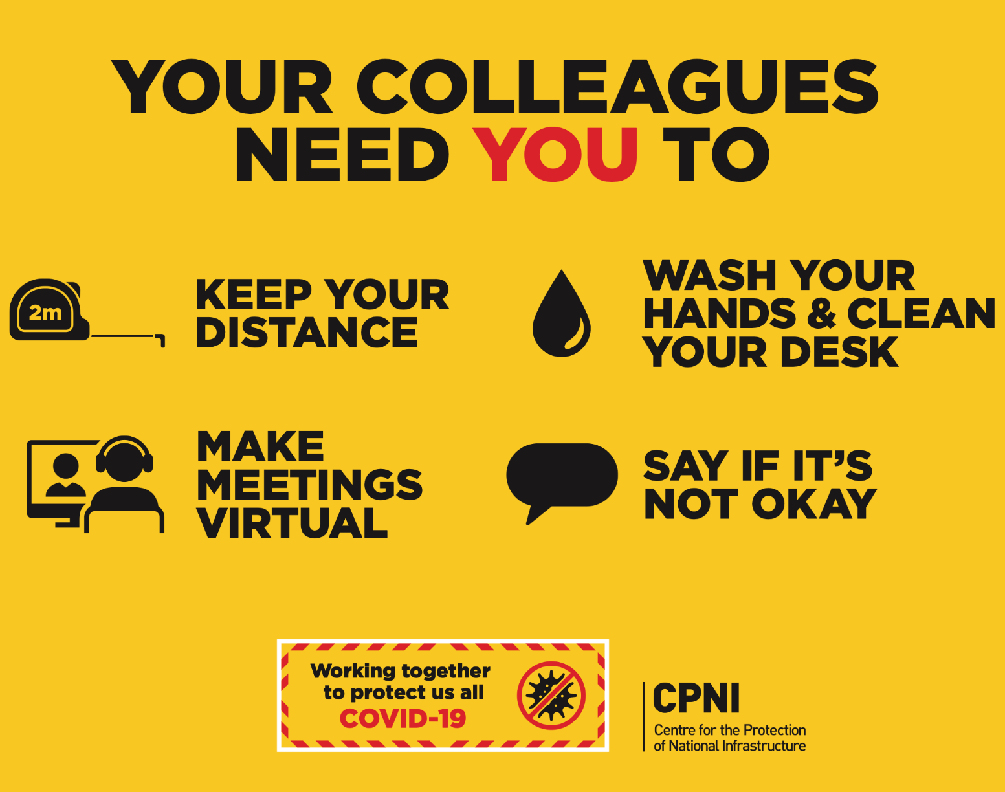

Do Your Part!

- Please Practice Social Distancing at all times
- Remain in your office and avoid in-person meetings as often as possible
- If in-person contact is required, stay 6 feet apart and wear a mask over nose and mouth
- If you must leave your office, wear a mask over nose and mouth
- Clean your work space at the beginning and end of every day
- Avoid congregating in common areas (break rooms, etc.)
Thank you for keeping you and your colleagues safe so we can continue to serve our clients with the best quality of care.

