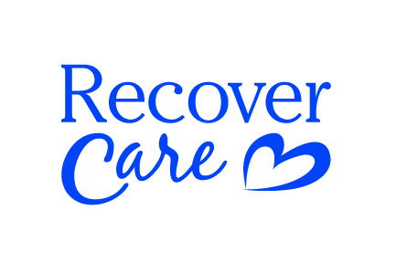

New CDC Guidelines
The CDC is now requiring surgical masks for all client interaction. Cloth masks are no long acceptable FOR CLIENT CARE. Additionally – the CDC and both MN and Wisconsin are requiring the use of eye protection in congregate living facilities when performing client care.

This means – all Recover Care Community staff must wear a standard/surgical mask and eye protection at every client interaction in a congregate living facility. This does NOT include, basic eyewear. This means staff MUST wear goggles, construction glasses (with thick sides), or a face shield.

Face Shields and surgical mask will be provided by Recover Care.

Please reach out to me if you have any questions or concerns.

Thank you,

Carly Checkalski
Lead Recover Care Administrator
715-456-4795

