Do you have our Patient Portal?

We made an investment in your patient experience because we want you to have your health information right at your fingertips.

Here are some of the things you can take advantage of when you have the
Patient Portal:
- Request your appointments and medication refills online
- Receive appointment reminders on your cell phone and via email
- Securely communicate between you and your provider
- Decrease in-office wait time by completing forms online

Access the Patient Portal online, or download the mobile app. Download the app in either the App Store for iPhone users or the Google Play Store for Android. Search for “InteliChart” in either store or use one of the QR codes below. Then download the app to your phone.

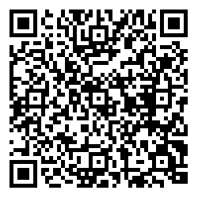
ANDROID

APPLE

OP Patient Portal powered by InteliChart

