Curbside Arrival
Let us know when you arrive for your appointment!
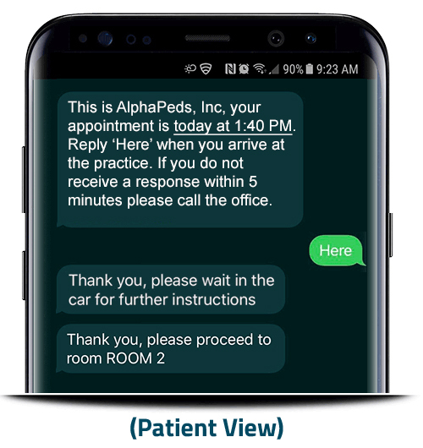

In a time where social distancing is key, <Insert Your Practice Name> is offering Curbside Arrival: This text-based solution allows you to announce your arrival from the safety of your own car, skipping the waiting room entirely. How it works:

- You’ll receive a reminder text prior to your visit with your appointment time and
copayment amount due
- When you arrive in the parking lot, announce your arrival by replying “Here” to the
reminder text
- We’ll text you instructions to either wait in the car or proceed to a specific exam room
- You can pay your copayment digitally via the Curbside Arrival text link
Our goal is to provide our patients and their families with safe, timely, top-quality care. Curbside Arrival is one of the many ways we’re able to do so.

