Sign-Up with Recover Care at Home’s Family Room Today!

With the Family Room, you will be able to access records of care online from any device with internet access. This access comes at no extra cost to you - access to the family room is part of our mission to provide the best possible care to your loved one and to empower you with the ability to care for them as well. You and other authorized family members/friends will be able to:

- Keep live track of caregiver status updates
- View scheduled shifts and personnel
- Coordinate and schedule events with other family members
- View your invoices online

If you are interested in signing up, or learning more about Recover Care at Home’s family room, please do one of the following:

- Complete the form below and mail it back to: “Recover Care at Home” at 5900 Green Oak Drive, St. 200, Minnetonka, MN 55343
- Complete the form below and email it to: recovercare@recoverhealth.org
- Call 952-230-6332, and someone will assist you

-----------------------------------------------------------------------------------------------------------
Your Name: | _________________________________ |  | Client Name: | _______________________________
Yes! Email me all future invoices! Yes! Send me an invitation to the Online Family Room!

Email address: ___________________________________ | Please check here to confirm that above named client, an authorized medical provider, or authorized fiduciary has provided expressed authorization for this contact to have online visibility to the client's care plan and the completion of care on a day-to-day basis.
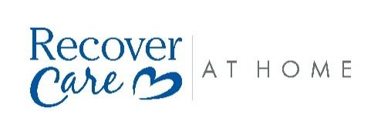
Please also send invitations to the Online Family Room to the following people (if applicable). By adding below, you are confirming that above named client, an authorized medical provider, or authorized fiduciary has provided expressed authorization for these contacts to have online visibility to the client's care plan and the completion of care on a day-to-day basis.
Name | Email Address

