Horizon Client Install

- Open browser and navigate to one of the following pages.
  - https://pc.servicemacusa.com
  - https://servicemac.evolvedaas.com (if a doesn’t work)
- If preferred a session can be ran through the web browser by typing in your username and password. If you desire to download an application for your desktop proceed to step 3. Please note: Running through web browser can limit certain application functions! It is recommended to install the application.
- Scroll down to the bottom and you’ll see a Download Link for Horizon Client. 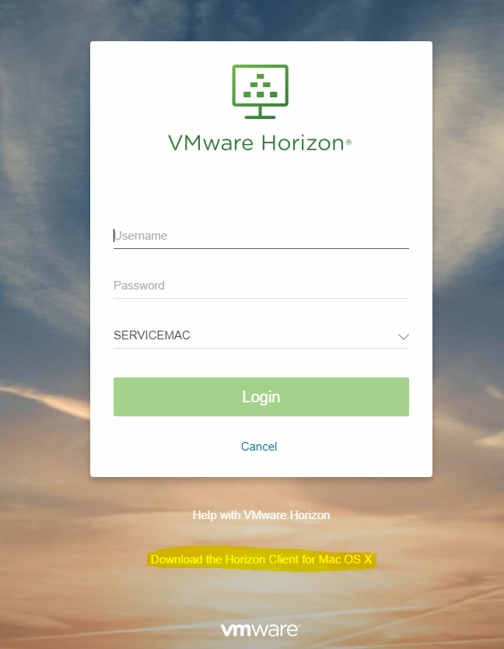

- On the downloads page click select the version for your Operating System.
For Windows, you’ll select ‘VMware Horizon Client for Windows”. For Mac OS, you’ll select ‘Go to Downloads’ for MacOS.
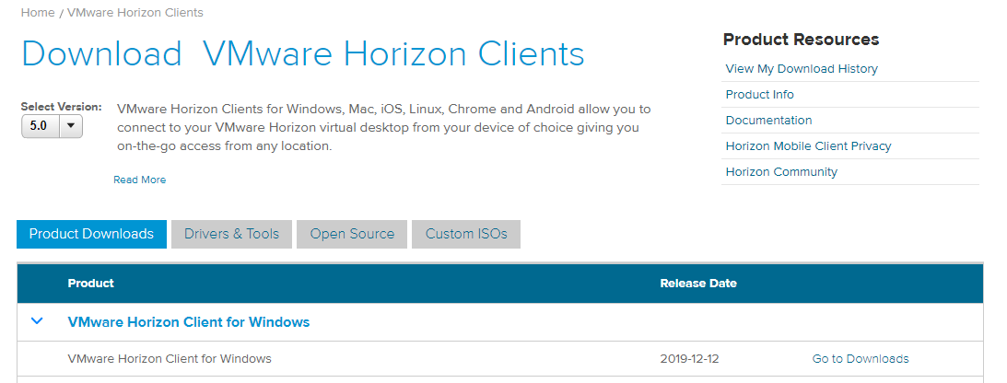

- Select the ‘Download’ button.
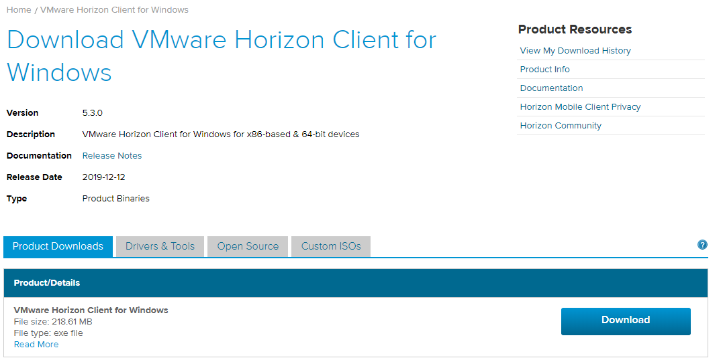

- Depending on the browser (Chrome was used in this example) after the download click “on the VMware-Horizon.exe file”

- After launching the installer click “Agree & Install”
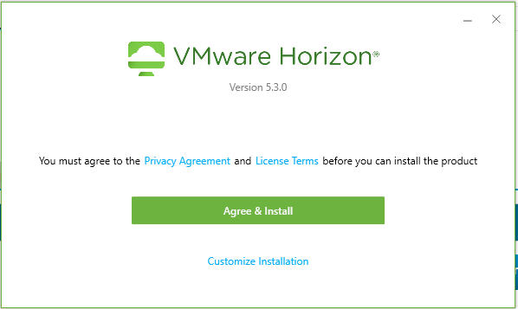

- Once you get the Success screen, you can hit Finish and the PC will ask to restart.

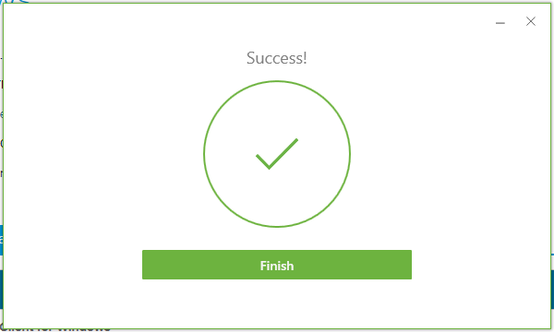

- After rebooting the PC, re-open VMware app. There should be a Desktop shortcut by default.
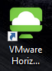

- Click on “Add Server” and in here you’ll type servicemac.evolvedaas.com.
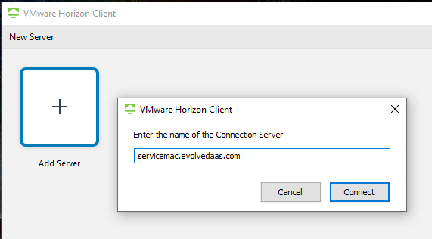

- Click Connect.

- Enter username & password
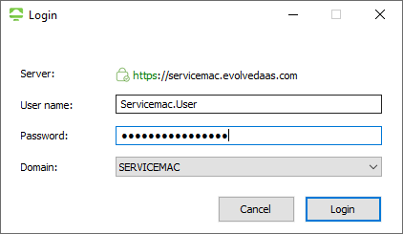

- New ServiceMac DaaS desktop will now launch – any issues please reach out to Techsupport@servicemacusa.com

