How to log in to the CAPRA Application and Review Portal
PLEASE NOTE: you must use only Google Chrome as your browser to log into the Portal – Internet Explorer will cause the system to crash.
The best way to log into the CAPRA Application and Review Portal and set up your agency’s account is the application form on the website: https://www.nrpa.org/certification/accreditation/CAPRA/overview-of-the-agency-accreditation-process/

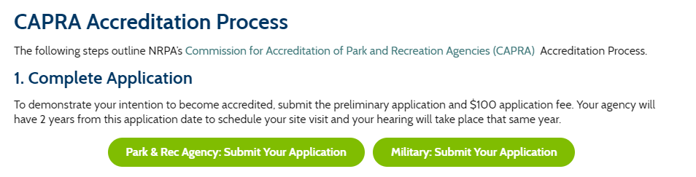

You will choose either the Park & Rec Agency OR Military depending on your organization.
On the next screen you will be prompted to log into NRPA using your current credentials (so have that information handy)
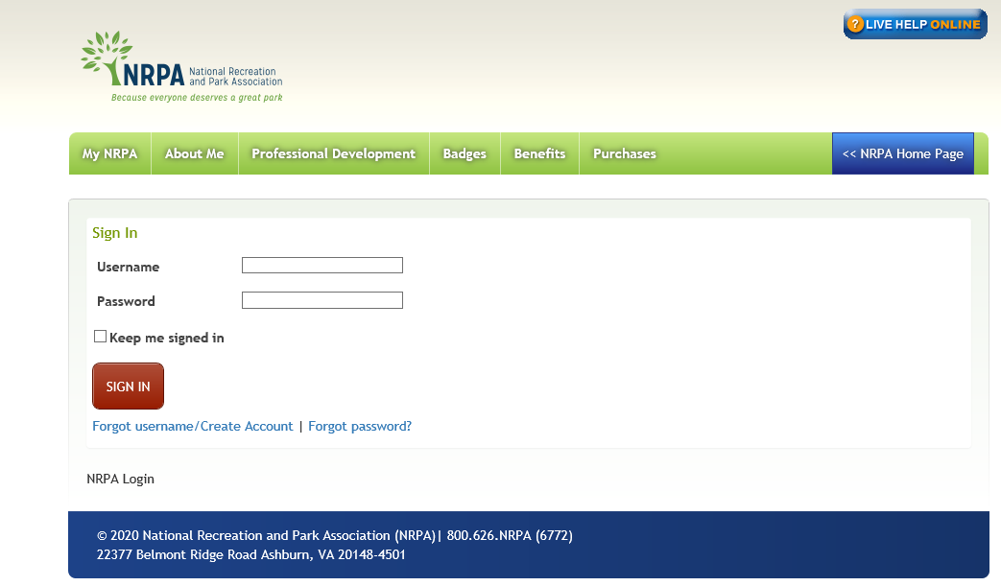
and once logged in you will be directed to the CAPRA Portal homepage: https://nrpa-capra.secure-platform.com/

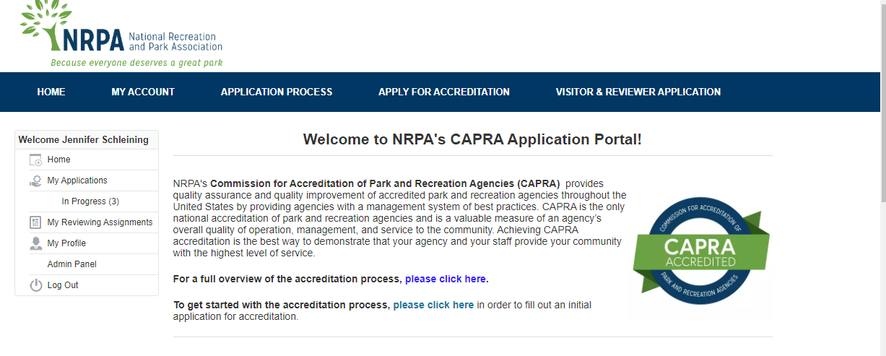
From this page you can start your application by following the link in the middle of the page OR by selecting “Apply for Accreditation” at the top of the page. Please indicate whether you are applying for initial or renewing accreditation (current CAPRA agencies must submit the short application so NRPA can update its records as needed but are NOT required to pay the fee).
Upon completion you will see the following confirmation on the screen
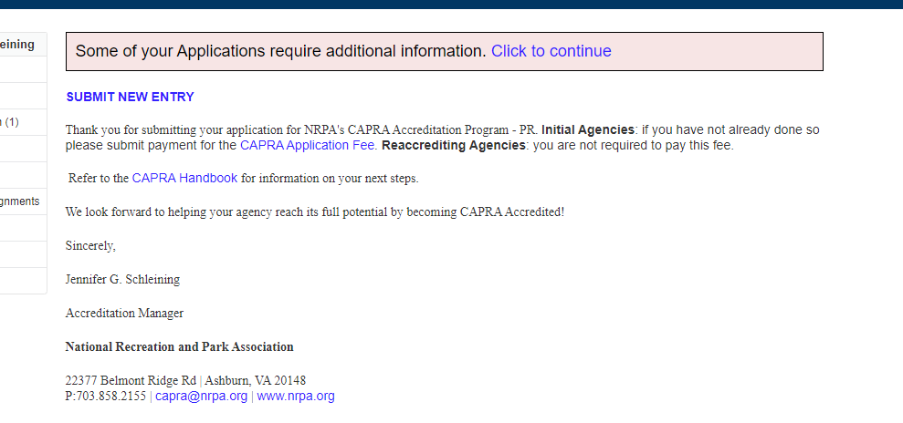

And you will receive a confirmation via email
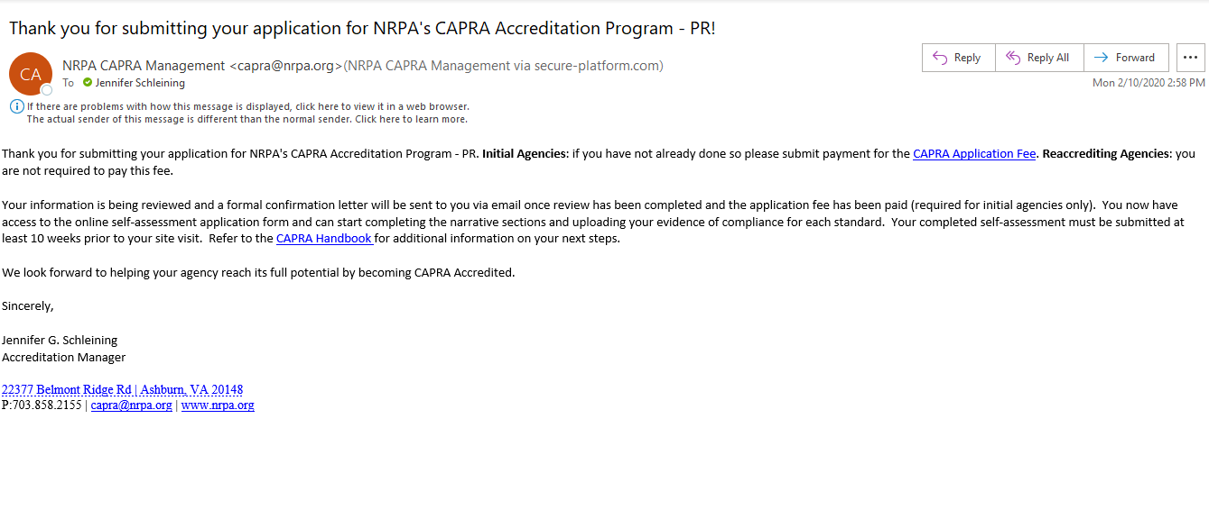

Completing this application is part one of the application process – part two is the submission of your online self-assessment report form which you will receive access to after the successful completion of part one.

