How To Complete Online Self-Assessment Report Form and Upload Evidence of Compliance
PLEASE NOTE: you must use only Google Chrome as your browser to log into the Portal – Internet Explorer will cause the system to crash.
After successful completion of your application (part one) – you will be granted access to the online self-assessment report form.
To access it log into the Portal and click on the “Click to continue” link:
And select your application by clicking “Open”
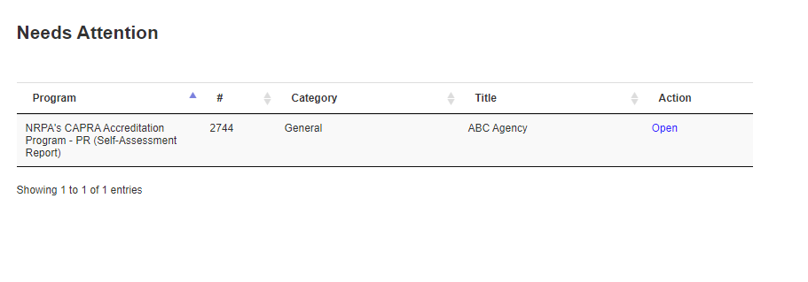
And this will bring you to the beginning of part two
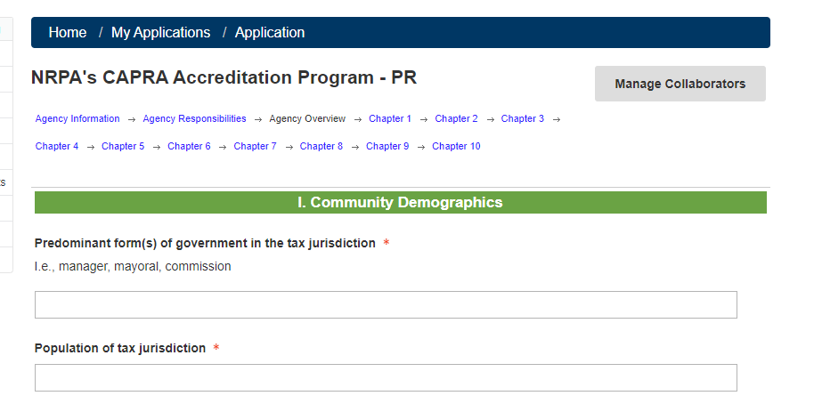

Note: The Portal allows you to add multiple staff members to work on your self-assessment – to do that select the “Manage Collaborators” button on the right hand side and add email addresses for those to be added as Collaborators. Those individuals will need to set up their own accounts in the Portal.
Completing your Narratives and Linking Evidence of Compliance
Once you complete the “Agency Overview” section you will move into Section 1 of the Standards:
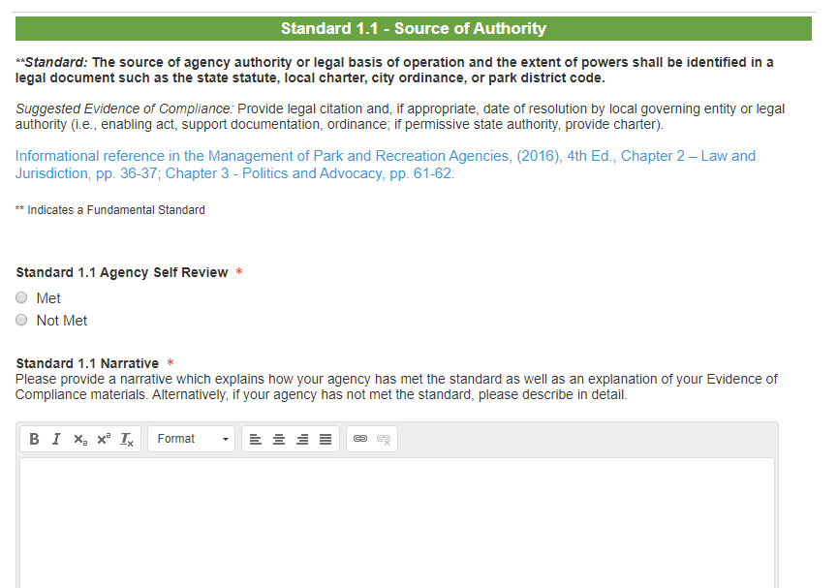”

Each standard will include the standard definition; suggested evidence of compliance; informational reference; section to indicate whether your agency has met or not met the standard; and a large textbox for your narrative.

The Commission asks that you provide weblinks to your related evidence of compliance in the body of your narratives.

When creating your link, select the “Target tab” and Select “New window” to make sure your evidence opens up in a new window on the page:
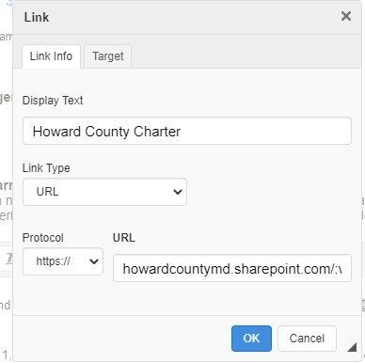

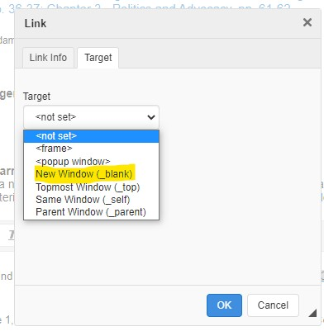

Depending on what document management system you are using you will also need to provide log in information for your system for all reviewers and visit team members.
Remember the CAPRA Reviewers and Visitors ask that the links direct them right to the specific item you are referencing and that you use highlighting and bookmarking when possible to identify the most important parts of your referenced text.
You can also include a link to additional evidence at the end of each section:
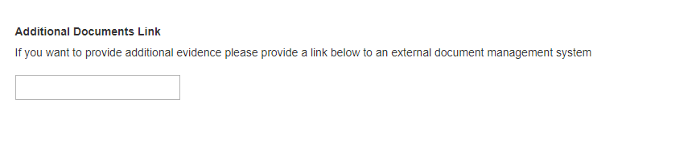

Each section must be completed for all fundamental standards indicated by the symbol “**”
You can save your work as you go along by selecting the “Save” button at the bottom of the page and the “Save and Next” button to move on to the next section. Sections do not have to be completed in order and you can navigate from one to the other at the top of the page.

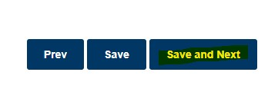
Once all sections have been completed and evidence links added you can submit your report for review by selecting the “Save and Submit” option at the bottom of the page of the last section.

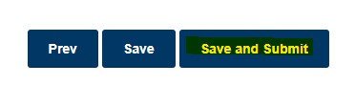
The system will provide you with a confirmation message on the screen and your submission will move from “In Complete” to “Complete” status. Once you have completed let the CAPRA Accreditation Manager know so they can provide your report to your assigned reviewers.

