­­­

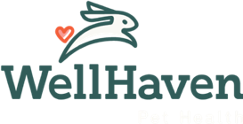

**Welcome to the WellHaven Family of Hospitals!**

WellHaven is proud to welcome new doctors to our family of hospitals. We embrace the shared responsibility of mentorship for new and recent graduates, and welcome you to our great profession.

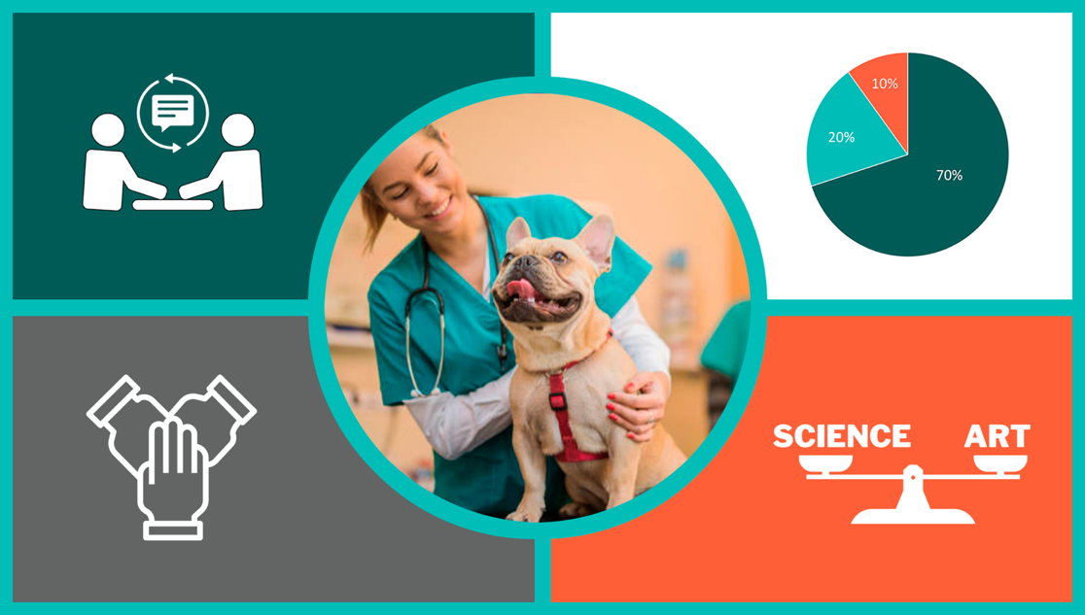

**Trust, Communication and Two-way Feedback**

A good mentor/mentee relationship involves trust, communication, and two-way feedback. A relationship in which you will both learn from one another. Some apprehension as you enter a new practice and profession is to be expected. It’s OK. Your mentor is there for you.

**Lifelong Learning**

Unlike school, your learning is no longer prescribed and tested each semester. Ultimately, you own your learning – it’s your lifelong pursuit and joy. A good model for learning is the 70:20:10 model. Seventy percent of your learning is on the job, twenty percent from mentors/coaches, and ten percent from conferences, podcasts, webinars, and reading.

**Veterinary Medicine is a Team Sport**

Don’t forget that the practice of veterinary medicine is a team sport. Team health care delivery provides for the best standard of care, career satisfaction, and patient outcomes. Your job as a doctor is to diagnose, prescribe and do surgery. Delegate all you can to your team, rely on them, trust them, empower them. Your success depends on your team.

**Both a Science and an Art**

Also, try to remember that the practice of medicine is both an art and a science. Your success rests as much on the “soft” side of practice as on the scientific. Mistakes will be made, be kind to yourself, rely on your team and your network of mentors. Have fun!

**Mentorship Program Overview**

**Mentorship Program Structure**

We hold four shared values – Well People, Well Pets, Well Practice, and Well Community. Well People includes your wellbeing, both personally and professionally. Take good care of yourself and don’t hesitate to ask for help.

Your mentor program includes several levels of support as you gain additional confidence and competence. All are available to you to help you on your journey, some will find some tools more valuable than others, take advantage of all of your resources. This guide is not meant to be prescriptive. You and your mentor are free to modify to meet your shared needs. Feel free to use this guide as a baseline.

* Your mentorship is personalized and flexible to meet your needs and your hospital’s needs – it is tailored to best support your development and considers how you prefer to learn and become proficient in skills, helps you identify your specific interests, sets realistic goals and milestones, and enables you and mentor to make adjustments along the way as needed.
* You will have a mentor and team at your hospital to provide you with support day-to-day.
* Additionally, you’ll have a Director of Medicine with years of experience in both practice and in mentoring to check in with you monthly or more as needed.
* With our network of sister hospitals within the WellHaven family, there’s opportunity to learn from experts in their respective area.
* You and your mentor are asked to read [AAHA's Mentoring Guidelines](https://www.aaha.org/globalassets/02-guidelines/mentoring/mentoring-guidelines.pdf) document. This guide can help align you and your mentor on what you plan to accomplish through your mentor period.

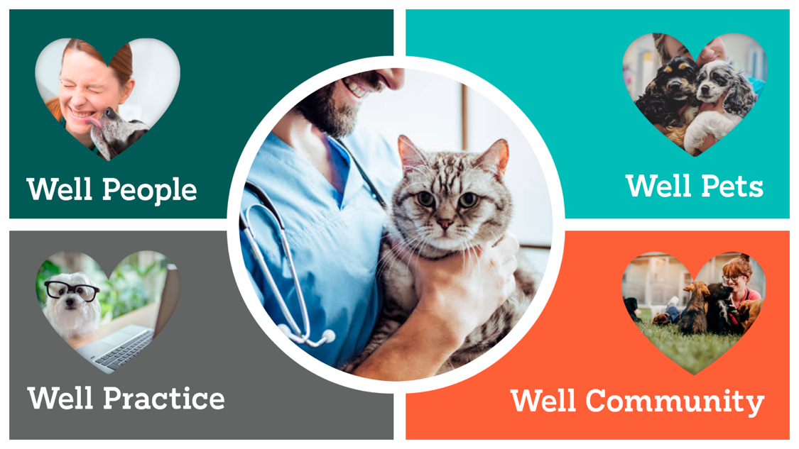

**Mentorship Program Resources**

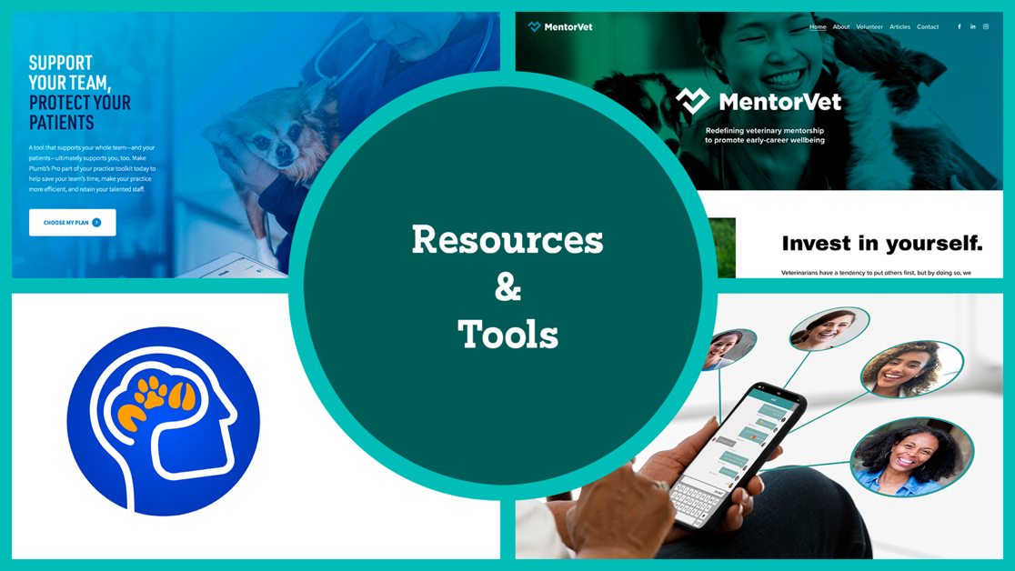

**Plumb’s Pro**

You will be enrolled in [Plumb’s Pro](https://plumbs.com/solutions/veterinary-professionals/) to provide you with the most up-to-date reference covering everything from diagnosis to discharge available on your phone or other device 24/7.

You face thousands of patient care decisions every day. With Plumb’s Pro, find all the trusted clinical answers you need on one easy-to-use platform.

**Mentor Vet**

You will also be enrolled in [MentorVet](https://www.mentorvet.net/about) — a virtual community of newer graduates providing virtual connections and expert resources from financial coaching to mental health resources to peer meetings and access to additional mentors within the industry. MentorVet’s online learning offers 10 CE credit hours and includes 5 modules including self-care, leadership, conflict management, ethical decision making and incremental care.

**Vets in Mind**

Should you choose to, you can take advantage of a wonderful free app called [Vets in Mind](https://www.vets-in-mind.org/). This app contains many resources you may find useful throughout your career. Vets in Mind is a nonprofit which connects all members of the vet community with quality information on health and wellness.

**Group Text for New/Recent Grads within the WellHaven Family of Hospitals**

A group text will be established allowing you to connect with other new and recent graduates within the WellHaven family of hospitals, providing you an additional community from which to learn and share.

**Additional Team Member Resources**

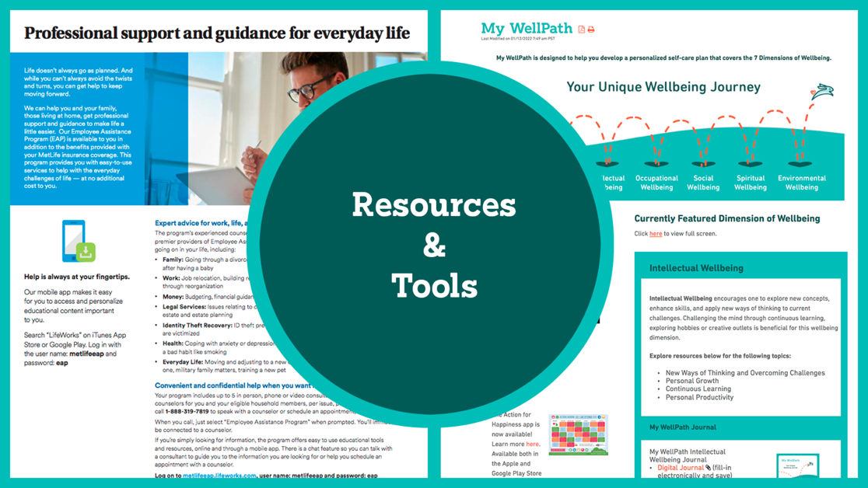

**Employee Assistance Program (EAP)**

WellHaven’s [Employee Assistance Program](https://wellhavenpethealth.knowledgeowl.com/help/metlife-lifeworks-employee-assistance-program-eap) (EAP) is a free resource offering expert advice on work, life, and well-being. Talk with counselors and experts about work, health, legal, money, and everyday life.

**My WellPath**

Don’t forget WellHaven’s [My WellPath](https://wellhavenpethealth.knowledgeowl.com/help/my-wellpath) program found on the knowledge base. This is a very robust set of tools that covers the seven dimensions of wellbeing — physical, emotional, intellectual, occupational, social, spiritual and environmental.

**Let’s Get Started!**

The first few days and weeks in any new position can be hectic. Be kind to yourself, give yourself some slack. New names, roles, systems, processes… don’t expect to get it all right away. Each day you’ll get a little better. Breathe.

Whenever possible meet or speak with your mentor prior to your start. Share your learning and coaching style. Do you learn better by doing or observing? Begin thinking about goals you’d like to achieve during your mentor period.

**Day 1**

**Onboarding Action Items**

|  |  |
| --- | --- |
| Description | Check when complete |
| Review [AAHA Mentor Guidelines](https://www.aaha.org/globalassets/02-guidelines/mentoring/mentoring-guidelines.pdf) |  |
| Review [AAHA Preventive Care Guidelines](https://www.aaha.org/globalassets/02-guidelines/preventive-healthcare/AAHA-Oncology-Guidelines-for-Dogs-and-Cats) |  |
| Review job description |  |
| Meet the team and review their roles – gain some understanding of what the front desk does, what nurses and assistants do |  |
| Tour the hospital |  |
| Meet with your Principal Doctor and Practice Manager |  |
| Find a desk/workstation |  |
| Log into eVet |  |
| DEA license applied/obtained |  |
| 1:1 with onsite mentor doctor |  |
| Display license if required |  |
| Review safety measures – radiation, first aid, patient handling, OSHA, eyewash, fire extinguisher |  |
| Review the WellHaven Handbook and [Benefits Guide](https://wellhavenpethealth.knowledgeowl.com/help/2022-benefits-guide) |  |
| Review Social Media policy |  |
| Review Harassment policy |  |
| Review schedule for next 90 days |  |
| Discuss appropriate dress |  |
| Exchange contact information |  |
|  |  |
|  |  |
|  |  |

* No appointments today – watch, shadow
* For AAHA hospitals – begin reviewing a few protocols daily/weekly

**Weeks 1-2 Suggested Activities**

* Determine how much pairing mentor needs and mentee can offer – shadow in rooms? How often? How long?
* Day 2 and 3 – take a few walk-in/drop-off appointments. Take a few wellness rooms.
* Day 4 through Week 2 – 45-minute to one-hour appointments are OK as you gain confidence and competence, you’ll get more efficient with practice.
* Shadow doctors for a few surgeries. Scrub in and assist to demonstrate to your mentor your ability to handle tissue and comfort in surgery.
* Preventive care – vaccine protocols, preventive care products, why we recommend what we do and parasiticides review.
* Review most common diagnoses and be prepared to address top 20 – healthy pet, itchy dog, dental, enteropathy, ear, obesity, musculoskeletal, mass, behavior, anal sacs, optho’, nails, parasites, trauma, neoplasia, upper respiratory, cardiac, trauma, urinary, lethargy.
* Healthy pet examinations – mentor to do some PE with you to confirm diagnostic abilities.
* History taking – what questions asked by team (e.g., diet, meds, supplements, preventive care, environment). Standard doctor questions for vomiting, diarrhea, inappetence, urinary accidents (cat vs. dogs), lameness, etc.
* Physical exam – nose to tail, describe abnormalities to mentor and plans to address.
* Medical records – SOAP for wellness vs sick vs anesthesia.
* Anesthetic protocols and emergency drugs.
* Diagnostic plans – see AAHA – review skin, ear, eye, vomiting, diarrhea, lameness, murmur… plan for normal workups and why (helps in communicating with clients).
* Patient care – ICU vs surgery vs drop off vs sick vs wellness.
* Verbal communication – consider role play for wellness vs sick vs upset client vs other.
* Treatment plans – based off of diagnostic plan.
* Wellness plan – which pets are appropriate to recommend and which are not.
* State practice act – comply with what vet tech/nurse can and cannot do.
* Evet practice (PIM).
* Doctor roles and responsibilities – per hospital and job description.
* Front and back staff responsibilities – workflow sheets for doctor to understand who is their specific support staff for the day and their responsibilities. Checklists where appropriate.
* Subscribe to Plumb’s Pro – review resources.
* Enroll in MentorVet – participate in modules and group events.
* Pharmacy – Cubex training where applicable. DEA compliance – logging and secure storage.
* Review patient flow with mentor and hospital team.
* Review best practices with mentor and hospital team.
* Sick pets review.
* Surgery – prepare for surgeries on schedule in advance; go over questions you have with mentor, go over procedure with mentor, have mentor scrub in for first few procedures.
* Client service – work to communicate effectively with client and team.
* Review commonly used rugs and doses – Plumb’s Pro.
* Review common diagnoses, workups, and client education.
* Weekly meeting with mentor – typically 15–30 minutes, these are for whatever you need – case reviews, medical records, questions, drug reviews, policy review, etc.
* For more information on benefit plans, view the [Benefits Presentation](https://wellhavenpethealth.knowledgeowl.com/help/2022-benefits-presentation) and/or contact [HR](mailto:hr@wellhaven.com).

**Notes or Other Activities for Weeks 1-2**

**Weeks 2-4**

**Appointments**

* After 2 weeks you should be moving towards 45-minute appointments. A goal of 15 – 20-minute wellness appointments and 20 – 30-minute sick appointments within 3 to 6 months is reasonable.
* Drop offs suggested for vomiting, diarrhea, inappetant pets to allow time for diagnostics and patient monitoring.
* Surgery – you will be added to the surgery schedule once you’ve demonstrated to your mentor adequate competence. Timeline will vary. Proficiency at performing ovariohysterectomies is often used as a surrogate for judging surgical abilities.
* Should you benefit from additional spay/neuter practice we have local resources to provide additional practice.

**Weekly Meeting with Mentor**

* Continue as needed. The goal is to have someone to help you. These can be case reviews, medical record reviews, case flow, specific procedures, delegating, work-life balance, client communication, team communication, client conflict, building teams, etc.
* Review production reports.
* Let your mentor know if you need more or less mentoring.
* These meetings are a good time to set goals over the coming weeks and months.

**First 6 Months**

Determine your needs in partnership with mentor, do you need further mentoring on…

* Dental extractions
* Ocular procedures
* Ultrasound basics
* Internal medicine case reviews
* Specific surgical procedures
* Emergency medicine

**Checklists – Diagnoses, Procedures, Surgeries**

There are a lot of new things to learn and become proficient at. We’ll take you through some foundational procedures, surgeries, and diagnoses. The following checklists are just a baseline, feel free to adapt them to meet the needs of you and your mentor.

Learning is a lifelong obligation and joy. As a mentee, be sure to take charge of your learning!

Click to download the checklist:

[Medical Case Review Checklist](https://dyzz9obi78pm5.cloudfront.net/app/image/id/61efb857165fa689377b2a2e/n/medical-case-review-checklist-mentor-guide.docx)

[Procedural Checklist](https://dyzz9obi78pm5.cloudfront.net/app/image/id/61efb85b165fa6b0377b28a8/n/procedural-checklist-mentor-guide.docx)

[Surgery Case Review Checklist](https://dyzz9obi78pm5.cloudfront.net/app/image/id/61efb85e165fa6e4377b255c/n/surgery-case-review-checklist-mentor-guide.docx)