Talking Points
HBA’s Strategic Plan Presentation
Slide 1—Title slide:
- After the 2021 annual business meeting, we received feedback from tenured volunteer leaders about HBA’s vision and strategic plan. We recognized there was an opportunity to provide background and context, and engage with you – that’s the objective of today’s presentation.

Slide 2—Today’s session:
- As you see in the agenda, we'll walk through HBA's core purpose, mission, vision—making note of our updated lexicon—as well as review the 3-year strategic plan for the organization through 2024​.
- We’re taking this opportunity to explain the evolution of the strategic plan, describe what’s coming and receive your feedback. Given you are HBA ambassadors, and partners of our Global Board of Directors, it's important to us that you feel informed and empowered to help spread the word.
- It’s also important to note upfront that we’re not fundamentally changing our mission or strategy but improving the way that we work together with bigger and bolder objectives that enable us to expand globally, and help advance women, further, faster.​
​
Slide 3—Mission and Vision (video)
- Before we dive into the 3-year Strategic Plan, let’s set the foundation with two key elements that are the bedrock of our strategy for the future—HBA's mission and vision.
- While our core purpose (the reason we exist) AND our mission (our business goals) are NOT changing, our lexicon, our wording, and our messaging are evolving.
- You know the old adage…a picture is worth a thousand words…so let’s SEE how our lexicon is evolving…..
[PLAY VIDEO]
Slide 4: Mission and Vision
- Please note that the video is available as part of this tool kit for use with your local members and other key stakeholders.
- This evolution is the result of several factors:
  - Our 2019-2020 relevancy study revealed that some of the lexicon terms we’ve been using for decades are no longer in sync with more common and familiar words.
  - Our Advisory Board, Global Board and many in our global community agree it’s time to evolve our lexicon to ensure greater relevancy and timeliness.
  - These changes will help HBA’s messaging more effectively align with the global marketplace around us.
- It also became apparent that it was time to establish and adopt a Vision. For the Future. As a North Star. As an aspirational state for all women in our workplace. Across the globe.
- And we believe…through research, data collection, and our collective experiences that:
  - By elevating women into positions of key decision-making in healthcare, we have a much better opportunity to influence health equity, which ultimately will lead to better health outcomes—a shared goal of our industry.
  - Our Vision is our bold aspiration of where we want to go. Our Mission and Strategy will help get us there.

Slide 5: Explaining Equality vs Equity
- OK, let’s take a minute to explore the differences within the concepts that you just saw in the video and within our Mission and Vision.
- What is the difference between equality and equity and why did we choose these terms?
- Here you can see a visual representation of the concepts behind each word. We were very intentional to look at equity, because we need to change the system. Equity is about providing the appropriate resources to each and everyone, according to their individual needs.

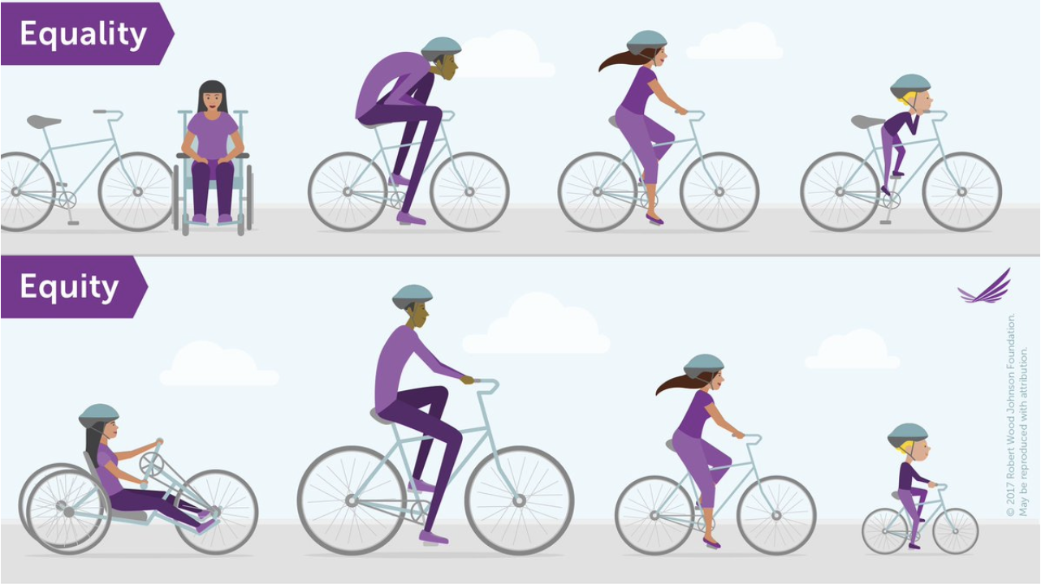
Slide 6: Key Stakeholders
- Now, let’s talk about our strategic plan:
- We’ve evolved it to focus on priorities within 3 key stakeholder groups, in which we mapped the 4 levers (customers, relevancy, advocacy, infrastructure) that some of you may have remembered from our previous strategy.
- This puts the emphasis on meeting the needs of these stakeholders and it assumes that the infrastructure and relevancy levers support meeting those needs.
- We intend to focus on the three groups depicted on this slide equally as they are our key stakeholders.

Slide 7: Strategy by Stakeholder Group
- Customer/Corporate Partner: includes organizations which sponsor HBA, as well as those that have signed up to be Corporate Partners. 80 percent of HBA’s current membership comes from Corporate Partners and we know that members are often the key to raising awareness and commitment from their organizations. We need to both “change the system” as well as have commitment from individuals to drive our mission, so our strategy here is:
  - To continue partnering with leading corporations to advance gender equity by collecting data, publishing best practices, and implementing solutions. As an example, we have an excellent basis from the Gender Parity Collaborative and we aim to leverage this initiative, moving forward, so we are the association that companies tap to better understand gender equity best practices.
  - We can expand both the impact of the HBA and our reach across our global corporate partners by providing expertise, thought leadership, and opportunities to develop women in these groups.
- The life force of our organization are our members and, in particular, our passionate and dedicated volunteers. The HBA provides opportunities for advancement by networking, skill development, and developing leadership skills through influence:
  - Our strategy is to strengthen the engagement of the growing 12,000+ members across the globe.
  - We know that members engage with the HBA: 1. because they share, and are inspired by, a common passion around HBA’s mission; 2. to grow their networks, and 3. for career advancement & leadership development.​
  - In addition to the offerings you’re familiar with, we will introduce new, senior-level programming and enhanced digital experiences.
- One of our bold additions is under Advocacy/Allyship:
  - We recognize that there is an opportunity to align with and mobilize people and organizations who support the mission of the HBA – to raise awareness, expand advocacy and accelerate our impact.
  - In particular, we want to engage male allies as advocates, implement best practices to advance under-represented groups, and develop our thought leadership globally.
  - We have already started to be more active in this area with several events that have focused on allyship.
- All of these three priority areas are of course interlinked. Let me share some examples:
  - We already have many allies within our corporate partners
  - Several corporate partners join the HBA because a member became a volunteer who convinced their employer to become a corporate partner
  - Corporate partners are an important platform for us to increase our individual membership

Slide 8: Member/volunteer value proposition
- Let’s now focus on the member/volunteer value:
- As you see, we want to customize our HBA offerings to address Member needs at all levels.​
- A key part of the value of the HBA is that it provides leadership development experiences, exposure, and opportunities to pay it forward for all members through volunteering.
- In particular, volunteer leaders of the HBA have a wonderful opportunity to learn and practice leadership by influence, which is so important in today’s dynamic organizations so let’s talk about that next.

Slide 9: Volunteers
- A key subset of our membership is you, our volunteers! We have more than 800 volunteer leaders plus countless micro-volunteers who are critical to achieving our mission – and we want to ensure that your passion and dedication also result in advancement and recognition for you. ​
- We have been working to improve the volunteer experience and leadership development that our HBA volunteers get from their contributions with projects like our role assessment as well as awards for enhanced visibility, which can be celebrated both within your organization and through online social media. ​
- We are in the process of developing further support for volunteers including: ​
  - A Learning management system (LMS) to create consistent and robust volunteer training and development.
  - Mapping the volunteer journey so that HBA volunteers can visualize their own development journey and enhance their overall experience
- THANK YOU for your time, commitment, and contributions to the HBA!

Slide 10:
- After viewing this presentation, if you have questions or feedback, please reach out through the boardstratplanning@hbanet.org email address and an HBA Global Board Member will respond.

Slide 11:
- In closing, here are thoughts for consideration…
- What ideas do you have as a volunteer/member to bring our strategy to life?​
- Be Bold – join the HBA on our transformational journey toward achieving our vision.​ Together, we are a united force for change!

###

Updated: 18 July 2022

