Name
Address
Address 2

Dear <RECIPIENT NAME>,

On behalf of the Healthcare Businesswomen’s Association, I extend my heartfelt congratulations to you for your outstanding contributions and the well-deserved recognition of receiving the <CHAPTER NAME> <AWARD NAME>.

For over 45 years, the HBA has been dedicated to advancing women in the healthcare business, and thanks to the tireless efforts of our volunteers, significant progress has been made in fulfilling the HBA’s mission. The steadfast commitment of our leaders has propelled the organization's global growth, creating numerous opportunities for members to cultivate exceptional skills in an inclusive and supportive environment.

The impactful leadership and unwavering dedication of volunteer leaders like yourself have played a pivotal role in the HBA's success, positively influencing the careers of our members and contributing to the advancement of the healthcare industry. This award serves as a testament to the remarkable work you have accomplished and the inspirational leadership skills you possess.

As we celebrate your achievements, we encourage you and those around you to take a moment for reflection, especially during this crucial time when the world is focused on achieving gender equity. Your accomplishments not only resonate within our United Force for Change network, but also contribute significantly to the broader dialogue surrounding inclusion in the healthcare sector.

Once again, congratulations on this well-deserved honor, and we look forward to witnessing your continued impact on the industry and the advancement of women in healthcare.

With gratitude,
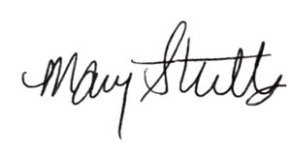

Mary Stutts
Chief Executive Officer, HBA

