Dear Ambassador,

Congratulations on completing the HBA Ambassador Program! The HBA is proud to recognize you for your commitment to achieving your personal professional goals, your innovation and collaboration in working on your program’s group initiatives, and your dedication to exploring the potential of your leadership.

**To ensure your accomplishment is continuously recognized and help you promote this achievement, the HBA is providing you with a digital badge.**

You will soon receive an email from our partner Credly to access your badge that can easily be added to your LinkedIn profile, as well as shared across your social media networks, on your website, or in your email signature.

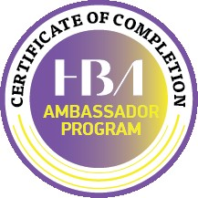

**What are the benefits of a digital badge?**

* A web-enabled version of your credentials and achievements that can be shared online
* A more efficient way of posting to social media platforms
* A trusted method for real-time verification

**What happens next?**

1. Click the link in the email sent directly from Credly
2. Create an account on the Credly site
3. Claim your badge and start sharing it on your platforms of choice

Further information about the Credly platform can be found in [their help center](http://support.youracclaim.com/), and feel free to contact us if you have any questions or need further assistance. Thank you and we look forward to your next chapter with the HBA!

The HBA Global Ambassador Team