Roles: Member Leader and Account Manager
Workflow – Searching for Corporate Partner HQ locations by region
Description: Completing this workflow will provide the user with CP’s headquarter locations in the region of interest.
- Login to HBA
- Select – HBA Corporate Partner Information on left vertical toolbar
- HBA Corporate Partner Search
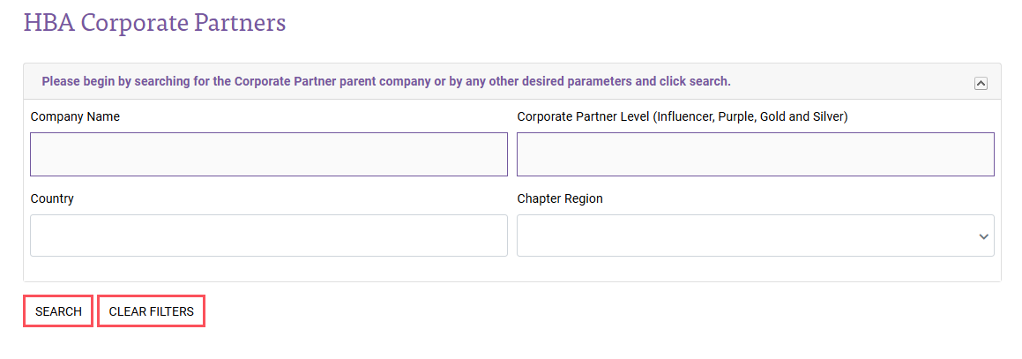
- Chapter Region – Select Region by typing first 3 characters or using dropdown

- Once region or regions have been populated, select search
- Locations of Corporate Partners along with primary contact info will be displayed
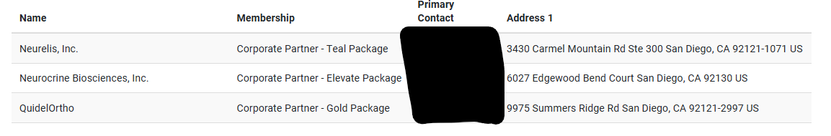

Workflow – Searching for Corporate Partner locations by region
Description: Completing this workflow will provide the user with CP’s satellite locations in the region of interest and point of contact information.
- Login to HBA
- Select – HBA Corporate Partner Information on left vertical toolbar
- Corporate Partner Locations
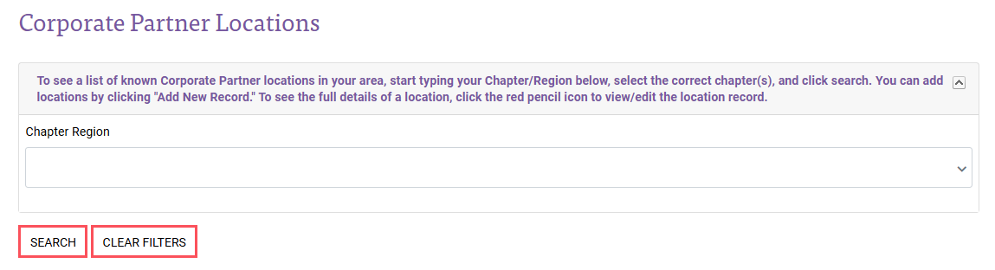
- Chapter Region – Select Region by typing first 3 characters or using dropdown
- Once region or regions have been populated, select search
- Satellite Locations of Corporate Partners along with primary contact info will be displayed
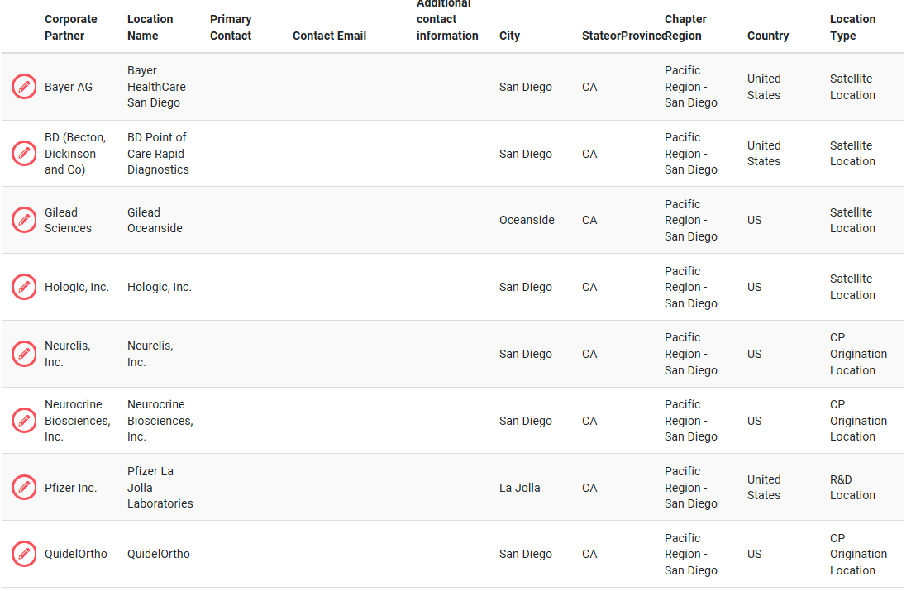

Workflow – Adding points of contact to a CP satellite office
Description: Completing this workflow will provide the user with the steps to add a point of contact to a CP’s satellite office information.
Start with the - as Searching for Corporate Partner locations by region Workflow
- Login to HBA
- Select – HBA Corporate Partner Information on left vertical toolbar
- Corporate Partner Locations
- Chapter Region – Select Region by typing first 3 characters or using dropdown
- Once region or regions have been populated, select search
- Satellite Locations of Corporate Partners along with primary contact info will be displayed
- (if adding new location) Click the + to add a new location and populate all address details known
- (if adding contact only) Select desired location to add point of contact using the edit icon
- Select desired location to add point of contact using the edit icon

- Location Contact is most desired entry
  - Important - Contact must be in the HBA system to populate this search
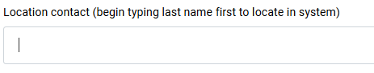
  - Begin by typing last name, select desired contact
  - Select SAVE
  - Search region again to confirm data entry in Primary Contact Column and Email column
  - Point of contact for the CP’s satellite location should display as desired

- Location Contact name and email (if name is not already in system)
  - Important –First/Last Name and email is required
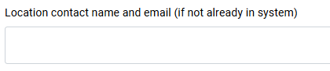
  - Free text first and last name and email address only
  - Select SAVE
  - Search region again to confirm data entry in Additional Contact Information column
  - Point of contact for the CP’s satellite location should display as desired

