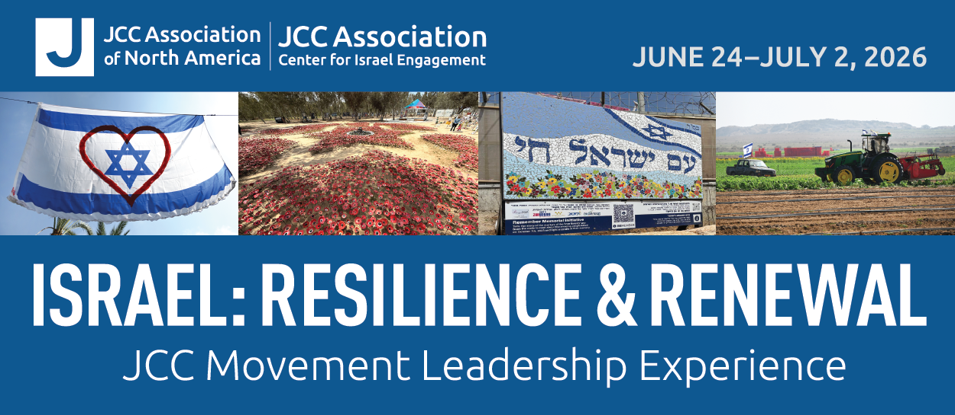

Dear [First Name],

On behalf of JCC Association of North America and the [Name of JCC], I am thrilled to invite you [and Name of Partner/Spouse] to join us for the JCC Movement Leadership Experience in Israel from June 24–July 2, 2026. This exciting journey will bring JCC board members and executives from the field together with JCC Association leaders from across North America to witness firsthand Israel’s emergence from a prolonged war into a season marked by hope, recovery, and renewal.

With time in Tel Aviv, Haifa, and Jerusalem, we will meet with thought leaders, entrepreneurs, and social activists and visit inspiring and innovative projects as well as some of the country’s lesser-known sites. Equally important, our traveling companions throughout the journey will include people who care deeply about the JCC world and North America’s Jewish community, including, of course, JCC Association’s newest leaders, President and CEO Barak Hermann and Board Chair Lissie Gottdenker.

We will begin in Tel Aviv on June 24, 2026, and travel to Haifa before the experience ends on July 2, 2026. The 22nd Maccabiah Games will open on July 1 in Jerusalem, and we encourage you to join us at this exciting event, which is a wonderful expression of Jewish peoplehood and pride.

Please don’t hesitate to be in touch if you have any questions. I look forward to traveling in Israel with you this summer!

With warm regards,

[Informal signature]

[First Name] [Last Name]
[Title: Executive Director/CEO]
[Name of JCC]

